CSI-145 Final Exam  
FALL 2016  
Tuesday, December 6th

**Number all your answers**

**When you are done, create a new folder, put your name on it. Copy your html file and all the images you used. Zip the folder and upload it to canvas.**

**At 2:30 pm today, canvas will be closed.**

Create a single web page that should contain the followings:

1. Add a div, add the following to it: text, image a paragraph, a list, and another paragrah. The links in the last paragraph should be working as well.

Dimension the div, so that it only takes a small portion of a page width.

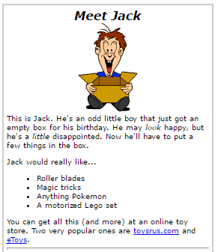

1. A Resume within a div

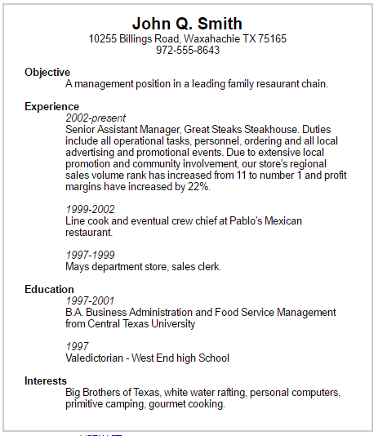

1. Add the table below: add required background color. Color does not have to be exactly the same.

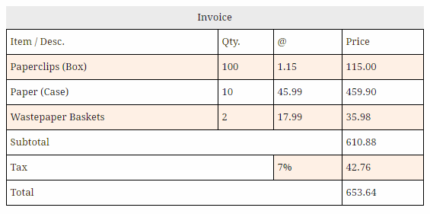

Javascript:

Add a paragraph to use as display for results:

1. Add a button that calls a method to display 6 distincts random values from 1 to 45
2. Globally define 2 arrays: cars that should be initialized to at least 6 cars, and prices that is initialized to a list of prices, where each price corresponds to a car price, related by position.
3. Add a button to call a function that displays both arrays side by side  
   as: car, price next line car, price, next line, so on….
4. Define a helper method getHighestPrice(). This method should return the higest value in the prices array.
5. Add a button “Display Most Expensive Car”. This button should call a method “displayMostExpensiveCar(). This method should use the helper method getHighestPrice to display the car with the highest price
6. Add the following in a div, with a similar border color as shown

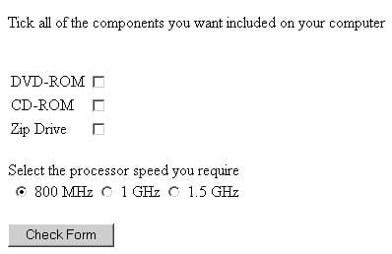

At the click of the “CheckForm” button display the selection made by user similar to the display below (in a message box)

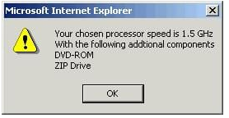

(note that your messagebox may have a different look, depending on the browser used.)

1. You are provided with six dice gif files. Every 2 seconds both image elements should display two of the gif files randomly. Like rolling two dice at a time.

