Osteotomy_web
Osteotomy_calc is a veterinary surgeon OP planning tool, written in Python by Uwe Schweinsberg.
The web-version of Osteotomy_web is embedded in the Flask web framework and forked from microblog.
A detailed documentations explains OP-Planning with Blender. Planning templates of examples are provided for download. A forum can be used for exchange of ideas and suggestions.

License
The program code and documentation is licensed under GNU GENERAL PUBLIC LICENSE Version 3.

Deployment
The source code is already accessible via a github repository.
After release of the Pumuckel case report , by Lorenz Schweinsberg, the site shall be deployed on a debian server.
NGINX is used as HTTP server, reverse proxy and IMAP/POP3 proxy server.
The application is deployed with Gunicorn, a Python WSGI HTTP Server for UNIX.
Password protected test versions of the Osteotomy and the Documentation website are already online.

The web framework Flask
Project Homepage. Tutorials used: Flask Web Development by Miguel Grinberg (O’Reilly)
and the Flask Mega-Tutorial.
Flask is writen in Python and licensed under BSD License

Structure of Osteotomy_web
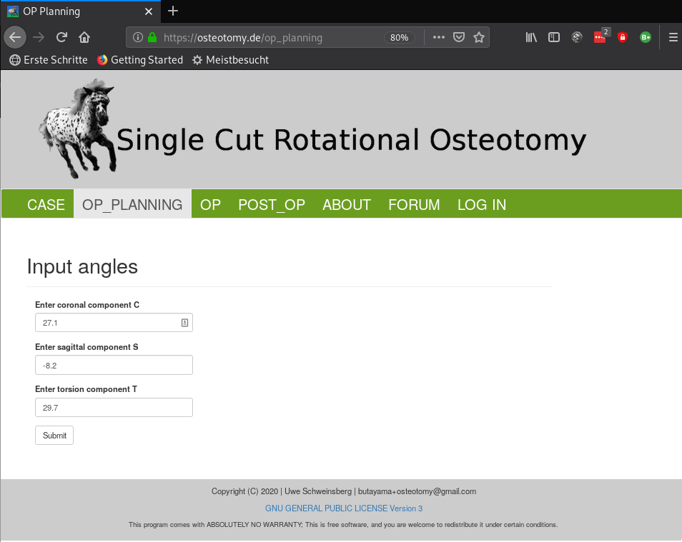

Calculation result
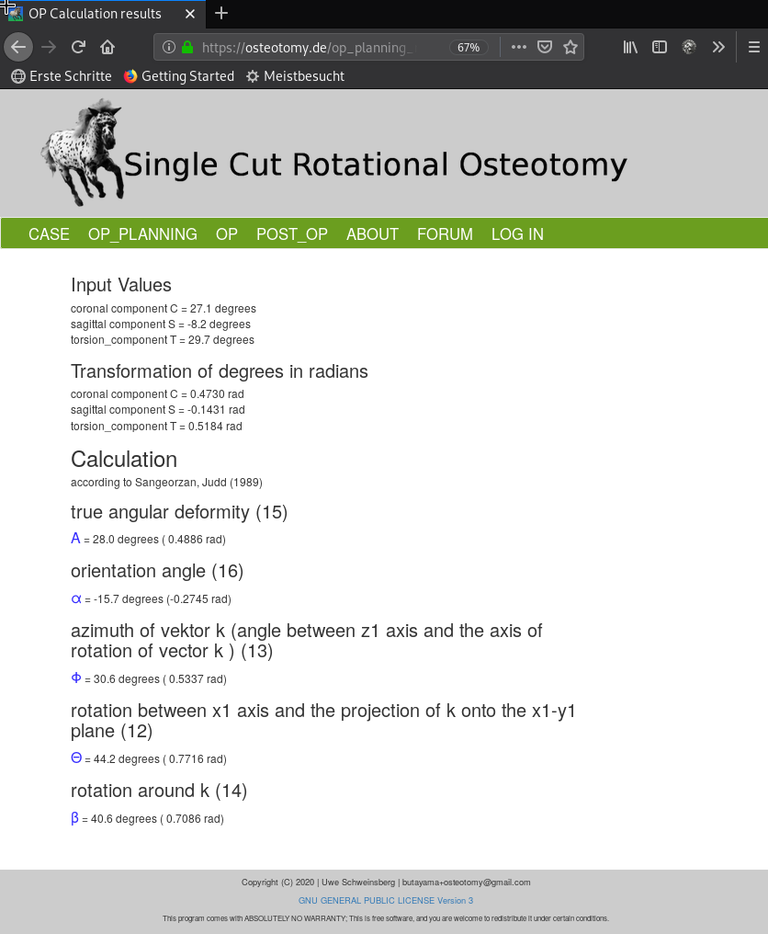

Documentation of OP-Planning with Blender
The documentation is rendered with docsify.
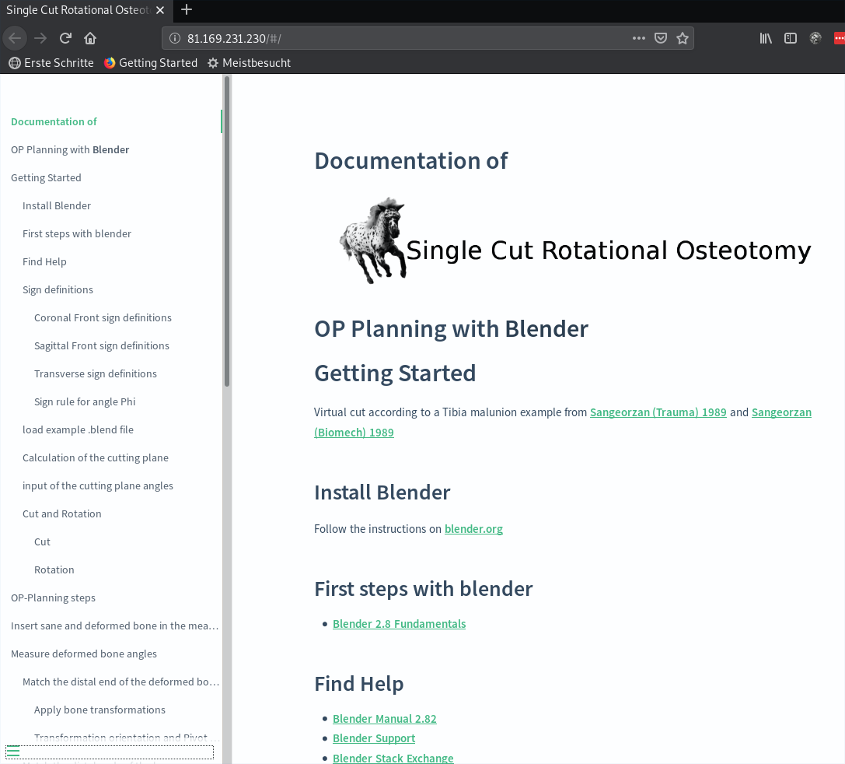
Blender is a 3D creation suite. It is used for angle measurement of 3D bone models and virtual OP procedures.

Authentication and security
- Flask-Login: Management of user sessions for logged-in users
- Werkzeug: Password hashing and verification
- itsdangerous: Cryptographically secure token generation and verification
- assignment of user roles according to permissions in a Flask-SQLAlchemy (MySQL) database.
- Forms are protected against CSRF with a form.hidden_tag() element and secret key.
- The secret key is stored in an environment variable.
- Secure https connection with valid certificate (test-version: Let's Encrypt)

Testing
- 35 test modules achieve a coverage of 62%.

ToDo
- Integration of the documentation into osteotomy_web.
- A cookie confirmation info still has to be implemented.

