***ABSTRACT***

*Internship Finder Management System is a web-based system that digitalizes the Internship Management. Nowadays, the modern world needs to digitalize every single work done; the main challenges faced by higher learning institutions are the management of interns, because of time and cost. These challenges are affecting the school, student and the welcoming institutions. The general objective of Internship Finder Management System is to develop a web application that will make significant change toward solving key problems most student face while they are doing the internship, greater convenience and better accessibility to the UTB CAREER CENTER. The specific objectives are to design an application that is able to get information of students applied and notified for internship, to develop an application that keeps track of record of institution or company that offers internships, to design an application that record information of students doing internship every year, to develop an application that generates mini report for student’s internship performance. In this research the researcher used the stratified random sampling to collect the data with a sample size of 40 respondents. And the researcher used also questionnaires, interview, observation and documentation as data collection methods. In this research the researcher found that according to the analysis of data gathered from the students, lecturers and staff of UTB Carrier Center the majority choose to implement the new system. Language used to develop this system is PHP and it is a web-based system. While testing the researcher found that the users were happy and they all said that Internship Finder Management System is a user friend system. As conclusion the researcher decided to implement the system Internship Finder Management System to tackle the problem stated. The researcher recommends UTB and Institutions to use this system in order to improve the way internships were handled.*

# Chap 5. IMPLEMENTATION, CODING AND TESTING

## Implementation and coding

* 1. **Introduction**

The Internship Finder Management System is designed following user point of view. The relative view design helps the users in accomplishing their task with ease. Attempts have been made to keep the design simple and understandable. The screens were designed using HTML and CSS the logic was written in PHP. The database used is MySQL where all the information is stored. The system runs on Apache Server.

* 1. **Description of implementation tools and technology**

The tools employed in designing the front-end of the Internship Finder Management System are:

* **XAMPP**It is an acronym that stands for X (Any OS), Apache, MySQL, and PHP (or Perl or Python). It is a Web development platform that defines the Operating System (Any OS), Web Server (Apache), database (MySQL), and scripting language (PHP, Perl, or Python).
* **HTML**Hypertext Markup Languages has been employed to design the web pages, forms, tables and creating some links.
* **Notepad++**Is the best way to create professional websites is now the easiest way to build powerful Internet applications. For the first time, you can work in a single environment to quickly create, build, and manage websites and Internet applications.

The following tools were employed in developing the back-end of the Internship Finder Management System:

* **MySQL**MySQL (pronounced “my S-Q-L" is a multithreaded, multi-user SQL database management system (DBMS). The basic program runs as a server providing multiuser access to a number of databases. MySQL is an open source RDBMS that relies on SQL for processing the data in the database. MySQL provides APIs for the languages C, C++, Eiffel, Java, Perl, PHP and Python. In addition, OLE DB and ODBC providers exist for MySQL data connection in the Microsoft environment. A MySQL .NET Native Provider is also available, which allows native MySQL to .NET access without the need for OLE DB. MySQL is most commonly used for Web applications and for embedded applications and has become a popular alternative to proprietary database systems because of its speed and reliability. MySQL can run on UNIX, Windows and Mac OS. This section describes some of the important characteristics of the MySQL Database Software. Internals and Portability: Written in C and C++.

* **PHP**PHP is a general-purpose scripting language designed to fill the gap between server side includes and Perl intended largely for the web environment. PHP generally runs on a web server.  
  Any PHP code in a requested file is executed by the PHP runtime, usually to create dynamic web page content. It can also be used for command-line scripting and client-side GUI applications. PHP can be deployed on most web servers, many operating systems and platforms, and can be used with many relational database management systems. It is available free of charge, and the PHP Group provides the complete source code for users to build, customize and extend for their own use. PHP primarily acts as a filter, taking input from a file or stream containing text and/or PHP instructions and outputs another stream of data; most commonly the output will be HTML. Since PHP 4, the PHP parser compiles input to produce byte code for processing by the Zend Engine, giving improved performance over its interpreter predecessor. Originally designed to create dynamic web pages, PHP now focuses mainly on server-side scripting, and it is similar to other server-side scripting languages that provide dynamic content from a web server to a client, such as Microsoft's Active Server Pages, Sun Microsystems' Java Server Pages, and mod_perl. PHP has also attracted the development of many frameworks that provide building blocks and a design structure to promote rapid application development (RAD). Some of these include CakePHP, Symfony, CodeIgniter, and Zend Framework, offering features similar to other web application frameworks.   
  The LAMP and WAMP architectures have become popular in the web industry as a way of deploying web applications. PHP is commonly used as the P in this bundle alongside Linux, Apache and MySQL, although the P may also refer to Python or Perl.

**Screen Shots and Source Codes**

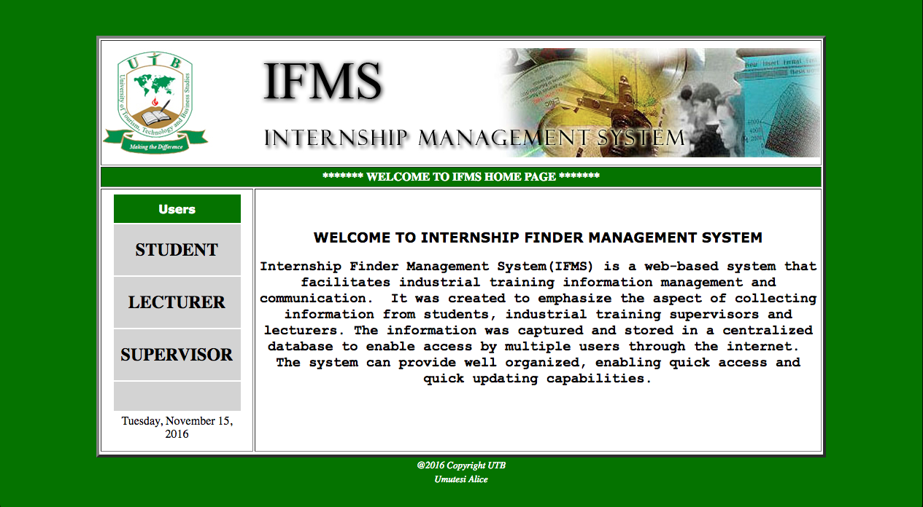

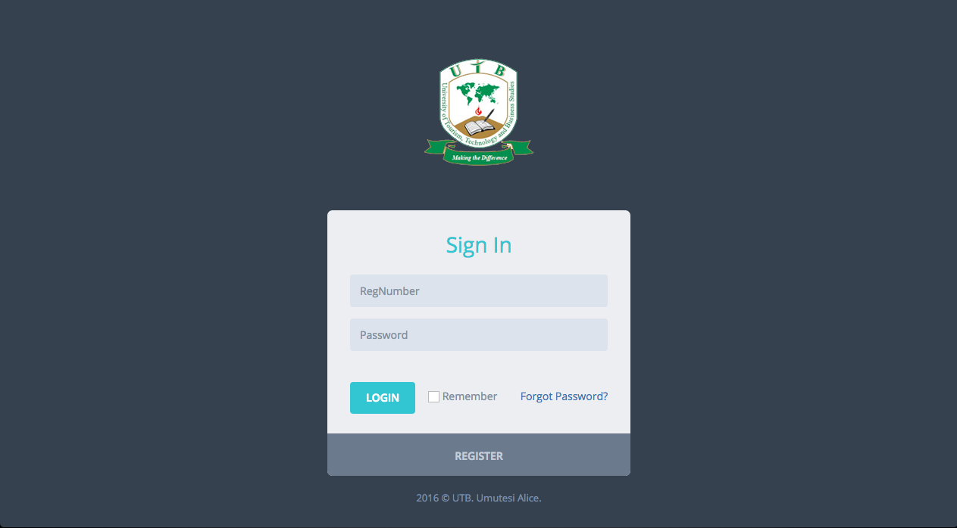

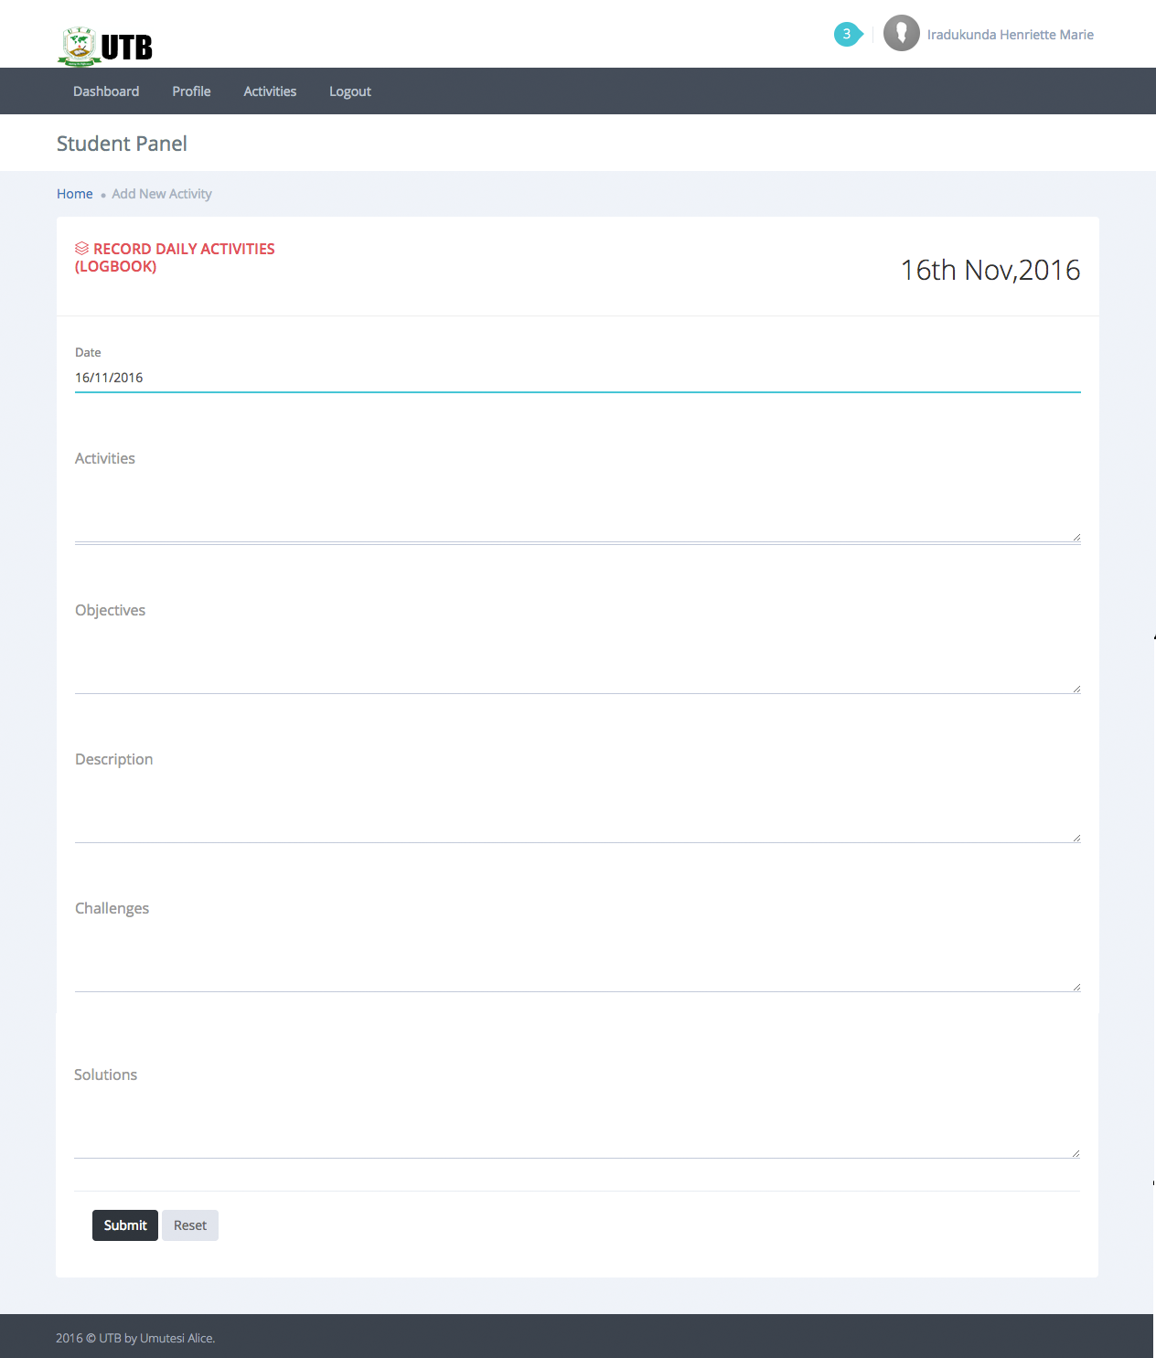

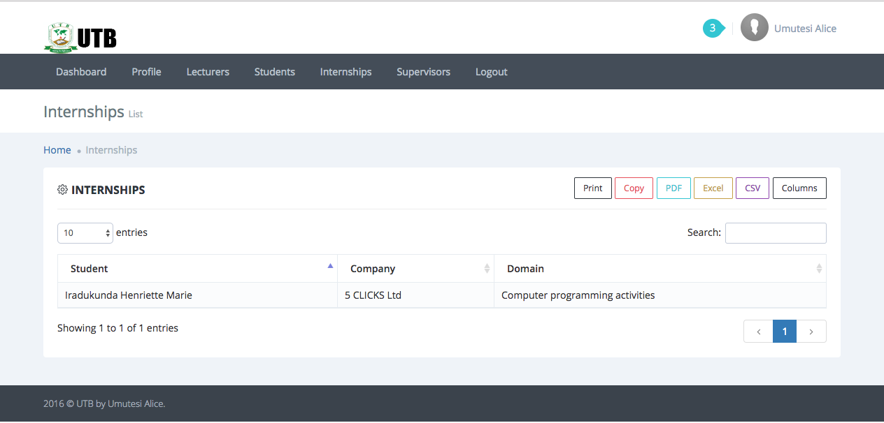

**index.php**

<!DOCTYPE html PUBLIC "-//W3C//DTD XHTML 1.0 Transitional//EN" "http://www.w3.org/TR/xhtml1/DTD/xhtml1-transitional.dtd">

<html xmlns="http://www.w3.org/1999/xhtml">

<head>

<meta http-equiv="Content-Type" content="text/html; charset=iso-8859-1" />

<title>Student Internship Finder Management System</title>

<style type="text/css">

<!--

body {

background-image: url();

background-repeat: repeat;

}

-->

</style>

<script src="Scripts/AC_RunActiveContent.js" type="text/javascript"></script>

</head>

<SCRIPT LANGUAGE="JavaScript">

<!-- This script and many more are available free online at -->

<!-- The JavaScript Source!! http://javascript.internet.com -->

<!-- Begin

var dn;

c1 = new Image(); c1.src = "images/digital-clock/c1.gif";

c2 = new Image(); c2.src = "images/digital-clock/c2.gif";

c3 = new Image(); c3.src = "images/digital-clock/c3.gif";

c4 = new Image(); c4.src = "images/digital-clock/c4.gif";

c5 = new Image(); c5.src = "images/digital-clock/c5.gif";

c6 = new Image(); c6.src = "images/digital-clock/c6.gif";

c7 = new Image(); c7.src = "images/digital-clock/c7.gif";

c8 = new Image(); c8.src = "images/digital-clock/c8.gif";

c9 = new Image(); c9.src = "images/digital-clock/c9.gif";

c0 = new Image(); c0.src = "images/digital-clock/c0.gif";

cb = new Image(); cb.src = "images/digital-clock/cb.gif";

cam = new Image(); cam.src = "images/digital-clock/cam.gif";

cpm = new Image(); cpm.src = "images/digital-clock/cpm.gif";

function extract(h,m,s,type) {

if (!document.images) return;

if (h <= 9) {

document.images.a.src = cb.src;

document.images.b.src = eval("c"+h+".src");

}

else {

document.images.a.src = eval("c"+Math.floor(h/10)+".src");

document.images.b.src = eval("c"+(h%10)+".src");

}

if (m <= 9) {

document.images.d.src = c0.src;

document.images.e.src = eval("c"+m+".src");

}

else {

document.images.d.src = eval("c"+Math.floor(m/10)+".src");

document.images.e.src = eval("c"+(m%10)+".src");

}

if (s <= 9) {

document.g.src = c0.src;

document.images.h.src = eval("c"+s+".src");

}

else {

document.images.g.src = eval("c"+Math.floor(s/10)+".src");

document.images.h.src = eval("c"+(s%10)+".src");

}

if (dn == "AM") document.j.src = cam.src;

else document.images.j.src = cpm.src;

}

function show3() {

if (!document.images)

return;

var Digital = new Date();

var hours = Digital.getHours();

var minutes = Digital.getMinutes();

var seconds = Digital.getSeconds();

dn = "AM";

if ((hours >= 12) && (minutes >= 1) || (hours >= 13)) {

dn = "PM";

hours = hours-12;

}

if (hours == 0)

hours = 12;

extract(hours, minutes, seconds, dn);

setTimeout("show3()", 1000);

}

// End -->

</script>

<script language="JavaScript" type="text/javascript">

function load_screen(s) {

form1.action=s;

form1.submit();

}

</script>

<style type="text/css">

<!--

a:link {color:black;text-decoration:none;}

a:visited {color:black;text-decoration:none;}

a:hover {color:black;text-decoration: underline;}

-->

</style>

<style type="text/css">

<!--

.bullet {list-style-image: url(images/arrow.gif);}

.style1 {

color: #FFFFFF;

font-weight: bold;

font-family: Verdana;

}

.style2 {

font-family: Verdana;

font-weight: bold;

}

.style3 {

font-size: small;

font-style: italic;

}

.style4 {

font-family: "Courier New", Courier, monospace

}

-->

</style>

<body bgcolor="#057300" onLoad="show3()">

<p>&nbsp;</p>

<table bgcolor="#FFFFFF" width="1000" border="4" align="center">

<tr bgcolor="FFFFFF">

<td colspan="2" background="" height="168"><img src="images/utb.jpg" align="left" /><img src="images/ban.jpg" align="right" /></td>

</tr>

<tr>

<td height="24" colspan="2" background="" bgcolor="#057300"><div align="center"><strong><font color="#FFFFFF">******* WELCOME TO IFMS HOME PAGE *******</font></strong></div></td>

</tr>

<tr>

<td width="217" align="center" valign="top"><table width="178" height="47" border="0">

<tr align="center">

<td width="185"><script type="text/javascript">

AC_FL_RunContent( 'codebase','http://download.macromedia.com/pub/shockwave/cabs/flash/swflash.cab#version=7,0,19,0','width','150','height','100','src','esilm_skm/calendar','quality','high','pluginspage','http://www.macromedia.com/go/getflashplayer','movie','esilm_skm/calendar' ); //end AC code

</script></td>

</tr>

<!--<tr bgcolor="#CC3300">

<td height="37" align="center" bgcolor="#432040"><p class="style1"><a href="#"><font color = "#FFFFFF">User Manuals</font></a></p> </td>

</tr>

<tr bgcolor="#CC3300">

<td height="37" align="center" bgcolor="#432040"><p class="style1"><a href="#"><font color = "#FFFFFF">Download Forms</font></a></p> </td>

</tr>-->

<tr valign="middle" bgcolor="lightgrey">

<td height="37" align="center" bgcolor="#057300"><span class="style2"><font color="#FFFFFF">Users</font></span></td>

</tr>

<tr valign="middle" bgcolor="lightgrey">

<td height="38" align="center" valign="middle">

<a href="student/login.php"><h2>STUDENT</h2></a>

</td>

</tr>

<tr valign="middle" bgcolor="lightgrey">

<td height="38" align="center" valign="middle">

<a href="lecturer/login.php"><h2>LECTURER</h2></a>

</td>

</tr>

<tr valign="middle" bgcolor="lightgrey">

<td height="38" align="center" valign="middle">

<a href="institution/login.php"><h2>SUPERVISOR</h2></a>

</td>

</tr>

<tr valign="middle" bgcolor="lightgrey">

<td height="38" align="center" valign="middle">&nbsp;</td>

</tr>

<tr>

<!--<td width="185" bgcolor="#000000"><img height=21 src="images/digital-clock/cb.gif" width=16 name=a /> <img height=21 src="images/digital-clock/cb.gif" width=16 name=b /> <img height=21 src="images/digital-clock/colon.gif" width=9 name=c /> <img height=21 src="images/digital-clock/cb.gif" width=16 name=d /> <img height=21 src="images/digital-clock/cb.gif" width=16 name=e /> <img height=21 src="images/digital-clock/colon.gif" width=9 name=f /> <img height=21 src="images/digital-clock/cb.gif" width=16 name=g /> <img height=21 src="images/digital-clock/cb.gif" width=16 name=h /> <img height=21 src="images/digital-clock/cam.gif" width=16 name=j /> </td>-->

</tr>

<tr>

<td align="center" bgcolor=""><script language="JavaScript">

<!-- This script and many more are available free online at -->

<!-- The JavaScript Source!! http://javascript.internet.com -->

<!-- Author: www.cgiscript.net -->

<!-- Begin

// Get today's current date.

var now = new Date();

// Array list of days.

var days = new Array('Sunday','Monday','Tuesday','Wednsday','Thursday','Friday','Saturday');

// Array list of months.

var months = new Array('January','February','March','April','May','June','July','August','September','October','November','Dicember');

// Calculate the number of the current day in the week.

var date = ((now.getDate()<10) ? "0" : "")+ now.getDate();

// Calculate four digit year.

function fourdigits(number) {

return (number < 1000) ? number + 1900 : number;

}

// Join it all together

today = days[now.getDay()] + ", " +

months[now.getMonth()] + " " +

date + ", " +

(fourdigits(now.getYear())) ;

// Print out the data.

document.write(today);

// End -->

</script> </td>

</tr>

</table></td>

<td width="846" valign="top" background="images/web2.jpg" align="center" style="background-position:center"><div align="center">

<p>&nbsp;</p>

<h3 class="style2">WELCOME TO INTERNSHIP FINDER MANAGEMENT SYSTEM</h3>

<h3 class="style4">Internship Finder Management System(IFMS) is a web-based system that facilitates industrial training information management and communication.&nbsp; It was created to emphasize the aspect of collecting information from students, industrial training supervisors and lecturers. The information was captured and stored in a centralized database to enable access by multiple users through the internet.&nbsp; The system can provide well organized, enabling quick access and quick updating capabilities.</h3>

<p>&nbsp;</p>

<p>&nbsp;</p>

</div></td>

</tr>

<tr bgcolor="FFFFFF"></tr>

</table>

<table width="705" align="center">

<tr>

<td width="697"><div align="center" class="style3"><font color="#FFFFFF">@<?php echo date('Y');?> Copyright UTB</font></div></td>

</tr>

<tr>

<td><div align="center" class="style3"><font color="#FFFFFF">Umutesi Alice</font></div></td>

</tr>

</table>

<div align="center"></div>

<p align="center" >&nbsp;</p>

</body>

</html>

<!-- Localized -->

**login.php**

<!DOCTYPE html>

<html lang="en">

<!-- BEGIN HEAD -->

<head>

<meta charset="utf-8" />

<title>IFMS | Student Login</title>

<meta http-equiv="X-UA-Compatible" content="IE=edge">

<meta content="width=device-width, initial-scale=1" name="viewport" />

<meta content="" name="description" />

<meta content="" name="author" />

<!-- BEGIN GLOBAL MANDATORY STYLES -->

<link href="http://fonts.googleapis.com/css?family=Open+Sans:400,300,600,700&subset=all" rel="stylesheet" type="text/css" />

<link href="../assets/global/plugins/font-awesome/css/font-awesome.min.css" rel="stylesheet" type="text/css" />

<link href="../assets/global/plugins/simple-line-icons/simple-line-icons.min.css" rel="stylesheet" type="text/css" />

<link href="../assets/global/plugins/bootstrap/css/bootstrap.min.css" rel="stylesheet" type="text/css" />

<link href="../assets/global/plugins/uniform/css/uniform.default.css" rel="stylesheet" type="text/css" />

<link href="../assets/global/plugins/bootstrap-switch/css/bootstrap-switch.min.css" rel="stylesheet" type="text/css" />

<!-- END GLOBAL MANDATORY STYLES -->

<!-- BEGIN PAGE LEVEL PLUGINS -->

<link href="../assets/global/plugins/select2/css/select2.min.css" rel="stylesheet" type="text/css" />

<link href="../assets/global/plugins/select2/css/select2-bootstrap.min.css" rel="stylesheet" type="text/css" />

<!-- END PAGE LEVEL PLUGINS -->

<!-- BEGIN THEME GLOBAL STYLES -->

<link href="../assets/global/css/components-rounded.min.css" rel="stylesheet" id="style_components" type="text/css" />

<link href="../assets/global/css/plugins.min.css" rel="stylesheet" type="text/css" />

<!-- END THEME GLOBAL STYLES -->

<!-- BEGIN PAGE LEVEL STYLES -->

<link href="../assets/pages/css/login.min.css" rel="stylesheet" type="text/css" />

<!-- END PAGE LEVEL STYLES -->

<!-- BEGIN THEME LAYOUT STYLES -->

<!-- END THEME LAYOUT STYLES -->

<link rel="shortcut icon" href="favicon.ico" /> </head>

<!-- END HEAD -->

<body class=" login">

<!-- BEGIN LOGO -->

<div class="logo">

<img src="../images/utb.png" alt="" />

</div>

<!-- END LOGO -->

<!-- BEGIN LOGIN -->

<div class="content">

<!-- BEGIN LOGIN FORM -->

<form class="login-form" action="student_login.php" method="post">

<h3 class="form-title font-green">Sign In</h3>

<?php

if (isset($_GET['register']) AND isset($_GET['regno'])) {

if ($_GET['register']=='FAIL') {

?>

<div class="alert alert-danger">

<strong>Error!</strong> Failed to register into the system because <?php echo $_GET['regno'];?> is not allowed to register.

</div>

<?php

}

}

?>

<div class="alert alert-danger display-hide">

<button class="close" data-close="alert"></button>

<span> Enter your RegNumber and Password. </span>

</div>

<div class="form-group">

<!--ie8, ie9 does not support html5 placeholder, so we just show field title for that-->

<label class="control-label visible-ie8 visible-ie9">RegNumber</label>

<input class="form-control form-control-solid placeholder-no-fix" type="text" autocomplete="off" placeholder="RegNumber" name="regno" /> </div>

<div class="form-group">

<label class="control-label visible-ie8 visible-ie9">Password</label>

<input class="form-control form-control-solid placeholder-no-fix" type="password" autocomplete="off" placeholder="Password" name="password" /> </div>

<div class="form-actions">

<button type="submit" class="btn green uppercase">Login</button>

<label class="rememberme check">

<input type="checkbox" name="remember" value="1" />Remember </label>

<a href="javascript:;" id="forget-password" class="forget-password">Forgot Password?</a>

</div>

<div class="create-account">

<p>

<a href="javascript:;" id="register-btn" class="uppercase">Register</a>

</p>

</div>

</form>

<!-- END LOGIN FORM -->

<!-- BEGIN FORGOT PASSWORD FORM -->

<form class="forget-form" action="student_forget.php" method="post">

<h3 class="font-green">Forget Password ?</h3>

<p> Enter your e-mail address below to reset your password. </p>

<div class="form-group">

<input class="form-control placeholder-no-fix" type="text" autocomplete="off" placeholder="Email" name="email" /> </div>

<div class="form-actions">

<button type="button" id="back-btn" class="btn btn-default">Back</button>

<button type="submit" class="btn btn-success uppercase pull-right">Submit</button>

</div>

</form>

<!-- END FORGOT PASSWORD FORM -->

<!-- BEGIN REGISTRATION FORM -->

<form class="register-form" action="student_register.php" method="post">

<h3 class="font-green">Sign Up</h3>

<?php

if (isset($_GET['register']) AND isset($_GET['regno'])) {

if ($_GET['register']=='FAIL') {

?>

<div class="alert alert-danger">

<strong>Error!</strong> Failed to register into the system because <?php echo $_GET['regno'];?> is not allowed to register.

</div>

<?php

}

}

?>

<div class="form-group">

<label class="control-label visible-ie8 visible-ie9">RegNumber</label>

<input class="form-control placeholder-no-fix" type="text" placeholder="RegNumber" name="regno" /> </div>

<div class="form-group">

<label class="control-label visible-ie8 visible-ie9">Name</label>

<input class="form-control placeholder-no-fix" type="text" placeholder="Name" name="name" /> </div>

<div class="form-group">

<label class="control-label visible-ie8 visible-ie9">Email</label>

<input class="form-control placeholder-no-fix" type="text" placeholder="Email" name="email" /> </div>

<div class="form-group">

<label class="control-label visible-ie8 visible-ie9">Password</label>

<input class="form-control placeholder-no-fix" type="password" autocomplete="off" id="register_password" placeholder="Password" name="password" /> </div>

<div class="form-group">

<label class="control-label visible-ie8 visible-ie9">Re-type Your Password</label>

<input class="form-control placeholder-no-fix" type="password" autocomplete="off" placeholder="Re-type Your Password" name="rpassword" /> </div>

<div class="form-actions">

<button type="button" id="register-back-btn" class="btn btn-default">Back</button>

<button type="submit" id="register-submit-btn" class="btn btn-success uppercase pull-right">Register</button>

</div>

</form>

<!-- END REGISTRATION FORM -->

</div>

<div class="copyright"> <?php echo date('Y')?> © UTB. Umutesi Alice. </div>

<!--[if lt IE 9]>

<script src="../assets/global/plugins/respond.min.js"></script>

<script src="../assets/global/plugins/excanvas.min.js"></script>

<![endif]-->

<!-- BEGIN CORE PLUGINS -->

<script src="../assets/global/plugins/jquery.min.js" type="text/javascript"></script>

<script src="../assets/global/plugins/bootstrap/js/bootstrap.min.js" type="text/javascript"></script>

<script src="../assets/global/plugins/js.cookie.min.js" type="text/javascript"></script>

<script src="../assets/global/plugins/bootstrap-hover-dropdown/bootstrap-hover-dropdown.min.js" type="text/javascript"></script>

<script src="../assets/global/plugins/jquery-slimscroll/jquery.slimscroll.min.js" type="text/javascript"></script>

<script src="../assets/global/plugins/jquery.blockui.min.js" type="text/javascript"></script>

<script src="../assets/global/plugins/uniform/jquery.uniform.min.js" type="text/javascript"></script>

<script src="../assets/global/plugins/bootstrap-switch/js/bootstrap-switch.min.js" type="text/javascript"></script>

<!-- END CORE PLUGINS -->

<!-- BEGIN PAGE LEVEL PLUGINS -->

<script src="../assets/global/plugins/jquery-validation/js/jquery.validate.min.js" type="text/javascript"></script>

<script src="../assets/global/plugins/jquery-validation/js/additional-methods.min.js" type="text/javascript"></script>

<script src="../assets/global/plugins/select2/js/select2.full.min.js" type="text/javascript"></script>

<!-- END PAGE LEVEL PLUGINS -->

<!-- BEGIN THEME GLOBAL SCRIPTS -->

<script src="../assets/global/scripts/app.min.js" type="text/javascript"></script>

<!-- END THEME GLOBAL SCRIPTS -->

<!-- BEGIN PAGE LEVEL SCRIPTS -->

<script src="../assets/pages/scripts/login.min.js" type="text/javascript"></script>

<script src="../assets/pages/scripts/ui-general.min.js" type="text/javascript"></script>

<!-- END PAGE LEVEL SCRIPTS -->

<!-- BEGIN THEME LAYOUT SCRIPTS -->

<!-- END THEME LAYOUT SCRIPTS -->

</body>

</html>

**addnewactivity.php**

<?php include("header.php");?>

<!-- BEGIN CONTAINER -->

<div class="page-container">

<!-- BEGIN CONTENT -->

<div class="page-content-wrapper">

<!-- BEGIN CONTENT BODY -->

<!-- BEGIN PAGE HEAD-->

<div class="page-head">

<div class="container">

<!-- BEGIN PAGE TITLE -->

<div class="page-title">

<h1>Student Panel</h1>

</div>

<!-- END PAGE TITLE -->

</div>

</div>

<!-- END PAGE HEAD-->

<!-- BEGIN PAGE CONTENT BODY -->

<div class="page-content">

<div class="container">

<!-- BEGIN PAGE BREADCRUMBS -->

<ul class="page-breadcrumb breadcrumb">

<li>

<a href="index.php">Home</a>

<i class="fa fa-circle"></i>

</li>

<li>

<span>Add New Activity</span>

</li>

</ul>

<!-- END PAGE BREADCRUMBS -->

<!-- BEGIN PAGE CONTENT INNER -->

<div class="page-content-inner">

<div class="row">

<div class="col-md-12">

<!-- BEGIN VALIDATION STATES-->

<div class="portlet light portlet-fit portlet-form ">

<div class="portlet-title">

<div class="caption">

<i class=" icon-layers font-red"></i>

<span class="caption-subject font-red sbold uppercase">Record Daily Activities <br>(Logbook)</span>

</div>

<div class="actions">

<h2><?php echo date('d')."th ".date('M').",".date('Y');?></h2>

</div>

</div>

<div class="portlet-body">

<!-- BEGIN FORM-->

<form action="addingnewactivities.php" method="POST">

<div class="form-body">

<input type="hidden" value="<?php echo $regno;?>" name="regno">

<input type="hidden" value="<?php echo $st_comp_id;?>" name="instid">

<div class="form-group form-md-line-input form-md-floating-label">

<input type="text" class="form-control" name="date" id="form_control_1" value="<?php echo date('d/m/Y');?>">

<label for="form_control_1">Date</label>

</div>

<div class="form-group form-md-line-input form-md-floating-label">

<textarea class="form-control" name="activity" rows="5" required="required"></textarea>

<label for="form_control_1">Activities</label>

<span class="help-block">Write activities here use Shift+ENTER to go to new line.</span>

</div>

<div class="form-group form-md-line-input form-md-floating-label">

<textarea class="form-control" name="objective" rows="5" required="required"></textarea>

<label for="form_control_1">Objectives</label>

<span class="help-block">Write objectives here, use Shift+ENTER to go to new line.</span>

</div>

<div class="form-group form-md-line-input form-md-floating-label">

<textarea class="form-control" name="description" rows="5" required="required"></textarea>

<label for="form_control_1">Description</label>

<span class="help-block">Write full Description of the activities here, use Shift+ENTER to go to new line.</span>

</div>

<div class="form-group form-md-line-input form-md-floating-label">

<textarea class="form-control" name="challenge" rows="5"></textarea>

<label for="form_control_1">Challenges</label>

<span class="help-block">Write challengess here if availaible, use Shift+ENTER to go to new line.</span>

</div>

<div class="form-group form-md-line-input form-md-floating-label">

<textarea class="form-control" name="solution" rows="5"></textarea>

<label for="form_control_1">Solutions</label>

<span class="help-block">Write solutions found for challenges stated here, use Shift+ENTER to go to new line.</span>

</div>

<div class="form-actions">

<div class="row">

<div class="col-md-12">

<input type="submit" class="btn dark" value="Submit">

<button type="reset" class="btn default">Reset</button>

</div>

</div>

</div>

</div>

</form>

<!-- END FORM-->

</div>

</div>

<!-- END VALIDATION STATES-->

</div>

</div>

</div>

<!-- END PAGE CONTENT INNER -->

</div>

</div>

<!-- END PAGE CONTENT BODY -->

<!-- END CONTENT BODY -->

</div>

<!-- END CONTENT -->

</div>

<!-- END CONTAINER -->

<?php include("footer.php");?>

**internships.php**

<?php include("header.php");?>

<!-- BEGIN CONTAINER -->

<div class="page-container">

<!-- BEGIN CONTENT -->

<div class="page-content-wrapper">

<!-- BEGIN CONTENT BODY -->

<!-- BEGIN PAGE HEAD-->

<div class="page-head">

<div class="container">

<!-- BEGIN PAGE TITLE -->

<div class="page-title">

<h1>Internships

<small>List</small>

</h1>

</div>

<!-- END PAGE TITLE -->

</div>

</div>

<!-- END PAGE HEAD-->

<!-- BEGIN PAGE CONTENT BODY -->

<div class="page-content">

<div class="container">

<!-- BEGIN PAGE BREADCRUMBS -->

<ul class="page-breadcrumb breadcrumb">

<li>

<a href="index.php">Home</a>

<i class="fa fa-circle"></i>

</li>

<li>

<span>Internships</span>

</li>

</ul>

<!-- END PAGE BREADCRUMBS -->

<!-- BEGIN PAGE CONTENT INNER -->

<div class="page-content-inner">

<div class="row">

<div class="col-md-12">

<!-- BEGIN EXAMPLE TABLE PORTLET-->

<div class="portlet light ">

<div class="portlet-title">

<div class="caption font-dark">

<i class="icon-settings font-dark"></i>

<span class="caption-subject bold uppercase">Internships</span>

</div>

<div class="tools"> </div>

</div>

<div class="portlet-body">

<table class="table table-striped table-bordered table-hover dt-responsive" id="sample_1">

<thead>

<tr>

<th> Student </th>

<th> Company </th>

<th> Domain </th>

</tr>

</thead>

<tbody>

<?php

$query="SELECT students.name as sname,rdb_companies.name as cname,rdb_companies.mainbusiness as mbus FROM students,rdb_companies WHERE students.inst_id=rdb_companies.id";

//die($query);

$sql=mysql_query($query);

while($row=mysql_fetch_array($sql)){

?>

<tr>

<td> <?php echo $row['sname'];?> </td>

<td> <?php echo $row['cname'];?> </td>

<td> <?php echo $row['mbus'];?> </td>

</tr>

<?php } ?>

</tbody>

</table>

</div>

</div>

<!-- END EXAMPLE TABLE PORTLET-->

</div>

</div>

</div>

<!-- END PAGE CONTENT INNER -->

</div>

</div>

<!-- END PAGE CONTENT BODY -->

<!-- END CONTENT BODY -->

</div>

<!-- END CONTENT -->

</div>

<!-- END CONTAINER -->

<?php include("footer.php");?>

**5.2. Testing**

**5.2.0 Introduction**

The main purpose of system testing for the Internship Finder Management System is to discuss the testing details of the use cases of the Internship Finder Management System. The system testing also describes the objectives and approach of the system testing effort for the Internship Finder Management System project. The aim of the system testing process was to determine all defects in the system .The system was subjected to a set of test inputs and various observations were made and based on these observations it will be decided whether the program behaves as expected or not.

**5.2.1. Objective of Testing**

The main objectives of system testing for the Internship Finder Management System are as follows:

* To identify the features of the system that will be tested.
* To identify and define all the activities necessary to prepare for and conduct the testing  process on the Internship Finder Management System.
* To define the pass/fail criteria for each item that will be tested
* To identify the deliverables of the testing phase.
* To discuss the testing techniques being used to test the Internship Finder Management System.

**5.2.2. Unit testing outputs**

In unit testing, various modules have been tested individually. This has been done manually to test if the expected result is actually seen on the screen. The following are test cases with the help of which the system has been tested.

|  |  |  |  |
| --- | --- | --- | --- |
| **No** | **Test Case** | **Expected Result** | **Actual Result** |
|  | Load of homepage | Display a homepage holding some information about the system and quick links to the user’s logins. | Pass |
|  | Student self registration | Student fills the register form with his/her registration number and if the registration number is not real it rejects with an alert. | Pass |
|  | Login to the system | If you have credentials you can login, eg. Lecturer, Student, Supervisor or Administrator. | Pass |
|  | Adding new activity | When clicked on Add Activity button it shows a form to fill the so-called logbook for today’s activities with targets challenges and solution found. | Pass |
|  | Listing the activities | When clicking on the menu called activities it lists the activities with status whether approved or not. | Pass |
|  | On clicking on print button or PDF, Excel it generates a report of the list. | It will print or generate a PDF or Excel file depending on which button pressed. | Pass |
|  | If user leave any textbox empty | It shows a message stating that he/she has to fill it. | Pass |
|  | If student tries to apply for internship at a company that is not valid. | It shows an alert message saying that he/she has to input the right tin of the RDB allowed institution only. | Pass |

1. **Validation Testing outputs**

Validation testing was conducted to verify if the researcher is building the right system, according to the factors stated in above chapters, after the verification process, the researcher claims that the application complies all needs for this test.

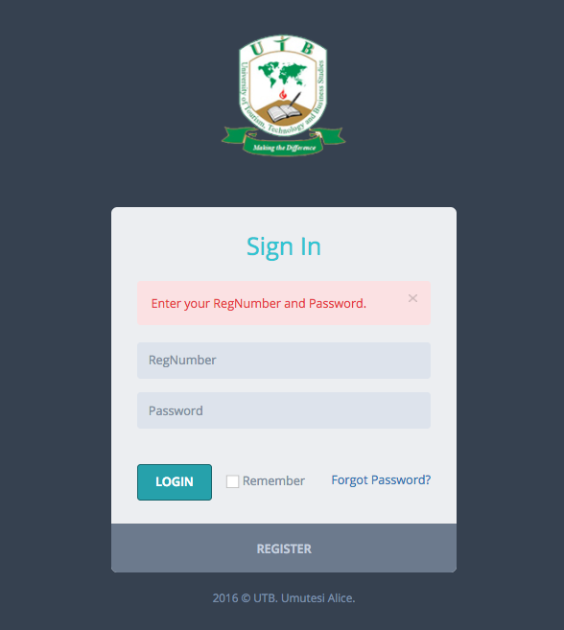

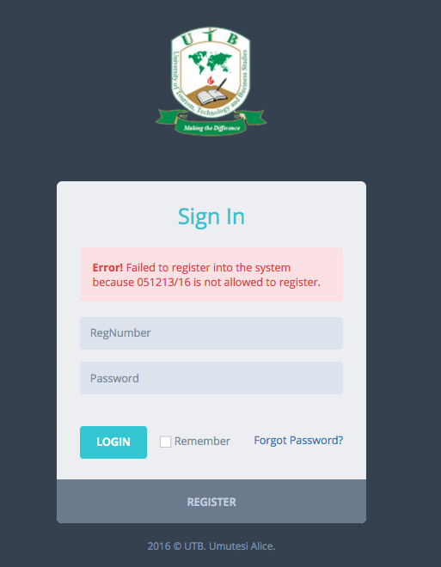

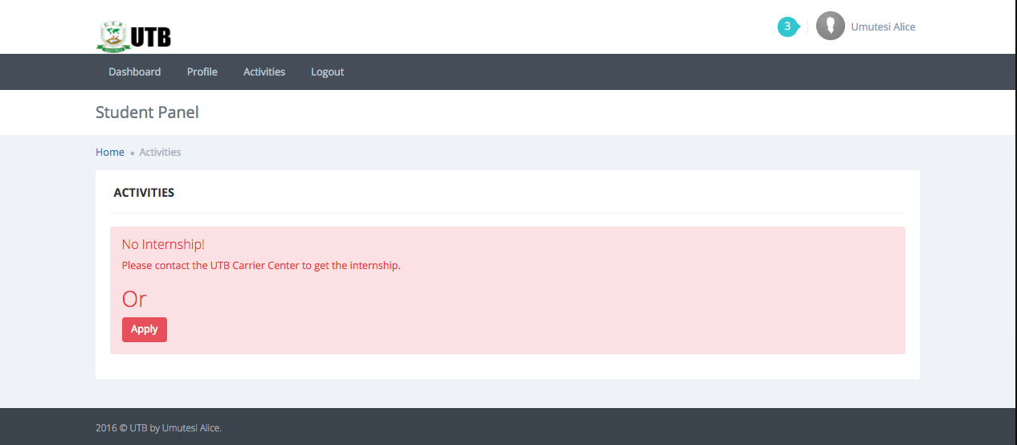

1. **Integration Testing Outputs**

In this type of testing we test various integration of the system module by providing the input. The primary objective is to test the module interfaces in order to ensure that no errors are occurring when one module invokes the other module. The designs interfaces of the system are all running like expected.

1. **Functional and system testing Results**

In Functional and system testing the following steps were followed to verify if the Internship Finder Management System complies all functions it is said to have. System testing bases on requirements of the system.

* The identification of functions that the system is expected to perform.
* The creation of input data based on the function’s specifications.
* The determination of output based on the function’s specifications.
* The execution of the test case.
* The comparison of actual and expected outputs.

According to the points given above the researcher found that the system complies all functionalities.

1. **Acceptance Testing Report**

This testing is generally performed when the project is nearing its end. This test mainly qualifies the application and decides if the users of the system will accept it. The users of the application are responsible for the test. Acceptance testing is the users view on the system where he/she checks to see if the system complies his/her needs, according to some users who tested the system they all said it is user friend as its screens are relative to any screen, therefore this system complies fits the users needs.

**RECOMMENDATION**

The researcher would like to recommend the UTB to implement the system in the carrier center department, so that the way internships are managed should improve. The system will benefit students, lecturers and the institutions welcoming students in many ways as it will reduce time and cost in all archaic process by digitalizing those processes and also make communication easier.

**REFERENCES**

**Books**

* Adil E. Shamoo and David B. Resnik (2003), *Responsible conduct of research*,
* Carmines EG, Zeller RA (1983), *Reliability and Validity Assessment*
* Deepti Ameta, Kalpana Mudaliar and Palak Patel (2015), *International Journal of  Managing Public Sector Information and Communication Technologies (IJMPICT) Vol. 6*,  No. 2, June
* Jill Collis and Roger Hussey (2003), *Business research: A practical guide for undergraduate and post graduate students 2nd Edition*, 2003
* John Gill and Phil Johnson (2002), *Research methods for managers, SAGE publication*, 2002
* K.Fisher, Wilson J.D (2005), *Evolution in information behavior modeling: Wilson’s model,* Medford, NJ: Information to day, 2005
* P.H. Collin (2003), *Easier English Student Dictionary 2nd Edition*
* Ranjit Kumar (2011), *Research Methodology a step-by-step for beginners 3rd Edition*, SAGE Publications.
* Richard M. Grinnel and Margret Williams (1990), *Research in social work: A primer*, F.E Peacock publishers, 1990
* Silberschatz and Henry F.Korth 1st edition (1988), *Database system concepts*,  MacGraw-Hill education
* Wilhelmina C. Savenye and Rhonda S.Robinson (2004), *Using qualitative research methods in higher education*, Springer US, 2004

**Internet**

* https://melsatar.wordpress.com/2012/03/15/software-development-life-cycle-models-and- methodologies/
* https://www.tutorialspoint.com/sdlc/sdlc_tutorial.pdf
* http://whatis.techtarget.com/definition/use-case-diagram
* https://melsatar.wordpress.com/2012/03/15/software-development-life-cycle-models-and-  methodologies/
* https://www.apache.org
* http://techopedia.org
* https://www.cms.gov/Research-Statistics-Data-and-Systems/CMS-Information-Technology/XLC/Downloads/SelectingdevelopmentApproach.pdf
* https://www.php.net/
* http://whatis.techtarget.com/definition/use-case-diagram