In this interface you should enter username and password for admin user to access the system.

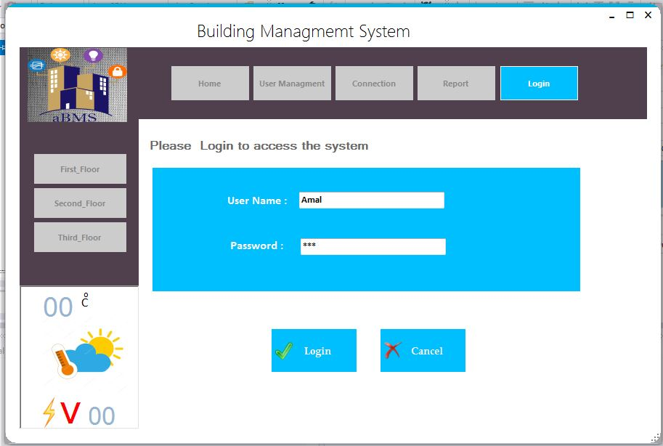

Figure (4.10) Login interface

In the connection interface system should be connected to the correct port to communicate between hardware and software.

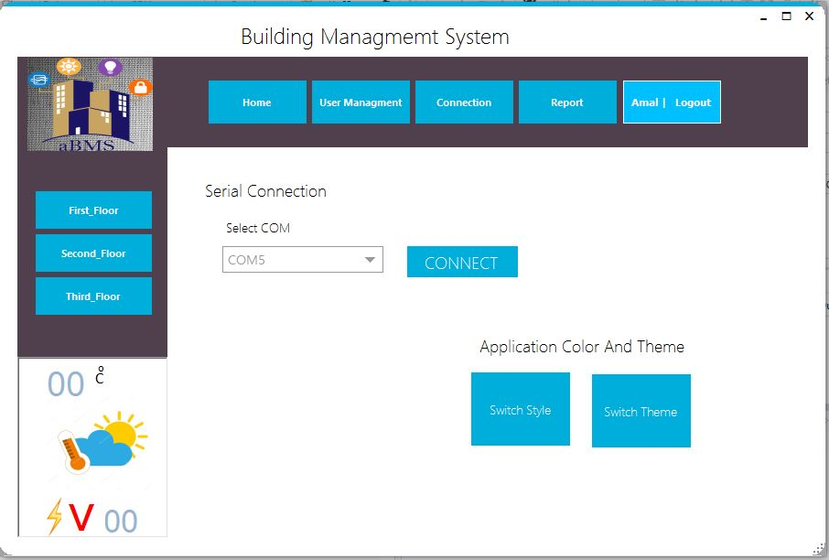

Figure (4.11) connection interface

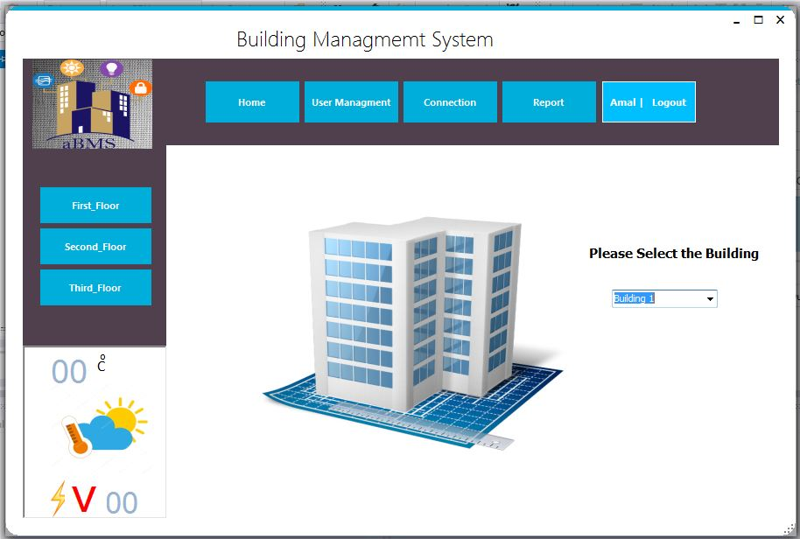Home interface display options where you can select the building you want to control.

Figure (4.12) home interface

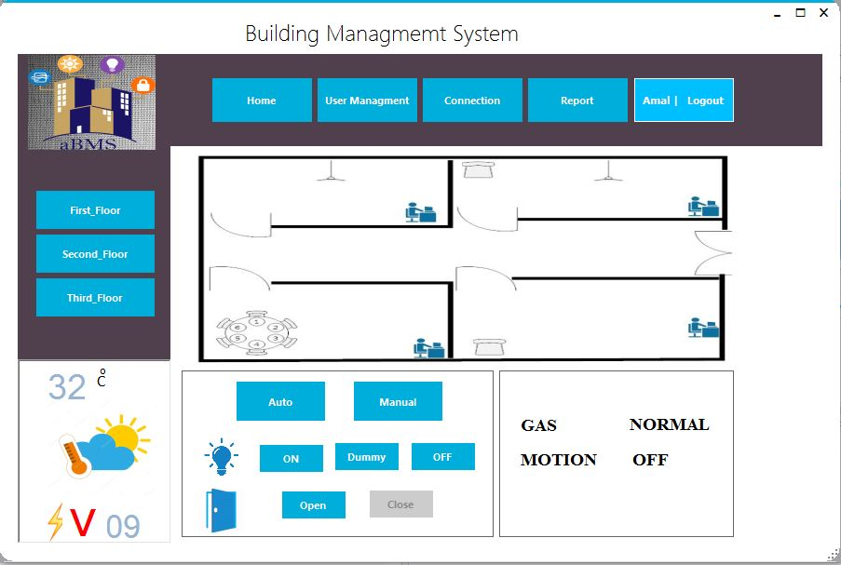First floor interface shows two services you can control, which is light with on| off buttons and door with open| close buttons, in the manual mode or the auto button which make them work automatically.

Figure (4.13) first floor interface

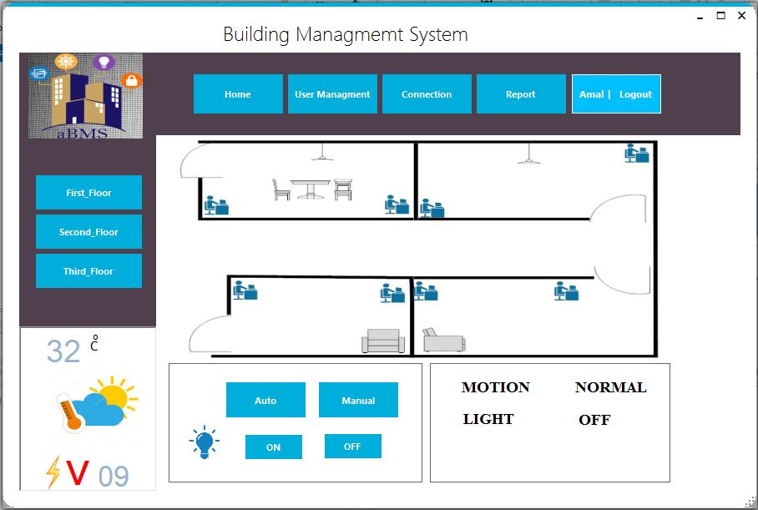Second floor interface shows light service that you can control with on| off buttons, in the manual mode or the auto button which make them work automatically.

Figure (4.14) second floor interface

Figure (4.13) first floor interface

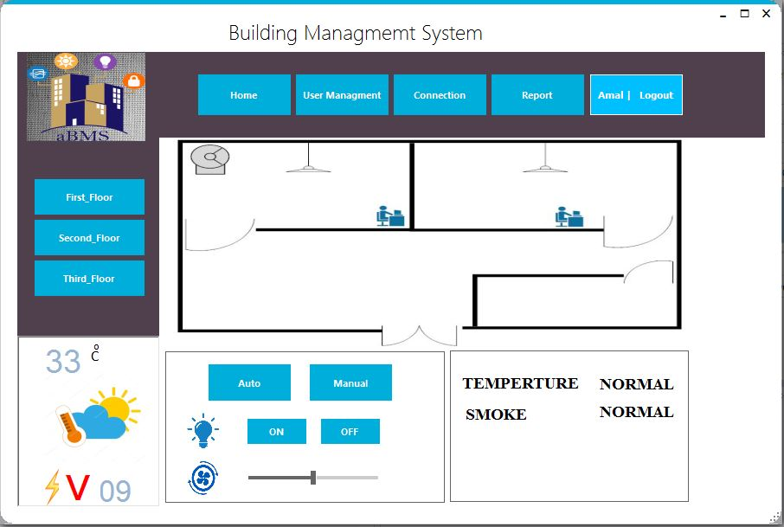First floor interface shows two services you can control, which is light with on| off buttons and door with open| close buttons, in the manual mode or the auto button which make them work automatically.

Figure (4.15) third floor interface

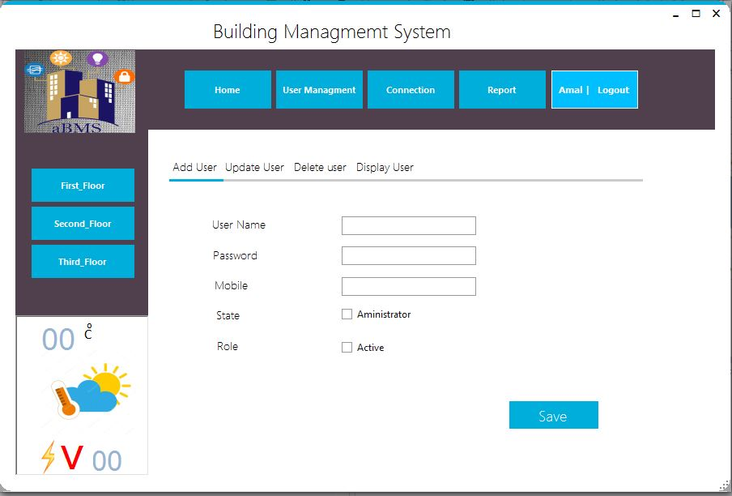User management interface shows information you must fill to add user, update user information, delete user and display system users.

Figure (4.15) third floor interface

Figure (4.16) user management interface

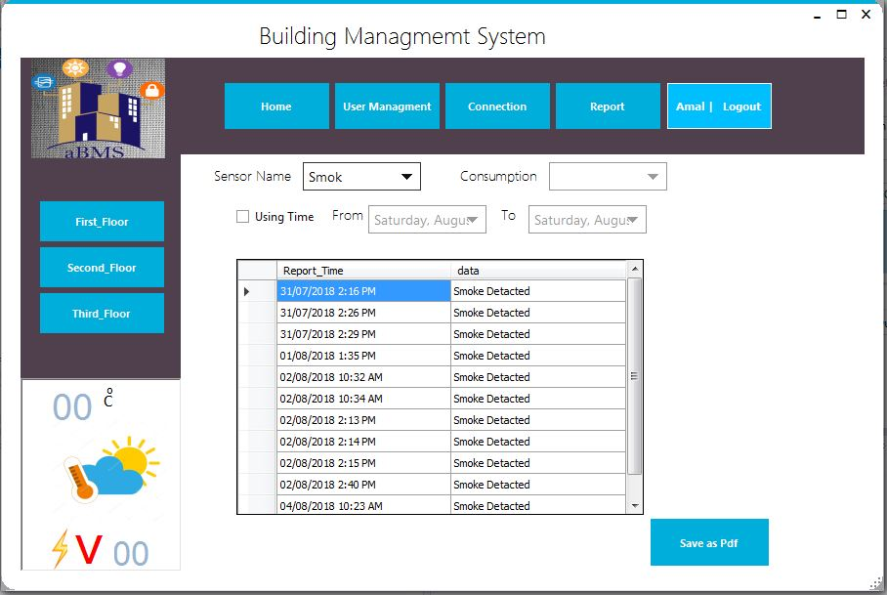Reports interface shows variety of reports for each sensor, for example smoke sensor. System also offers report about the whole system with consumption reports for all the services in the building.

Figure (4.16) user management interface

Figure (4.17) report interface

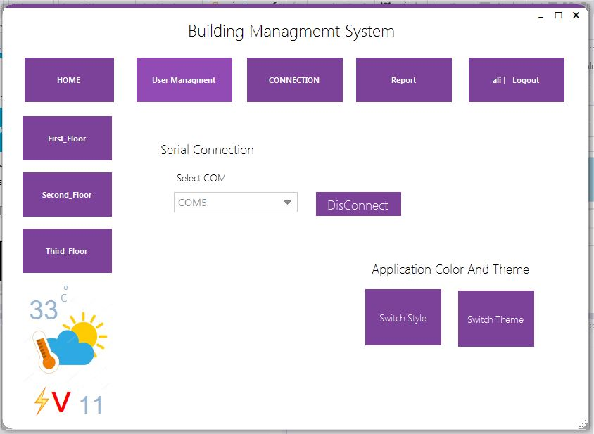Here there is option where you can switch the style and theme by changing the color.

Figure(4.18) style and theme interface

Figure (4.17) report interface

The gas window appears when the system detects high percentage of gas.

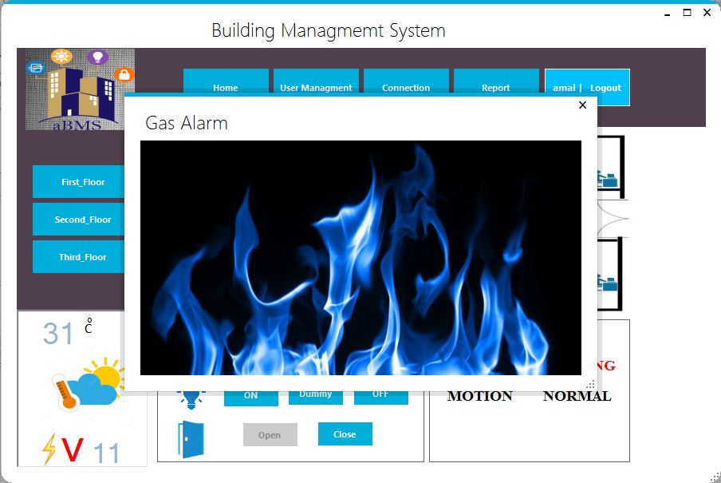

Figure (4.19) gas alarm interface

The smoke window appears when the system detects high percentage of smoke.

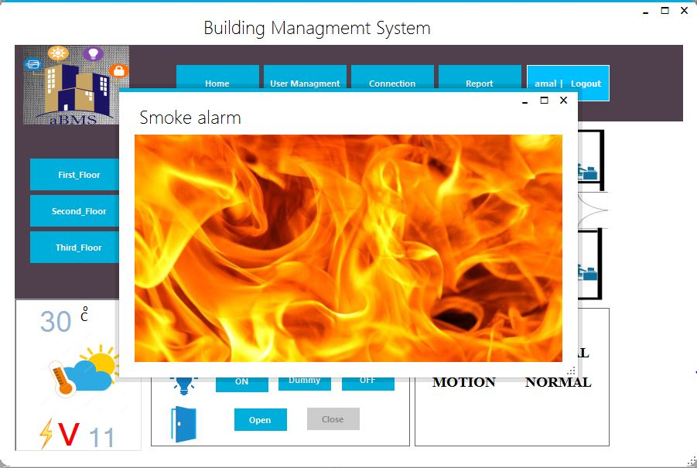

Figure(4.19) gas alarm interface

## 

Figure (4.20) smoke alarm interface