***KINGDOM OF SAUDI ARABIA | JAZAN UNIVERSITY***

***COLLEGE OF COMPUTER SCIENCE & INFORMATION SYSTEMS***

**COURSE – INTERNET TECHNOLOGY**

**CODE – INFS-241**

**MINI PROJECT**

**Souq.com**

**GROUP\**

|  |  |
| --- | --- |
| Student Name | Student ID |
| Huda khubrany | **201801510** |
| Amani oraibi | **201806766** |
| Noura alharbi | **201701379** |
| Amal shapi | **201806741** |

**TEACHER NAME –Ms.Tayyaba Rasheed**

***Introduction***

We connect people and products – opening up a world of possibility. From bracelets and backpacks to tablets and toy cars – we give you access to everything you need and want. Our range is unparalleled, and our prices unbeatable.   
  
Driven by smart technology, everything we do is designed to put the power directly in your hands – giving you the freedom to shop however, whenever and wherever you like.   
  
We’re trusted by millions, because we don’t just deliver to your doorstep, we were born here. With Souq.com you’ll always be getting a good deal – with exceptional service that makes your shopping experience as easy and seamless as possible.   
  
This is Souq.com – the power is in your hands.

**Home page**

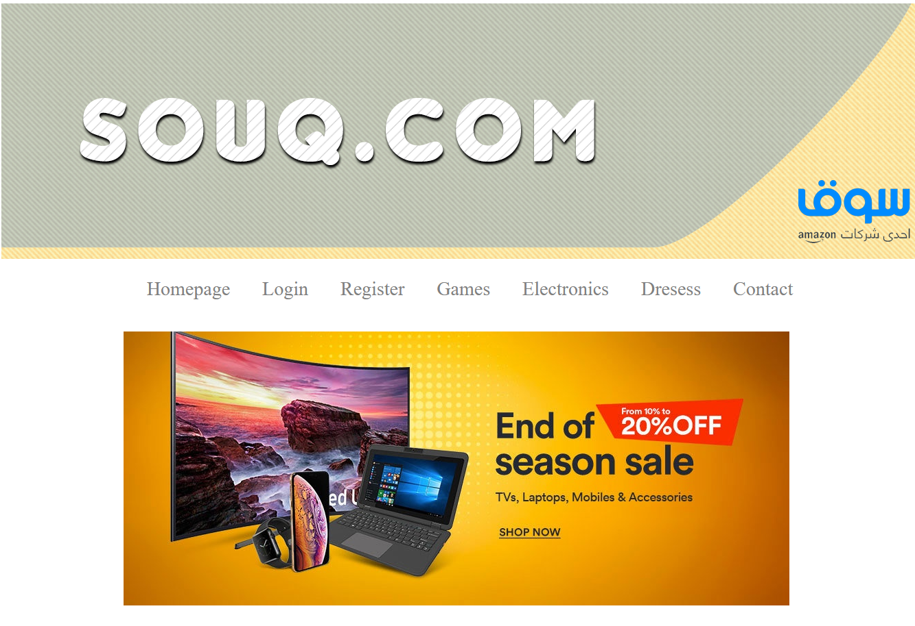

<html>

<head>

<title>**Homepage**</title>

<style>

**ul{**

**text-align: center;**

**font-size: 28;**

**}**

**li{**

**display: inline;**

**padding: 20;**

**color:gray;**

**}**

**a{**

**text-decoration:none;**

**}**

</style>

<script>

alert**(**"Suqe.com"**)**

**function** show**()** **{**

**}**

</script>

</head>

<body>

<img src=**"images/1.png"**>

<ul>

<a href=**"home.html"**><li> **Homepage** </li></a>

<a href=**"Login.html"**><li> **Login** </li></a>

<a href=**"Register.html"**><li> **Register** </li></a>

<a href=**"games.html"**><li> **Games** </li></a>

<a href=**"electronics.html"**><li> **Electronics** </li></a>

<a href=**"Dressess.html"**><li> **Dresess** </li></a>

<a href=**"contact.html"**><li> **Contact** </li></a>

</ul>

<br>

<center>

<a href=**"Electronics.html"**><img src=**"images/offers.png"**></a>

</center>

<br><br><br>

<img src=**"images/2.png"**>

</body>

</html>

**Login**

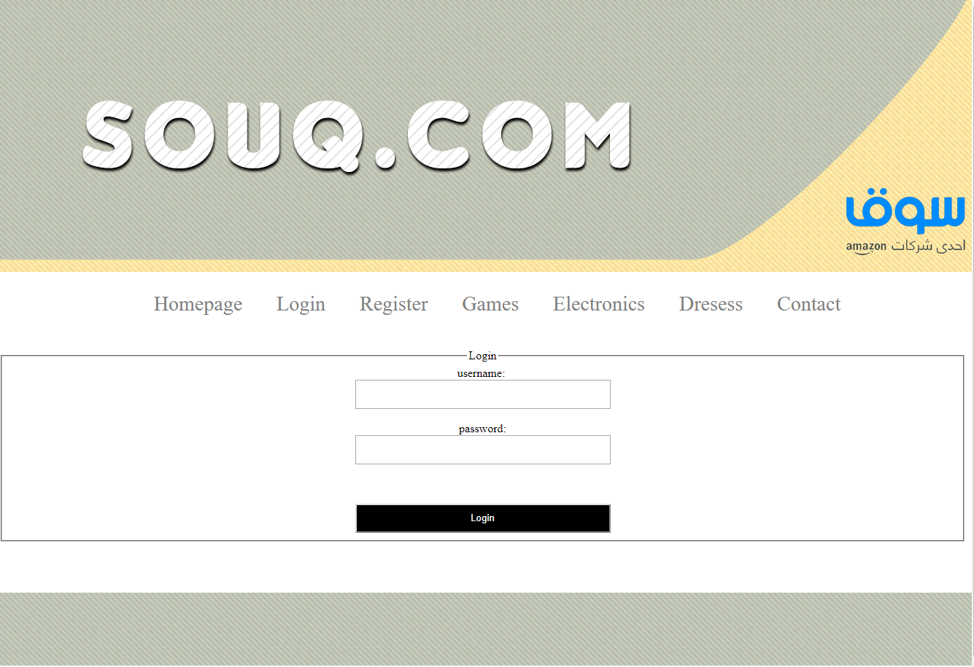

<html>

<head>

<title>**Login**</title>

<style>

**ul{**

**text-align: center;**

**font-size: 28;**

**}**

**li{**

**display: inline;**

**padding: 20;**

**color:gray;**

**}**

**a{**

**text-decoration:none;**

**}**

**input{**

**width:350;**

**height: 40;**

**}**

**input[type="submit"]{**

**background-color: black;**

**color:white;**

**}**

</style>

</head>

<body>

<img src=**"images/1.png"**>

<ul>

<a href=**"home.html"**><li> **Homepage** </li></a>

<a href=**"Login.html"**><li> **Login** </li></a>

<a href=**"Register.html"**><li> **Register** </li></a>

<a href=**"games.html"**><li> **Games** </li></a>

<a href=**"electronics.html"**><li> **Electronics** </li></a>

<a href=**"Dressess.html"**><li> **Dresess** </li></a>

<a href=**"contact.html"**><li> **Contact** </li></a>

</ul>

<br>

<center>

<form action=**"home.html"**>

<fieldset>

<legend>**Login**</legend>

**username:** <br>

<input type=**"text"**><br><br>

**password:**<br>

<input type=**"password"**><br><br>

<br>

<br>

<input type=**"submit"** value=**"Login"**>

</fieldset>

</form>

</center>

<br><br><br>

<img src=**"images/2.png"**>

</body>

</html>

**Register**

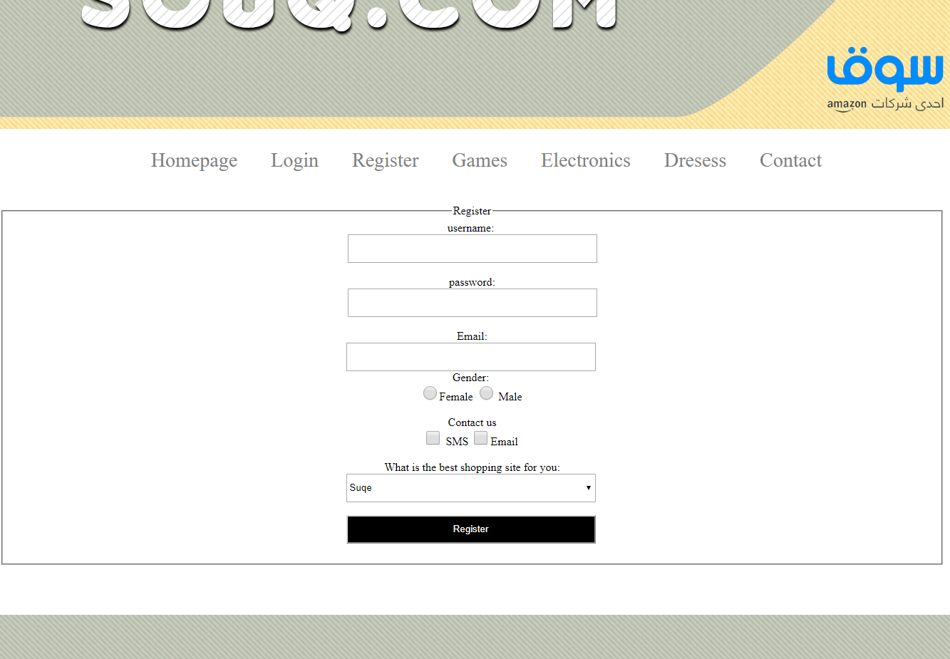

<html>

<head>

<title>**Register**</title>

<style>

**ul{**

**text-align: center;**

**font-size: 28;**

**}**

**li{**

**display: inline;**

**padding: 20;**

**color:gray;**

**}**

**a{**

**text-decoration:none;**

**}**

**input{**

**width:350;**

**height: 40;**

**}**

**input[type="submit"]{**

**background-color: black;**

**color:white;**

**}**

**input[type=radio],[type=checkbox]{**

**height: 20;**

**width: 20;**

**}**

**select{**

**width:350;**

**height: 40;**

**}**

</style>

</head>

<body>

<img src=**"images/1.png"**>

<ul>

<a href=**"home.html"**><li> **Homepage** </li></a>

<a href=**"Login.html"**><li> **Login** </li></a>

<a href=**"Register.html"**><li> **Register** </li></a>

<a href=**"games.html"**><li> **Games** </li></a>

<a href=**"electronics.html"**><li> **Electronics** </li></a>

<a href=**"Dressess.html"**><li> **Dresess** </li></a>

<a href=**"contact.html"**><li> **Contact** </li></a>

</ul>

<br>

<center>

<form action=**"home.html"**>

<fieldset>

<legend>**Register**</legend>

**username:** <br>

<input type=**"text"**><br><br>

**password:**<br>

<input type=**"password"**><br><br>

**Email:**<br>

<input type=**"email"**><br>

**Gender:**

<br>

<input type=**"radio"**>**Female**

<input type=**"radio"**> **Male**

<br><br>

**Contact us**<br>

<input type=**"checkbox"**> **SMS**

<input type=**"checkbox"**>**Email**

<br><br>

**What is the best shopping site for you:**<br>

<select>

<option>**Suqe**</option>

<option>**Amazon**</option>

<option>**Ebay**</option>

<option>**Noon**</option>

</select>

<br>

<br>

<input type=**"submit"** value=**"Register"**>

<br>

<br>

</fieldset>

</form>

</center>

<br><br><br>

<img src=**"images/2.png"**>

</body>

</html>

**Games**

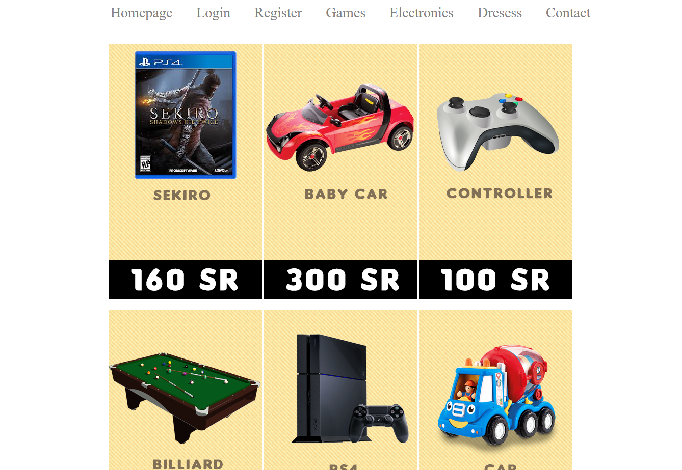

<html>

<head>

<title>**Games**</title>

<style>

**ul{**

**text-align: center;**

**font-size: 28;**

**}**

**li{**

**display: inline;**

**padding: 20;**

**color:gray;**

**}**

**a{**

**text-decoration:none;**

**}**

</style>

</head>

<body>

<img src=**"images/1.png"**>

<ul>

<a href=**"home.html"**><li> **Homepage** </li></a>

<a href=**"Login.html"**><li> **Login** </li></a>

<a href=**"Register.html"**><li> **Register** </li></a>

<a href=**"games.html"**><li> **Games** </li></a>

<a href=**"electronics.html"**><li> **Electronics** </li></a>

<a href=**"Dressess.html"**><li> **Dresess** </li></a>

<a href=**"contact.html"**><li> **Contact** </li></a>

</ul>

<br>

<center>

<img src=**"images/g1.png"**>

<img src=**"images/g2.png"**>

<img src=**"images/g3.png"**>

<br>

<br>

<img src=**"images/g4.png"**>

<img src=**"images/g5.png"**>

<img src=**"images/g6.png"**>

</center>

<br><br><br>

<img src=**"images/2.png"**>

</body>

</html>

**Electronics**

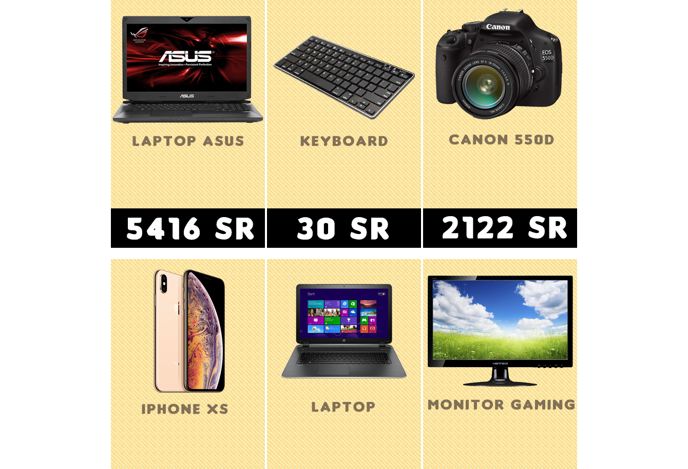

<html>

<head>

<title>**Electronics**</title>

<style>

**ul{**

**text-align: center;**

**font-size: 28;**

**}**

**li{**

**display: inline;**

**padding: 20;**

**color:gray;**

**}**

**a{**

**text-decoration:none;**

**}**

</style>

</head>

<body>

<img src=**"images/1.png"**>

<ul>

<a href=**"home.html"**><li> **Homepage** </li></a>

<a href=**"Login.html"**><li> **Login** </li></a>

<a href=**"Register.html"**><li> **Register** </li></a>

<a href=**"games.html"**><li> **Games** </li></a>

<a href=**"electronics.html"**><li> **Electronics** </li></a>

<a href=**"Dressess.html"**><li> **Dresess** </li></a>

<a href=**"contact.html"**><li> **Contact** </li></a>

</ul>

<br>

<center>

<img src=**"images/a.png"**>

<img src=**"images/b.png"**>

<img src=**"images/c.png"**>

<br>

<br>

<img src=**"images/d.png"**>

<img src=**"images/f.png"**>

<img src=**"images/g.png"**>

</center>

<br><br><br>

<img src=**"images/2.png"**>

</body>

</html>

**Dresses**

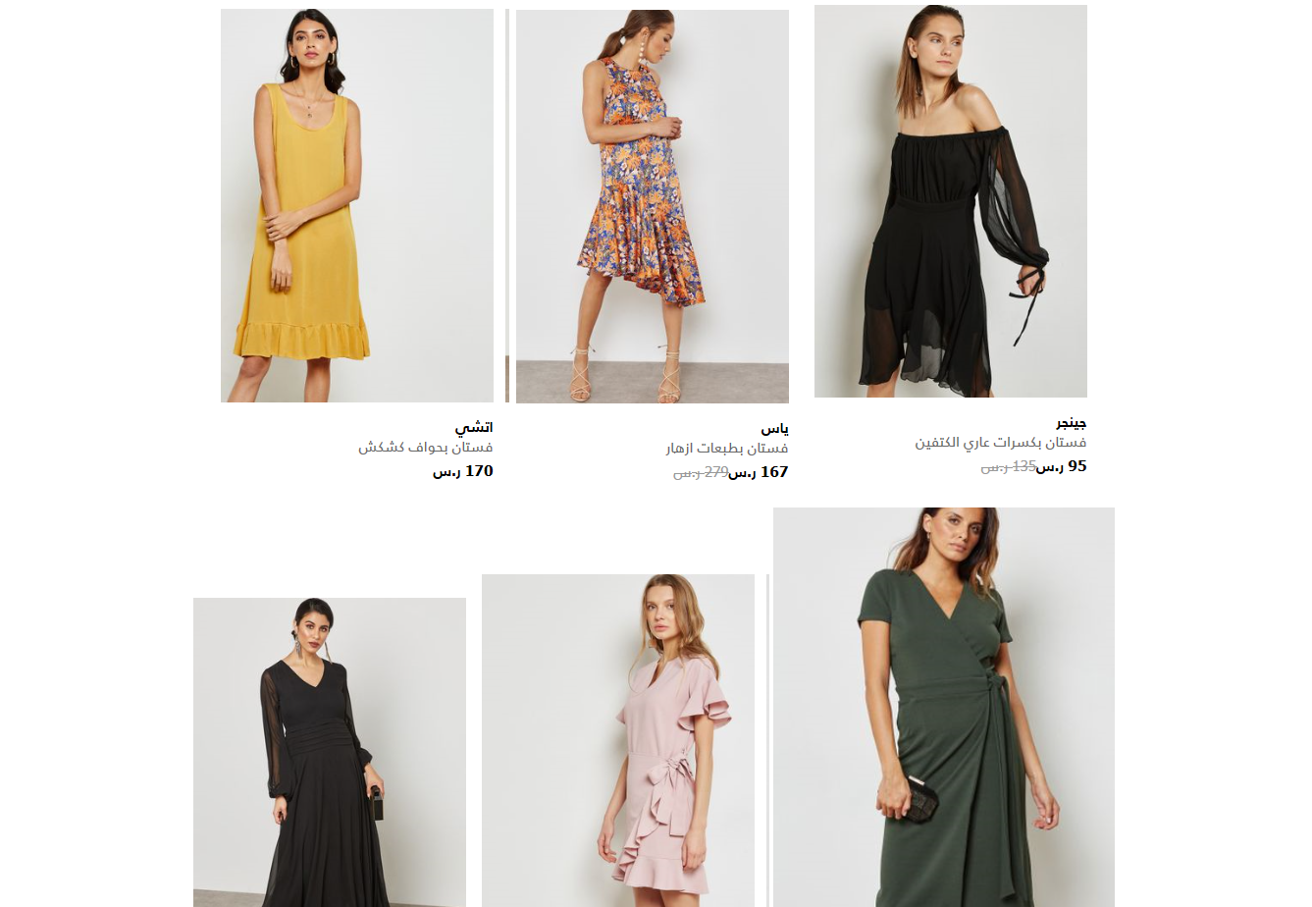

<html>

<head>

<title>**dresess**</title>

<style>

**ul{**

**text-align: center;**

**font-size: 28;**

**}**

**li{**

**display: inline;**

**padding: 20;**

**color:gray;**

**}**

**a{**

**text-decoration:none;**

**}**

</style>

</head>

<body>

<img src=**"images/1.png"**>

<ul>

<a href=**"home.html"**><li> **Homepage** </li></a>

<a href=**"Login.html"**><li> **Login** </li></a>

<a href=**"Register.html"**><li> **Register** </li></a>

<a href=**"games.html"**><li> **Games** </li></a>

<a href=**"electronics.html"**><li> **Electronics** </li></a>

<a href=**"Dressess.html"**><li> **Dresess** </li></a>

<a href=**"contact.html"**><li> **Contact** </li></a>

</ul>

<br>

<center>

<img src=**"images/D1.png"**>

<img src=**"images/D2.png"**>

<img src=**"images/D3.png"**>

<br>

<br>

<img src=**"images/D4.png"**>

<img src=**"images/D5.png"**>

<img src=**"images/D6.png"**>

</center>

<br><br><br>

<img src=**"images/2.png"**>

</body>

</html>

**Contact us**

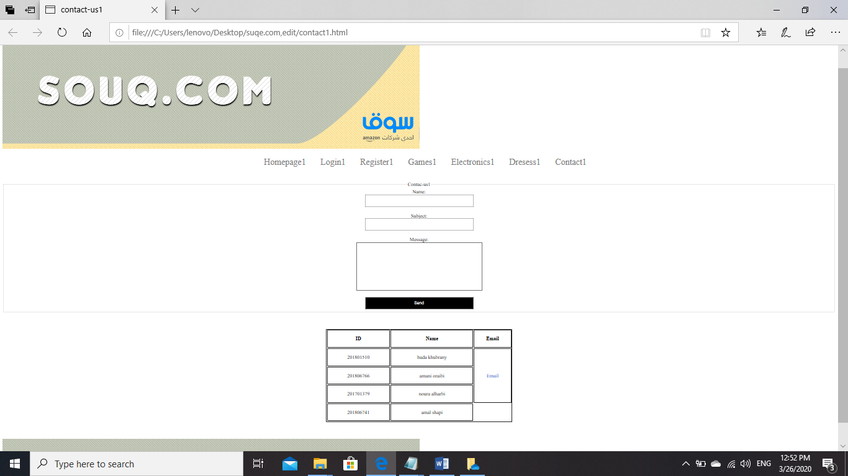

<html>

<head>

<title>**contact-us**</title>

<style>

**ul{**

**text-align: center;**

**font-size: 28;**

**}**

**li{**

**display: inline;**

**padding: 20;**

**color:gray;**

**}**

**a{**

**text-decoration:none;**

**}**

**input{**

**width:350;**

**height: 40;**

**}**

**input[type="submit"]{**

**background-color: black;**

**color:white;**

**}**

**td{**

**text-align: center;**

**}**

</style>

</head>

<body>

<img src=**"images/1.png"**>

<ul>

<a href=**"home.html"**><li> **Homepage** </li></a>

<a href=**"Login.html"**><li> **Login** </li></a>

<a href=**"Register.html"**><li> **Register** </li></a>

<a href=**"games.html"**><li> **Games** </li></a>

<a href=**"electronics.html"**><li> **Electronics** </li></a>

<a href=**"Dressess.html"**><li> **Dresess** </li></a>

<a href=**"contact.html"**><li> **Contact** </li></a>

</ul>

<br>

<center>

<form action=**"home.html"**>

<fieldset>

<legend>**ContacUs**</legend>

**Name:** <br>

<input type=**"text"**><br><br>

**Subject:**<br>

<input type=**"text"**><br><br>

**Message:** <br>

<textarea cols=**"48"** rows=**"10"**></textarea>

<br>

<br>

<input type=**"submit"** value=**"Send"**>

</fieldset>

</form>

<br>

<br>

<table border=**"1"** width=**"600"** height=**"300"**>

<tr>

<th> **ID** </th>

<th> **Name** </th>

<th> **Email** </th>

</tr>

<tr>

<td> 201801510 </td>

<td> huda khubrany</td>

<td rowspan="3"> <a href="huda47800@gmail.com"> Email </td>

</tr>

<tr>

<td> 201806766</td>

<td> amani oraibi</td>

</tr>

</tr>

<tr>

<td> 201701379</td>

<td> noura alharbi</td>

</tr>

<tr>

<td> 201806741</td>

<td> amal shapi</td>

</tr>

</table>

</center>

<br><br><br>

<img src=**"images/2.png"**>

</body>

</html>