Rev. Butler Vin Cole
419 N. McNeil St. Memphis, TN 38112 | 901.831.8417 | butler.ward@outlook.com

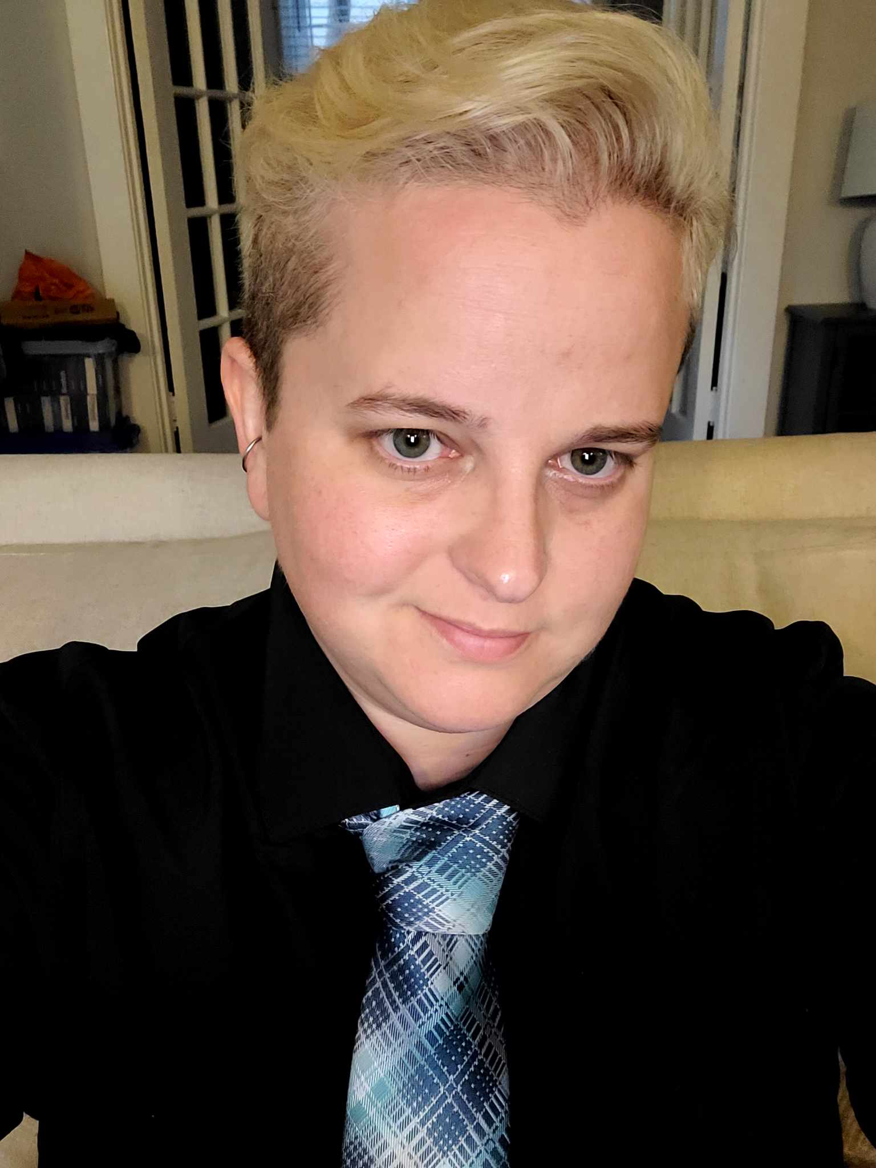
EDUCATION
In Progress Modern Gun School (Vocational & Technical School –
Since 3/3/25 Online) – Advanced Gunsmithing II

2024 - March APC Board Certified Clinical Chaplain
Status: Complete

2016-2017 Chaplain (C.P.E.) Residency
Agency: VA Medical Center in Memphis, TN
Completed 4 Units Level 1 & II: August 2017
Supervisor: Chaplain Robert Whiteford

2017 Ordination (Commissioning) & Endorsement: July 14, 2017
Agency: Federation of Christian Ministries

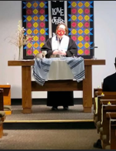
2009-2015 Masters of Divinity
Memphis Theological Seminary – Memphis, TN
Cumulative GPA: 3.79 (Honors)

2004-2008 Bachelor of Arts: Christian Ministries
Bethel College – McKenzie, TN
Minor: Theatre
Cumulative GPA: 3.6 (Honors)

PROFESSIONAL PROFILE

Clinical Chaplain, ordained minister, and spiritual counselor with over 20 years’ experience in ministry. Previous extensive work history in the industries of food, catering, music, theatre, caregiving, and retail. The customer service I provide is rooted in hospitality and aimed at building rapport to empower others to achieve their expressed desires while working to meet their needs in a timely, efficient fashion. My chaplain background has equipped me to offer culturally relevant practices for meaning and purpose through methods of reflective listening in meeting people where they are and striving to embody affirmative care to all persons unique to their own personhood, values, and beliefs. I encapsulate dynamic energy and a sincere love for creating collaboratively with others. I aspire to be malleable within my own growth curves, learning from mistakes, diversifying my skills, remaining open to constructive critique, and willing to take risks where appropriate. I have a fond interest in learning, creating, researching, coordinating, and developing best care practices for all persons I engage. I naturally have a calming presence in chaotic situations, work best in high paced environments, and love to create safe spaces for people to be human while enduring challenges that come in everyday circumstances.

CORE SKILLS

o Customer Service o Creative Problem Solver o Quality Assurance
o Conflict Resolution o Innovative Visionary o Relationship Building o Active Listener o Community Engagement o Content Creator
o Proficient Skills in Microsoft Office o Adaptability o Negotiation Skills
o Engaging Communicator o Emotional Intelligence o Effective Documentation
CAREER SUMMARY (starting with the most recent)

12/10/17 – present Clinical Chaplain
Lt. Col. Luke Weather Jr. VA Medical Center – Memphis, TN
Primary Assignment: Acute care – ICU, surgery, Covid units, palliative care, hospice care, P.T.S.D., substance abuse, acute psych, and outpatient mental health.
Role:
o Provision of spiritual care to patients, their families, and staff in crisis, end of lie situations, and mental health challenges.
o Coordinate, promote, & facilitate large events for all persons within my care. i.e. memorial services, worship services, seasonal services, and retreats.
o Conceptualize, develop, and facilitate behavioral health groups and spirituality groups,
o Respond to and triage crisis situations such as verbal altercations requiring de-escalation skills, end of life, deaths, emotional trauma, and suicidal patients.
o Create safe spaces for all persons to feel, question, doubt, or wrestle with some of life’s most prominent questions as it relates to their spirituality or personal beliefs.
o Support patients as they explore key components of the human experience as it relates to their spirituality such as meaning making, purpose, loss, personhood, identifying values, belonging, forgiveness, afterlife, and moral injury etc.
o Initiated, established, and maintained relationships with community contacts who can adequately meet the needs of patients from various belief systems.
o Provide training and education to providers on how spirituality is an integral aspect of whole health via facilitating Power Point presentations and sharing resources.
Includes: 07/16/16 – 09/1/2017 – Chaplain Residency at VA Medical Center
01/01/2014 – 06/01/2014 – Chaplain Internship at The MED (Level I trauma)

Ministry: 20 yrs. experience in ministry which includes youth ministry, homeless ministry, pulpit supply preaching, officiating weddings, funerals, and other sacraments from diverse belief systems. Previous outreach coordinator for Room in the Inn (RITI) in which I coordinated emergency shelter for homeless people at 50+ churches. Certified S.OA.R. (SSI/SSDI) case manager for chronically homeless and hold proficient skills in administration, communication, and relationship building.

Food Industry: 16 yrs. experience in over 8 locations in various positions such as assistant manager, sous chef, food expeditor, and server. Longest employment included CFY Catering, LLC. Jobs entailed fast-paced environments where tasks, decisions, and changes occur rapidly, requiring quick adaptation and efficient multitasking under pressure. Prepared food for events with attendance ranging from 75-800 people. Other tasks included training employees, handling money, totaling daily profits, managing inventory, maintaining working relationships with vendors, transporting items, washing dishes, and ensuring health inspection guidelines were met.

Theatre/Music Industry: Previous work in theatre includes work for large production companies such as Crew One Productions of Memphis, TN, or community theatre programs at The Dixie Carter Performing Arts Center (Huntingdon, TN) and A.C.T.S. at Germantown United Methodist Church. Positions held include technical theatre instructor, faculty assistant, director, stage manager, set designer, lighting/sound crew, costume/prop coordinator, and house management. Completed load in, set up, show call, breakdown, and load out for large shows at big venues like Fed Ed Forum, or the Georgia Dome in Atlanta, GA. Completed 20 concert events, some of which include widely known artists such as Metallica, U2, Usher, ACDC, and The Eagles to name a few. Theatrically, directed 13 shows, stage managed 6 shows, built set designs for 7 shows, and performed in 5 musicals.

Retail & Misc.: Held positions in retail as sales associate or cashier at Hollywood Cinema Theatre, American Eagle Outfitters, Rite-Aid, Santa’s Pen, & the Little General Store. Tasks included overnight stocking, scanning items, inventory, stocking items, cleaning, answering phones, organization, processing payments, issuing receipts, applying coupons, handling complaints, money orders, completing orders with vendors, giftwrapping, hanging ad tags, product rotation, facing, folding clothes, resetting store shelves, and handling substantial amounts of money. As a caregiver, I worked for six months at A Place Called Home in McKenzie, TN and aided disabled or elderly persons with activities of daily living, such as changing, bathing, toileting, eating, shopping, laundry, and light house cleaning. I worked as a lifeguard and resident assistant (R.A.) for the dormitories at Bethel College where I received my undergrad for four years. I also became a successful entrepreneur in college by creating my own cleaning business that became so successful I co-coordinated it with a friend in which we had 15+ people working under us, and the business was presented on at the Students in Free Enterprise (S.I.F.E.) organization’s conference in 2007.

AWARDS

o Received “I CARE” Medical Center Director’s Challenge Coin Award for outstanding service two years in a row. (VA Hospital: 2023, 2024)
o Received the “Outstanding Religious Studies Student Award.” (Bethel College, 2008)
o Received the “Outstanding Theatre Student Award.” (Bethel College, 2008)
o Received the NAIA “Bethel College Soccer Wildcat Award” for being the player on my team displaying the most honesty and integrity. (Bethel College, 2008)

NOTE: I am clinical chaplain who is interested in a career change. I have enjoyed my time as a chaplain doing meaningful yet challenging work, but I long to work in a positive work environment where I feel valued in a team-oriented atmosphere. I am extremely creative, intuitive, detail-oriented, and possess strong interpersonal skills. I have obtained extensive medical terminology from working in hospitals for 10+ years. I have vast administrative experience in my job as a chaplain and various roles as a minister in which I oversaw numerous events such as fundraisers, dinner theatres, memorial services, worship services, mission trips, emergency shelter for the homeless, and a myriad of events with 10-300 in attendance. These administrative duties included highlighting organizations, time management, recruiting volunteers, delegating tasks, designing and printing programs, PowerPoint presentations, graphic design for social media, website design, multitasking, triaging situations as they occur, and implementing effective scheduling and organizational skills while managing up to 15 calendars at one time. It would be an honor and privilege to be selected for an interview and to serve your patients with the divine hospitality they deserve.

- Detailed work histories & references are made available upon request.

