**StarLabs 2022 - Documentation**

**PlantUML**

**PlantUML** is a component that allows to quickly write:

1. Sequence diagram
2. Usecase diagram
3. Class diagram
4. Object diagram
5. Activity diagram
6. Component diagram
7. Deployment diagram
8. State diagram
9. Timing diagram

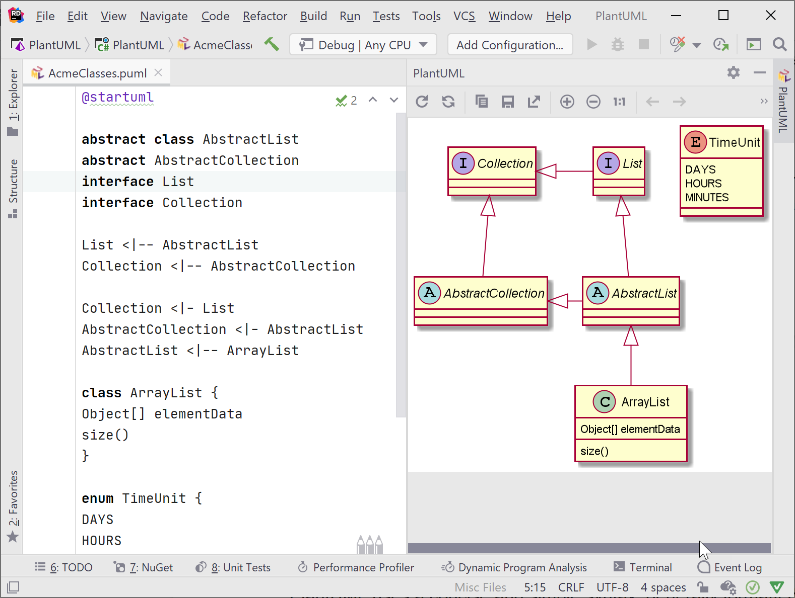

The following **non-UML** diagrams are also supported:

1. JSON Data
2. YAML Data
3. Network diagram (nwdiag)
4. Wireframe graphical interface
5. ArchiMate diagram
6. Specification and Description Language (SDL)
7. Ditaa diagram
8. Gantt diagram
9. MindMap diagram
10. Work Breakdown Structure diagram
11. Mathematic with ASCII Math or JLaTeXMath notation
12. Entity Relationship diagram