**StarLabs 2022 - Documentation**

**REST [REST API (Representational State Transfer)]**

REST is the acronym that stands for: Representational State Transfer. REST is an architectural style of distributed system. It is based upon the set of principles that describes how network resources are defined and addressed. REST is bigger than Web Services. RESTful services uses HTTP (Hyper Text Transfer Protocol) to communicate. REST system interface with external systems as web resources identified by URIs (Uniform Resource Identifiers). The data format is described by using JSON schema notation, and it requires the use of the HTTP transport protocol .

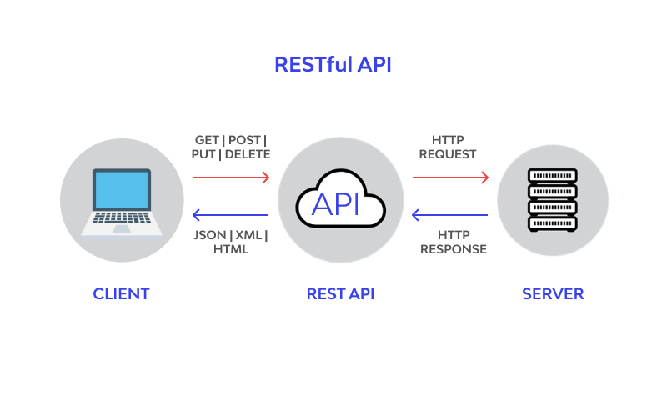

REST system should have the following constrains.

1. Uniform Interface
2. Statelessness
3. Client-Server
4. Cacheable
5. Layered System

REST uses HTTP Verbs ([HTTP Requests](CodeSamples/CRUDController.cs)). Most used Http requests.

1. GET – Retrieve data or information *Syntax* [HttpGet]
2. POST – Generate or create resource ex.(Submit button), *Syntax* [HttpPost]
3. PUT – Update existing resource *Syntax* [HttpPut]. Sends the data in form of object as

well as in parameter too.

1. DELETE – Delete existing resource *Syntax* [HttpDelete].
2. PATCH – Update existing resource without modifying the entire data

*Syntax* [HttpPatch].

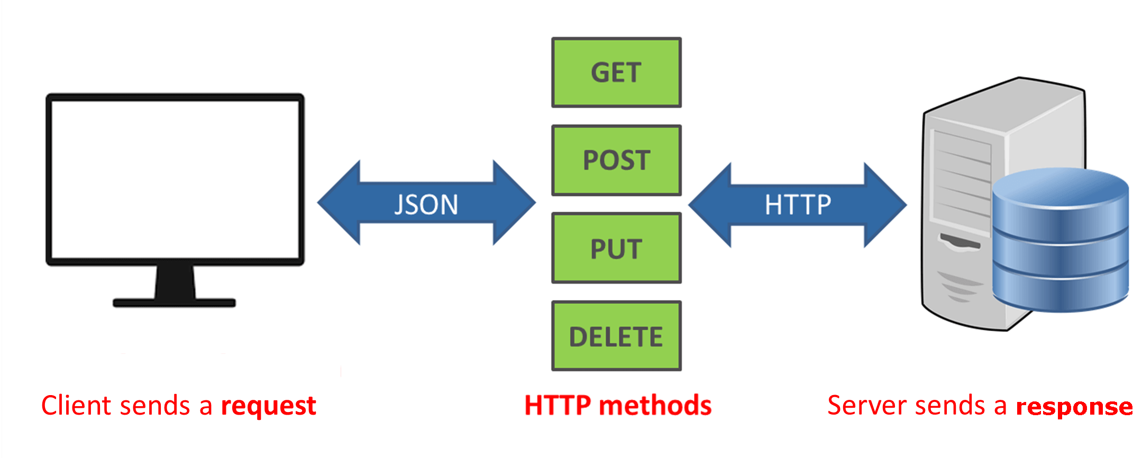

**Difference between *PUT* and *PATCH***

**PUT** is a method of modifying resource where the client sends data that updates the entire resource whereas **PATCH** is a method of modifying resources where the client sends partial data that is to be updated without modifying the entire data.

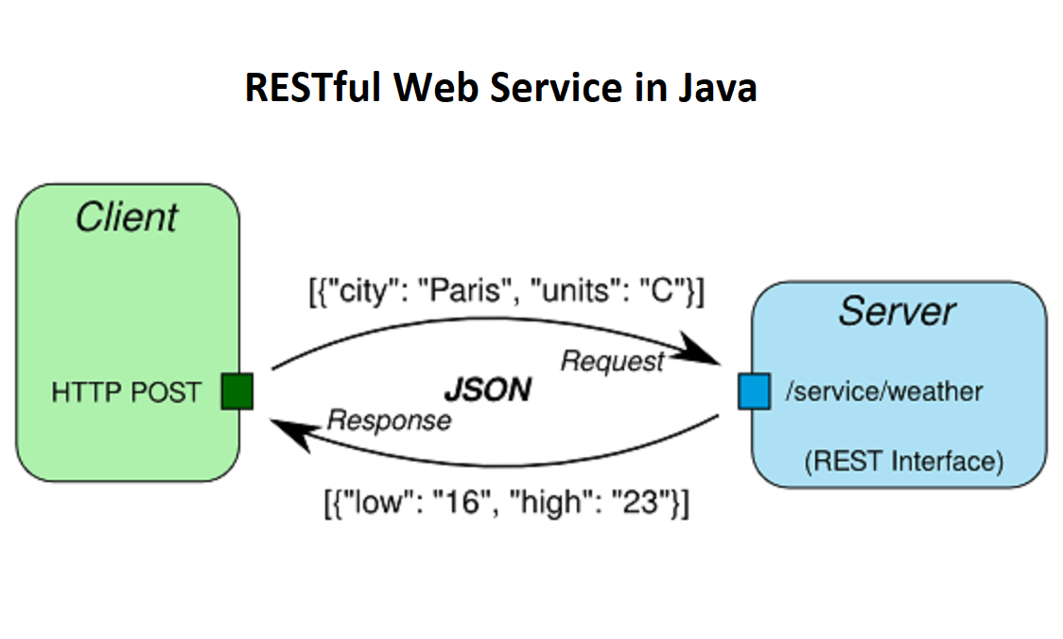

**Advantages and disadvantages of REST API:**

***Advantages of REST API:***

1. REST API is easy to understand and learn, due to its simplicity, known API.
2. With REST API, being able to organize complicated applications & makes it easy to use resources.
3. The high load can be managed with help out of HTTP proxy server & cache.
4. REST API is easy to explore and discover.
5. It makes it simple for new clients to work on other applications, whether it is designed specifically for purpose or not.
6. Use standard HTTP procedure call- outs to retrieve data and requests.
7. REST API depends on codes, can use it to synchronize data with a website without any complications.
8. Users can avail access to the same standard objects and data model when compared to SOAP-based web services.
9. Brings flexibility formats by serializing data in XML or JSON format.

***Disadvantages or Challenges in REST:***

1. **Lack of state:**most web applications require stateful mechanisms. Suppose you purchase a website which has a mechanism to have a shopping cart. It is required to know the number of items in the shopping cart before the actual purchase is made. This burden of maintaining the state lies on the client, which makes the client application heavy and difficult to maintain.
2. **Last of security:**REST doesn’t impose security such as SOAP. That is the reason REST is appropriate for public URLs, but it is not good for confidential data passage between client and server