**StarLabs 2022 - Documentation**

**SQL (Structured Query Language)**

Structured Query Language (SQL) is a standardized programming language that is used to manage relational databases and perform various operations on the data in them. SQL is regularly used not only by database administrators, but also by developers writing data integration scripts and data analysts looking to set up and run analytical queries.

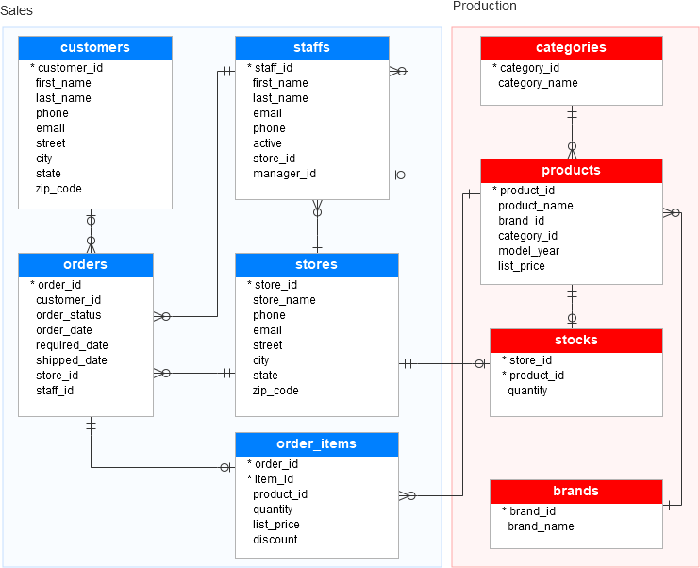

***SQL is used for the following:***

1. Modifying database table and index structures;
2. Adding, updating and deleting rows of data; and
3. Retrieving subsets of information from within relational database management systems (RDBMSes) -- this information can be used for transaction processing, analytics applications and other applications that require communicating with a relational database

SQL queries and other operations take the form of commands written as statements and are aggregated into programs that enable users to add, modify or retrieve data from database tables. A table is the most basic unit of a database and consists of rows and columns of data. A single table holds records, and each record is stored in a row of the table. Tables are the most used type of database objects, or structures that hold or reference data in a relational database. Other types of database objects include the following:

1. **Views** are logical representations of data assembled from one or more database tables.
2. **Indexes** are lookup tables that help speed up database lookup functions.
3. **Reports** consist of data retrieved from one or more tables, usually a subset of that data that is selected based on search criteria.

***SQL commands are divided into several different types, including the following:***

1. **Data Definition Language (DDL)**commands are also called *data definition commands* because they are used to define data tables.
2. **Data Manipulation Language (DML)**commands are used to manipulate data in existing tables by adding, changing or removing data. Unlike DDL commands that define how data is stored, DML commands operate in the tables defined with DDL commands.
3. **Data Query Language** consists of just one command, SELECT, used to get specific data from tables. This command is sometimes grouped with the DML commands.
4. **Data Control Language** commands are used to grant or revoke user access privileges.
5. **Transaction Control Language** commands are used to change the state of some data for example, to COMMIT transaction changes or to ROLLBACK transaction changes.

***Advantages of SQL***

1. **No programming needed** SQL does not require a large number of coding lines for managing the database systems. We can easily access and maintain the database by using simple SQL syntactical rules. These simple rules make the SQL user-friendly.
2. **High-Speed Query Processing** A large amount of data is accessed quickly and efficiently from the database by using SQL queries. Insertion, deletion, and updating operations on data are also performed in less time.
3. **Standardized Language** SQL follows the long-established standards of ISO and ANSI, which offer a uniform platform across the globe to all its users.
4. **Portability** The structured query language can be easily used in desktop computers, laptops, tablets, and even smartphones. It can also be used with other applications according to the user's requirements.
5. **Interactive language** We can easily learn and understand the SQL language. We can also use this language for communicating with the database because it is a simple query language. This language is also used for receiving the answers to complex queries in a few seconds.
6. **More than one Data View** The SQL language also helps in making the multiple views of the database structure for the different database users.

***Disadvantages of SQL***

* 1. **Cost:** The operation cost of some SQL versions is high. That's why some programmers cannot use the Structured Query Language.
  2. **Interface is Complex:** Another big disadvantage is that the interface of Structured query language is difficult, which makes it difficult for SQL users to use and manage it.
  3. **Partial Database control:** The business rules are hidden. So, the data professionals and users who are using this query language cannot have full database control.