**StarLabs 2022 - Documentation**

***TDD***

***Test Driven Development (TDD)***

TDD is software development approach in which test cases are developed to specify and validate what the code will do. In simple terms, test cases for each functionality are created and tested first and if the test fails then the new code is written in order to pass the test and making code simple and bug-free. Test-Driven Development starts with designing and developing tests for every small functionality of an application. TDD framework instructs developers to write new code only if an automated test has failed. This avoids duplication of code. The TDD full form is Test-driven development.

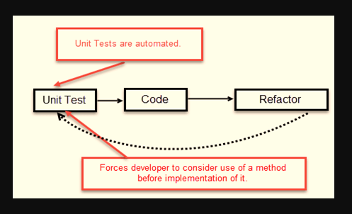

***How to perform TDD Test:***

1. Add a test.
2. Run all tests and see if any new test fails.
3. Write some code.
4. Run tests and Refactor code.
5. Repeat.

***TDD Vs. Traditional Testing:***

1. With traditional testing, a successful test finds one or more defects. It is same as TDD. When a test fails, you have made progress because you know that you need to resolve the problem.
2. TDD ensures that your system actually meets requirements defined for it. It helps to build your confidence about your system.
3. In TDD more focus is on production code that verifies whether testing will work properly. In traditional testing, more focus is on test case design. Whether the test will show the proper/improper execution of the application in order to fulfill requirements.
4. In TDD, you achieve 100% coverage test. Every single line of code is tested, unlike traditional testing.
5. The combination of both traditional testing and TDD leads to the importance of testing the system rather than perfection of the system.
6. In Agile Modeling (AM), you should “test with a purpose”. You should know why you are testing something and what level its need to be tested.

***What is acceptance TDD and Developer TDD***

1. Acceptance TDD (ATDD): With ATDD you write a single acceptance test. This test fulfills the requirement of the specification or satisfies the behavior of the system. After that write just enough production/functionality code to fulfill that acceptance test. Acceptance test focuses on the overall behavior of the system. ATDD also was known as Behavioral Driven Development (BDD).
2. Developer TDD: With Developer TDD you write single developer test i.e. unit test and then just enough production code to fulfill that test. The unit test focuses on every small functionality of the system. Developer TDD is simply called as TDD.The main goal of ATDD and TDD is to specify detailed, executable requirements for your solution on a just in time (JIT) basis. JIT means taking only those requirements in consideration that are needed in the system. So increase efficiency.

