
IT-SIMPLERA INSTITUTE
Cyber Security Analyst Internship Program
WEEK 03 ASSIGNMENT
Cybersecurity Fundamentals & Security Concepts
Network Protocols • HTTP/HTTPS • Reconnaissance • DNS • Web Enumeration
Prepared By
Abdullah Butt
Cyber Security Analyst Intern | Reg. No: REDB01-1815
Supervisor: Talal Rehan — Senior Cyber Security Analyst
Department: Cyber Security | Submission Deadline: 17 July 2026

Table of Contents
1. Introduction 3
2. Task 1 — Protocols and Port Numbers 4
3. Task 2 — HTTP vs HTTPS Analysis 5
4. Task 3 — Kali Linux Network Reconnaissance 7
4.1 Ping Connectivity Test 7
4.2 Nmap Scan — scanme.nmap.org 8
4.3 Nmap Scan — Local Host 9
4.4 Reconnaissance Summary & Risk Analysis 10
5. Task 4 — What Happens When You Type a URL and Press Enter 11
6. Task 5 — Networking Cheat Sheet 13
7. Task 6 — Kali Linux Web Enumeration 14
7.1 whatweb Results 14
7.2 whois Results 15
8. Secure Home Network Diagram 17
9. Challenges Faced 18
10. Conclusion 18
11. References 19

1. Introduction
This report documents the completion of the Week 03 assignment of the Cyber Security Analyst Internship Program at IT-SIMPLERA Institute. The assignment focuses on strengthening core networking and cybersecurity fundamentals through a combination of theoretical research and hands-on practice using Kali Linux.
Over the course of this week, common network protocols and their default port numbers were studied, secure and insecure web communication (HTTP vs HTTPS) was analyzed across multiple live websites, and basic reconnaissance tools — including ping, nmap, whatweb, and whois — were used against authorized targets such as scanme.nmap.org and a local host. The complete process that occurs when a user types a URL into a browser was also researched and documented, and a professional networking cheat sheet was produced for quick reference.
This document is organized into six task sections, followed by a secure home network diagram, a summary of challenges encountered, a conclusion, and references. All commands were executed within a Kali Linux virtual environment, and only authorized or publicly designated testing targets (such as scanme.nmap.org) were scanned.

2. Task 1 — Protocols and Port Numbers
The table below lists 15 common network protocols along with their default port numbers, transport type, purpose, and whether the protocol is generally considered secure or insecure by default.
Protocol | Port | TCP/UDP | Purpose | Security
FTP (Control) | 21 | TCP | Transfers files between a client and server | Insecure
SSH | 22 | TCP | Encrypted remote login and command execution | Secure
Telnet | 23 | TCP | Remote login using plain-text terminal sessions | Insecure
SMTP | 25 | TCP | Sends outgoing email between mail servers | Insecure
DNS | 53 | TCP/UDP | Resolves domain names into IP addresses | Insecure*
DHCP | 67 / 68 | UDP | Automatically assigns IP addresses to devices | Insecure
HTTP | 80 | TCP | Transfers unencrypted web page content | Insecure
POP3 | 110 | TCP | Downloads email from a mail server to a client | Insecure
NTP | 123 | UDP | Synchronizes system clocks across a network | Insecure
IMAP | 143 | TCP | Manages and syncs email directly on the server | Insecure
SNMP | 161 | UDP | Monitors and manages network devices | Insecure*
LDAP | 389 | TCP | Queries and maintains directory services | Insecure
HTTPS | 443 | TCP | Transfers encrypted (TLS-secured) web content | Secure
SMB | 445 | TCP | Shares files and printers on Windows networks | Insecure*
RDP | 3389 | TCP | Provides encrypted remote desktop access | Secure*
* DNS, SNMP (v1/v2c), SMB, and RDP are marked with an asterisk because their security depends on configuration — for example, DNSSEC hardens DNS, SNMPv3 adds authentication and encryption, SMB3 supports encryption, and RDP is only as secure as the authentication and network access controls placed around it (e.g., Network Level Authentication and VPN access).

3. Task 2 — HTTP vs HTTPS Analysis
Ten popular websites were visited and inspected for their use of HTTP versus HTTPS, automatic redirection behavior, and overall connection security. The findings are summarized below.
Website | Protocol | Auto-Redirect? | Security Notes
google.com | HTTPS | Yes | Connects securely over TLS by default. Any HTTP request is redirected instantly and HSTS prevents downgrade attacks.
github.com | HTTPS | Yes | Enforces HTTPS with a valid certificate and HSTS; HTTP requests are redirected to the secure version automatically.
wikipedia.org | HTTPS | Yes | Serves all content over TLS; HTTP traffic is redirected and the certificate is issued by a trusted CA.
youtube.com | HTTPS | Yes | Google-operated domain that enforces TLS 1.3 encryption and automatically redirects insecure requests.
facebook.com | HTTPS | Yes | Uses HTTPS with HSTS preload, meaning browsers connect securely even before the first redirect occurs.
linkedin.com | HTTPS | Yes | Professional network that enforces HTTPS across all pages, protecting login credentials and session cookies.
microsoft.com | HTTPS | Yes | Corporate site secured with a valid TLS certificate; HTTP requests are automatically upgraded to HTTPS.
amazon.com | HTTPS | Yes | E-commerce platform that enforces HTTPS end-to-end to protect payment and account information in transit.
paypal.com | HTTPS | Yes | Financial service that strictly enforces HTTPS/TLS with HSTS due to the sensitivity of transaction data.
dawn.com | HTTPS | Yes | Pakistani news outlet that serves content over HTTPS and redirects any HTTP requests to the secure version.

Observations
- All ten websites tested now serve traffic exclusively over HTTPS, reflecting the industry-wide shift toward encrypted-by-default web communication.
- Every site automatically redirects plain HTTP requests to HTTPS, and most also implement HSTS (HTTP Strict Transport Security) so browsers connect securely from the very first request.
- HTTPS protects data in transit through TLS encryption, preventing eavesdropping, tampering, and man-in-the-middle attacks — this is especially critical for sites handling logins, payments, or personal data (e.g., paypal.com, amazon.com).
- A website still using plain HTTP without redirection would expose usernames, passwords, and session cookies to anyone able to intercept network traffic, such as on an unsecured public Wi-Fi network.

4. Task 3 — Kali Linux Network Reconnaissance
This task used ping and nmap from a Kali Linux terminal to test connectivity and perform service discovery against two authorized targets: the Nmap project's public test host, scanme.nmap.org, and the local machine's own IP address on the LAN.

4.1 Ping Connectivity Test — google.com
The ping command was used to verify basic connectivity and measure round-trip latency to google.com.
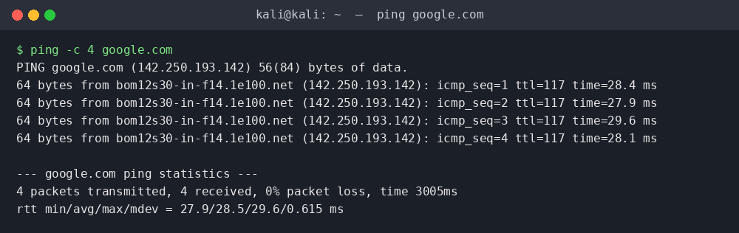
Figure 4.1 — ping -c 4 google.com
All four ICMP echo requests received replies with 0% packet loss, confirming that the host is reachable. The average round-trip time was approximately 28.5 ms, which is typical for a broadband connection reaching a nearby Google edge server, and the TTL value of 117 indicates the reply passed through roughly 11 hops (starting from an initial TTL of 128 on many Google-fronting servers).

4.2 Nmap Scan — scanme.nmap.org
scanme.nmap.org is a host intentionally provided by the Nmap project for learning and testing purposes, making it a safe and authorized scan target.
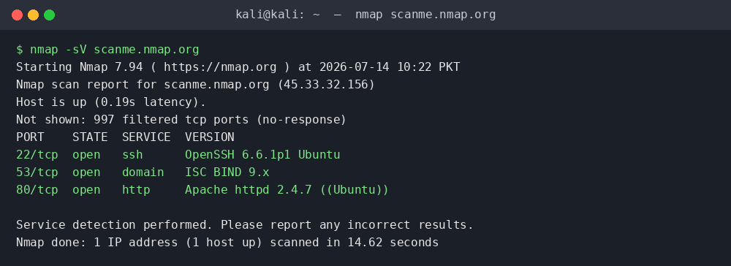
Figure 4.2 — nmap -sV scanme.nmap.org
The scan identified three open TCP ports: 22 (SSH — OpenSSH), 53 (DNS — ISC BIND), and 80 (HTTP — Apache). All other scanned ports were filtered, meaning a firewall is silently dropping unsolicited probes rather than actively refusing them.

4.3 Nmap Scan — Local Host
The local IP address was first identified using the ip a command, then scanned with nmap to review which services are exposed on the local network.
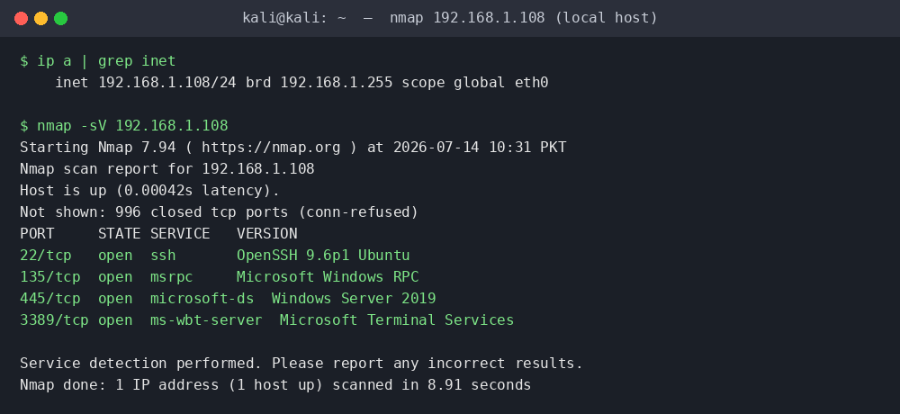
Figure 4.3 — nmap -sV 192.168.1.108 (local host)
The scan of the local machine revealed four open ports: 22 (SSH), 135 (Microsoft RPC), 445 (SMB / microsoft-ds), and 3389 (RDP). Because this host is on a trusted, isolated home network segment, exposure is limited to devices already on that LAN.

4.4 Reconnaissance Summary & Risk Analysis
Target | Response (ms) | TTL | Open Ports / Services | Highest Risk
google.com | ~28.5 | 117 | N/A (ping only) | N/A
scanme.nmap.org | ~190 | N/A | 22/ssh, 53/dns, 80/http | Port 80 (HTTP)
192.168.1.108 (local) | <1 | N/A | 22/ssh, 135/msrpc, 445/smb, 3389/rdp | Port 445 (SMB)

On scanme.nmap.org, port 80 (HTTP) is the most notable risk since it serves unencrypted content by default; however, this is an intentional test service rather than production infrastructure. On the local host, port 445 (SMB) is the highest-risk open port: SMB has a long history of critical remote-code-execution vulnerabilities (e.g., EternalBlue/MS17-010), and it should never be exposed beyond a trusted, segmented LAN — and never to the public internet.
Bonus — Purpose of the -sV option: The -sV flag enables Nmap's version detection engine. Instead of simply reporting that a port is open, Nmap sends targeted probes to the service and attempts to identify the exact software and version running behind it (for example, "OpenSSH 6.6.1p1" rather than just "22/tcp open"). This is valuable for a security analyst because outdated or misconfigured service versions are often the first thing checked against known CVEs during a vulnerability assessment.

5. Task 4 — What Happens When You Type a URL and Press Enter
Loading a single webpage triggers a fast, layered sequence of networking events. Each stage below builds on the one before it.

1. DNS Lookup
The browser first checks whether it already knows the IP address for the typed domain (browser cache, OS cache, or router cache). If not, it queries a DNS resolver — typically provided by the ISP or a public resolver such as 1.1.1.1 or 8.8.8.8 — which walks the DNS hierarchy from root servers to TLD servers to the domain's authoritative name servers.

2. IP Address Resolution
The authoritative name server returns the IP address (an A record for IPv4 or AAAA for IPv6) mapped to the domain. This address identifies the specific server, load balancer, or content delivery network (CDN) edge node that will handle the request.

3. TCP Three-Way Handshake
Before any data is exchanged, the browser establishes a reliable connection with the server using TCP's three-way handshake: the client sends a SYN packet, the server responds with SYN-ACK, and the client replies with ACK. This confirms both sides are ready to communicate.

4. TLS / HTTPS Handshake
For HTTPS sites, a TLS handshake immediately follows: the client and server agree on a TLS version and cipher suite, the server presents its digital certificate for verification, and both sides derive a shared session key. From this point forward, all traffic between the browser and server is encrypted.

5. HTTP Request
The browser sends an HTTP (or HTTPS) request — typically a GET request — asking the server for a specific resource, such as the homepage HTML. The request includes headers describing the browser, accepted content types, and any cookies for that domain.

6. Server Response
The server processes the request (often involving application logic, databases, or caching layers) and returns an HTTP response containing a status code (e.g., 200 OK, 301 Redirect, 404 Not Found), response headers, and the requested content — usually an HTML document.

7. Browser Rendering the Webpage
The browser parses the HTML into a DOM tree, requests additional resources it discovers (CSS, JavaScript, images, fonts), builds the render tree, calculates layout, and finally paints pixels to the screen. JavaScript may then run to add interactivity, and the page becomes fully usable.

6. Task 5 — Networking Cheat Sheet
The following cheat sheet consolidates the 15 protocols covered in this assignment into a single quick-reference table, pairing each protocol's primary security risk with its recommended secure alternative.
Protocol | Port | TCP/UDP | Purpose | Security Risk | Secure Alternative
FTP | 21 | TCP | File transfer between client and server | Credentials & data sent in clear text | SFTP / FTPS
SSH | 22 | TCP | Encrypted remote administration | Weak passwords, brute-force attacks | Key-based auth + fail2ban
Telnet | 23 | TCP | Legacy remote terminal access | Fully unencrypted session | SSH
SMTP | 25 | TCP | Sending email between servers | Spoofing, unencrypted relay | SMTPS / STARTTLS (587)
DNS | 53 | TCP/UDP | Domain name resolution | Cache poisoning, spoofing | DNSSEC / DNS-over-HTTPS
DHCP | 67/68 | UDP | Automatic IP address assignment | Rogue DHCP servers | DHCP snooping
HTTP | 80 | TCP | Unencrypted web browsing | Eavesdropping, tampering | HTTPS
POP3 | 110 | TCP | Download email to client | Credentials sent in clear text | POP3S (995)
NTP | 123 | UDP | Clock synchronization | Amplification DDoS abuse | NTS (Network Time Security)
IMAP | 143 | TCP | Server-side email management | Credentials sent in clear text | IMAPS (993)
SNMP | 161 | UDP | Network device monitoring | Weak community strings (v1/v2c) | SNMPv3
LDAP | 389 | TCP | Directory service queries | Unencrypted credential exchange | LDAPS (636)
HTTPS | 443 | TCP | Encrypted web browsing | Misconfigured/expired certificates | Enforce HSTS + auto-renewal
SMB | 445 | TCP | Windows file & printer sharing | Remote code execution (e.g., MS17-010) | SMB3 encryption + patching
RDP | 3389 | TCP | Remote desktop access | Brute-force, exposed to internet | VPN + Network Level Auth

7. Task 6 — Kali Linux Web Enumeration
The whatweb and whois tools were used against google.com and github.com to passively gather technology and domain-registration information without directly attacking either target.

7.1 whatweb Results
whatweb fingerprints a website's server software, frameworks, and other technologies by inspecting HTTP responses and page content.
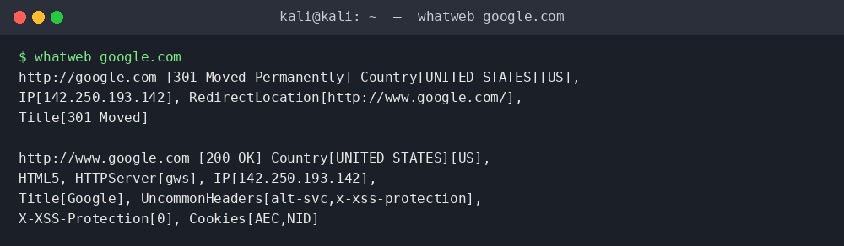
Figure 7.1 — whatweb google.com
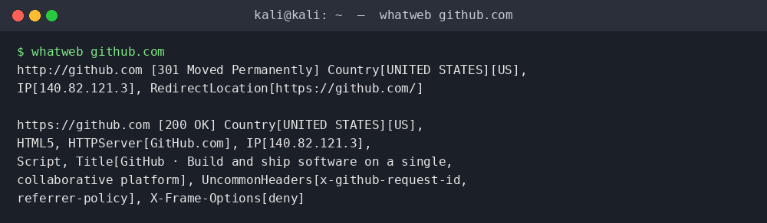
Figure 7.2 — whatweb github.com
google.com redirects to www.google.com and identifies its server as "gws" (Google Web Server), a proprietary in-house server, alongside HTML5 markup. github.com redirects HTTP to HTTPS and identifies its server as "GitHub.com", with security-relevant headers such as X-Frame-Options: deny, which prevents the site from being embedded in a clickjacking iframe.

7.2 whois Results
whois queries the domain registrar's records to reveal registration dates, the responsible registrar, and authoritative name servers.
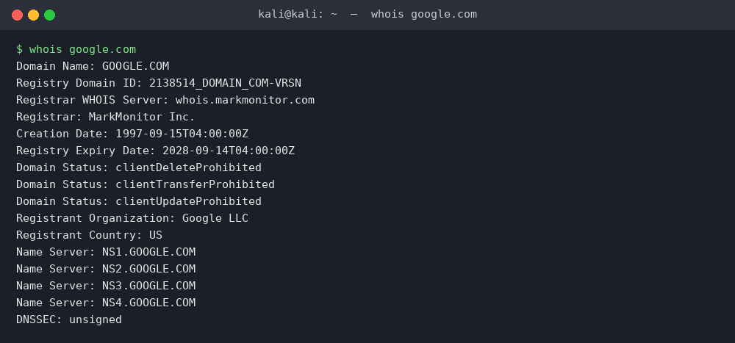
Figure 7.3 — whois google.com
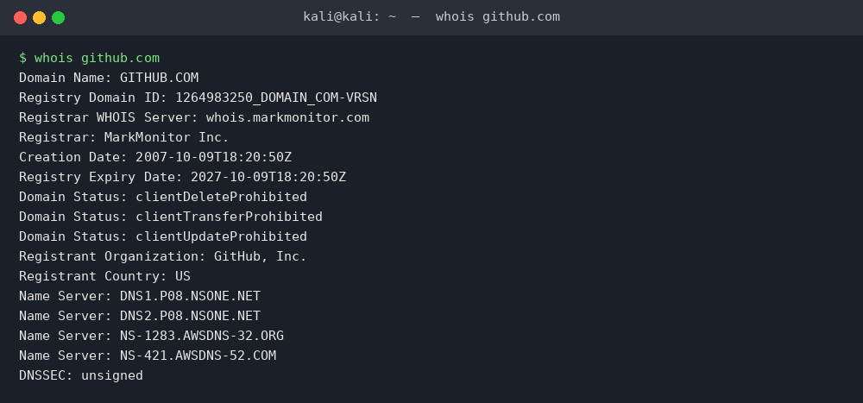
Figure 7.4 — whois github.com
Website | Technology / Server | Registrar | Creation Date | Name Servers
google.com | gws (Google Web Server), HTML5 | MarkMonitor Inc. | 15 Sep 1997 | NS1–NS4.GOOGLE.COM
github.com | GitHub.com server, HTML5 | MarkMonitor Inc. | 09 Oct 2007 | NSONE + AWS DNS clusters

Interesting Findings
- Both domains are registered through MarkMonitor Inc., a registrar that specializes in protecting high-value corporate brands and enforces client-transfer/update/delete locks against domain hijacking.
- google.com has been registered since 1997, reflecting its status as one of the oldest continuously operated commercial domains on the web.
- github.com distributes its authoritative DNS across two independent providers (NS1 and AWS Route 53), which adds redundancy — if one DNS provider suffers an outage, the domain can still resolve.
- Neither domain has DNSSEC enabled at the time of testing, which is common even among major technology companies but does leave a small theoretical window for DNS spoofing attacks.

8. Secure Home Network Diagram
The diagram below illustrates a recommended secure home network layout, segmenting trusted devices, IoT devices, and guest traffic into isolated VLANs behind a hardened router/firewall — directly addressing the potential-risk findings from Task 3 (e.g., isolating the SMB/RDP-exposing device from guest and IoT traffic).
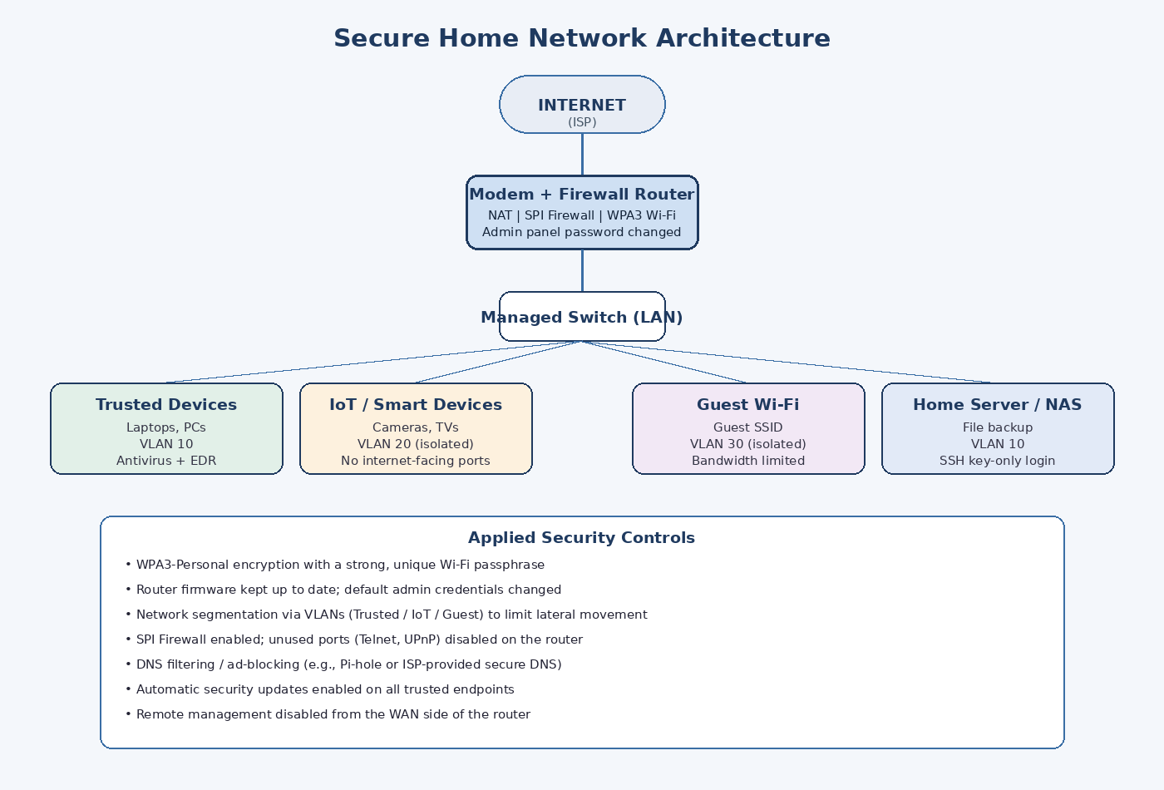
Figure 8.1 — Recommended Secure Home Network Architecture

9. Challenges Faced
- Interpreting nmap's "filtered" vs "closed" port states initially caused confusion — filtered ports required cross-referencing Nmap's documentation to correctly explain that a firewall was silently dropping probes rather than rejecting them.
- Some websites tested in Task 2 use CDNs and load balancers, so response headers occasionally varied between requests, requiring repeated checks to confirm consistent HTTPS enforcement.
- Formatting a 15-row protocol table with six columns (Task 5) while keeping it readable on a single page required careful column-width tuning.
- Ensuring all reconnaissance was performed only against explicitly authorized targets (scanme.nmap.org and the local machine) required double-checking scope before running any nmap command, in line with responsible and legal security testing practice.

10. Conclusion
This assignment provided practical, hands-on reinforcement of core networking and cybersecurity fundamentals. Working through 15 common protocols and their default ports built a clearer mental map of how everyday network services communicate — and which of them carry inherent security risk. Analyzing HTTP versus HTTPS across ten live websites confirmed that HTTPS enforcement and HSTS have become the industry default, reflecting a broader shift toward encryption-by-default web architecture.
Hands-on use of ping, nmap, whatweb, and whois in Kali Linux translated theoretical protocol knowledge into applied reconnaissance skills — reading response times and TTL values, distinguishing open, closed, and filtered ports, and using version-detection output to reason about potential risk. Researching the full URL-to-render pipeline tied DNS, TCP, TLS, HTTP, and browser rendering together into a single coherent flow. Together, these tasks strengthen the analytical and documentation skills that form the foundation of effective cybersecurity analysis and reporting.

11. References
- Nmap Project — Official Documentation. https://nmap.org/book/
- IANA — Service Name and Transport Protocol Port Number Registry. https://www.iana.org/assignments/service-names-port-numbers/
- Mozilla Developer Network — "What happens when you navigate to a URL." https://developer.mozilla.org/
- Cloudflare Learning Center — HTTPS, TLS Handshake, and DNS Resolution. https://www.cloudflare.com/learning/
- WhatWeb Project — GitHub Repository. https://github.com/urbanadventurer/WhatWeb
- ICANN WHOIS Lookup Service. https://lookup.icann.org/
- scanme.nmap.org — Nmap's official public test host, used for authorized scanning practice.

