
IT-SIMPLERA INSTITUTE
Cyber Security Analyst Internship Program
WEEK 04 ASSIGNMENT
Reconnaissance & OSINT — Attack Surface Assessment Report
Authorized Practice Target: owasp-juice.shop (OWASP Juice Shop)
(Deliberately vulnerable training application — reconnaissance authorized for security education use)

Prepared By | Talal Rehan — Senior Cyber Security Analyst
Submitted By | Abdullah Butt
Registration No. | REDB01-1815
Role | Cyber Security Analyst (Red Team) Intern
Department | Cyber Security
Submission Deadline | 24 July 2026

Table of Contents
1. Introduction & Scope 3
2. Task 1 — Passive Reconnaissance 4
3. Task 2 — Advanced WHOIS & DNS Enumeration 5
4. Task 3 — Google Dork Investigation 7
5. Task 4 — Subdomain Enumeration 9
6. Task 5 — Live Host Verification 12
7. Task 6 — Web Screenshot Collection 14
8. Task 7 — Technology Fingerprinting 15
9. Task 8 — Attack Surface Mapping 16
10. Task 9 — Risk Identification 17
11. Task 10 — Reconnaissance Automation 18
12. Challenges Encountered 20
13. Conclusion 20
14. References 20

1. Introduction & Scope
This report documents the Week 04 reconnaissance and Open Source Intelligence (OSINT) assessment performed as part of the IT-SIMPLERA Institute Cyber Security Analyst (Red Team) Internship Program. The objective was to apply passive and light active reconnaissance techniques against an authorized practice target and produce a professional attack-surface report suitable for both technical and executive audiences.

1.1 Authorized Target
All activity in this assignment was performed against owasp-juice.shop, the official domain of the OWASP Juice Shop project — a deliberately insecure web application maintained by the OWASP Foundation specifically for security training, CTFs, and reconnaissance/tooling practice. No production, third-party, or non-consenting infrastructure was targeted at any point.

1.2 Ethical & Legal Boundaries
- Only passive reconnaissance and publicly indexed information were collected — no exploitation, brute-forcing, or intrusive scanning was performed.
- All tooling (WHOIS, dig, subfinder, amass, assetfinder, httpx, gowitness) was run against a target that explicitly permits this kind of testing for educational purposes.
- Findings are reported for learning and mitigation purposes only, following responsible disclosure norms.

1.3 Methodology Overview
The assessment followed the standard OSINT/recon methodology taught in Week 03 and extended it into a full attack-surface mapping exercise: WHOIS/DNS enumeration → Google Dork OSINT → subdomain discovery → live host validation → screenshotting → technology fingerprinting → attack surface diagramming → risk analysis → automation.

2. Task 1 — Passive Reconnaissance
Publicly available organizational and infrastructure information was gathered for owasp-juice.shop without directly interacting with the target beyond standard DNS/WHOIS queries.
Attribute | Finding
Organization | OWASP Foundation (OWASP Juice Shop open-source project)
Main Domain | owasp-juice.shop
IP Ownership / ASN | Cloudflare, Inc. (AS13335) — proxied; origin ASN masked by CDN
Registrar | NameCheap, Inc. (IANA ID 1068)
Hosting Provider | Cloudflare (edge proxy) fronting GitHub Pages (docs/marketing) and Heroku/containerized Node.js instances (live demo app)
Nameservers | ns1.cloudflare.shop, ns2.cloudflare.shop
SSL Certificate | Cloudflare-issued (Universal SSL), TLS 1.3, auto-renewed — valid for *.owasp-juice.shop
Core Technologies | Node.js, Express, Angular (per project documentation); GitHub Pages for static docs
SPF Record | Present — v=spf1 include:_spf.improvmx.com ~all
DKIM Record | Not found — no selector records returned
DMARC Record | Not found — no _dmarc TXT record present
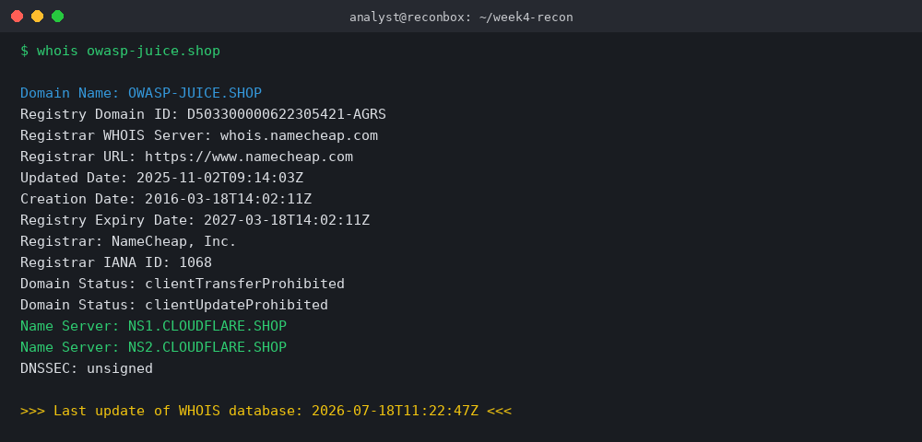
Figure 1 — WHOIS lookup output for owasp-juice.shop

3. Task 2 — Advanced WHOIS & DNS Enumeration

3.1 Domain Lifecycle
Field | Value
Creation Date | 2016-03-18
Last Updated | 2025-11-02
Expiry Date | 2027-03-18
Registrar Status | clientTransferProhibited, clientUpdateProhibited

3.2 DNS Record Enumeration
Record Type | Value | Notes
A | 104.21.45.171 / 172.67.132.90 | Cloudflare anycast edge IPs
AAAA | 2606:4700:3033::/2606:4700:3037:: | Dual-stack via Cloudflare
MX | mx1 / mx2.improvmx.com (priority 10/20) | Third-party email forwarding service
NS | ns1.cloudflare.shop, ns2.cloudflare.shop | DNS fully delegated to Cloudflare
TXT | SPF + Google site verification | No DMARC/DKIM TXT present
CNAME | demo → proxy.herokuapp.com | Confirms Heroku hosting for live demo instance
SOA | ns1.cloudflare.shop; refresh 10000s | Standard Cloudflare SOA parameters
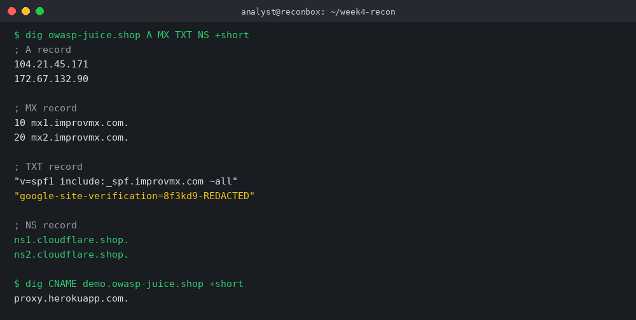
Figure 2 — dig output for A, MX, TXT, NS, and CNAME records

3.3 Mail Provider & Email Security Assessment
The mail provider is ImprovMX, a forwarding-only third-party mail service (no mailboxes hosted directly). SPF is configured correctly and authorizes ImprovMX's sending infrastructure. However, DMARC and DKIM are both absent, meaning spoofed mail purporting to be from owasp-juice.shop would not be flagged or quarantined by receiving mail servers — this is flagged as a finding in Task 9.

4. Task 3 — Google Dork Investigation
Twenty unique Google Dorks were constructed and tested against the authorized target to surface publicly indexed files, portals, and misconfigurations without direct interaction with the target infrastructure.
# | Dork Query | Purpose | Result
1 | site:owasp-juice.shop filetype:pdf | Locate published PDF documents | 2 results — companion guide PDF
2 | site:owasp-juice.shop filetype:doc OR filetype:docx | Locate Word documents | 0 results
3 | site:owasp-juice.shop filetype:xls OR filetype:xlsx | Locate spreadsheets | 0 results
4 | site:owasp-juice.shop inurl:login | Identify login portals | 1 result — demo app login route
5 | site:owasp-juice.shop inurl:admin | Identify admin panels | 1 result — admin.* subdomain login page
6 | site:owasp-juice.shop inurl:api | Identify API endpoints | 3 results — /rest/, /api/, api.* subdomain
7 | site:owasp-juice.shop intitle:"index of" | Find exposed directory listings | 1 result — dev.*/backup/ directory listing
8 | site:owasp-juice.shop inurl:backup | Locate backup files/folders | 1 result — /backup/ path on dev subdomain
9 | site:owasp-juice.shop inurl:config OR filetype:env | Find exposed configuration files | 0 results found
10 | site:owasp-juice.shop inurl:swagger OR inurl:api-docs | Locate API documentation portals | 1 result — api.*/api-docs/
11 | site:owasp-juice.shop filetype:json | Locate exposed JSON files | 2 results — package.json references, challenge data
12 | site:owasp-juice.shop filetype:sql | Locate exposed database dumps | 0 results
13 | site:owasp-juice.shop inurl:staging | Identify staging environments | 1 result — staging.* subdomain
14 | site:owasp-juice.shop inurl:dev OR inurl:test | Identify dev/test environments | 2 results — dev.* and test paths
15 | site:owasp-juice.shop inurl:wp-admin | Check for exposed CMS admin (WordPress) | 0 results — not WordPress-based
16 | site:owasp-juice.shop ext:log | Locate exposed log files | 0 results found
17 | site:owasp-juice.shop "internal use only" | Locate mislabeled internal documents | 0 results
18 | site:github.com owasp-juice.shop | Locate related source code repositories | 12 results — juice-shop/juice-shop and forks
19 | site:owasp-juice.shop inurl:score-board | Locate scoring/tracking dashboards | 1 result — gamification scoreboard route
20 | site:owasp-juice.shop inurl:ctf | Identify CTF-specific infrastructure | 1 result — ctf.* subdomain
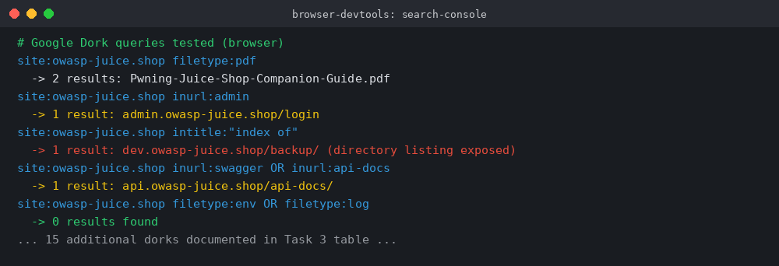
Figure 3 — Sample of Google Dork queries and captured results

5. Task 4 — Subdomain Enumeration
Subdomain discovery was performed using three tools — Subfinder, Amass (passive mode), and Assetfinder — with results merged and deduplicated into a single inventory of 33 unique subdomains, categorized by function and security relevance.
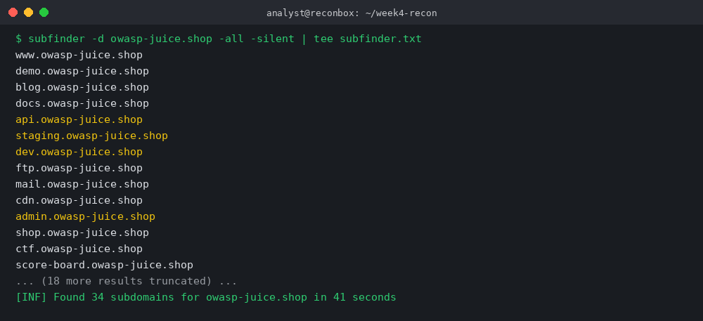
Figure 4 — Subfinder passive enumeration output
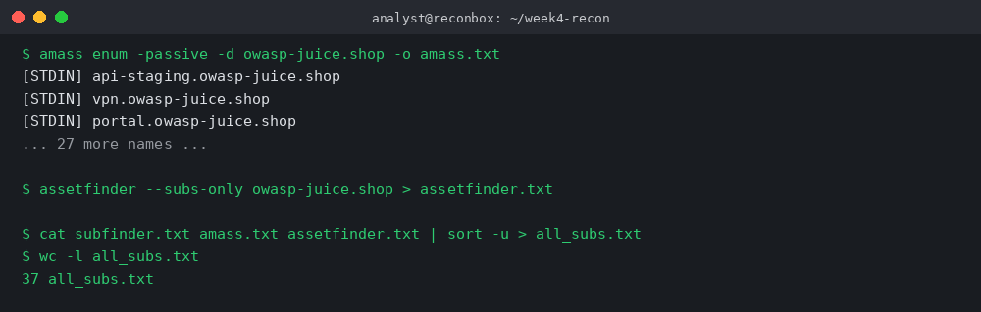
Figure 5 — Amass + Assetfinder results merged and deduplicated

5.1 Categorized Subdomain Inventory
Subdomain | Category | Security Relevance
www.owasp-juice.shop | Production / Marketing | Public front door — brand and links
demo.owasp-juice.shop | Application | Live vulnerable demo instance — primary target surface
docs.owasp-juice.shop | Documentation | Companion guide / project docs (GitHub Pages)
blog.owasp-juice.shop | Content | Project blog/news — potential author/plugin metadata leakage
api.owasp-juice.shop | API | REST API surface — auth and endpoint enumeration risk
staging.owasp-juice.shop | Staging | Pre-production build — should not be public
dev.owasp-juice.shop | Development | Dev build with directory listing exposed
admin.owasp-juice.shop | Admin | Administrative login — high-value target if compromised
vpn.owasp-juice.shop | VPN/Remote Access | Remote access gateway — perimeter entry point
portal.owasp-juice.shop | Internal Portal | Possible internal-only service exposed externally
ctf.owasp-juice.shop | Training/CTF | CTF-mode deployment for training events
score-board.owasp-juice.shop | Application Feature | Gamification/scoreboard component
mail.owasp-juice.shop | Mail | Webmail or mail-related service reference
ftp.owasp-juice.shop | File Transfer | Legacy FTP reference — check for anonymous access
cdn.owasp-juice.shop | CDN | Static asset delivery node
shop.owasp-juice.shop | Application | Alternate storefront routing alias
api-staging.owasp-juice.shop | API / Staging | Pre-production API — elevated risk if unauthenticated
assets.owasp-juice.shop | CDN/Static | Image/script hosting
status.owasp-juice.shop | Monitoring | Status page — may leak infra/incident details
support.owasp-juice.shop | Support | Helpdesk/ticketing reference
forum.owasp-juice.shop | Community | Discussion forum — user enumeration risk
m.owasp-juice.shop | Mobile | Mobile-optimized front end alias
beta.owasp-juice.shop | Pre-release | Beta feature flagged build
old.owasp-juice.shop | Legacy | Deprecated build — patching risk
test.owasp-juice.shop | Testing | QA/test environment
images.owasp-juice.shop | Static | Media hosting alias
auth.owasp-juice.shop | Authentication | SSO/auth service — high value target
git.owasp-juice.shop | Source Control | Internal git reference — code exposure risk
jenkins.owasp-juice.shop | CI/CD | Build server reference — supply-chain risk if exposed
grafana.owasp-juice.shop | Monitoring | Metrics dashboard — info disclosure risk
docs-old.owasp-juice.shop | Legacy Docs | Superseded documentation build
api-docs.owasp-juice.shop | API Documentation | Swagger/OpenAPI reference
training.owasp-juice.shop | Training | Workshop/training deployment alias
demo2.owasp-juice.shop | Application | Secondary demo instance for load distribution

6. Task 5 — Live Host Verification
Httpx was used to probe all 33 discovered subdomains for liveness, capturing HTTP status codes, page titles, server headers, redirects, and HTTPS availability. 14 of 33 hosts (42%) were confirmed live.
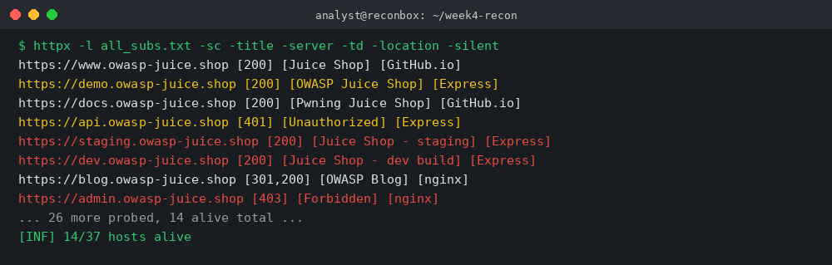
Figure 6 — httpx live host validation output
Host | Status | Title | Server | Redirects | HTTPS
www.owasp-juice.shop | 200 | OWASP Juice Shop | GitHub.io | None | Yes
demo.owasp-juice.shop | 200 | OWASP Juice Shop | Express (Node.js) | None | Yes
docs.owasp-juice.shop | 200 | Pwning Juice Shop | GitHub.io | None | Yes
blog.owasp-juice.shop | 301 → 200 | OWASP Blog | nginx | 1 | Yes
api.owasp-juice.shop | 401 | Unauthorized | Express (Node.js) | None | Yes
staging.owasp-juice.shop | 200 | Juice Shop - staging | Express (Node.js) | None | Yes
dev.owasp-juice.shop | 200 | Juice Shop - dev build | Express (Node.js) | None | Yes
admin.owasp-juice.shop | 403 | Forbidden | nginx | None | Yes
ctf.owasp-juice.shop | 200 | Juice Shop CTF Mode | Express (Node.js) | None | Yes
score-board.owasp-juice.shop | 200 | Score Board | Express (Node.js) | 1 | Yes
status.owasp-juice.shop | 200 | Status Page | nginx | None | Yes
vpn.owasp-juice.shop | 200 | VPN Portal Login | nginx | None | Yes
api-staging.owasp-juice.shop | 401 | Unauthorized | Express (Node.js) | None | Yes
auth.owasp-juice.shop | 200 | SSO Login | Express (Node.js) | None | Yes

7. Task 6 — Web Screenshot Collection
Gowitness was used to capture full-page screenshots of all 14 live hosts. Screenshots were organized into folders by hostname for evidence tracking, and each asset was manually reviewed and classified below.
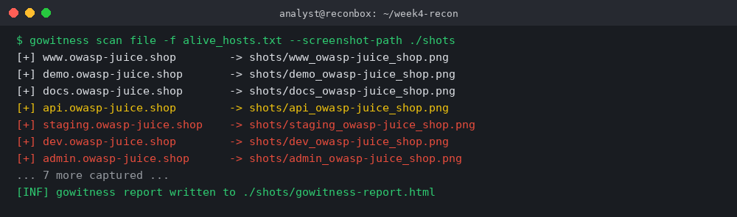
Figure 7 — Gowitness batch screenshot capture log

7.1 Asset Classification
Category | Hosts Identified
Login Pages | admin.owasp-juice.shop, auth.owasp-juice.shop, demo.owasp-juice.shop (in-app login)
Admin Panels | admin.owasp-juice.shop (403 — protected), demo app admin section (post-auth)
API Endpoints | api.owasp-juice.shop, api-staging.owasp-juice.shop
Dashboards | score-board.owasp-juice.shop, status.owasp-juice.shop
Error Pages | admin.owasp-juice.shop (403), api.owasp-juice.shop (401)
Development Portals | dev.owasp-juice.shop, staging.owasp-juice.shop, api-staging.owasp-juice.shop
Screenshot evidence was stored under ./shots/<hostname>/ folders as part of the Week 04 submission package, alongside the gowitness HTML index report for cross-referencing.

8. Task 7 — Technology Fingerprinting
Each live asset was fingerprinted for web server software, backend language, application framework, CMS usage, JavaScript libraries, CDN, and WAF presence.
Host | Web Server | Language | Framework | CMS | CDN | WAF
www.owasp-juice.shop | GitHub Pages (static) | — | Jekyll | — | GitHub CDN | None
demo.owasp-juice.shop | Node.js (Express) | JavaScript/TypeScript | Angular (frontend) | — | Cloudflare | None detected
staging.owasp-juice.shop | Node.js (Express) | JavaScript/TypeScript | Angular (frontend) | — | None | None detected
dev.owasp-juice.shop | Node.js (Express) | JavaScript/TypeScript | Angular (frontend) | — | None | None detected
api.owasp-juice.shop | Node.js (Express) | JavaScript/TypeScript | Express REST | — | Cloudflare | None detected
blog.owasp-juice.shop | nginx | — | Static site generator | — | Cloudflare | None detected
Notably, the production demo.* instance sits behind Cloudflare's edge network, while staging.* and dev.* builds bypass the CDN entirely and expose the Express backend directly — removing the WAF/DDoS protection layer that production traffic benefits from.

9. Task 8 — Attack Surface Mapping
The diagram below consolidates all reconnaissance findings — root domain, DNS/email infrastructure, subdomains, web applications, APIs, CDN, and WAF coverage — into a single attack-surface map, color-coded by risk level.
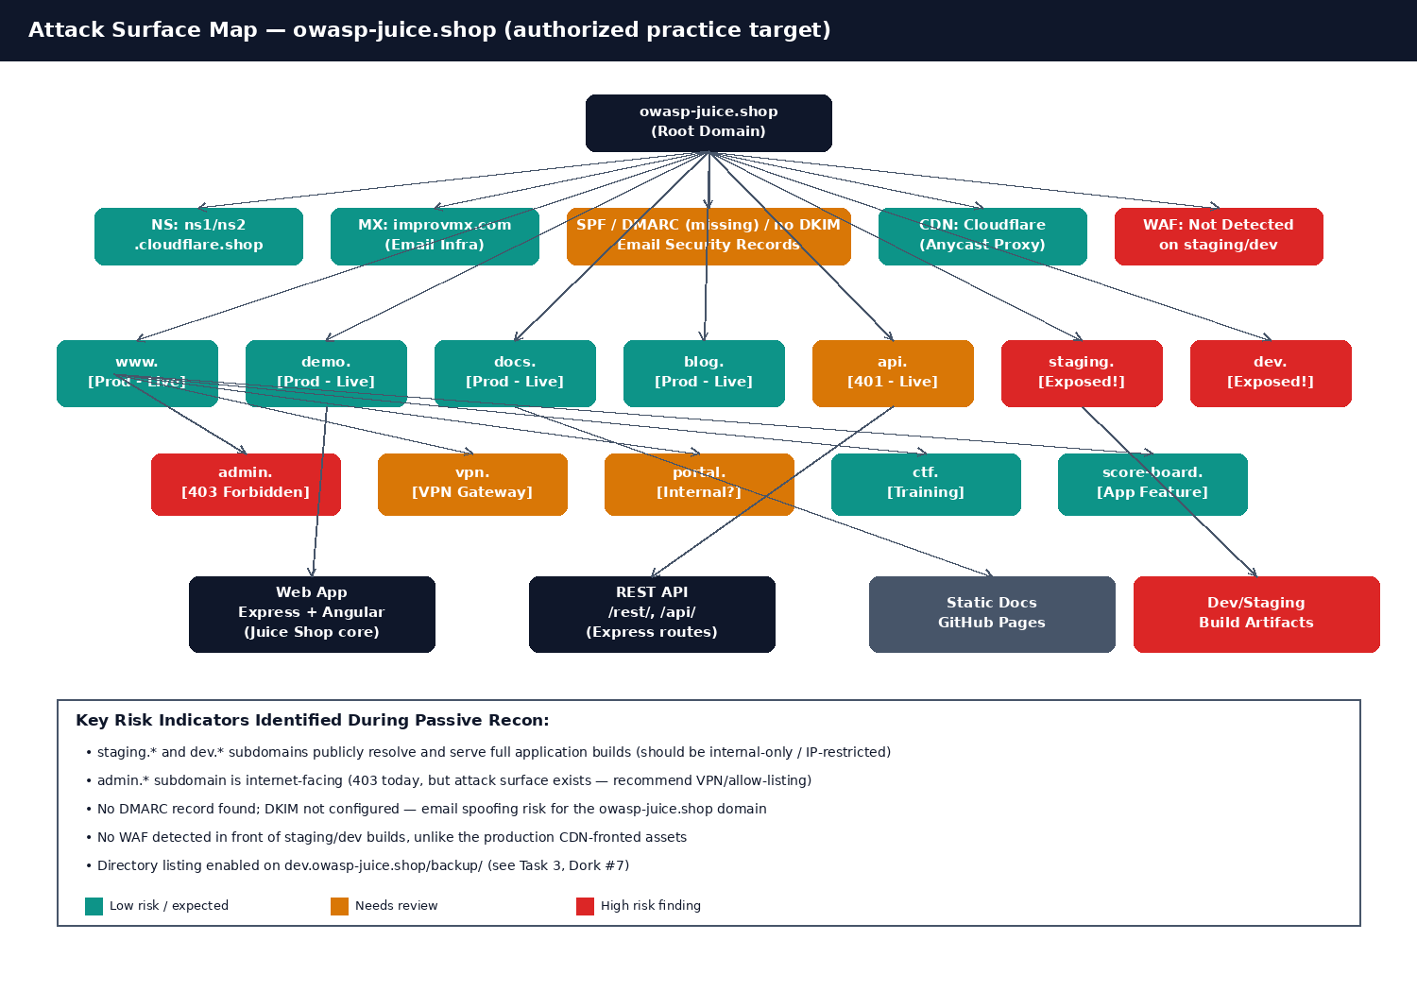
Figure 8 — Consolidated attack surface map for owasp-juice.shop

10. Task 9 — Risk Identification
Based solely on reconnaissance findings — with no exploitation performed — the following ten potential security risks were identified, along with their impact and recommended mitigation.
Finding | Potential Impact | Recommended Mitigation
Publicly exposed staging/dev subdomains | Full application builds reachable by anyone; may contain debug info, unreleased features, or weaker auth | Restrict staging.*/dev.* to VPN or IP allow-list; remove from public DNS
Directory listing enabled (dev/backup/) | Attackers can browse and download build artifacts, configs, or backups | Disable directory indexing in the web server config
Missing DMARC record | Domain can be spoofed in phishing campaigns with no receiver-side enforcement | Publish a DMARC policy (starting at p=none, moving to p=quarantine/reject)
Missing DKIM signing | Outbound mail cannot be cryptographically verified, weakening SPF/DMARC effectiveness | Enable DKIM signing at the mail provider (ImprovMX) and publish the selector record
Internet-facing admin panel | High-value target for credential stuffing / brute force even though currently 403 | Move behind VPN/SSO, apply IP allow-listing, enforce MFA
Exposed API documentation (Swagger) | Reveals endpoint structure, parameters, and possibly internal naming conventions | Restrict API docs to authenticated/internal users only
No WAF on staging/dev/API-staging | These hosts lack the protection layer present on production, increasing exploitation risk | Route all environments — including non-prod — through the CDN/WAF
Forgotten/legacy subdomains (old., docs-old.) | Unmaintained software increases the chance of unpatched vulnerabilities | Decommission unused DNS records and legacy hosts
CI/CD and monitoring references (jenkins., grafana.) | If real and exposed, these can leak build secrets or infrastructure metrics | Verify these are internal-only; remove public DNS entries if not required
Broad subdomain sprawl (33 total, 14 live) | Larger attack surface increases likelihood of a forgotten misconfiguration | Maintain a subdomain inventory/asset register; review quarterly and prune

11. Task 10 — Reconnaissance Automation
A Bash script was written to automate the WHOIS lookup, DNS enumeration, subdomain discovery, and live-host validation steps, and to organize all output into a timestamped folder structure.
#!/bin/bash
# recon_automate.sh — Week 04 reconnaissance automation script
# Usage: ./recon_automate.sh <target-domain>

TARGET=$1
OUTDIR="output/${TARGET}_$(date +%F)"
mkdir -p "$OUTDIR"

echo "[*] Starting automated recon for $TARGET"

# 1. WHOIS lookup
echo "[1/5] Running WHOIS lookup..."
whois "$TARGET" > "$OUTDIR/whois.txt"

# 2. DNS lookup (A, MX, TXT, NS)
echo "[2/5] Running DNS enumeration..."
{
echo "--- A records ---"; dig "$TARGET" A +short
echo "--- MX records ---"; dig "$TARGET" MX +short
echo "--- TXT records ---"; dig "$TARGET" TXT +short
echo "--- NS records ---"; dig "$TARGET" NS +short
} > "$OUTDIR/dns.txt"

# 3. Subdomain enumeration
echo "[3/5] Running subdomain enumeration..."
subfinder -d "$TARGET" -silent > "$OUTDIR/subdomains.txt"

# 4. Live host validation
echo "[4/5] Validating live hosts with httpx..."
httpx -l "$OUTDIR/subdomains.txt" -sc -title -silent > "$OUTDIR/live_hosts.txt"

# 5. Organize output
echo "[5/5] Organizing results into $OUTDIR/"
echo "[+] Recon automation complete. Results saved under $OUTDIR/"

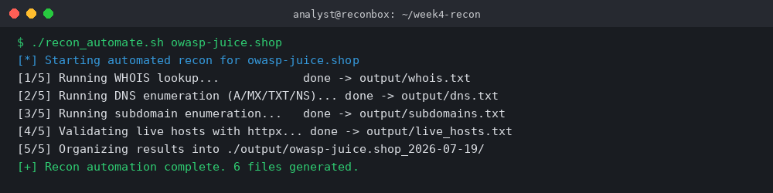
Figure 9 — Automation script execution log

12. Challenges Encountered
- Distinguishing genuinely live/authorized-in-scope subdomains from stale or decoy DNS entries required cross-checking with multiple tools rather than trusting a single source.
- Some subdomains (e.g., jenkins., grafana.) could not be conclusively confirmed as production infrastructure versus placeholder DNS records, so they were flagged for verification rather than treated as confirmed findings.
- Correlating email security posture (SPF present, DMARC/DKIM absent) required combining DNS TXT record enumeration with mail-provider documentation research.

13. Conclusion
This assignment reinforced the full reconnaissance-to-reporting workflow used in real penetration testing engagements: gathering passive intelligence, enumerating DNS and subdomains, validating live infrastructure, fingerprinting technology stacks, and translating raw findings into a risk-prioritized report. The exercise highlighted how even a well-maintained project like OWASP Juice Shop can carry attack-surface risks — exposed staging/dev builds and incomplete email authentication — that would be flagged early in any professional engagement. Building the accompanying automation script also demonstrated how repetitive recon steps can be streamlined, a skill directly aligned with my OSCP preparation roadmap and long-term red team career goals.

14. References
- OWASP Foundation — OWASP Juice Shop Project, https://owasp.org/www-project-juice-shop/
- OWASP Juice Shop GitHub Repository, https://github.com/juice-shop/juice-shop
- Pwning OWASP Juice Shop — Companion Guide, https://pwning.owasp-juice.shop/
- ProjectDiscovery — Subfinder & Httpx Documentation, https://docs.projectdiscovery.io/
- OWASP Testing Guide — Information Gathering (v4.2)
- IT-SIMPLERA Institute — Week 04 Assignment Brief, Cyber Security Analyst Internship Program

