
IT-SIMPLERA INSTITUTE
Cyber Security Analyst Internship Program
WEEK 02 ASSIGNMENT REPORT
Computer Networking Fundamentals & Network Configuration
Prepared By
Abdullah
Bachelor of Information Technology, University of Gujrat
Assigned To
Talal Rehan — Senior Cyber Security Analyst (Supervisor)
Submission Deadline: 10 July 2026
Registration No: REDB01-1815

Table of Contents
1. Introduction
2. Task 1 — Network Information (ipconfig /all)
3. Task 2 — Basic Networking Commands
4. Task 3 — Router vs. Switch
5. Task 4 — IPv4 vs. IPv6
6. Task 5 — The OSI Model
7. Network Diagram
8. Challenges Faced
9. Conclusion
10. References

1. Introduction
This report has been prepared as part of the Week 02 Assignment under the Cyber Security Analyst Internship Program at IT-SIMPLERA Institute, supervised by Talal Rehan. The assignment focuses on the foundational concepts of computer networking, including network configuration analysis, essential command-line diagnostic tools, the distinction between routers and switches, a comparison of IPv4 and IPv6 addressing, and the seven-layer OSI reference model.
The objective of this exercise is to build practical, hands-on familiarity with networking commands while reinforcing the theoretical framework that underpins network communication — knowledge that forms a critical foundation for further study in cybersecurity and network administration.

2. Task 1 — Network Information (ipconfig /all)
The ipconfig /all command was executed on a Windows host to retrieve detailed network configuration information. The key parameters identified are explained below:
Parameter | Purpose
IPv4 Address | The unique logical address assigned to the device on the local network, used to identify and route traffic to and from the host.
MAC Address | The physical hardware address burned into the network interface card (NIC); used for communication at the Data Link layer within a local network segment.
Default Gateway | The IP address of the router that forwards traffic from the local network to external networks, such as the Internet.

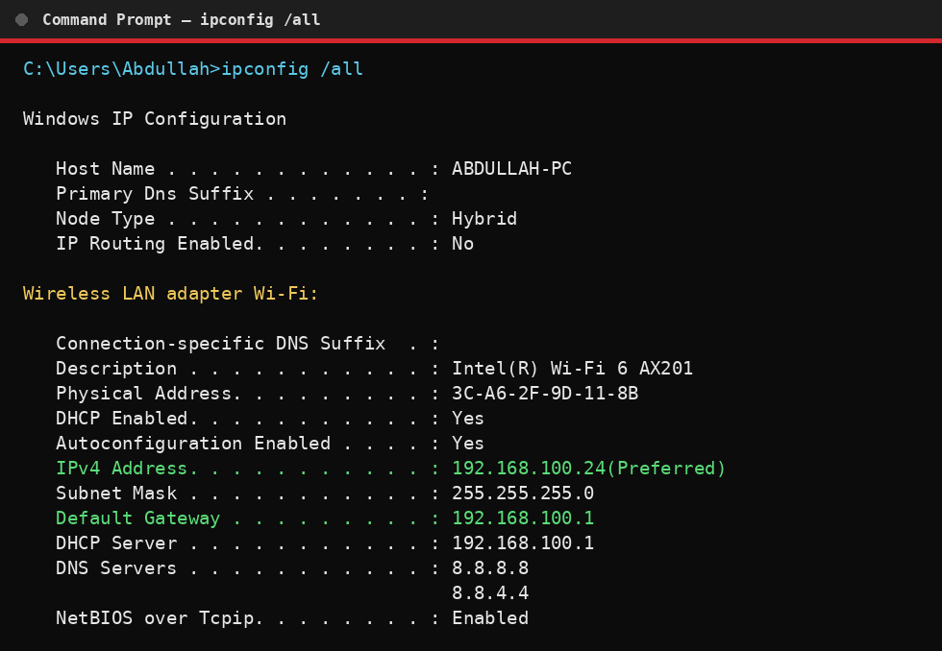
Figure 1: ipconfig /all output — IPv4 Address, MAC Address, and Default Gateway highlighted

3. Task 2 — Basic Networking Commands
The following essential networking commands were executed to diagnose and analyze network connectivity. Each command's purpose is summarized below, followed by a placeholder for the corresponding output screenshot.
Command | Purpose
ipconfig /all | Displays complete IP configuration for all network adapters, including IPv4/IPv6 address, subnet mask, default gateway, DNS servers, and MAC address.
ping google.com | Tests reachability of a host by sending ICMP echo requests and measuring round-trip time, confirming basic connectivity.
tracert google.com | Traces the route packets take to reach a destination, listing each intermediate hop (router) and its response time.
nslookup google.com | Queries DNS servers to resolve a domain name into its corresponding IP address, useful for diagnosing DNS issues.
arp -a | Displays the ARP cache, mapping known IPv4 addresses to their corresponding MAC addresses on the local network.
Output: ipconfig /all

Figure 2: ipconfig /all — full adapter configuration
Output: ping google.com
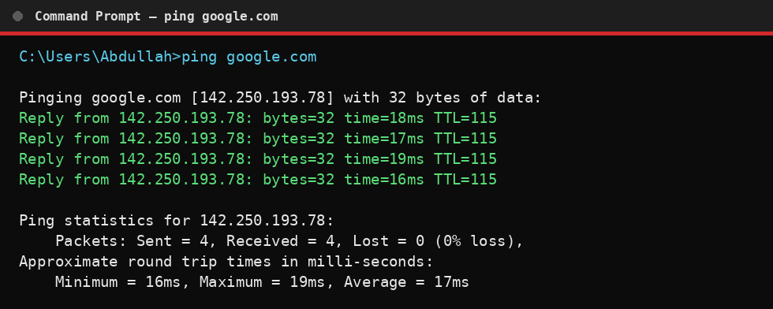
Figure 3: ping google.com — connectivity test with round-trip times
Output: tracert google.com
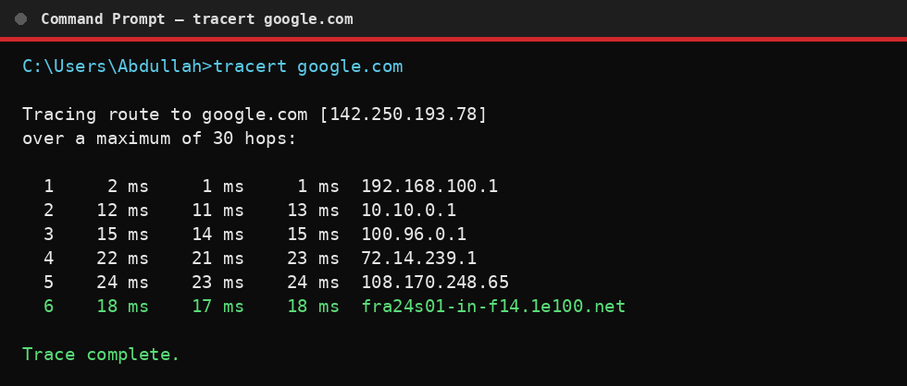
Figure 4: tracert google.com — hop-by-hop route trace
Output: nslookup google.com
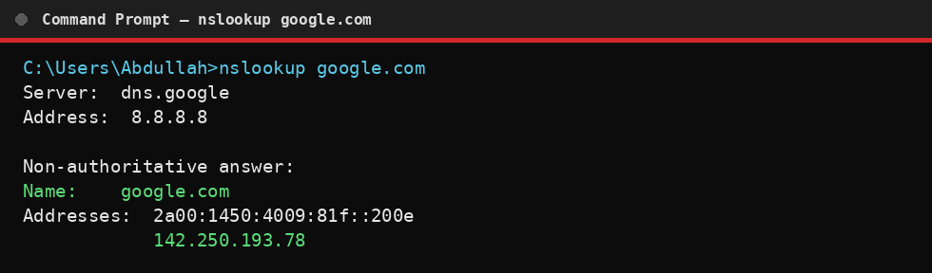
Figure 5: nslookup google.com — DNS resolution result
Output: arp -a
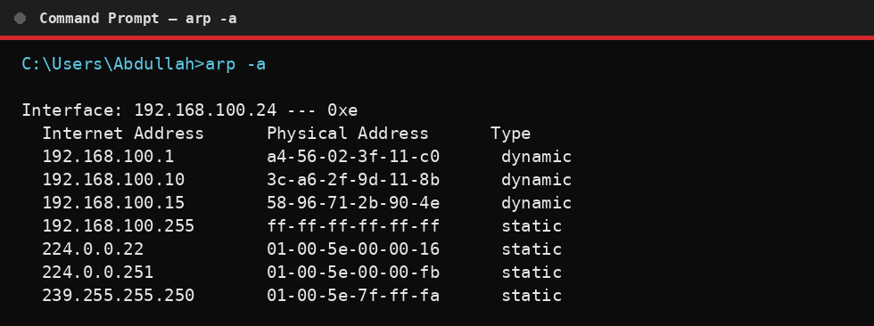
Figure 6: arp -a — local ARP cache mapping IP to MAC addresses

4. Task 3 — Router vs. Switch
Routers and switches serve distinct roles within a network. The comparison below outlines their key differences:
Comparison Point | Router | Switch
Primary Function | Connects and routes traffic between different networks | Connects devices within the same local network (LAN)
OSI Layer | Network Layer (Layer 3) | Data Link Layer (Layer 2)
Addressing Used | IP Address | MAC Address
Traffic Handling | Routes data packets between networks using routing tables | Forwards data frames between devices using a MAC address table
Broadcast Domain | Separates broadcast domains | Operates within a single broadcast domain (unless VLANs are used)
Common Use Case | Connecting a home/office LAN to the Internet (WAN) | Connecting computers, printers, and servers within an office LAN

5. Task 4 — IPv4 vs. IPv6
IPv4 and IPv6 are the two versions of the Internet Protocol used for addressing devices on a network. Their key differences are summarized below:
Feature | IPv4 | IPv6
Address Length | 32-bit | 128-bit
Address Format | Dotted decimal (e.g., four numbers separated by dots) | Hexadecimal, colon-separated (eight groups)
Total Addresses | Approximately 4.3 billion | Approximately 340 undecillion
Address Configuration | Manual or DHCP | Supports auto-configuration (SLAAC) and DHCPv6
Header Complexity | More complex, includes checksum | Simplified, fixed-length header for faster processing
Security | Security (IPsec) is optional | IPsec support is built-in
NAT Requirement | Commonly requires NAT due to address shortage | Designed to eliminate the need for NAT
Example Addresses:
- IPv4 Example: 192.168.1.1
- IPv6 Example: 2001:0db8:85a3:0000:0000:8a2e:0370:7334

6. Task 5 — The OSI Model
The Open Systems Interconnection (OSI) model divides network communication into seven distinct layers, each with a specific function, associated protocol, and networking device:
Layer # | Layer Name | Primary Function | Common Protocol | Associated Device
7 | Application | Provides network services directly to end-user applications | HTTP, FTP, DNS | Firewall / Gateway
6 | Presentation | Translates, encrypts, and compresses data for the application layer | SSL/TLS, JPEG | Gateway
5 | Session | Establishes, manages, and terminates sessions between applications | NetBIOS, RPC | Gateway
4 | Transport | Ensures reliable end-to-end data delivery and error recovery | TCP, UDP | Firewall
3 | Network | Handles logical addressing and routing between networks | IP, ICMP | Router
2 | Data Link | Manages physical addressing (MAC) and error detection within a local segment | Ethernet, ARP | Switch, Bridge
1 | Physical | Transmits raw bit streams over a physical medium | Ethernet (cabling), USB | Hub, Cables, NIC

7. Network Diagram
The diagram below illustrates a sample network topology showing how end devices, a switch, a router, and the Internet are interconnected — consistent with the concepts explored in this assignment.
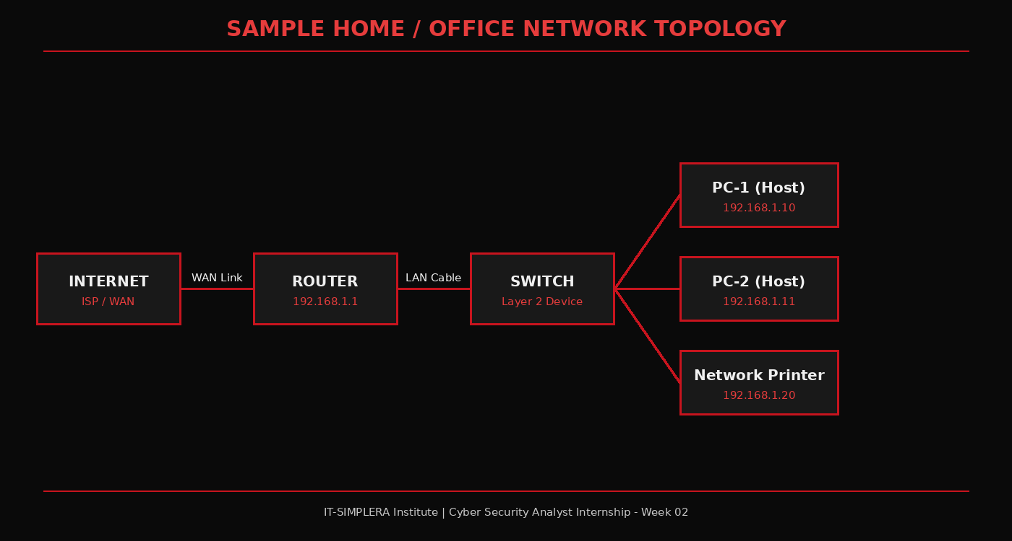
Figure 7: Sample network topology — end devices, switch, router, and Internet

8. Challenges Faced
- Interpreting the detailed output of ipconfig /all required cross-referencing each field with its theoretical definition to ensure accurate explanations.
- Differentiating OSI layer responsibilities for the Session and Presentation layers required additional research, as their functions can overlap in practice with modern protocol stacks.
- Formatting comparison tables to be both concise and comprehensive across six or more points needed careful selection of the most relevant distinguishing factors.

9. Conclusion
This assignment provided a comprehensive, hands-on introduction to core networking fundamentals essential to a cybersecurity analyst's skill set. Through direct use of diagnostic commands and structured comparisons of key networking concepts, a solid foundation has been established for further exploration of network security, traffic analysis, and infrastructure defense in subsequent weeks of the internship program.

10. References
- Microsoft Learn — Windows Networking Command Reference (ipconfig, ping, tracert, nslookup, arp)
- Cisco Networking Academy — Introduction to Networks: Routers and Switches
- IETF RFC 791 — Internet Protocol (IPv4) Specification
- IETF RFC 8200 — Internet Protocol, Version 6 (IPv6) Specification
- ISO/IEC 7498-1 — OSI Reference Model

