IT-SIMPLERA • RED TEAM INTERNSHIP • WEEK 01 | 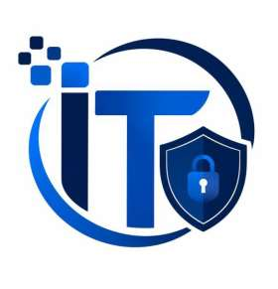  IT-SIMPLERA INSTITUTE  Internship Weekly Report  SUMMARY REPORT  Week 01 Internship Summary  Student Name Abdullah  Registration No. REDB01-1815  Role Red Team Intern  Institute IT-SIMPLERA Institute  Instructor Talal Rehan  Week Week 01  Submission Date 1st July 2026  CONFIDENTIAL — Prepared for internal training purposes

Executive Summary
This assignment covers the basic concepts of cybersecurity and their practical applications. It includes research on five real-world cyberattacks, their impact, and how they violated the CIA Triad. The report also explains the purpose, functions, and use cases of three cybersecurity tools: Nmap, Gobuster, and Metasploit, with screenshots from a controlled lab environment.
In addition, a secure home network diagram is presented to demonstrate basic network security practices. The report also describes the daily responsibilities of a cybersecurity analyst, including monitoring security alerts, investigating incidents, and improving system security. Overall, this assignment helped strengthen my understanding of cybersecurity concepts and their application in real-world scenarios.

Objective
The objective of this assignment is to enhance understanding of cybersecurity by studying real-world cyberattacks, evaluating their impact on the CIA Triad, researching industry-standard cybersecurity tools, designing a secure home network, and exploring the daily responsibilities of a cybersecurity analyst. This assignment aims to bridge theoretical knowledge with practical cybersecurity concepts and best practices.

Environment
Component | Details
Operating System (Host) | Windows (Host Machine)
Virtualization Software | Oracle VirtualBox
Attacker VM | Kali Linux
Target VM | Metasploitable2 (192.168.66.9)
Network Type | Host-Only Adapter (isolated lab network)
Tools Installed | Nmap, Gobuster, Metasploit
Network Interface | eth0 on Metasploitable2; eth0 on Kali Linux

Task No. 1: 5 Real Cyber Attacks

1. The Equifax Data Breach (2017)
Year: 2017
Organization: Equifax
Type: The attack occurred due to a vulnerability in a web application framework called Apache Struts, which Equifax failed to patch despite the availability of a fix months before the breach.
Description: In 2017, Equifax, one of the largest credit reporting agencies in the United States, suffered a major data breach that affected around 147 million people. The attackers gained access to sensitive personal information such as names, Social Security numbers, dates of birth, and home addresses. As a result, millions of individuals were put at risk of identity theft and financial fraud. The breach happened because Equifax did not install a security patch for a known vulnerability in the Apache Struts web application framework. Although the patch had been available for several months, it was never applied. This allowed the attackers to enter the company's network, move through different systems, and steal sensitive data without being detected for about 76 days.
Impact: Causes a data breach that compromised the personal information of 147 million Americans.

2. New Blue Locker Ransomware Attacking Oil & Gas Sector in Pakistan
Year: August 6, 2025
Organization: Pakistan Petroleum Limited (PPL)
Type: Ransomware
Description: In August 2025, Pakistan's National Cyber Emergency Response Team (NCERT) issued warnings to 39 government ministries after a major ransomware campaign targeted the country's critical infrastructure. One of the main victims was Pakistan Petroleum Limited (PPL), the country's second-largest oil company. The attack took place on August 6, 2025, just a few days before Pakistan's Independence Day. The attackers used Blue Locker ransomware to encrypt PPL's systems and steal more than 1 TB of sensitive data. The incident highlighted the growing cyber threats facing critical infrastructure in South Asia and emphasized the importance of strong cybersecurity measures to protect essential organizations.
Impact: The breach affected crucial operational data, including Petrel Studio exploration files, production databases, operations plans, and financial records.

3. GitHub TeamPCP Supply Chain Attack
Year: 23 June 2026
Organization: GitHub
Type: Software Supply Chain Attack / Data Breach
Description: In 2024, the TeamPCP threat group compromised a GitHub employee's computer by using a malicious Visual Studio Code extension. Once the attackers gained access, they stole data from around 3,800 internal GitHub repositories, including source code, documentation, and internal development resources. After discovering the attack, GitHub launched an investigation, removed the malicious extension, and revoked the compromised credentials to prevent further access. The company also confirmed that there was no evidence that customer repositories or GitHub user accounts were affected by the incident.
Impact: The breach exposed thousands of GitHub's internal repositories and highlighted the security risks posed by compromised developer tools and software supply chain attacks. The incident reinforced the importance of endpoint security, code-signing, least-privilege access, and continuous monitoring of development environments.

4. Twitter Bitcoin Scam Hack
Year: 2020
Organization: Twitter
Type: Social Engineering / Account Takeover
Description: In 2020, attackers used social engineering techniques to deceive Twitter employees into giving them access to the company's internal administrative tools. With this access, they took control of several high-profile Twitter accounts, including those belonging to Elon Musk, Bill Gates, Barack Obama, and Apple. The attackers used these accounts to post fake Bitcoin giveaway messages, encouraging people to send cryptocurrency with the promise of receiving more in return. The incident demonstrated how human error and social engineering can be just as dangerous as technical vulnerabilities.
Impact: More than 130 high-profile accounts were compromised, fraudulent cryptocurrency scams collected over $100,000, and the incident exposed weaknesses in internal access controls and employee security awareness.

5. MOVEit Attack (2023)
Year: 2023
Organization: MOVEit Transfer Customers (Thousands of organizations worldwide)
Type: Zero-Day Exploit / Data Breach
Description: In 2023, the Cl0p ransomware group took advantage of a previously unknown zero-day vulnerability in the MOVEit Transfer file-sharing software. The vulnerability, identified as CVE-2023-34362, allowed the attackers to gain unauthorized access to sensitive data belonging to organizations that used the software. Instead of encrypting the victims' systems like traditional ransomware attacks, the attackers focused on stealing confidential information. They later used the stolen data to pressure organizations into paying a ransom, making the attack one of the largest data theft incidents of 2023.
Impact: More than 2,500 organizations and over 90 million individuals were affected worldwide. The breach exposed sensitive personal and business data, leading to financial losses, legal investigations, and increased emphasis on timely patch management and third-party software security.

Task No. 2: CIA Triad
Principle | Definition
Confidentiality | Confidentiality is the protection of sensitive information from unauthorized access. It ensures that only authorized users can view or use the data. Common methods used to maintain confidentiality include encryption, passwords, authentication, and access control.
Integrity | Integrity ensures that data remains accurate and trustworthy throughout its lifecycle. It prevents unauthorized users from changing or deleting information. Techniques such as hashing, digital signatures, checksums, and version control help maintain the integrity of data.
Availability | Availability means that authorized users can access information and systems whenever they are needed. To ensure availability, organizations use backups, redundant hardware, disaster recovery plans, and security measures to protect against threats like DDoS attacks that can disrupt services.

Attacks | Confidentiality | Integrity | Availability | Explanation
Blue Locker Ransomware (2025) | Violated (Directly) | Violated (Directly) | Violated (Directly) | Confidentiality: Sensitive data was stolen. Integrity: Files were encrypted and changed. Availability: Systems became unavailable until recovery.
Equifax Data Breach (2017) | Violated (Directly) | Not violated | Violated (indirectly) | Confidentiality: Personal data of 147 million people was exposed. Integrity: No evidence of data modification. Availability: Some services were temporarily unavailable during recovery.
GitHub TeamPCP Supply Chain Attack (2026) | Violated (Directly) | Violated (Indirectly) | Not violated | Confidentiality: Internal repositories were accessed without permission. Integrity: A malicious VS Code extension affected the development environment. Availability: GitHub services remained available.
MOVEit Transfer Zero-Day Attack (2023) | Violated (Directly) | Not violated | Not violated | Confidentiality: Attackers stole sensitive files. Integrity: Data was stolen but not modified. Availability: Systems continued operating normally.
Twitter Bitcoin Scam Hack (2020) | Violated (Directly) | Violated (Directly) | Violated (indirectly) | Confidentiality: Internal employee tools were accessed without authorization. Integrity: Legitimate tweets were replaced with scam messages. Availability: Some Twitter features were temporarily restricted during the response.

Task No. 3: Real Cybersecurity Tools: Nmap, Gobuster, Metasploit

Tool No. 1: Nmap
Purpose: Network discovery and security auditing
Function: Its function is provide network discovery like open ports, operating system version and determining which systems are online based on the response it receives from the targeted system.
Use Case: It was used to find 23 open ports using -sV command for metasploitable2 and it is used in reconnaissance phase for penetration testing and ethical hacking.

Tool No. 2: Gobuster
Purpose: Web directory and file enumeration
Function: Its function is to provide hidden directories, hidden pages using brute force technique.
Use Case: Used to find 13 hidden directories using the command (gobuster dir -u http://192.168.66.9 -w /usr/share/wordlists/dirb/common.txt).

Tool No. 3: Metasploit
Purpose: Exploitation and post exploitation
Function: Its function is to provide exploits, payloads, backdoors and post exploitation tools to verify that whether vulnerabilities can be exploit.
Use Case: It was used to provide access into metasploitable2 through ftp backdoor.
The fig 1 shows an nmap scan for the target metasploitable2 using the command nmap -sV 192.168.66.9. The purpose of using using tool was to find information about the target like whether the target is online and open ports, and operating system version. The phase of finding information about the target is called reconnaissance phase.
The fig 1 shows all 23 open ports.
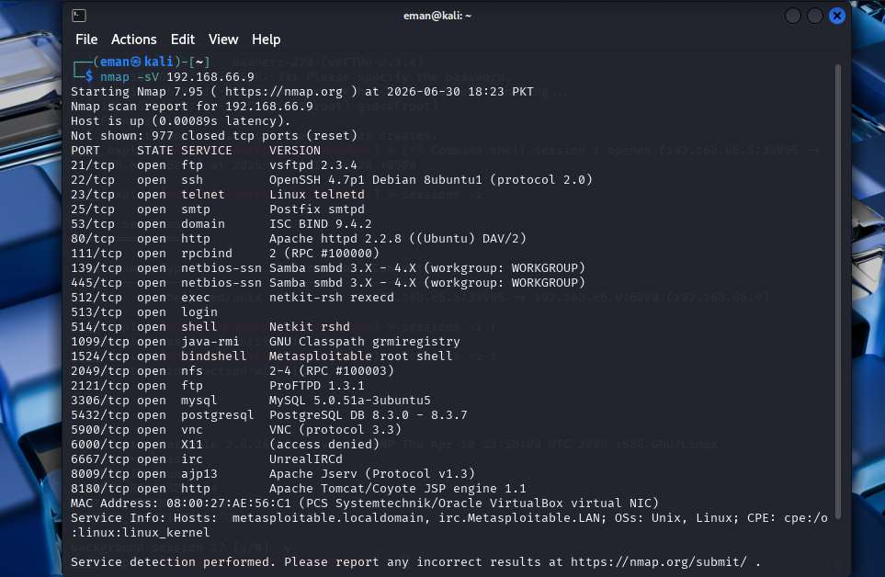
fig 1

Tool No. 2: Gobuster
Below the fig 2 shows a gobuster tool revealing hidden directories and pages for the target (metasploitable2). The purpose of using this tool to reveal any hidden web directories that might be helpful for the access into the target system.
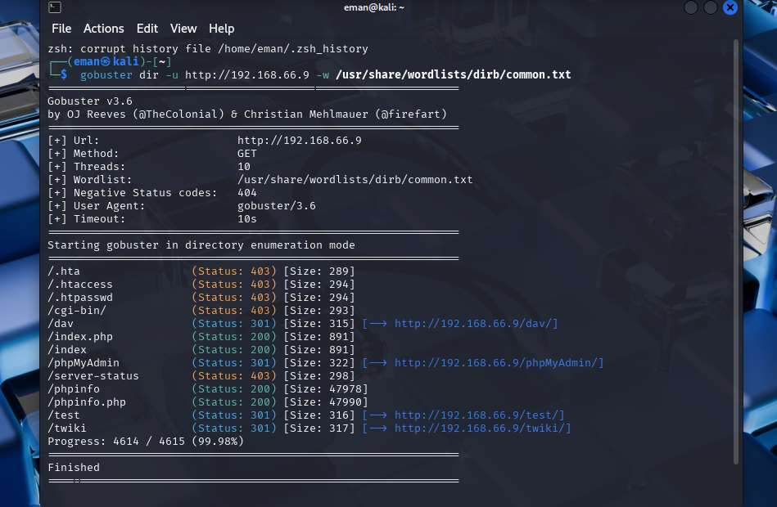
fig 2

Tool No. 3: Metasploit
The fig 3.1 shows the interface of metasploit.
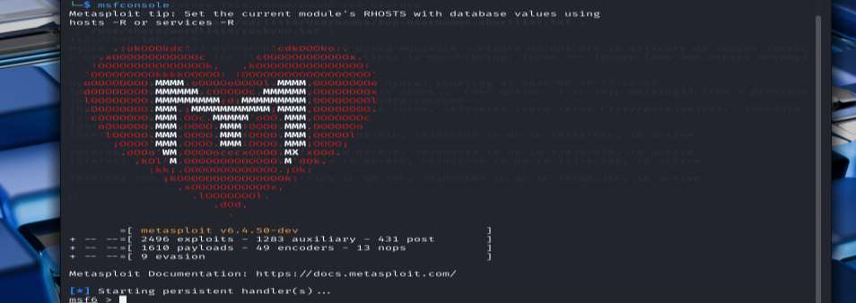
fig 3.1
In fig 1 which shows the list of open ports on the ports were vsftpd 2.3.4 version to gain access. Fig 3.2 shows that the vsftpd backdoor exploit was searched.
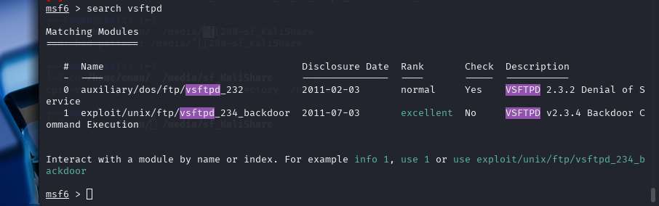
fig 3.2
The fig 3.3 shows that vsftpd_234_backdoor was used by setting the RHOST as targets ip address (192.168.66.9). After the run command the backdoor session was created for the target.
In fig 3.4 the session was created which causes successful access into the target. It shows system enumeration commands.
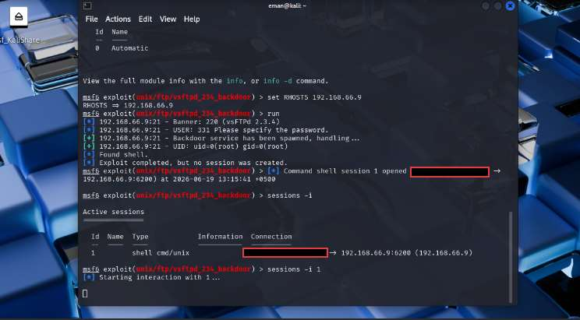
fig 3.3
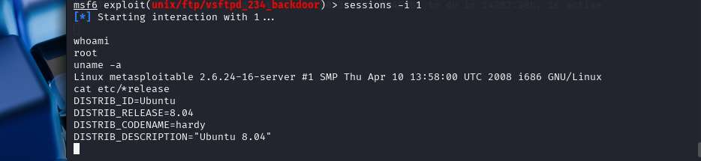
fig 3.4

Task No. 4: A Secure Home Network Diagram
The diagram below shows a secure home network. It includes a modem, hardware, a router and a switch.
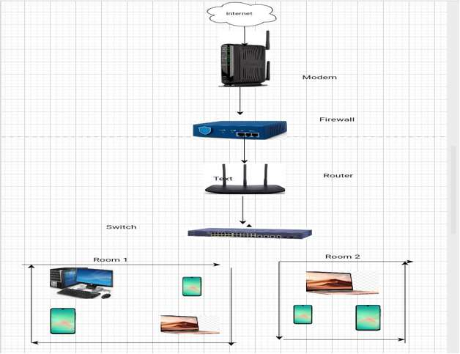

Task No. 5: A Day in Life of a Cybersecurity Analyst
A cybersecurity analyst starts the day by checking the organization's Security Information and Event Management (SIEM) dashboard. The SIEM collects logs from devices such as firewalls, servers, computers, and network equipment, then generates alerts whenever suspicious activity is detected. The analyst reviews these alerts to decide whether they are false positives, which are harmless events, or true positives, which indicate a real security threat. If a true positive is identified, the analyst gathers the necessary evidence, creates an incident ticket, and escalates it to the SOC Level 2 or Incident Response Team for further investigation.
Throughout the day, the analyst continues monitoring the network for suspicious activities such as unusual login attempts, unauthorized access, malware infections, phishing attacks, or abnormal network traffic. They also use threat intelligence sources to check whether suspicious IP addresses, domains, or file hashes are linked to known cyber threats. Continuous monitoring helps detect and respond to security incidents as quickly as possible.
In the afternoon, the analyst focuses on proactive security tasks. These include threat hunting, where they actively search for hidden threats that may have bypassed security systems, and vulnerability scanning to identify outdated software, missing patches, weak passwords, or system misconfigurations. They also perform security audits to evaluate the organization's security and identify areas that need improvement.
Based on the findings, the analyst recommends and implements security improvements such as installing software updates, applying security patches, updating firewall rules, strengthening access controls, and enabling multi-factor authentication. These measures help reduce security risks and improve the organization's overall protection.
Before finishing the day, the analyst documents all investigations, incidents, and actions taken in detailed reports. Proper documentation helps other security teams understand what happened and supports future investigations. Since cyber threats continue to evolve, cybersecurity analysts also spend time learning about new attack techniques, practicing in labs, and improving their skills to stay prepared for future threats.

