Abu Butt March 16, 2017

CSc 30100

Assignment 2

1)

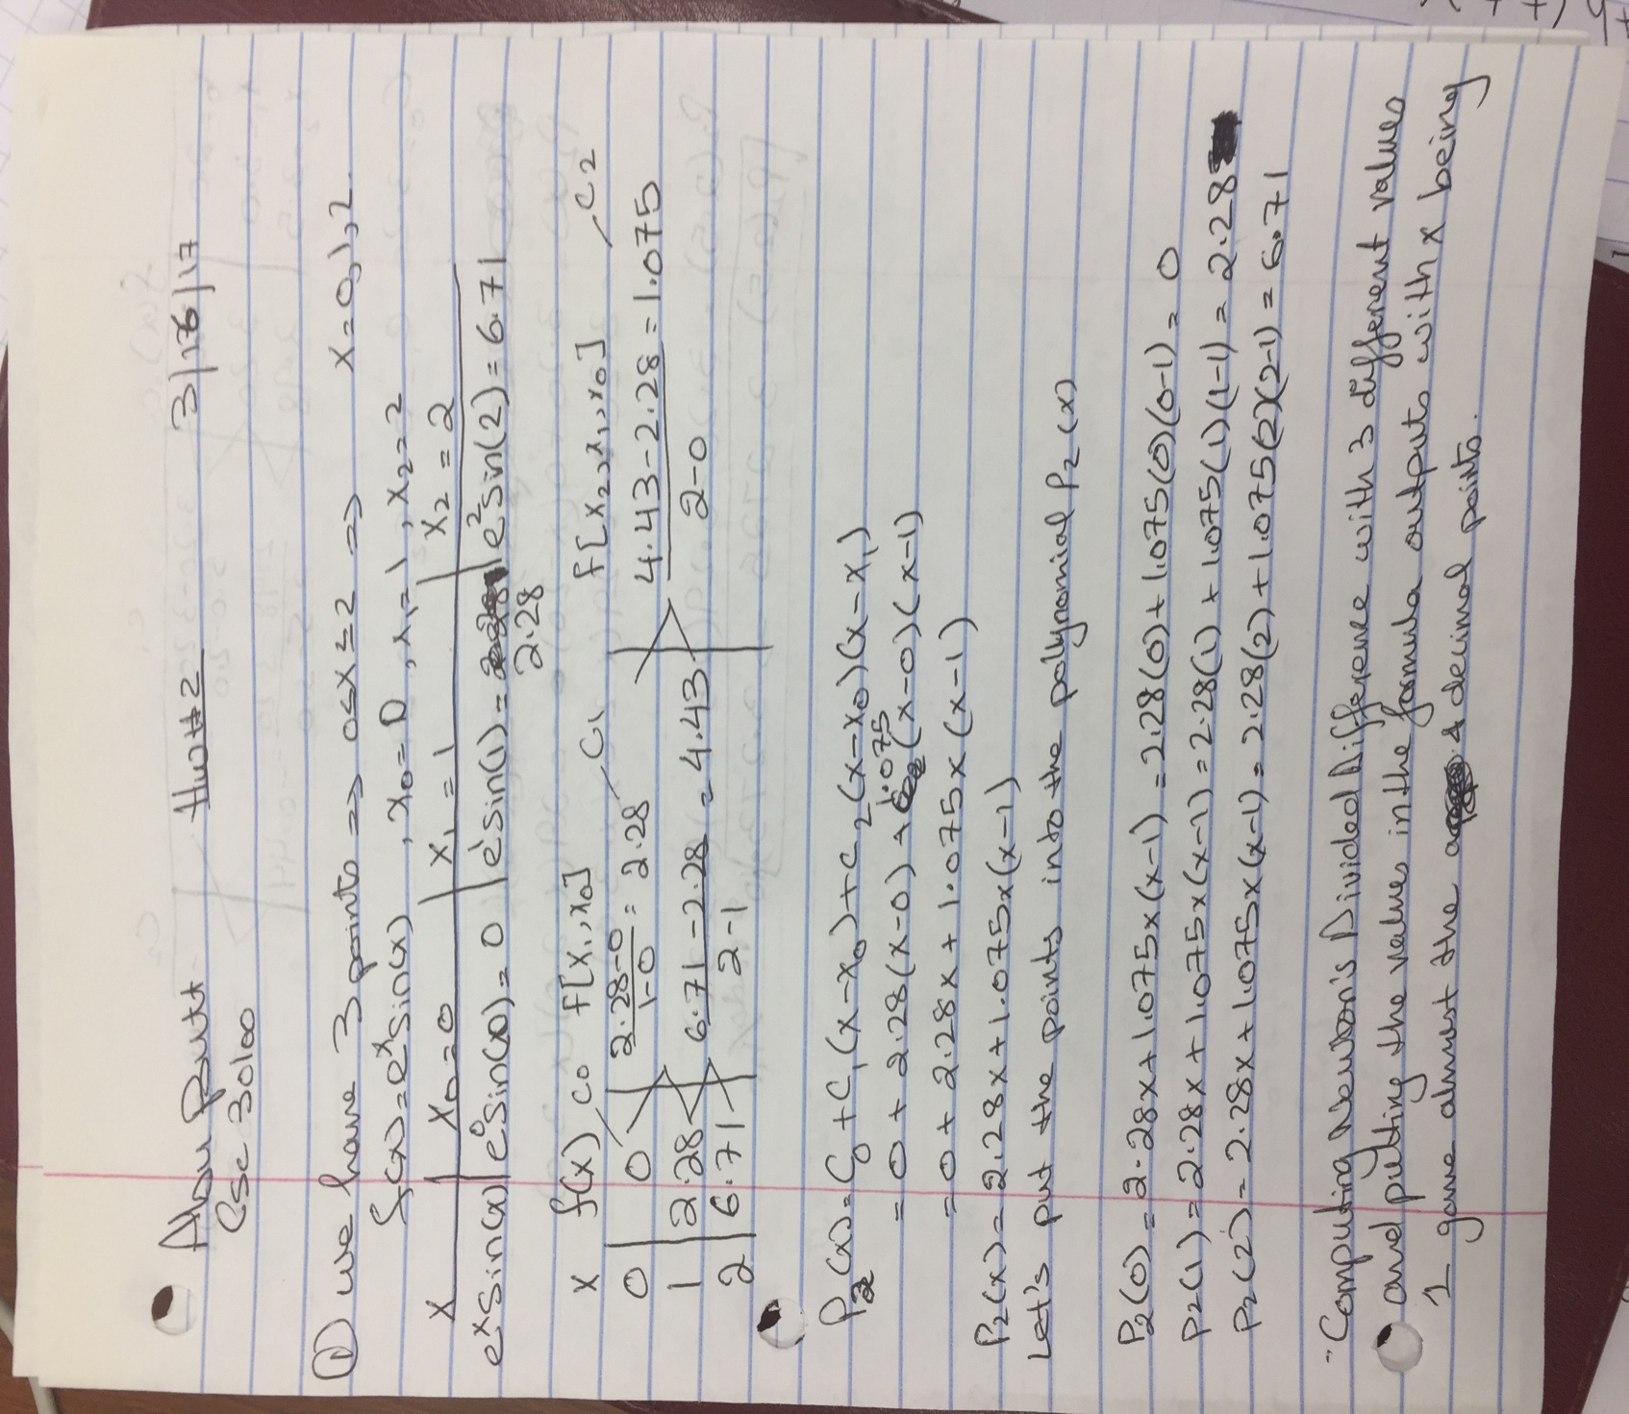

2)

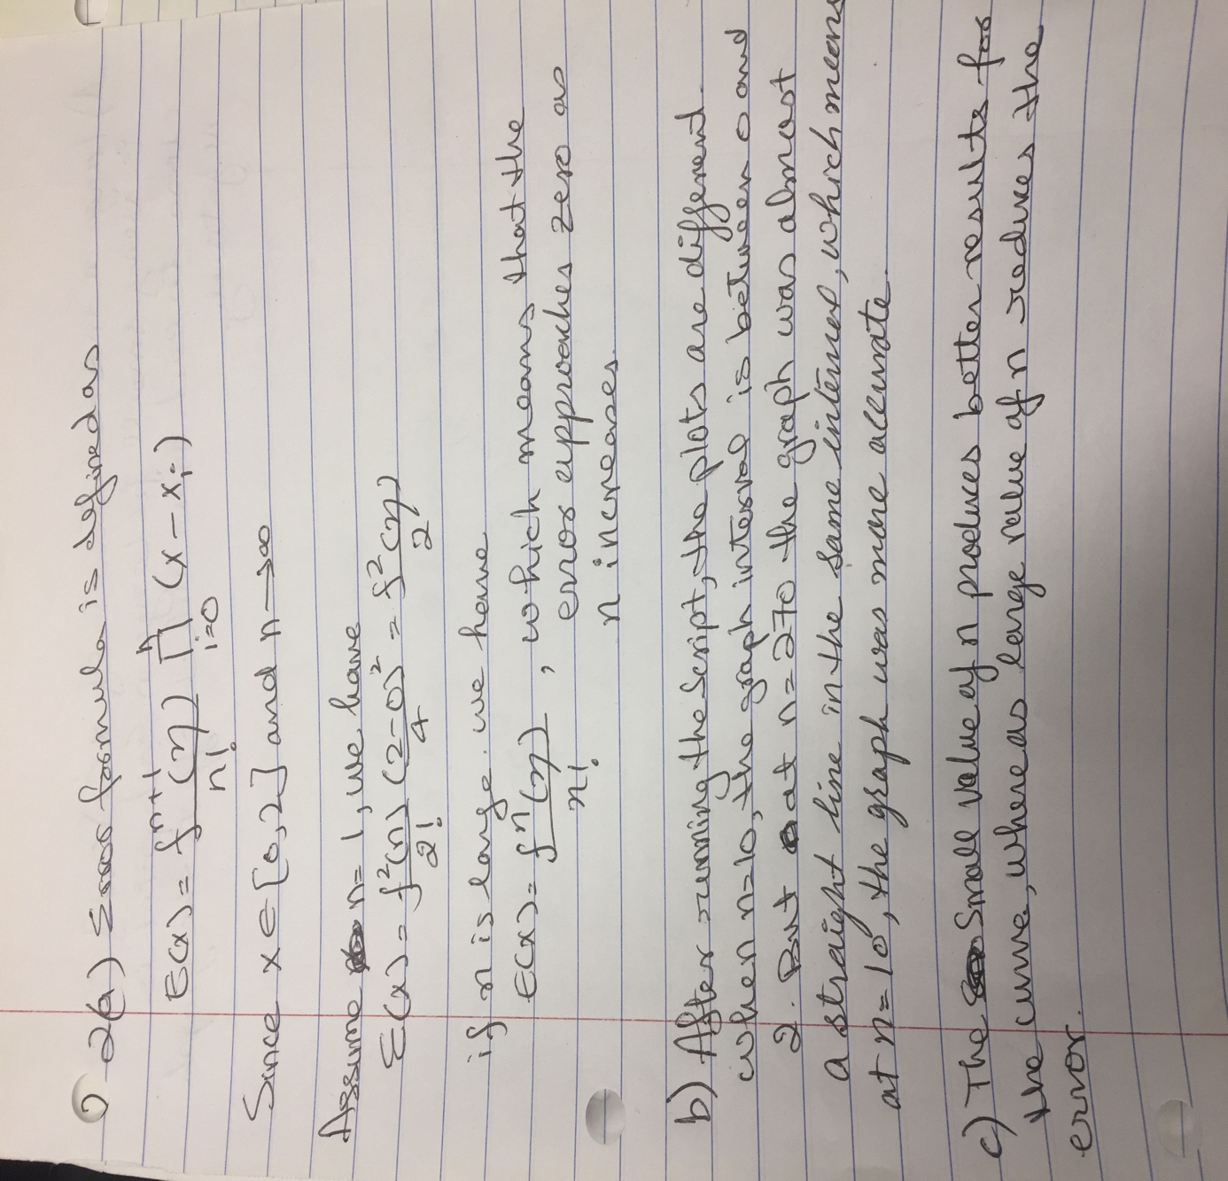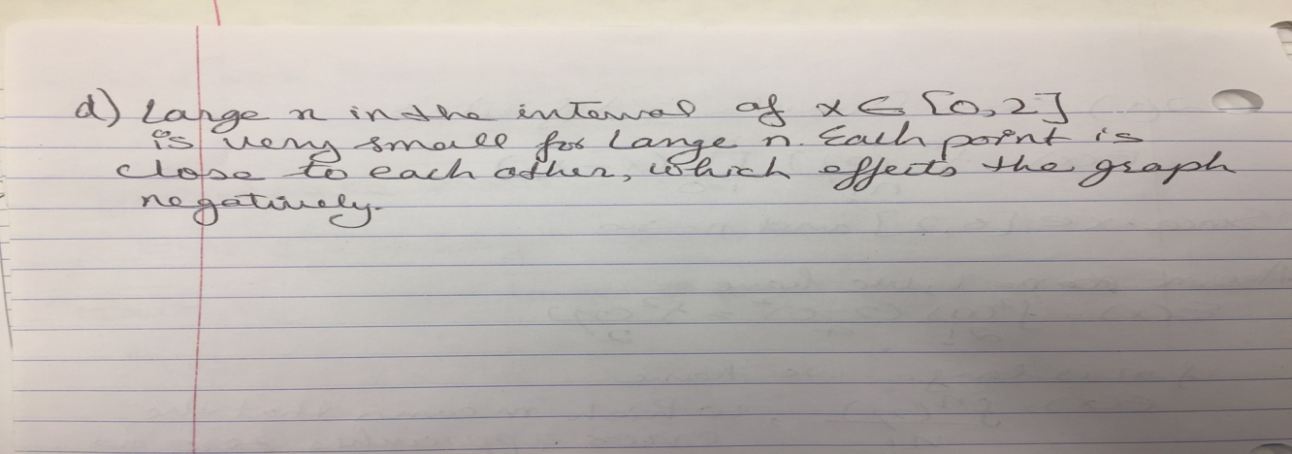

3)

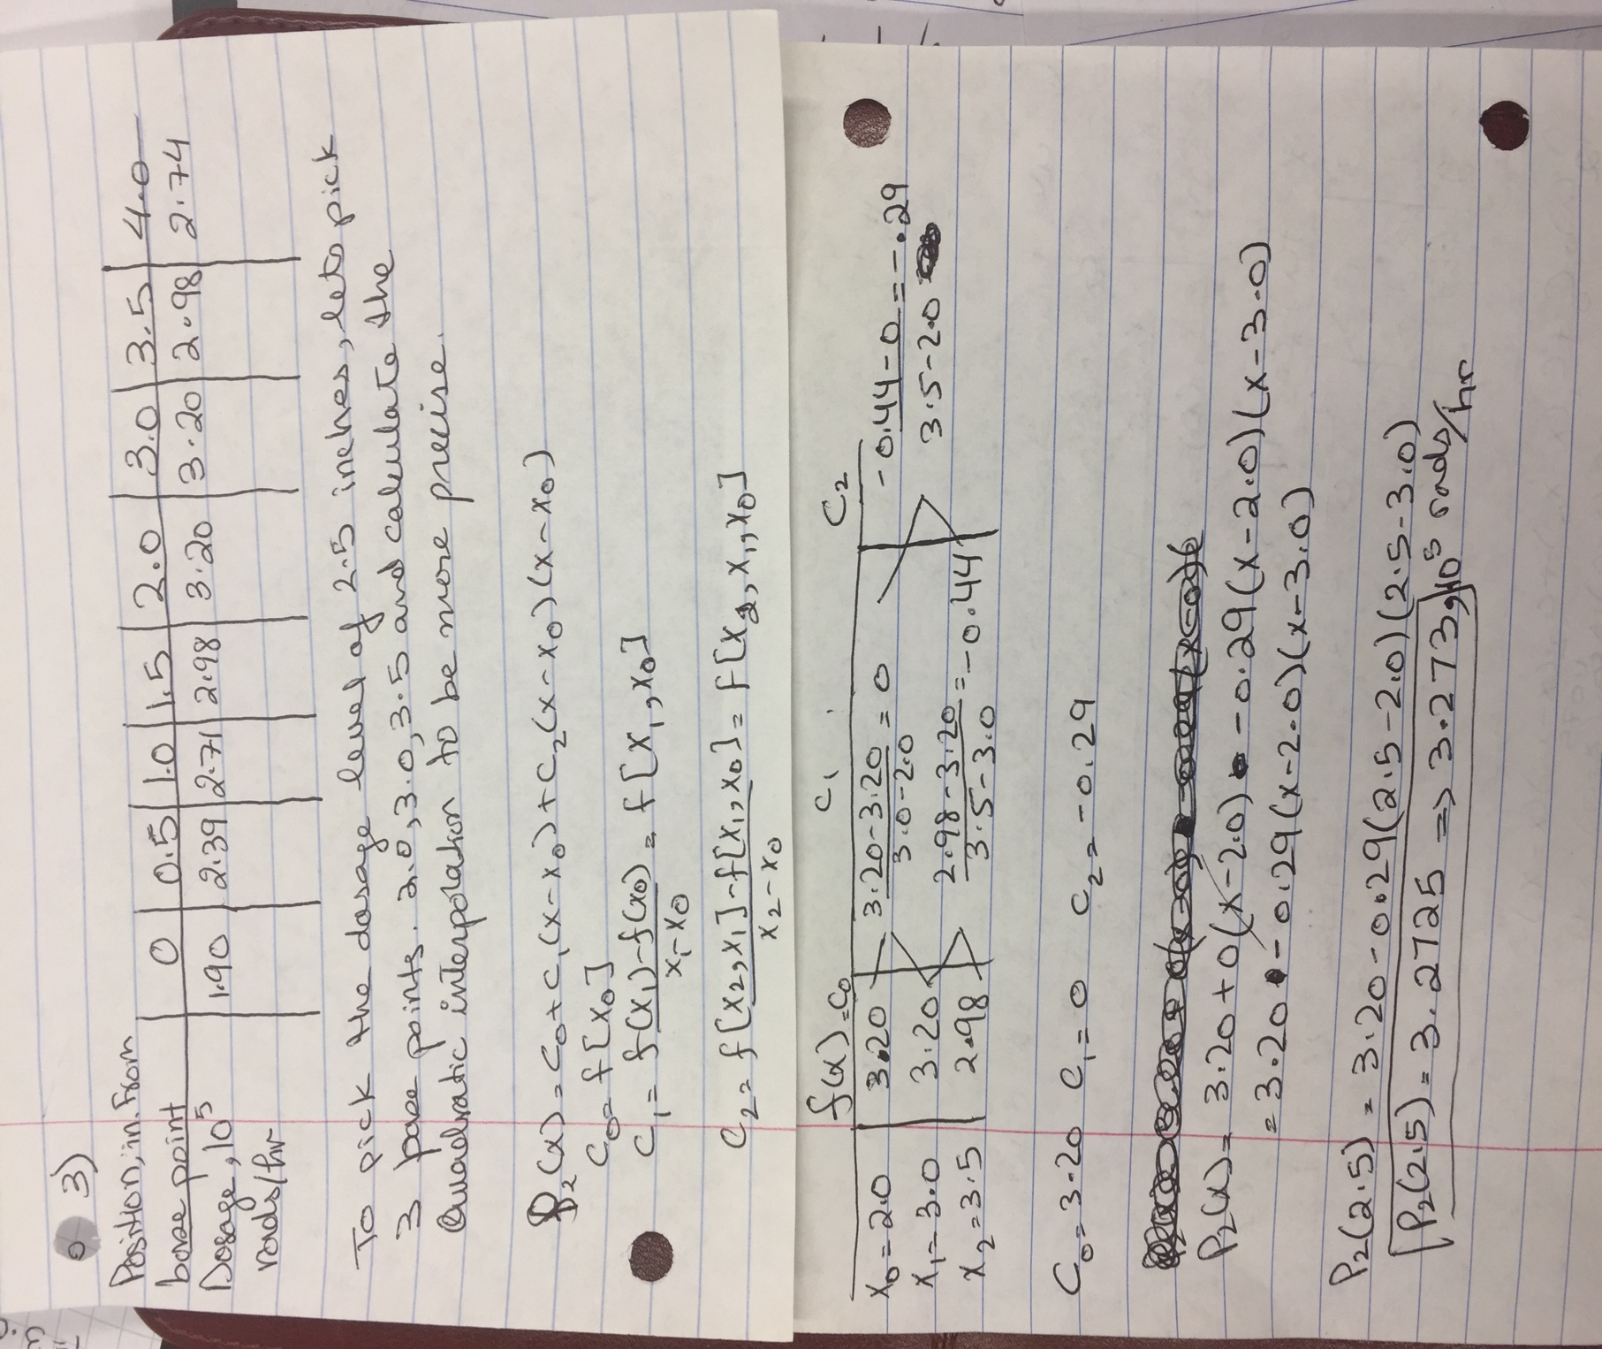

4)

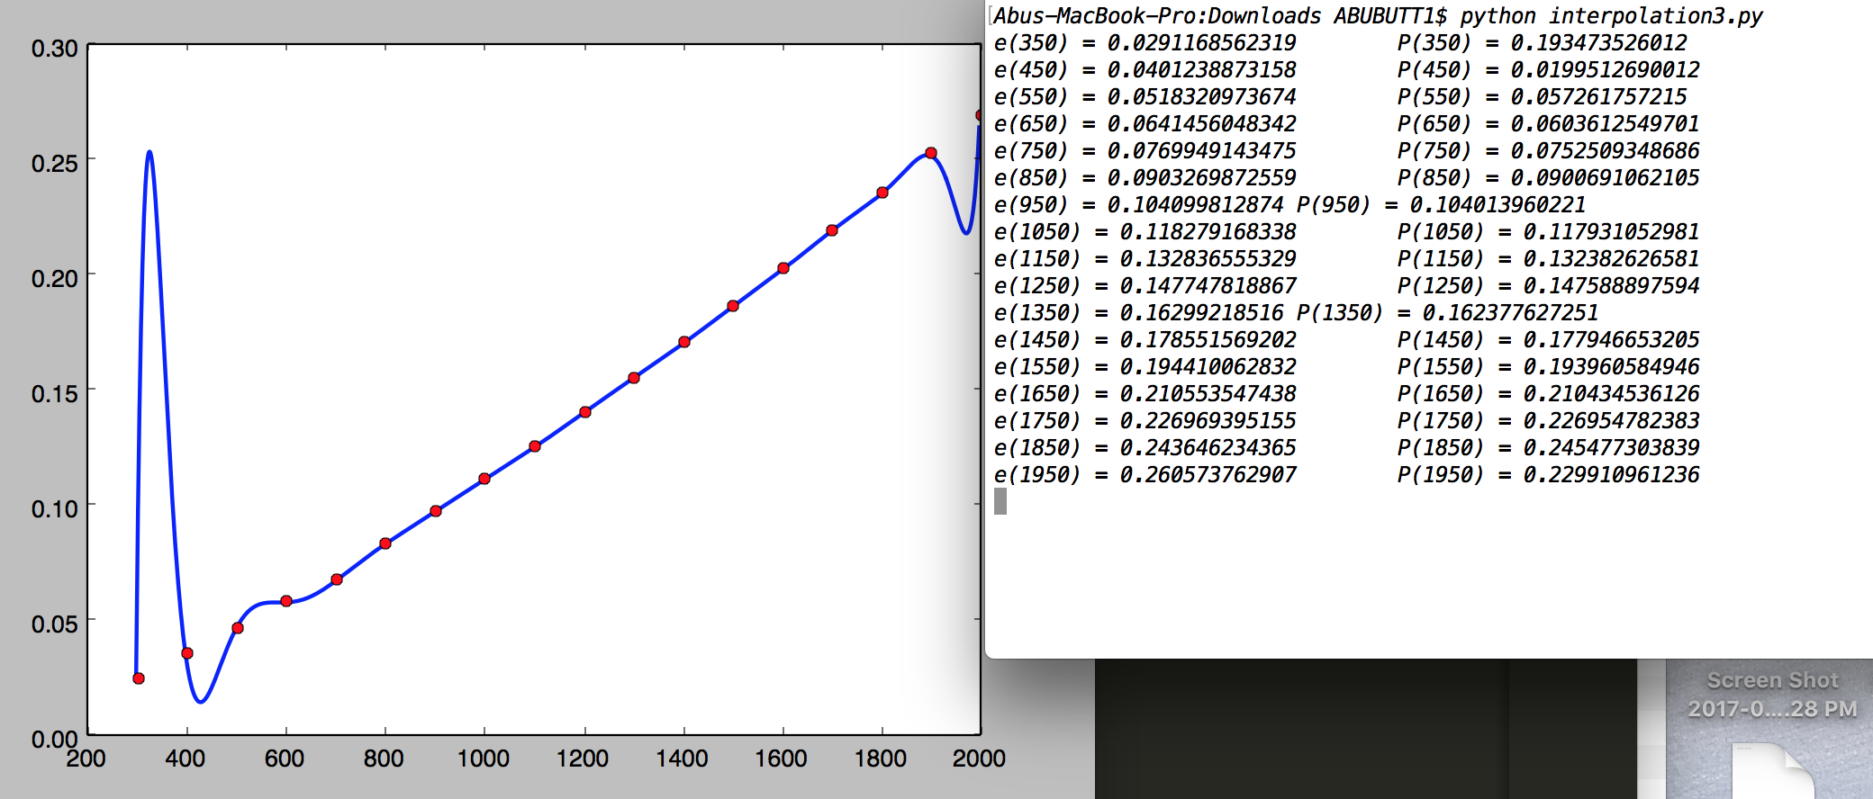

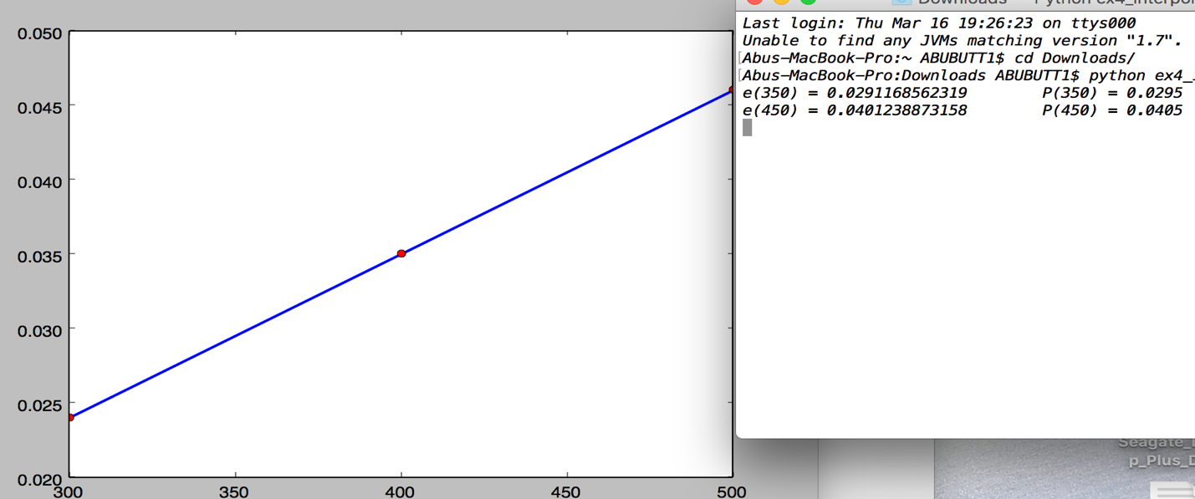

The given equation represent data, which gives a smooth line through points. Polynomial interpolation, the accuracy is more accurate. Due to large numbers of data point, we will be using lagrange interpolation. The output compares both equations, and shows that P(x) is inaccurate at points near the head and tail of the graph. Second figure is the modification of the code with only 3 points, which is a polynomial of the 3rd degree. A high degree of the results gives poor results of the function but better accuracy at each points.