HAJI GUL GROUP OF COMPANIES
 |  |  | Title: OBC/VTS PROCEDURE
 |  |  | Document #: |  | HGGC/OM/SOP-06 | Rev # | 01
 |  |  | Effective Date |  | 01-01-2022
 |  |  | Review Date |  | 01-01-2025
REVISION HISTORY
 | Revision | Date |  | Change
 | 00 | January 01, 2022 |  | Created
 | 01 | January 01, 2023 |  | - Reformatting of the whole document.  - Précised Clause numbers.  - FOB Key utilization added, Clause # 5.5.  - MDVR Spot Check Checklist added for reference.  - Add Records.
 | 02 | January 01, 2024 |  | Reviewed
 | 03 | January 01,2025 |  | Reviewed

HAJI GUL GROUP OF COMPANIES
 | Title: OBC/VTS PROCEDURE
 | Document #: | HGGC/OM/SOP-06 | Rev # | 01
 | Effective Date | 01-01-2022
 | Review Date | 01-01-2025
OBC/VTS Procedure

- PURPOSE:

  - The Purpose of this system is to track all vehicles which are in operation for delivering petroleum product at different locations. The VTS/OBC system shall be used for compliance of company policy on transportation of petroleum product, driver management and tracking trucks to prevent any unethical act by drivers.=

- SCOPE:

  - This procedure shall be applicable to all vehicles carrying dangerous good, which are operating by the name of M/S HAJI GUL GROUP OF COMPANIES.
  - This procedure shall be applicable to drivers who are operating the company fleet for delivering/loading of petroleum product.

- DEFINITIONS AND ABBRIVATIONS USED:

3.1 VTS / OBC = (Vehicle Tracking System / On-Board Computer): device for recording driving parameters and
3.2 behavior and for geolocating vehicles, usually called an “VTS / OBC”
3.3 Continuous Driving Time (CDT) = sum of consecutive driving time non intercut with Break Time,
3.4 Break Time = minimum driver rest time between two driving times,
3.5 Daily Driving Time (DDT) = total time spent driving in one calendar day,
3.6 Daily Working Time (DWT) = driving time, plus working time does not spend driving, in one day,
3.7 Daily Rest Time (DRT) = Time between a driver ceasing professional activity on day D
and restarting on D+1,
3.8 Weekly Driving Time (WDT) = Total driving time over one calendar week (from Monday to Sunday).
3.9 Weekly Rest Time (WRT) = Duration of the longest continuous rest between two periods of
driving, over 7 days rolling.,
3.10 Highway = Highway” means a highway primarily designed for inter-provincial or cross-border connectivity
and placed under the jurisdiction of the National Highway Authority.
  - Motorway = A network of multiple-lane, high-speed, controlled-access highways in Pakistan which are owned, maintained, and operated federally by Pakistan's National Highway Authority.
3.12 Single Carriage Way = is a single road with one or two lanes within a single carriage way with no central
reservation or median strip to separate the opposite flows
  - Track = a track is referred to as a non-asphalted road

Operation manager responsibility
  - Operation Manager shall ensure that vehicle tracking data are being taken on daily basis and are recorded.
  - Operation Manager shall ensure that all vehicles are equipped with VTS and required features are operational.

- PROCEDURE:
  - VTS Rep. shall maintain vehicle tracking record of all Vehicles.
  - VTS Rep. shall check vehicle current location on daily basis.
  - VTS Rep. shall verify the vehicle location with drivers frequently.
  - VTS Rep. shall record non-compliant act by drivers which includes speed violation, harsh braking, night time violation and working hour violation.
  - VTS rep. shall ensure that all drivers are using Driver Identification Keys properly.
  - VTS rep. shall be responsible to report FOB malfunctioning to Tracker Service Providers via on email and taking higher management in loop.
  - VTS Rep. shall also be ensured that the vehicle is not park at blackspot area.
  - VTS Rep. shall be responsible for maintaining trip logs for both operation (Long haul, Local)

  - MDVR MONITORING:
    - VTS Rep. shall ensure that all vehicles are equipped with MDVR and the devices are in working conditions.
    - VTS Rep. shall be responsible to perform Spot checks through MDVR as per Spot Check Plan.
    - VTS team shall monitor MDVR operation/working frequently.
    - VTS team shall record MDVR reports on daily basis.
    - VTS Team shall inform/contact MDVR/Tracking company for any malfunction of MDVR/tracker. The issue should also be communicated to Operation Manager for info.
    - VTS team shall record video clips of such events which can be used for driver counselling and training to reduce incident rate.
    - VTS Team shall provide recorded video after any incident/accident within an hour after the incident.

HAJI GUL GROUP OF COMPANIES
 | Title: OBC/VTS PROCEDURE
 | Document #: | HGGC/OM/SOP-06 | Rev # | 01
 | Effective Date | 01-01-2022
 | Review Date | 01-01-2025
  - Geo-Fencing:
    - Black spot can be identified by the following means:
      - While performing RHM
      - NMPI reporting.
      - At the time of journey closing
      - Journey communication
      - Accident/incident spots
    - VTS rep. shall collect latitude and longitude of the identified black spot
    - VTS rep. shall send the identified latitude and longitude to the tracker service provider and ask them to geo-fence 100 meters of the spot.
    - Tracker company shall notify the VTS department if any vehicle stops at the black spot for more than 5 minutes.
    - VTS rep. shall contact the driver and ask the reason for stoppage.
    - VTS rep. shall inform the reply of driver to Manager Operations
    - Operation Manager shall also talk to driver, if driver fails to satisfy the reason for stoppage, Operation Manager shall ask the VTS rep. to record the followings for further investigation:
      - Date
      - Time
      - Longitudes and Latitude
      - Location common name
      - Vehicle reg. #
      - Driver name
      - Reason for stoppage

    - Driver shall be interrogated once the journey is completed. Action will be taken as per the consequence management policy.

Consequences in Case of Violations

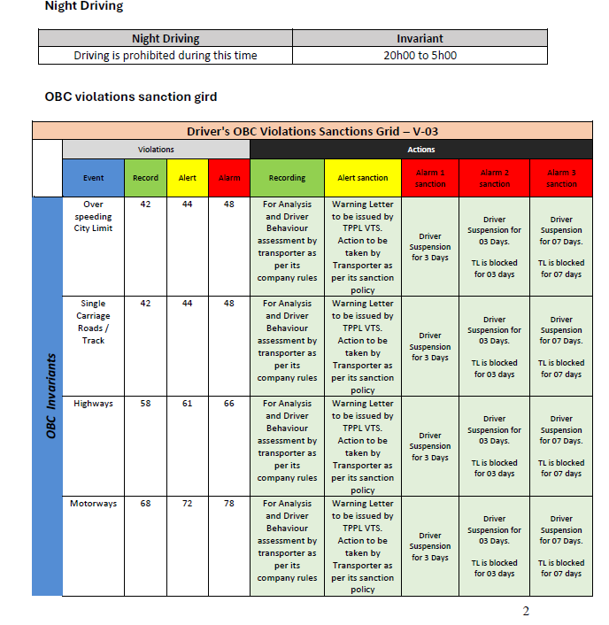

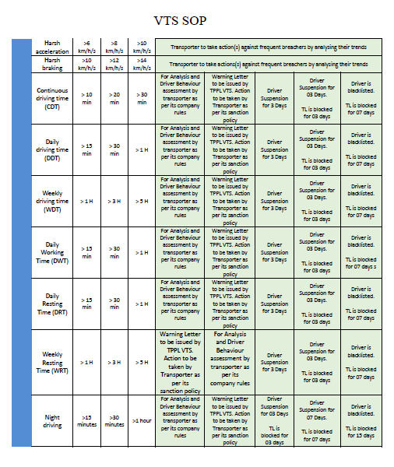

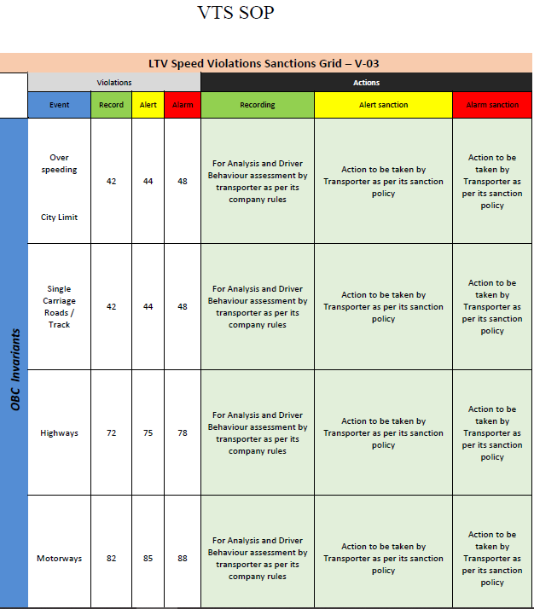

VTS SOP

Driver's Mis-behaviors & Malpractice and Safety Rules Violation Policy

Driver's Misbehaviours & Malpractice and Safety Rules Violation Policy (Version 02)
 | Misbehavior | Event | Sanctions (First Time) | Sanctions (Second Time) | Sanctions (Third Time)
Driver Behaviour |  |  | Driver Suspension for | Driver Suspension for 07 | Driver is
 |  |  | 7 Days | Days | blacklisted.
 | Mobile phone while driving | Alarm
 |  |  |  | TL is blocked for 07 days | TL is blocked for
 |  |  |  |  | 15 days.
 |  |  | Driver Suspension for | Driver Suspension for 03 | Driver is
 |  |  | 3 Days | Days | blacklisted.
 | Safety belt not used while driving | Alarm |  | TL is blocked for 03 days | TL is blocked for
 |  |  |  |  | 07 days.
 | Smoking while driving | Alarm | Driver is blacklisted.
 |  |  | TL is blocked for 07 days.
 | Driving dangerously on the road | Alarm | To be taken by transporter after investigating as per Transporter Policy (Supporting Document to be provided to TPPL)
 | Malpractice with OBC and Driving | Alarm | Driver is backlisted.
 |  |  | TL is blocked for 15 days.
 | Fiddling with MDVR (Driver’s malfunction or damage to equipment (broke seal of equipment box, Camera angle etc.) | Alarm | 5000/- per tank truck + Warning Letter to driver by transporter | 10000/- per Tank Truck (For same tank truck of 1st violation) + 2nd Warning Letter to driver by Transporter | Driver Blacklisted
 | Transporters Driver/Truck is involved in Product Theft at a black spot / Illegal Warehouse | Alarm | Permanent Black listing of both Drivers in SAP / STL Blocking of Truck for One month in SAP. A penalty of 500,000 to the Transporter.  Warning letter to the Transporter. | Permanent Black listing of both Drivers in SAP  / STL  Permanent Blacklisting of truck in TPPL.  A penalty of 1,000,000 Pkrs to the Transporter Action plan to be submitted to TPPL by Transporter
 | Alteration in Tank Lorry for product Theft  (Dip Pipe, Pressure system or any other modification) | Alarm | Drivers are blacklisted.  A penalty of 500,000 to the Transporter.  Warning letter to the Transporter.
 | Tank Lorry driving by non-listed driver |  | Blacklisting of Driver at all TPPL locations Warning letter to the Transporter Submission of action plan to improve Driver Management | Blacklisting of Driver at all TPPL locations  Warning letter to the Transporter  Imposition of Penalty of 250,000 Pkr | Blacklisting of Driver at all TPPL locations Warning letter to the Transporter Imposition of Penalty of 500,000 Pkr
 | Unauthorized passenger | Alarm | 3 days Suspension | 1 week Suspension | 1 month Suspension
 | Suspicious Parking  Parking of truck more than 10 minutes through a point of particular interest such  as “illegal warehouse/black spot”, “area known as a product draw-off /mixing location”, etc.). | Alarm | Driver Suspension for 7 Days | Driver Blacklisted  TL is blocked for 07 days
 | Accident due to Malpractice of Driver (OBC /MDVR Malpractice or any other) | Alarm | Permanent Black listing of both Drivers in SAP / STL Permanent Blacklisting of truck in TPPL.  A penalty of 1,000,000 PKr to the Transporter Action plan to be submitted to TPPL by Transporter
 | Negative feedback from Loading Terminals (Loading safety Rules) | Alarm | Driver Suspension for 3 Days | Driver Suspension for 7 Days | Driver Suspension for  15 Days
 | Violation in Spot Checks at Retail Outlets or on the Road | Event | Warning by the transporter (confirmed by email from the transporter) | Driver Suspension for 15 Days | Driver Suspension for 30 Days

Prepared by:
Designation | Department | Date | Signature
Manager (Operations) | Operations | Jan 01st, 2022

Reviewed by:
Designation | Department | Date | Signature
Manager (HSEQ) | HSEQ | Jan 01st, 2025

Approved by:
Designation | Department | Date | Signature
CEO | All | Jan 01st, 2025

HAJI GUL GROUP OF COMPANIES
 | Title: OBC/VTS PROCEDURE
 | Document #: | HGGC/OM/SOP-06 | Rev # | 01
 | Effective Date | 01-01-2022
 | Review Date | 01-01-2025
- RECORDS:

Sr. # Document Name Document # Retention Period
  - Daily Vehicle Monitoring System Generated 1 Year
  - Driver Driving, Duty & Rest Hours HGGC/OM/CHK01 1 Year
  - MDVR Spot Check Checklist HGGC/VM/CHK06 1 Year
  - Consequence Management HGGC/DM/FM001 1 Year
  - Violation Dashboard Dashboard 1 Year

