Project Plan

Product HTML5 Standard Website

Muhammad Butt & Phil Stickna

Table of Contents
1. Introduction 3
1.1 Foreword 3
1.2 Background 3
2. Project Organization 3
2.1 Development Model 3
2.2 Project Team 4
3. Risk Analysis 5
4. Hardware and Software Requirements 5
5. Schedule and Breakdown Structure 6
6. Market and Design Research 7

1. Introduction

1.1 Foreword

The purpose of this document is to provide information about the HTML5 standard website project. It will include the project schedules, risks, project team, and the work break down structure. This plan will:
- Provide a general product description.
- Identify required resources.
- Identify schedules and activities to be performed.

1.2 Background
Our group was assigned to make an informational website using the skills we had learned in class. Our

2. Project Organization

2.1 Development Model

Our group is going to base our work on sites such as html5rocks.com and w3schools.com which are both two great examples of how to make a informational website.

2.2 Project Team
The table below lists the members of the HTML5 standard website project team. The project Team consists of 2

Project Team
Muhammad Butt
Phil Stickna

3. Risk Analysis

3.1 Risk Analysis
Risk | Affects | Descriptions
Quality of Information | Confusion | We need to make the information as simple as possible so newcomers to HTML5 don’t get scared of all the information
Creating Video or Music player with HTML5
Graphics abilities of HTML5 through animation

3.2 Risk Analysis (i)
Risk | Probability | Effects
Quality of Information | Low
Creating Video or Music player with HTML5 | Medium
Graphics abilities of HTML5 through animation | High

3.2 Risk Analysis Strategy
Risk | Solution / Mitigation
Quality of Information | Base it on a the Dummies handbook guides
Creating Video or Music player with HTML5 | Using videos from YouTube or creating our own
Graphics abilities of HTML5 through animation | Learning how to code in html5 animations.

4. Hardware and Software Requirements
This project has minimal hardware and software requirements, on the hardware side there are no requirements as this is an online site, and everything will be hosted online using a hosting site. On the Software side there are going to requirements for different parts of the project, for example the planning and designing stage we would need to have Adobe Illustrator and Photoshop, and during the implementation and coding stages we would have to make sure the website works on different types of browsers and supports html5, flash etc.

5. Schedule and Work Breakdown Structure
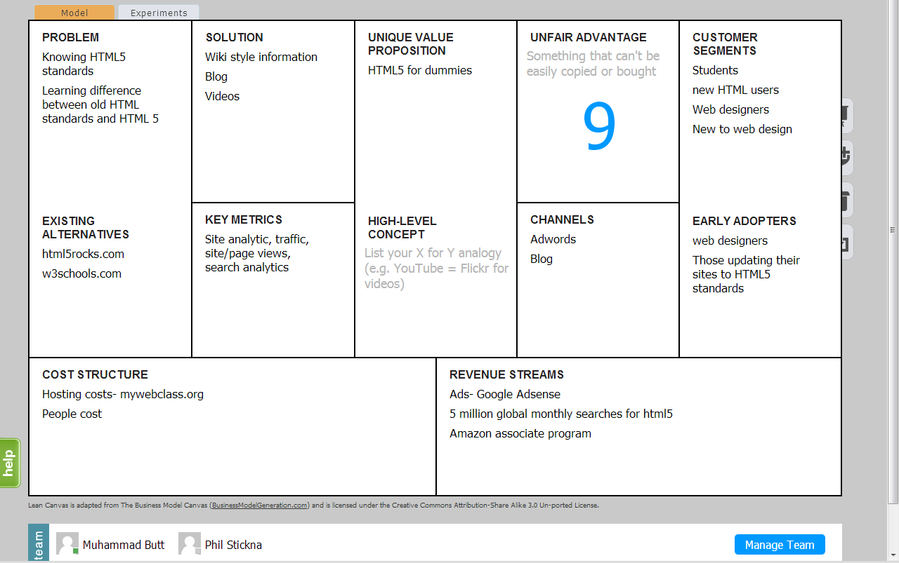

6. Market and Design Research
Market Research:
Google Adwords:
HTML5- 5 million global searches monthly and 1 million local searches monthly
HTML5 Standards- 4400 global searches monthly and 1000 local searches monthly

Both have low competition; therefore there is a lot of space for new entries.

Design Research:
We are going to use a Flat design for our website, as it allows the website to minimalistic and easier to look and surf through. As our site will be an information website, we need to make sure that the high amounts of text on it doesn’t intimidate a new user, therefore by using a flat design we can ease this issue.

