#Author @Bridge1998

**Import packages**

import numpy as np

import pandas as pd

import matplotlib.pyplot as plt

%matplotlib inline

from sklearn import datasets,model_selection,linear_model,metrics,decomposition

df = pd.read_csv("UF_R3_ANALYSIS_LASTMAJOR2007.csv")

df.isnull().sum()

df.dropna(axis=0, how='any',inplace=True)

df['STUDENT_SUCCESSNO'].value_counts()

**One Hot Encoding**

df_JUNIOR_SENIOR_FLAGNO=df['JUNIOR_SENIOR_FLAGNO'].apply(str).str.get_dummies().add_prefix('JUNIOR_SENIOR_FLAGNO: ')

df_ENRL_CNT = df['ENRL_CNT'].apply(str).str.get_dummies().add_prefix('ENRL_CNT: ')

df_MAJORCOUNT=df['MAJORCOUNT'].apply(str).str.get_dummies().add_prefix('MAJORCOUNT: ')

df_UF_CLASSNO=df['UF_CLASSNO'].apply(str).str.get_dummies().add_prefix('UF_CLASSNO: ')

df_RESIDENCYNO=df['RESIDENCYNO'].apply(str).str.get_dummies().add_prefix('RESIDENCYNO: ')

df_TERM_END_DT_SID_CATGRYNO=df['TERM_END_DT_SID_CATGRYNO'].apply(str).str.get_dummies().add_prefix('TERM_END_DT_SID_CATGRYNO: ')

df_TERM_BEG_DT_CATGRYNO=df['TERM_BEG_DT_CATGRYNO'].apply(str).str.get_dummies().add_prefix('TERM_BEG_DT_CATGRYNO: ')

df_LOW_TERM_GPA_IND=df['LOW_TERM_GPA_IND'].apply(str).str.get_dummies().add_prefix('LOW_TERM_GPA_IND: ')

df_PARTTIME_TERM_IND=df['PARTTIME_TERM_IND'].apply(str).str.get_dummies().add_prefix('PARTTIME_TERM_IND: ')

df_NOT_REG_TERM_IND=df['NOT_REG_TERM_IND'].apply(str).str.get_dummies().add_prefix('NOT_REG_TERM_IND: ')

df_WITHDRWL_TERM_IND=df['WITHDRWL_TERM_IND'].apply(str).str.get_dummies().add_prefix('WITHDRWL_TERM_IND: ')

df_FULLTIME_TERM_IND=df['FULLTIME_TERM_IND'].apply(str).str.get_dummies().add_prefix('FULLTIME_TERM_IND: ')

df_OVR_12HR_TERM_IND=df['OVR_12HR_TERM_IND'].apply(str).str.get_dummies().add_prefix('OVR_12HR_TERM_IND: ')

df=pd.concat([df,df_JUNIOR_SENIOR_FLAGNO,df_ENRL_CNT,df_MAJORCOUNT,df_UF_CLASSNO,df_RESIDENCYNO,df_TERM_END_DT_SID_CATGRYNO,df_TERM_BEG_DT_CATGRYNO,df_LOW_TERM_GPA_IND,df_PARTTIME_TERM_IND,df_NOT_REG_TERM_IND,df_WITHDRWL_TERM_IND,df_FULLTIME_TERM_IND,df_OVR_12HR_TERM_IND],axis=1)

df = df.drop([

'JUNIOR_SENIOR_FLAGNO',

'ENRL_CNT',

'MAJORCOUNT',

'UF_CLASSNO',

'RESIDENCYNO',

'TERM_END_DT_SID_CATGRYNO',

'TERM_BEG_DT_CATGRYNO',

'LOW_TERM_GPA_IND',

'PARTTIME_TERM_IND',

'NOT_REG_TERM_IND',

'WITHDRWL_TERM_IND',

'FULLTIME_TERM_IND',

'OVR_12HR_TERM_IND'

],axis=1)

**Create test dataset and train dataset**

df2 = pd .read_csv("UF_R3_ANALYSIS_LASTMAJOR0714BE.csv")

df2.to_csv("train.csv", index=False)

df3 = df1[(df1['TERM_BEG_DT_SID'] >=20150101) & (df1['TERM_BEG_DT_SID'] <= 20191231)]

df3.to_csv("test.csv", index=False)

train = pd.read_csv("train.csv")

test = pd.read_csv("test.csv")

mid = train['STUDENT_SUCCESSNO']

train.drop(labels=['STUDENT_SUCCESSNO'], axis=1,inplace = True)

train.insert(0, 'STUDENT_SUCCESSNO', mid)

train_x = train.values[0:, 1:]

train_y = train.values[0:, 0]

result_x = test.values[0:, 0:]

**Split the train dataset**

from sklearn.model_selection import train_test_split

x_train, x_test, y_train, y_test = train_test_split(train_x, train_y,test_size=0.1,random_state=33)

**Fit the model**

from numpy import ravel

from sklearn.neighbors import KNeighborsClassifier as kNN

model = kNN(n_neighbors = 3, algorithm='auto', weights='distance')

model.fit(x_train,ravel(y_train))

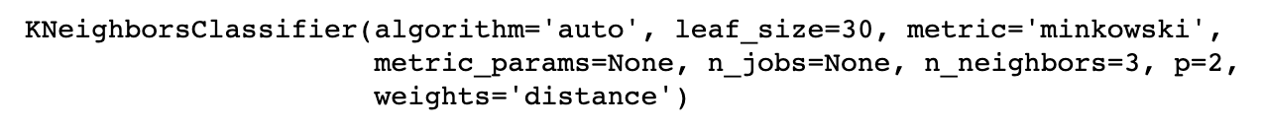

**Model result**

y_predict = model.predict(x_test)

print("score on the testdata:",model.score(x_test,y_test))

print(classification_report(y_test,y_predict))

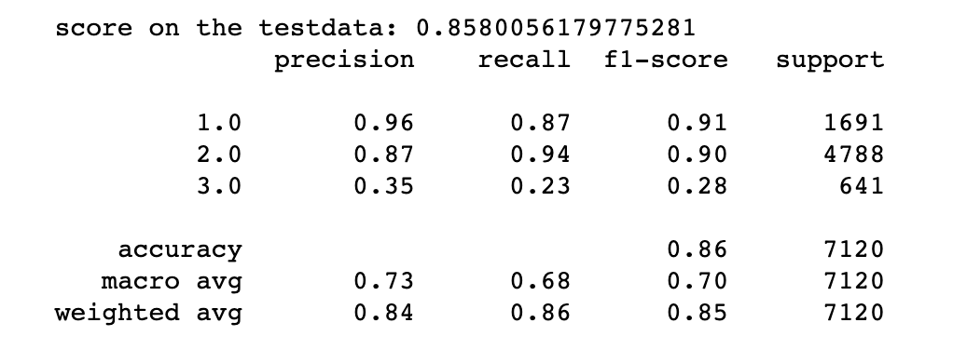

**List probability of predicting successfully, predicting results, and actual results. Create a csv file**

probablity = model.predict_proba(x_test)

list_pro = []

for i in range(probablity.shape[0]):

pro = max(list(probablity[i]))

list_pro.append(pro)

index = np.array(id).reshape((-1,1))[:,0:1]

result = pd.DataFrame(np.column_stack((np.array(y_test).reshape(-1,1),np.array(y_predict).reshape(-1,1),np.array(list_pro).reshape(-1,1))),

columns=['test_label','predict_lable','probablity'])

result.to_csv('knn_result.csv',index=False,header=True,encoding='gbk')

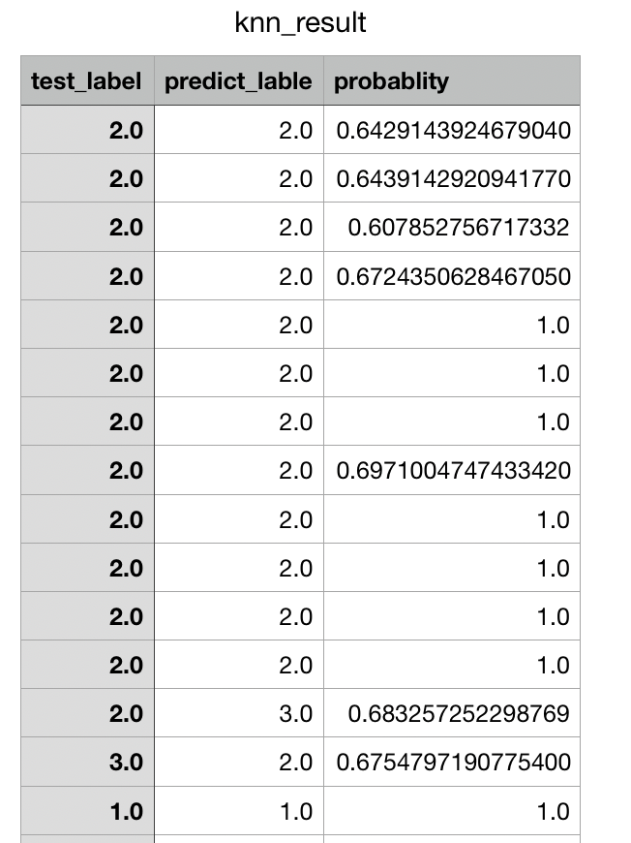

**Find all the incorrect results and create a csv file**

diff_index = []

for i in range(result.shape[0]):

diff_index.append(result['test_label'][i] != result['predict_lable'][i])

print(diff_index)

diff = result[diff_index]

diff_x = x_test[diff_index]

diff.to_csv('knn_result_diff.csv',index=False,header=True,encoding='gbk')

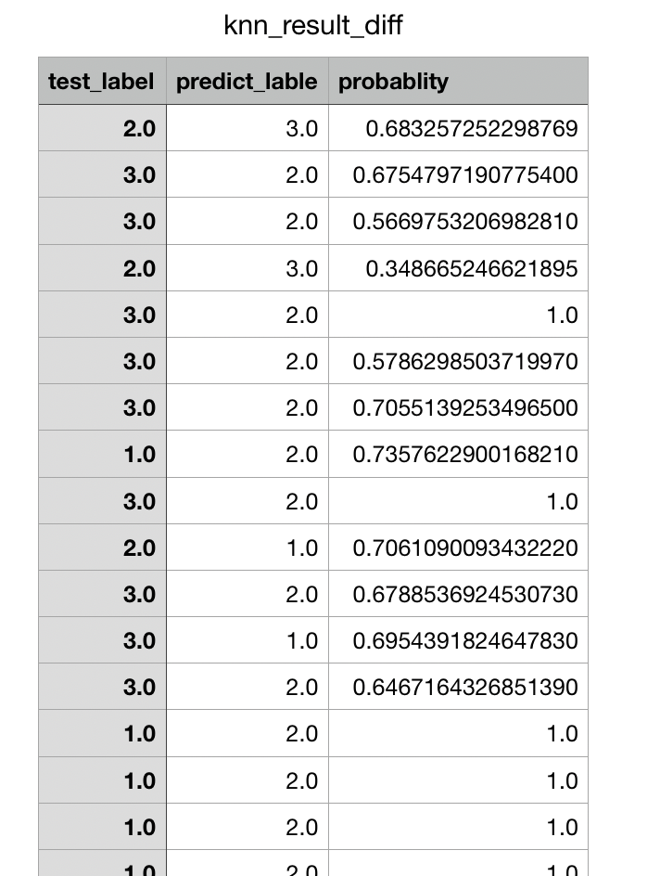

**Predict results of testing dataset and create a csv file**

mid = test['STUDENT_SUCCESSNO']

test.drop(labels=['STUDENT_SUCCESSNO'], axis=1,inplace = True)

test.insert(0, 'STUDENT_SUCCESSNO', mid)

x_test = test.values[0:, 1:]

y_test = test.values[0:, 0]

y_predict = model.predict(x_test)

index = np.array(id).reshape((-1,1))[:,0:1]

result = pd.DataFrame(np.column_stack(np.array(y_predict).reshape(-1,1),)),

columns=['predict_lable'])

result.to_csv('predict_result.csv',index=False,header=True,encoding='gbk')

