Market Survey

1.1 Background
As the population surges, food security may be the most vital problem in the world. According to United Nations [1], customers tend to waste about 17% of all food they can gain and about 2 billion people suffer from Micronutrient deficiencies. Meanwhile, some FAO officials also appeal that technological innovations may be effective pathways to relief or even solve this problem [1].

In recent years, there has been a growing need for effective systems to quantify and analyze food waste in canteens and restaurants, leveraging advanced computer science techniques such as computer vision, artificial intelligence, and database management. Multiple software solutions, including SafetyCulture Food Waste Management Software and Winnow, have been developed to address this issue. These systems typically provide functionalities such as identifying food waste categories and quantities through image analysis, maintaining historical records, and generating periodic reports (e.g., weekly or monthly) with recommendations aimed at reducing waste.

While these solutions are effective, their focus tends to be primarily on optimizing the commercial operations of restaurants, providing statistics solely to food sellers. However, our proposed system expands upon this approach by establishing a direct link between food waste and individual users through face recognition technology. This enables us to provide personalized waste statistics for each user, alongside aggregated data for canteen or restaurant operators. Thus, we aim to implement features that include facial recognition [2], food category and quantity recognition [3] [4], and

Some existing systems are discussed in the following section.

.1.2 Similar System

1.2.1 SafetyCulture Food Waste Management Software
SafetyCulture Food Waste Management Software provides a comprehensive solution to improve and streamline the food waste management process. It allows workers to conduct inspections using checklists, ensuring thoroughness in monitoring waste management facilities. Additionally, smart sensors can be integrated into the system to monitor factors like air quality in the kitchen and automatically notify food sellers when waste disposal is necessary.

Key features of SafetyCulture’s platform include:

- Standardized Processes: The software offers audit forms, inspection guides, waste logs, and hazard control checklists, accessible from any device to ensure consistent and efficient management practices.
- Real-Time Reporting: During inspections, workers can report food waste issues instantly and assign corrective actions, allowing teams to address problems promptly.
- System Integration: It can be integrated with other management platforms (e.g. IoT sensors), providing a unified workflow for greater efficiency.
- Asset Monitoring: Equipment and assets related to food waste management can be tracked using QR codes, allowing easy access to critical information whenever needed.

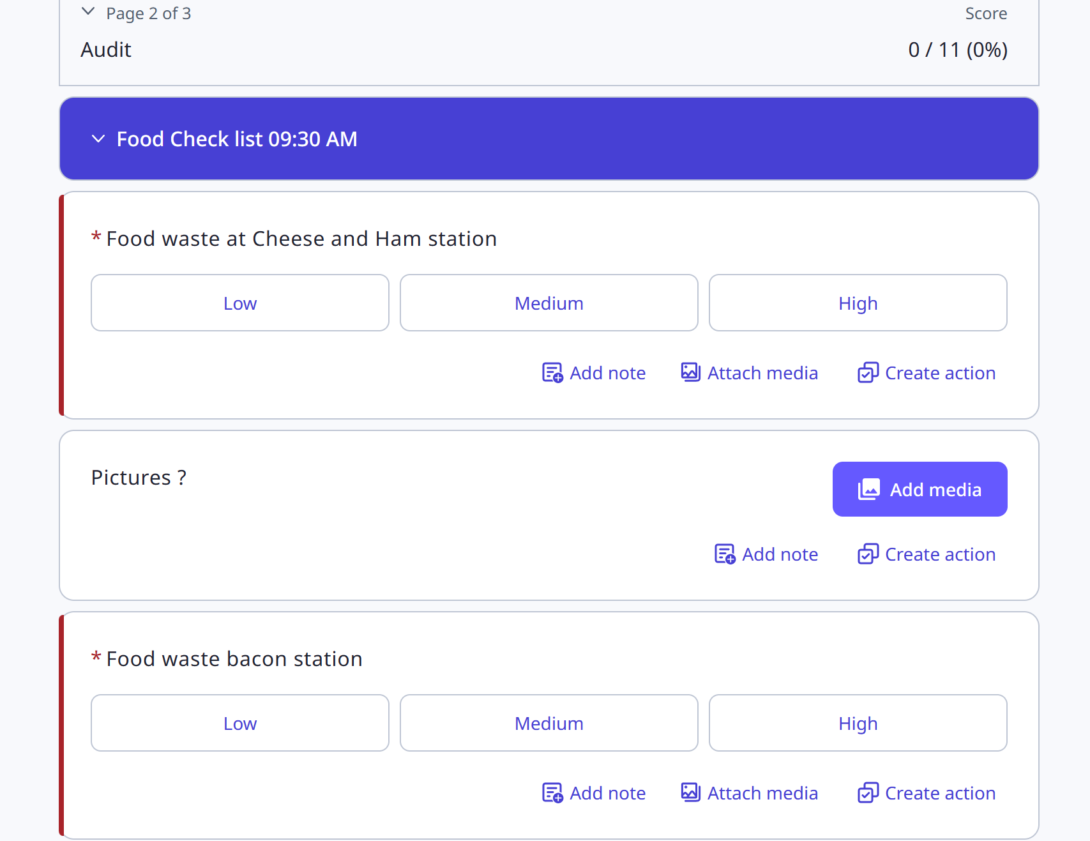
Fig.1: a food waste checklist created in SafetyCulture

The SafetyCulture food waste management software simply provides a platform for recording food waste statistics and generates reports about past food wastage. However, it is less intelligent in detecting food waste categories and quantity, despite allowing implementing multiple sensors to automatically record environmental factors, most processes are conducted by staff by creating and filling checklists, while our system tries to detect food waste automatically with the help of computer vision techniques, but its functions about generating real-time reports with database bata and easy access to hardware monitoring still worth learning.

1.2.2 Winnow
This platform utilizes advanced technology including VisionAI+ and VisionPW+ to track and analyze food waste, providing actionable insights to help kitchens minimize waste and optimize their operations.

The key features of this system are:

- Waste Tracking: Kitchen staff can easily input data about the types and amounts of food being discarded by taking pictures of food waste, allowing for precise tracking and analysis.
- Data Analytics: It analyzes the collected data and provides statistics like which foods are being wasted most frequently. Which can be used to make decisions about menu changes, portion sizes, and purchasing practices.
- User-Friendly Interface: The system features an intuitive interface that allows kitchen staff to quickly log waste and access reports.
- Reporting: Winnow generates detailed reports that summarize waste data, enabling managers to track progress over time and measure the effectiveness of waste reduction initiatives.
- Integration with Other Systems: The platform also can integrate with existing kitchen management systems.

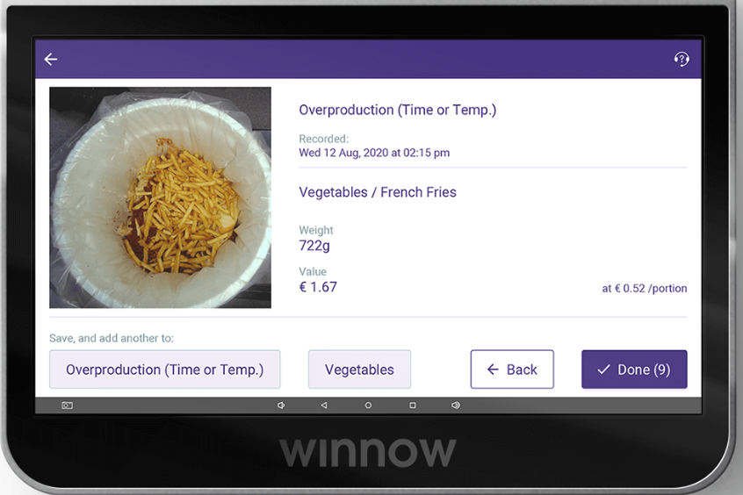
Fig.2: waste detection interface in Winnow’s system

Winnow is more intelligent and automated, utilizing Computer Vision and AI techniques to detect food waste categories and using sensors at the waste bin to measure the weight of that type of food waste. It also provides detailed reports about overall statistics and suggestions on menu changes, making this system more in line with the goals of our project, providing convenience for food sellers to minimize food wastage. However, this system involves using multiple sensors including cameras (to detect food waste category) and weight sensor (to measure food waste quantity), while our system aims to depend solely on cameras to collect food waste information, which simplify the system architecture and reduce system overhead. In addition, compared to Winnow’s system, our system not only provides statistics and suggestions to food sellers to reduce food waste, but also allow individual users to record their food consumption and generate advice on nutritional intake and food waste, rising the awareness of food wastage.

1.2.3 Discussion
Compared to two systems mentioned, our system features in several unique functions and architecture:
- Lightweight automatic food waste detection: Our system detects food waste solely with a camera with the help of computer vision techniques, reduce system complexity and overhead.
- More informatic food waste statistics with face recognition: Our system not only provides basic information about wastage (e.g. most wasted food type, total waste quantity) but utilize face recognition technology to link one serving of food waste to a specific face (hint: the identity of face will not be accessible though), providing more informatic statistics.
- Service for both food sellers and individual users: Our system consists of two subsystems, one for food sellers to detect food waste in canteens/restaurants to mitigate food waste, one for individual users to record food intake, getting advice on food consumption and waste.
However, both systems talk about the system’s integrability with other management systems, which should also be considered in our system.

Food Recognition

2.1 Detecting Food
To distinguish different foods, it is important to concentrate on color, texture and shape, especially the color. [3], As a result, we need an appropriate pathway to analyze images and select proper models in current situations. CNN (Convolution Neural Network) [3] and YOLO (You Only Look Once) [5] are two main models frequently applied in similar systems. CNN is primarily designed for image classification and feature extraction, specialized models like Faster R-CNN [6] and Mask R-CNN [7] can provide various features based on practical requirements. While YOLO is a specialized model for real-time object detection, it features in detecting not only what the object is but where it is in the image and can process multiple objects in the same image at the same time.

2.2 Measuring food quantity
Besides food recognition and categorization, another challenge is measuring the quality of food waste. The weight of an object can be influenced by various factors including density and size, thus measuring weight from image can be difficult. The solution could be first using object segmenting models like Mask R-CNN [7], PointNet [8] or PointRCNN [9] to measure the size of the food waste and use CNN to predict the weight of the food waste.

Face Recognition

3.1 Detecting human face
Our system involves connecting food waste to the specific individual face contributing to it, thus, except recognizing food waste, the system also needs to detect and recognize the face of the individual holding it. Frequently used tools and frameworks are OpenCV, Dlib, FaceNet [12], ArcFace [13] and DeepFace [14] [15]. Some efficient algorithms include traditional algorithm based on Haar features like Viola-Jones and Deep Learning-enabled algorithms like MTCNN (Multitask Cascaded Convolutional Networks) and SSD (Single Shot Multibox Detector) which can detect human faces from images.

3.2 Extracting face features
Another significant task of facial recognition is extracting facial features from human faces and linking them to corresponding food wastage. Deep learning helps to solve this problem effectively [11]. Some CNN (Convolutional Neural Network)-enabled models are FaceNet as mentioned, VGGFace [16] which apply the VGG-16 neural network structure to extract high-dimensional features from faces, and ArcFace that provide more robustness and accuracy by introducing an angular margin to the softmax loss function [13]. The capability of CNN to extract features from images allows us to utilize these models to identify specific faces and store them into the database with corresponding food waste statistics. [11]

3.3 Existing solutions

3.3.1 PaddleDetection
PaddleDetection is an open-source toolkit built on the PaddlePaddle deep learning framework developed by Baidu. It is designed for object detection and instance segmentation tasks with various advantages:
- Various models: It supports abundant models mentioned, including YOLO, Faster R-CNN, Cascade-RCNN, and RetinaNet, can fulfill various tasks based on actual requirements.
- Various pre-trained models: It provides pre-trained models for common datasets like COCO and VOC, saving time for model training and data collection.
- User-friendly API: It enables easy training and inference, making deep learning accessible to a wider audience, suitable for software or embedded development, offering high performance and flexibility for real-time detection solutions.

However, PaddleDetection also has several disadvantages:
- Not specialized for face recognition: It contains less models for face features extraction compared to other face recognition specialized, thus require more time on model training and adjusting while using.
- Low performance for face recognition: Since PaddleDetection is not specialized for face recognition, it requires more complicated processes to do face recognition, which causes heavier system overhead and low performance in real-time recognition.

3.3.2 face_recognition
face_recognition is an open-source python library specialized for face recognition, which is extended on Dlib library, it has following advantages:
- Ease of use: It packs multiple functions in Dlib and therefore provides a simple and intuitive API, allowing for quick implementation of face recognition tasks.
- High accuracy: It utilizes deep learning models that deliver high accuracy in face recognition.
- Pre-trained models: It also provides abundant pre-trained models for face recognition, saving time and resources.

It also has some unappealing disadvantages:
- Performance on multiple faces: It struggles with performance and speed with trying to deal with very large datasets or when trying to recognize multiple faces simultaneously.
- Resources intensive: Since it utilizes deep learning models, it requires a good amount of memory and computational power, especially for real-time applications.

3.3.3 OpenFace
OpenFace is an open-source project designed for facial recognition and facial feature extraction, built on deep learning techniques. It has following advantages:
- High-performance: It features pre-trained models that were trained on large scale datasets, having advantages in both recognition accuracy and real-time processing speed.
- Pre-trained models: It also provides multiple models for face recognition.
Disadvantages:
- Difficult to implement: The complex structure of OpenFace makes it difficult to implement in software.
- High demand on hardware: The use of deep learning techniques makes the operation of OpenFace algorithms causing heavy computational overhead.

3.4 Discussion
Our system eventually chooses to use face_recognition for face recognition, because it has high accuracy in facial detection and facial feature extraction tasks. and it is easy to use, providing efficiency in software development. In addition, our system aims to detect only one person and one serving of food at a single time, thus its drawbacks in recognizing multiple faces simultaneously can be ignored.

Database

4.1 PostgreSQL
In this project, we have selected PostgreSQL as our database management system due to its advanced features and suitability for complex data handling. PostgreSQL is an open-source relational database that excels in maintaining data integrity and supporting sophisticated querying capabilities [17]. The database architecture will encompass several key components: it will store user account information, food waste metrics, and comprehensive analyses of food consumption patterns. Furthermore, it will incorporate facial recognition data to enable secure authentication for user logins.

Utilizing PostgreSQL's robust analytical functions, the system will generate detailed reports that assess food waste alongside recent intake, facilitating the scoring and ranking of users based on their consumption behaviors. Additionally, the database will analyze food waste data to formulate predictive recommendations for cafeteria menus, thereby assisting management in making data-driven decisions.

4.2 Time-series analysis
To enhance decision-making, we will implement time series analysis on food waste data. This will involve collecting and preparing historical data, visualizing trends, and applying models (e.g. ARIMA [18] or LSTM [19]) for accurate forecasting. The resulting time series report will provide insights into food waste patterns, helping to predict future waste and suggest appropriate menu adjustments to minimize waste.

4.3 Data Encryption
This system involves collecting real human facial data which leads to the problem of data and personal information safety. Thus, encryption of the database may also be taken into consideration, PostgreSQL mentioned features TDE (Transparent Data Encryption) [20] technique, which ensures the safety of database and keeps the accessibility of the database from application level. However, it fails to encrypt the data stored in memory, causing potential data safety issues during the utilization of data at application level. ALE (Application-Level Encryption) [21] is another possible solution; it encrypts the data at application level before they are put into database, and decrypts when extracting them from database. However, this repeated encryption and decryption process causes considerable overhead.

Reference:
[1] United Nations (2021) Food waste: a global problem that undermines healthy diets [online]. Available at: https://news.un.org/en/story/2021/09/1101532 [Accessed 19 October 2024].

[2] F. Schroff, D. Kalenichenko and J. Philbin, "FaceNet: A unified embedding for face recognition and clustering," 2015 IEEE Conference on Computer Vision and Pattern Recognition (CVPR), Boston, MA, USA, 2015, pp. 815-823, doi: 10.1109/CVPR.2015.7298682.

[3] Zhang, Y., Deng, L. and Zhu, h. (2023) Deep learning in food category recognition [online]. Information Fusion [online] 98: Available at: https://www.sciencedirect.com/science/article/pii/S1566253523001756?via%3Dihub#sec0037 [Accessed 19 October 2024].

[4] T. Ege, Y. Ando, R. Tanno, W. Shimoda and K. Yanai, "Image-Based Estimation of Real Food Size for Accurate Food Calorie Estimation," 2019 IEEE Conference on Multimedia Information Processing and Retrieval (MIPR), San Jose, CA, USA, 2019, pp. 274-279, doi: 10.1109/MIPR.2019.00056.

[5] Alexey Bochkovskiy, Chien-Yao Wang, and Hong-Yuan Mark Liao. “Yolov4: Optimal speed and accuracy of object detection”. In: arXiv preprint arXiv:2004.10934 (2020).

[6] S. Ren, K. He, R. Girshick and J. Sun, "Faster R-CNN: Towards Real-Time Object Detection with Region Proposal Networks," in IEEE Transactions on Pattern Analysis and Machine Intelligence, vol. 39, no. 6, pp. 1137-1149, 1 June 2017, doi: 10.1109/TPAMI.2016.2577031.

[7] K. He, G. Gkioxari, P. Dollár and R. Girshick, "Mask R-CNN," 2017 IEEE International Conference on Computer Vision (ICCV), Venice, Italy, 2017, pp. 2980-2988, doi: 10.1109/ICCV.2017.322.

[8] R. Q. Charles, H. Su, M. Kaichun and L. J. Guibas, "PointNet: Deep Learning on Point Sets for 3D Classification and Segmentation," 2017 IEEE Conference on Computer Vision and Pattern Recognition (CVPR), Honolulu, HI, USA, 2017, pp. 77-85, doi: 10.1109/CVPR.2017.16.

[9] S. Shi, X. Wang and H. Li, "PointRCNN: 3D Object Proposal Generation and Detection From Point Cloud," 2019 IEEE/CVF Conference on Computer Vision and Pattern Recognition (CVPR), Long Beach, CA, USA, 2019, pp. 770-779, doi: 10.1109/CVPR.2019.00086.

[10] I. Nyalala, C. Okinda, C. Kunjie, T. Korohou, L. Nyalala, Q. Chao, “Weight and volume estimation of poultry and products based on computer vision systems: a review” 2021 Poultry Science, Volume 100, Issue 5.

[11] H. Wang, J. Hu and W. Deng, "Face Feature Extraction: A Complete Review," in IEEE Access, vol. 6, pp. 6001-6039, 2018, doi: 10.1109/ACCESS.2017.2784842.

[12] F. Schroff, D. Kalenichenko and J. Philbin, "FaceNet: A unified embedding for face recognition and clustering," 2015 IEEE Conference on Computer Vision and Pattern Recognition (CVPR), Boston, MA, USA, 2015, pp. 815-823, doi: 10.1109/CVPR.2015.7298682.

[13] J. Deng, J. Guo, J. Yang, N. Xue, I. Kotsia and S. Zafeiriou, "ArcFace: Additive Angular Margin Loss for Deep Face Recognition," in IEEE Transactions on Pattern Analysis and Machine Intelligence, vol. 44, no. 10, pp. 5962-5979, 1 Oct. 2022, doi: 10.1109/TPAMI.2021.3087709.

[14] Y. Taigman, M. Yang, M. Ranzato and L. Wolf, "DeepFace: Closing the Gap to Human-Level Performance in Face Verification," 2014 IEEE Conference on Computer Vision and Pattern Recognition, Columbus, OH, USA, 2014, pp. 1701-1708, doi: 10.1109/CVPR.2014.220.

[15] M. Gulhane, S. Kumar, M. Kumar, Y. Dhankhar and B. Kaliraman, "Advancing Facial Recognition: Enhanced Model with Improved Deepface Algorithm for Robust Adaptability in Diverse Scenarios," 2023 10th IEEE Uttar Pradesh Section International Conference on Electrical, Electronics and Computer Engineering (UPCON), Gautam Buddha Nagar, India, 2023, pp. 1384-1389, doi: 10.1109/UPCON59197.2023.10434721.

[16] Q. Cao, L. Shen, W. Xie, O. M. Parkhi and A. Zisserman, "VGGFace2: A Dataset for Recognising Faces across Pose and Age," 2018 13th IEEE International Conference on Automatic Face & Gesture Recognition (FG 2018), Xi'an, China, 2018, pp. 67-74, doi: 10.1109/FG.2018.00020.

[17] S. Pete (2024) What is PostgreSQL? Everything You Need to Know. Percona. [Online] Available at: https://www.percona.com/blog/what-is-postgresql-used-for/. [Accessed 21 October 2024].

[18] J. Noble (2024) Introducing ARIMA models. IBM. [Online] Available at: https://www.ibm.com/topics/arima-model/. [Accessed 21 October 2024].

[19] R. C. Staudemeyer and E. R. Morris. “Understanding LSTM a tutorial into Long Short-Term Memory Recurrent Neural Networks”. In arXiv preprint ArXiv:1909.09586 (2019).

[20] W. Zhan, B. Jin, H. Xu and C. Dong, "Data Security Management Based on Transparent Encryption Policy," 2022 IEEE 2nd International Conference on Mobile Networks and Wireless Communications (ICMNWC), Tumkur, Karnataka, India, 2022, pp. 1-4, doi: 10.1109/ICMNWC56175.2022.10032001.

[21] Y. Ding and K. Klein, "Model-Driven Application-Level Encryption for the Privacy of E-health Data," 2010 International Conference on Availability, Reliability and Security, Krakow, Poland, 2010, pp. 341-346, doi: 10.1109/ARES.2010.91

