PH126 Logic I Fast-track Lecture 1
Lecturer: s.butterfill@warwick.ac.uk

An argument is logically valid just if there’s no possible situation in which the premises are true and the conclusion false

A counterexample to an argument is a possible situation in which its premises are T and its conclusion F.

An argument is sound just if it is logically valid and its premises are true

Identity: two principles
If b=c then whatever is true of b is also true of c
a=a is never false

Truth tables for ∧, ∨, ¬
Rough guide:  ‘∧’ means and  ‘∨’ means or  ‘¬’ means not
  P | ¬P
  T | F
  F | T

P | Q | P ∧ Q | P∨Q
T | T | T | T
T | F | F | T
F | T | F | T
F | F | F | F
The truth value of a sentence is true (T) when the sentence is true and false (F) when the sentence is false.

Truth tables can be used to show that an argument is valid. For example:
 | P ∨Q | // It went up the left fork or it went up the right fork
 | ¬P | // It didn’t go up the left fork
 | Q | // It went up the right fork

Truth tables for this argument
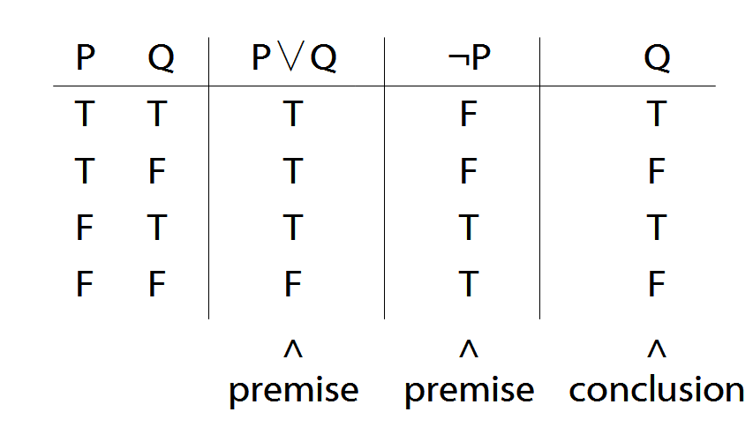

Terminology
A connective joins one or more sentences to make a new sentence. E.g. ‘because’, ‘¬’. The sentences joined by a connective are called constituent sentences.
E.g. in ‘P∧Q’,
∧ is the connective
P, Q are the constituent sentences
Complex truth table example
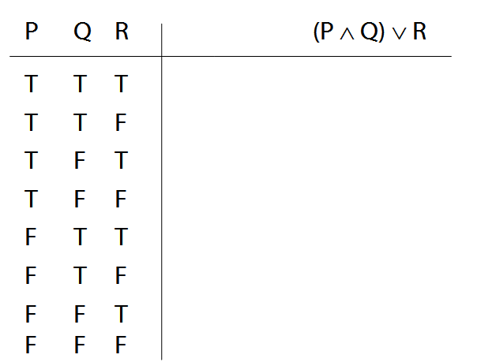
Logical Validity
Argument 3
1. (P ∧ Q) ∨ R
2. P ∨ ¬P
Argument 3b
1.
2. P ∨ ¬P
Argument 4
1. P ∧ ¬P
2. (P ∧ Q) ∨ R
P ∨ ¬P is a logical truth
logical truth defined p. 568
P ∧ ¬P is a contradiction
contradiction defined p. 564

PH126: Exercises 00 for fast track
From Barwise & Etchemendy, Language, Proof and Logic (those marked * are optional).

Be sure to read the corresponding parts of the textbook before attempting to complete the exercises.

A. From the textbook:
2.8, 2.10, 2.12, 2.21 (counterexamples)
3.1, 3.3 (negation)
3.5, 3.7 (conjunction)
3.14–15 (scope, counterexamples)
4.1–2 (truth tables)
4.12–4.16 (truth tables)

B. State the textbook definition and page number for each of the following:
- argument [p. 41] | - name
- premise | - object
- conclusion | - predicate
- logically valid argument | - property  - truth value
- logical consequence | - atomic sentence  - Fitch format
- logically sound argument | - FOL
*C. (optional) Disambiguate the following by giving alternative readings.
Example:
  - Pierre is a foreign coin collector.
– Pierre is foreign and he collects coins.
– Pierre collects foreign coins.
  - I want to marry a Norwegian.
  - This is a hospital where doctors are trained.
  - Ormus said that Vina was happy then.
  - No one hates a man after he shoots him.
  - A woman and a girl each had a hat and the woman gave hers to the girl.
  - One can’t remove the rods too quickly.
  - Ayesha clumsily stamped on a snail.
(Some examples are from http://www.vuse.vanderbilt.edu/~jgray/funny.html)

Some exercises can be submitted with grade grinder. The others are to be sent by email or on paper directly to your seminar leader*.

When are they due?
2pm on the day before the seminar (unless otherwise instructed). This includes work submitted with Grade Grinder.

How to submit?
You need to submit some of these exercises to your seminar leader.* You can put them in their pigeon hole in the Philosophy Department. Or you can email them to your seminar group leader.

Using Grade Grinder
When using Grade Grinder, be sure to enter your seminar leader’s* name and email address in the ‘instructor’s name’ and ‘instructor’s email address’ sections. E.g.:

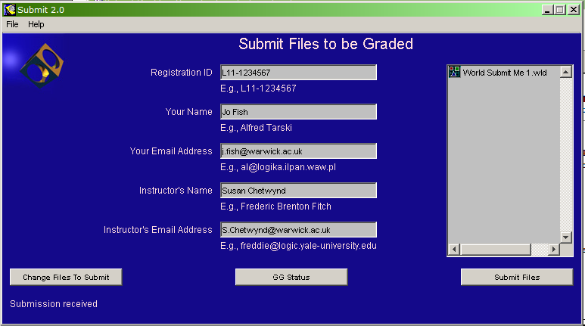

Students should submit work electronically using Grade Grinder. However, individuals may exceptionally submit any or all exercises on paper if they have reason to do so.

*Not sure who your seminar leader is? First sign up for a seminar group (http://reporttool.warwick.ac.uk/philosophy), then click on the name of your seminar group and select the ‘details’ tab.

What if I can’t do the exercises?
Ask a friend. Or submit your best attempt. Seminars are compulsory but students may not attend a seminar unless they have either submitted attempts at the exercises emailed their seminar group leader for special permission (e.g. in case of illness).
Work submitted late may not be marked.

