PH126 Logic I fast-track Lecture 2
Lecturer: s.butterfill@warwick.ac.uk
Proofs with ∧
Rules of proof are given near the end of the textbook.
example
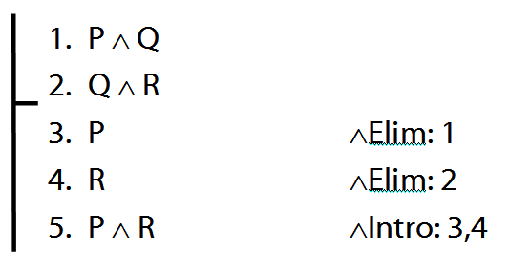

Proofs with identity
example (with missing justification)
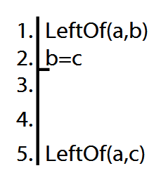
Proofs with ∧Intro and ∨Intro
Example
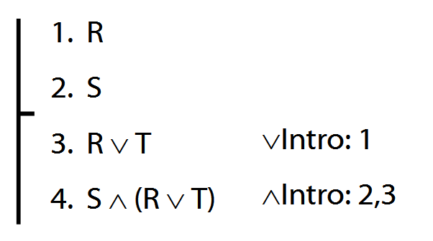
After the premises, each line in a proof is guaranteed to be a logical consequence of the lines above.

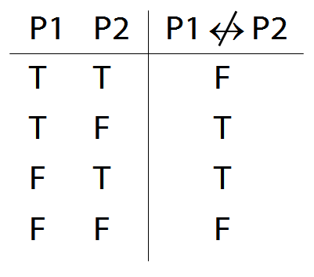
The following rule is unacceptable. Why?
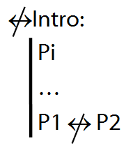

Truth-functional connectives
A connective joins one or more sentences to make a new sentence. E.g. ∧, ¬, because
A sentence joined by a connective is a constituent sentence. E.g. P in “P because Q”
A truth functional connective produces a new sentence whose truth value depends only on the truth values of its constituent sentences.
When P and Q are both true, “P because Q” is sometimes true and sometimes false. Therefore, ‘because’ is not a truth-functional connective
How to order reference columns
[not in lecture]
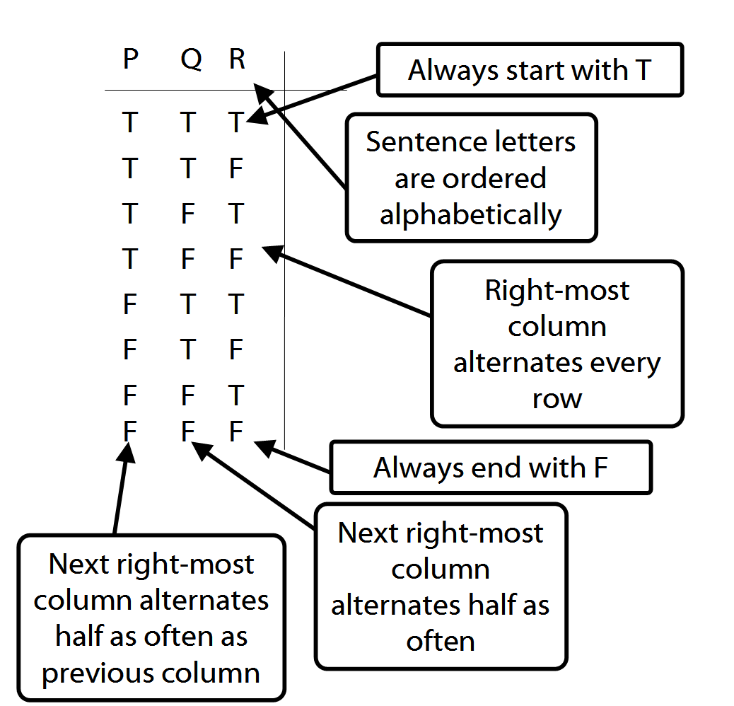

A∧B∨C
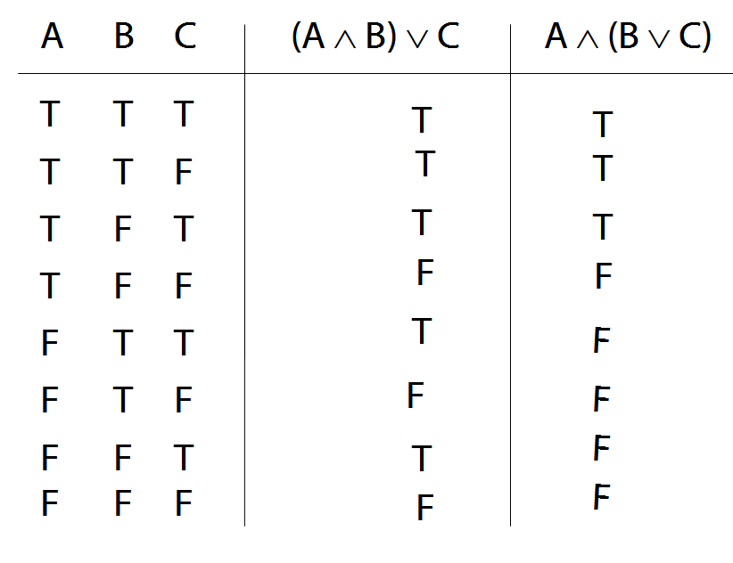

Ambiguity
Lexical ambiguity, e.g. “give me a note”
Structural ambiguity, e.g. “Two puffins ate six fish”, “I shot an elephant in my pyjamas”
What is the source of structural ambiguity in natural languages?

Rule 1: a NP followed by a VP is a S
Rule 2: a Vt followed by a NP is a VP
Rule 3: a NP followed by a PP is a S
Rule 4: A Vt followed by a NP then a PP is a VP

Two derivations of Groucho Marx’ claim, “I shot an elephant in my pyjamas”
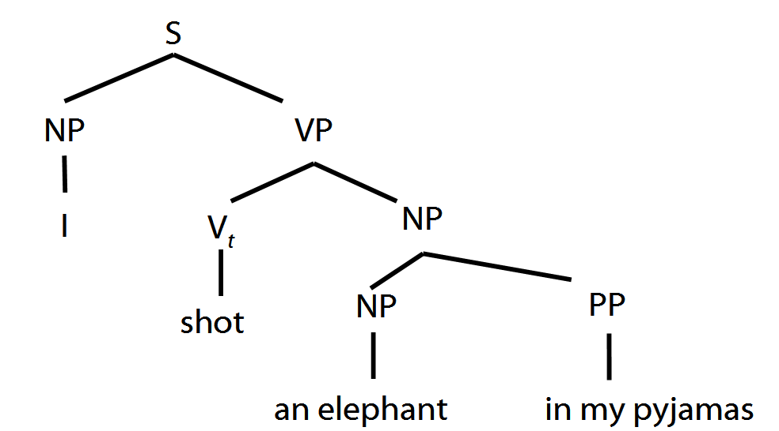

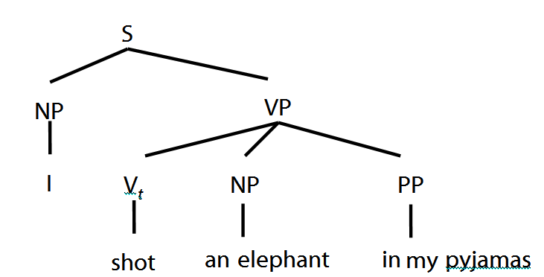

- Not every sequence of words is a sentence.
- Which sequences of words are sentences is determined by rules.
- The rules specify how to construct sentences from fragments.
- The rules impose a tree-like structure on sentences.
- Structural ambiguity occurs when the same linear sequence of words can be derived from different rules.

Rule of Proof: ∨Elim
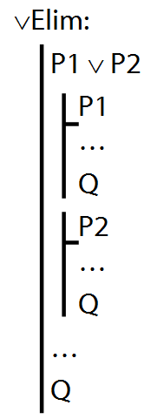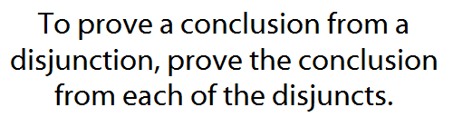

Example proof with ∨Elim
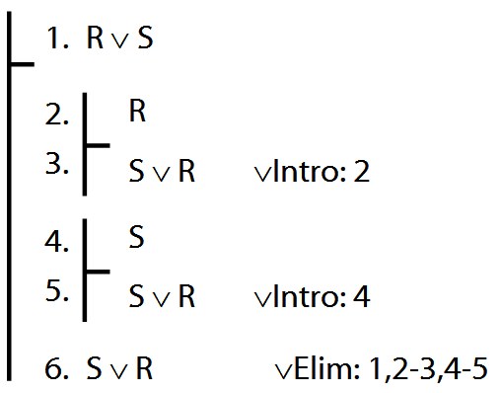

Exercises 02
For your second seminar
Only for fast groups
3.19 (translation)
4.31 (equivalences)
5.3–6 (validity)
6.7–12 (proofs)
6.18–6.20 (proofs with subproofs)
either:
6.24–6.27
or, if possible:
6.40–6.42

