PH126 Logic I Fast Lecture 6
Lecturer: s.butterfill@warwick.ac.uk
Quantifier Recap
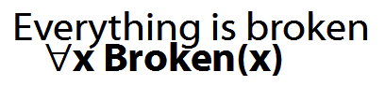
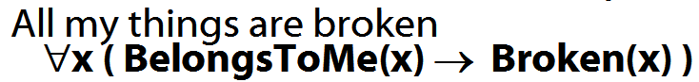
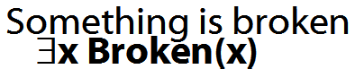
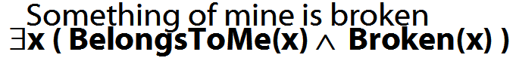
How to determine truth of a sentence with an existential quantifier as the main connective
1. Give every object a name.
2. For each name in turn, create a new sentence like this: delete the quantifier and replace all instances of the variable it binds with that name
3. If ANY OF the new sentences are true, so is the original.

How to determine truth of a sentence with a universal quantifier as the main connective
1. Give every object a name.
2. For each name in turn, create a new sentence like this: delete the quantifier and replace all instances of the variable it binds with that name
3. If ALL OF the new sentences are true, so is the original.
Multiple quantifiers
There is a store for everything
∃y∀x StoreFor(y,x)
∀y∃x StoreFor(x,y)
Other sentences to translate:
Wikipedia has an article about everything
Everyone hurts someone they love
Someone hurts everyone she loves

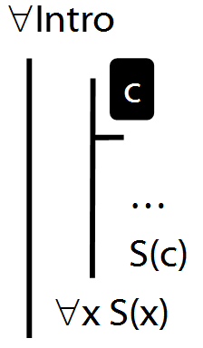

∀Intro Example proof
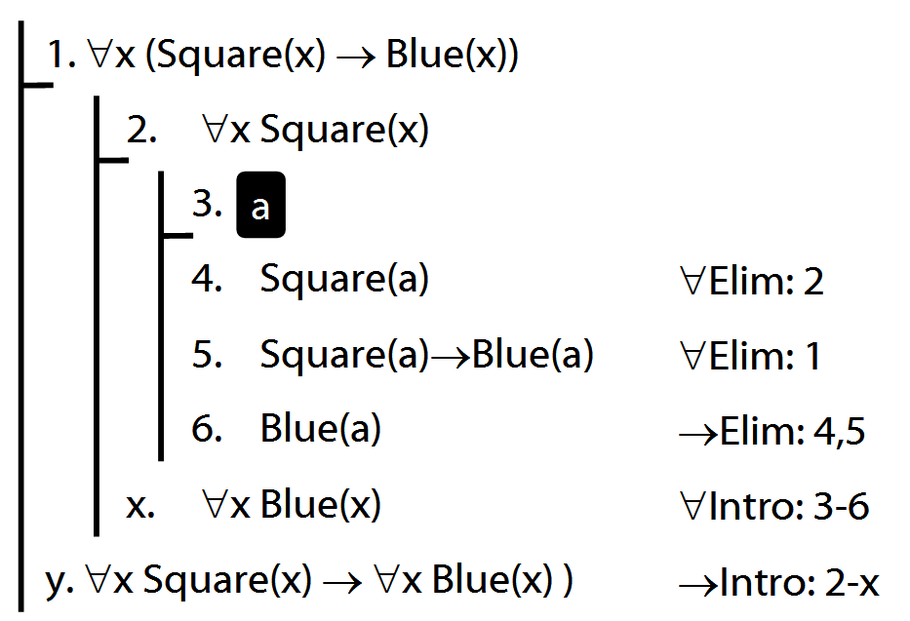

Exercise
If the following is valid, give a formal proof. If it is not valid, give a counterexample.
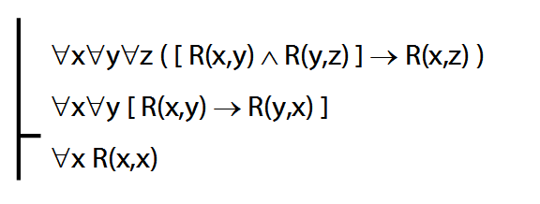

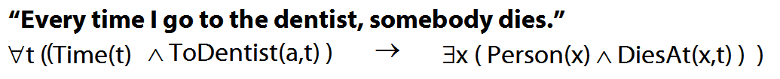
Truth-functional completeness (LPL §7.4)
How many truth-functions can be constructed using 2 sentence letters?

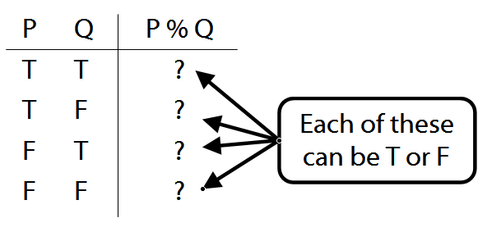
Df. ‘A set of truth-functors is said to be expressively adequate (or sometimes functionally complete) iff, for every truth-function whatever, there is a formula containing only those truth-functors which express that truth-function, i.e. which has as its truth-table the truth-table specifying that function.’ (Bostock, Intermediate Logic p. 45)
Illustration of the proof that {¬, ∧, ∨} is truth-functionally complete:
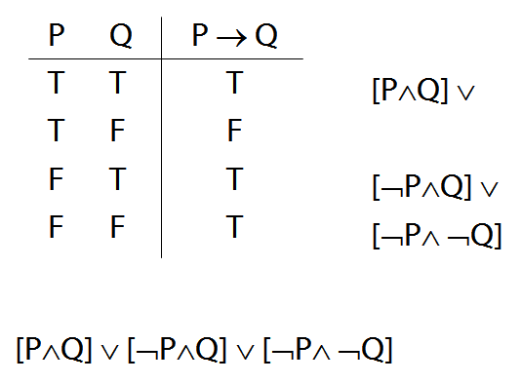

Exercise assuming {¬,∨,∧} is truth-functionally complete, show that {¬,∨} is.
Quantifier equivalences
P→Q ╡╞ ¬Q→¬P
∀x ( Square(x) → Broken(x) )
╡╞ ∀x (¬Broken(x) → ¬Square(x) )

P→Q ╡╞ ¬P∨Q
∀x ( Square(x) → Broken(x) )
╡╞ ∀x (¬Square(x) ∨ Broken(x) )

¬P∨Q ╡╞ ¬(P∧ ¬Q)
∃x ¬F(x) ╡╞ ¬∀x F(x)
∀x (¬Square(x) ∨ Broken(x) )
╡╞ ∃¬x ( Square(x) ∧ ¬Broken(x) )

∃x ¬Created(x) ╡╞ ¬∀x Created(x)

Exercises 07
For your seventh seminar
Only for fast groups
11.10 (nb. especially no. 20)
11.13
13.43–45
13.49–50
14.2–3
14.10–11

Despite what book says, DON’T even THINK about using TAUT CON.

