PH126 Logic I Fast Lecture 8
Lecturer: s.butterfill@warwick.ac.uk

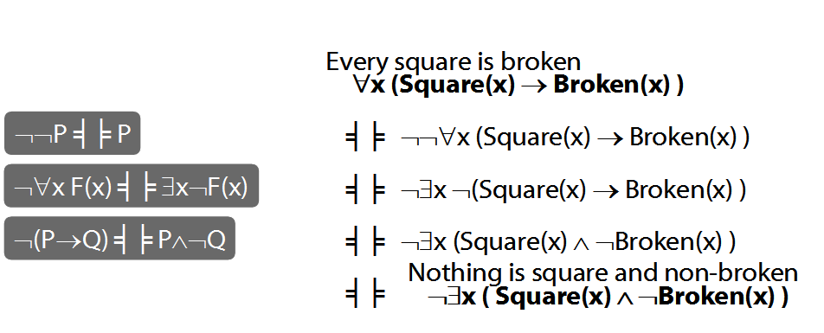

Number
There are at least two squares:
∃x ∃y ( Square(x) ∧ Square(y) ∧ ¬x=y)
At least two squares are broken:
∃x ∃y ( Square(x) ∧ Broken(x) ∧ Square(y) ∧ Broken(y) ∧ ¬x=y)
There are at least three squares:
∃x ∃y ∃z ( Square(x) ∧ Square(y) ∧ Square(z) ∧ ¬x=y ∧ ¬y=z ∧ ¬x=z)
There are at most two squares:
¬There are at least three squares
¬∃x ∃y ∃z ( Square(x) ∧ Square(y) ∧ Square(z) ∧ ¬x=y ∧ ¬y=z ∧ ¬x=z)
There are exactly two squares:
There are at most two squares ∧ There are at least two squares

Number: Alternatives
There is at most one square:
∀x∀y( (Square(x) ∧ Square(y)) → x=y )
There are at most two squares:
∀x∀y∀z( (Square(x)∧Square(y)∧Square(z))
→
(x=y∨y=z∨x=z)
)
There is exactly one square:
∃x ( Square(x) ∧ ∀y( Square(y) → x=y ))
There are exactly two squares:
∃x∃y (Square(x) ∧ Square(y) ∧ ¬x=y ∧
∀z( Square(z) → (z=x ∨ z=y) ))

The
‘The’ can be a quantifier, e.g. ‘the square is broken’. How to formalise it?
The square is broken
⇔There is exactly one square and it is broken
∃x ( Square(x) ∧
∀y( Square(y) → x=y ) ∧
Broken(x)
)

