PH126 Logic I  Lecture 2
Lecturer: s.butterfill@warwick.ac.uk

Identity: two principles
If b=c then whatever is true of b is also true of c
a=a is never false

Truth tables and some truth functional connectives
Rough guide:
‘∧’ means and
‘∨’ means or
‘¬’ means not

P | Q | P ∧ Q | P∨Q
T | T | T | T
T | F | F | T
F | T | F | T
F | F | F | F

P | ¬P
T | F
F | T

The truth value of a sentence is true (T) when the sentence is true and false (F) when the sentence is false.
Truth tables can be used to show that an argument is valid. For example:

 | P ∨Q | // It went up the left fork or it went up the right fork
 | ¬P | // It didn’t go up the left fork
 | Q | // It went up the right fork

Truth tables for this argument
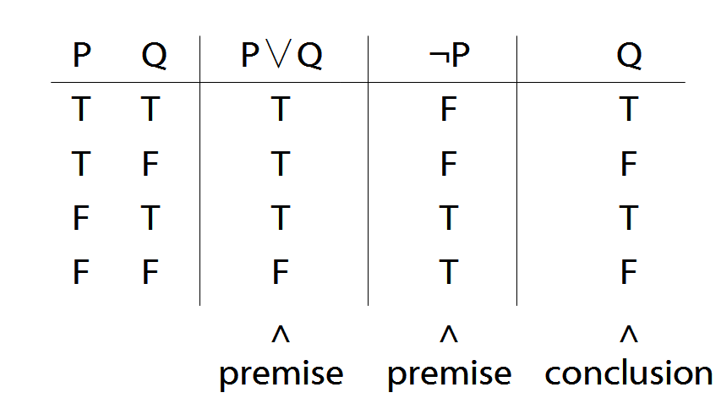

Terminology
A connective joins one or more sentences to make a new sentence. E.g. ‘because’, ‘¬’
The sentences joined by a connective constituent sentences.
E.g. in ‘P∧Q’,
∧ is the connective
P, Q are the constituent sentences
Complex Truth Tables: an example
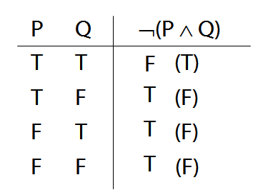

Logical Validity
Argument 3
1. (P ∧ Q) ∨ R
2. P ∨ ¬P
Argument 3b
1.
2. P ∨ ¬P
Argument 4
1. P ∧ ¬P
2. (P ∧ Q) ∨ R
P ∨ ¬P is a logical truth (see p. 568)
P ∧ ¬P is a contradiction (see p. 564)

