PH126 Logic I  Lecture 4
Lecturer: s.butterfill@warwick.ac.uk
Proofs with ∧Intro and ∨Intro
Example
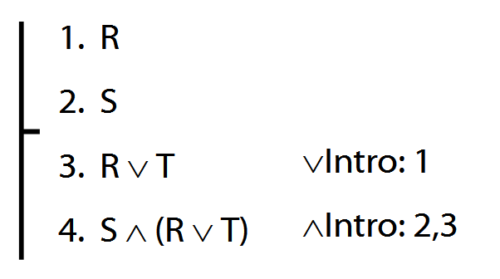
After the premises, each line in a proof is guaranteed to be a logical consequence of the lines above.

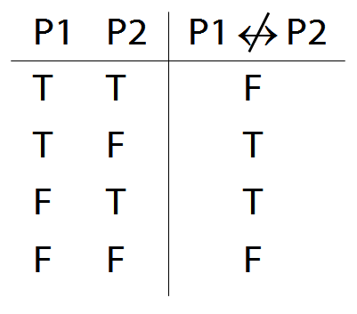
The following rule is unacceptable. Why?
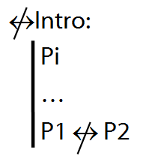
Truth-functional connectives
A connective joins one or more sentences to make a new sentence. E.g. ∧, ¬, because
A sentence joined by a connective is a constituent sentence. E.g. P in ‘P because Q’
A truth functional connective produces a new sentence whose truth value depends only on the truth values of its constituent sentences.
When P and Q are both true, ‘P because Q’ is sometimes true and sometimes false. Therefore, ‘because’ is not a truth-functional connective

A∧B∨C
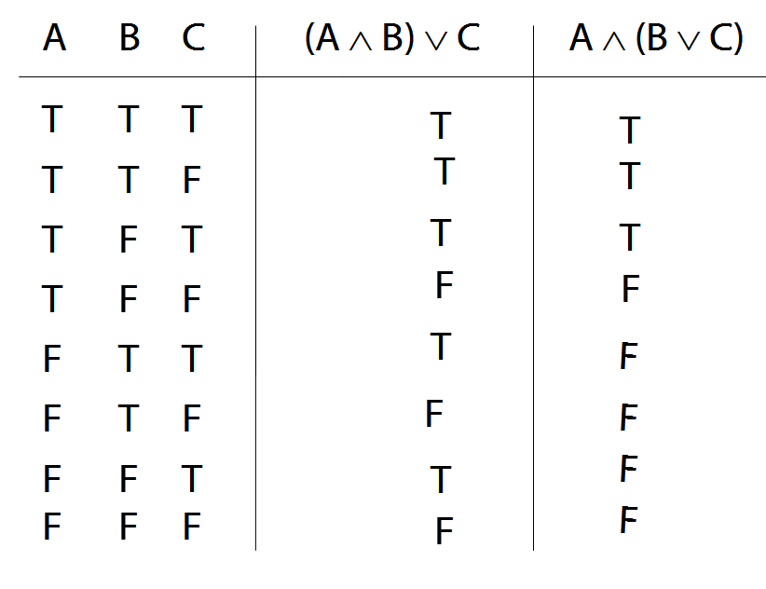
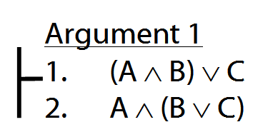
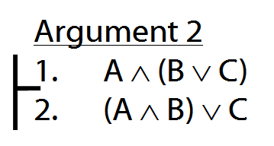
How to order reference columns
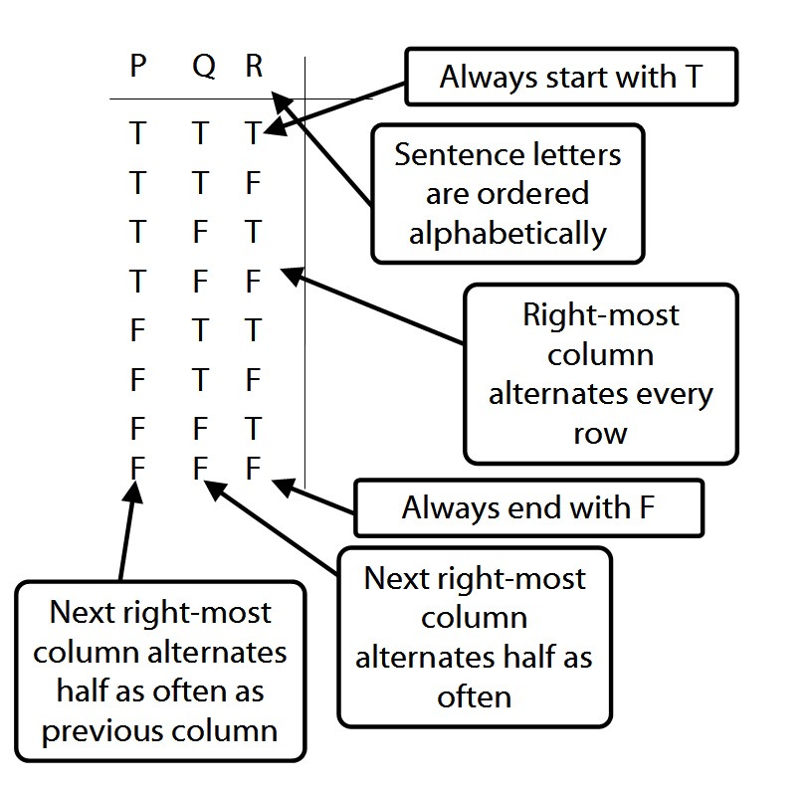

Ambiguity
Lexical ambiguity, e.g. ‘give me a note’
Structural ambiguity, e.g. ‘Two puffins ate six fish’, ‘I shot an elephant in my pyjamas’
What is the source of structural ambiguity in natural languages?

Rule 1: a NP followed by a VP is a S
Rule 2: a Vt followed by a NP is a VP
Rule 3: a NP followed by a PP is a S
Rule 4: A Vt followed by a NP then a PP is a VP

Two derivations of Groucho Marx’ claim, ‘I shot an elephant in my pyjamas’
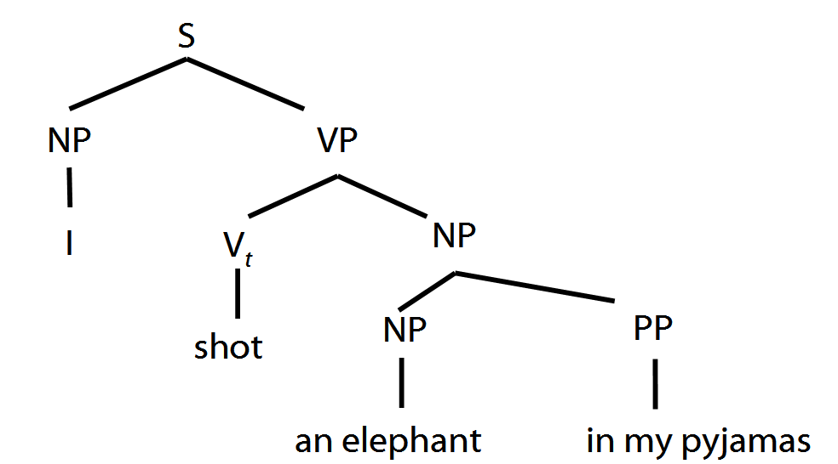

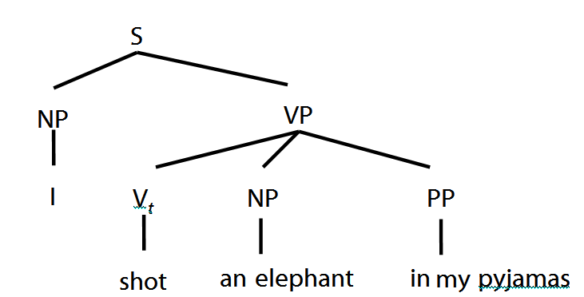

- Not every sequence of words is a sentence.
- Which sequences of words are sentences is determined by rules.
- The rules specify how to construct sentences from fragments.
- The rules impose a tree-like structure on sentences.
- Structural ambiguity occurs when the same linear sequence of words can be derived from different rules.

