PH133 Logic Exercises
Weekly exercises for the logic part of PH133.

When are they due?
2pm on the day before the seminar (unless otherwise instructed by the seminar group leader). This includes work submitted with Grade Grinder.
Who to submit the exercises to?
Submit all exercises to your seminar group leader.

*Not sure who your seminar leader is?
First sign up for a seminar group (http://reporttool.warwick.ac.uk/philosophy), then click on the name of your seminar group and select the ‘details’ tab.

How to submit?
You need to submit some of these exercises using ‘grade grinder’ (see below); other exercises need to be submitted on paper or by email. For these other exercises, you can put them in your seminar group leader’s* pigeon hole in the Philosophy Department. Or you can email them to your seminar group leader.

Using Grade Grinder
When using Grade Grinder, be sure to enter your seminar leader’s* name and email address in the ‘instructor’s name’ and ‘instructor’s email address’ sections. E.g.:

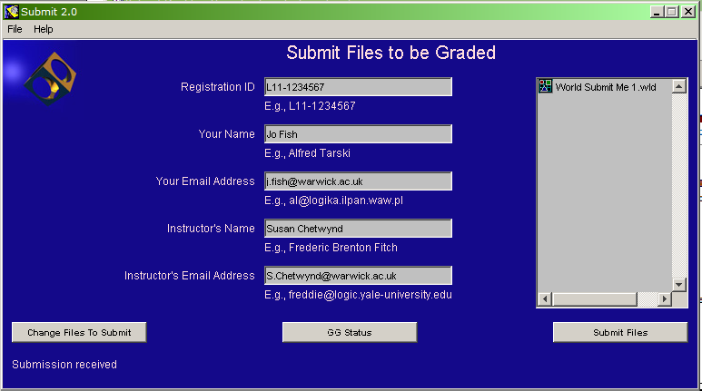

Students are encouraged to submit work electronically using Grade Grinder. However, individuals may exceptionally submit any or all exercises on paper if they have reason to do so.

Reading
Always read the associated sections of the textbook (Barwise & Etchemendy, Language, Proof and Logic) before attempting the exercises. E.g. read section §3.4 before attempting exercise 3.11.

What do the numbers below refer to?
They are exercises in the textbook for this course, Barwise & Etchemendy’s Language, Proof and Logic.

Exercises 01

For your first seminar
1.1–1.5, 1.9–1.10
2.3, 2.4 (arguments and validity)
2.10, 2.12, 2.21 (counterexamples)
3.1–2 (negation)
3.5, 3.7 (conjunction)
4.1–2 (truth tables)

Exercises 02

For your second seminar
3.8, 3.12–13
3.20, 3.21, 3.22
4.4–7 (truth tables)
4.12–4.14 (truth tables)
5.1–4 (validity)
6.1-6 (proofs)
6.7, 6.9-10 (proofs and counterexamples)

Exercises 03
4.17-18 (truth tables)
9.1 (quantifiers)
9.2 (quantifiers)
9.4–5 (quantifiers)
9.15–17, (translation)

Exercises 04
9.4–5, 9.8–10, 9.12 (quantifiers)
EITHER 6.17–20 (proof)
OR 6.33, 6.40 (proofs)
9.18, 9.20 (trans)
10.9 part 1 only (trans)
10.20
10.24–7
DO NOT USE TAUT CON. EVER.

Further Exercises
11.2, 11.4, 11.8, 11.9 (multiple quantifiers)
13.1–4 (quantifier proofs/counterex)
13.10–15 (quantifier proofs/counterex)

