PH126 Logic I Lecture 16
Lecturer: s.butterfill@warwick.ac.uk

Number: Alternatives
There is at most one square:
∀x∀y( (Square(x) ∧ Square(y)) → x=y )
There are at most two squares:
∀x∀y∀z( (Square(x)∧Square(y)∧Square(z))
→
(x=y∨y=z∨x=z)
)
There is exactly one square:
∃x ( Square(x) ∧ ∀y( Square(y) → x=y ))
There are exactly two squares:
∃x∃y (Square(x) ∧ Square(y) ∧ ¬x=y ∧
∀z( Square(z) → (z=x ∨ z=y) ))
The
‘The’ can be a quantifier, e.g. ‘the square is broken’. How to formalise it?
The square is broken
There is exactly one square and it is broken
There is at most one square and there is at least one square and it is broken
There is at most one square and there is at least one square and all squares are broken
¬ ∃x ∃y ( Square(x) ∧ Square(y) ∧ ¬x=y )
∧ ∃x Square(x)
∧ ∀x ( Square(x) → Broken(x)
Which shorter sentences are equivalent to this?
Translation from Logiya
Domain: {people and actions}
D(x) : x is desirable
V(x) : x is virtuous
A(x) : x is an action
P(x,y) : x performed y
a : Ayesha
i. ∀x( D(x) → V(x) )
ii. ∀x( (A(x) ∧ D(x)) → V(x) )
iii. ∃x( A(x) ∧ ¬D(x) )
iv. ∃x( A(x) ∧ ¬D(x) ∧ V(x) )
v. ∃x( A(x) ∧ P(a,x) ∧ ¬V(x) )
vi. ¬∃x(
∃y( A(y) ∧ P(x,y) ∧ ¬V(y) )
∧
¬∃z( A(z) ∧ P(x,z) ∧ V(z) )
)

Truth-functional completeness (LPL §7.4)
Preliminary: How many truth-functions can be constructed using 2 sentence letters?

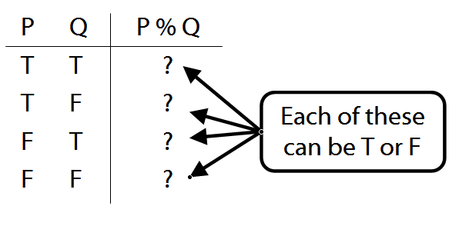
Truth-functional completeness: For any truth function, we can easily find a logically equivalent one using only ¬, ∨, ∧

Better: ‘A set of truth-functors is said to be expressively adequate (or sometimes functionally complete) iff, for every truth-function whatever, there is a formula containing only those truth-functors which express that truth-function, i.e. which has as its truth-table the truth-table specifying that function.’ (Bostock, Intermediate L’gic p. 45)

Illustration of how the proof that {¬, ∧, ∨ is truth-functionally complete}:
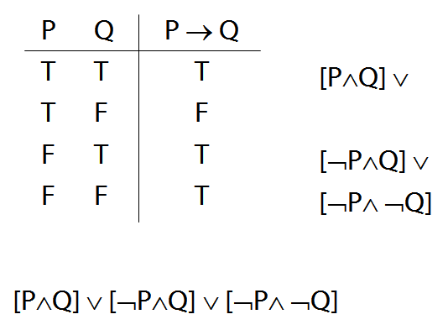

Exercise assuming {¬,∨,∧} is truth-functionally complete, show that {¬,∨} is?

Could There Be Nothing?
Here are three proofs that something exist. They indicate what in Fitch would need modifying to allow for the possibility of an empty world.

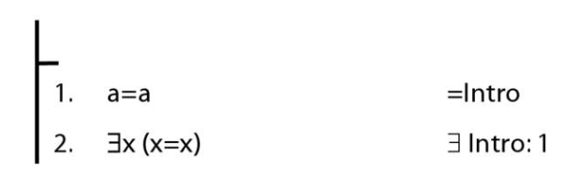

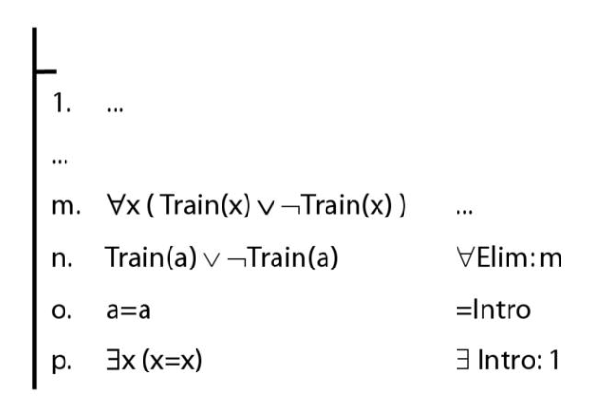

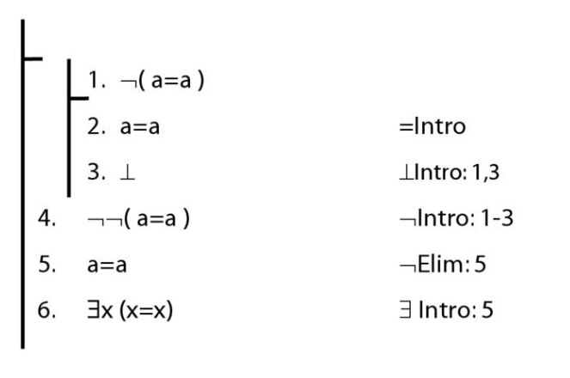

Exercises 08
There isn’t a seminar for these; you should attempt them over the vacation.
Not for fast groups
11.11, 11.13, *11.10
13.6–7, *13.8–9
13.19, 13.23–27 (*13.28–31)
(*13. 33, 35, 37, 39)
13.43–45, 13.49–50, *13.51–52
14.1, 14.2, 14.3 (*14.4–5) [trans]
*14.10–12, *14.13 [proofs]
*14.26, 14.28 [trans]

Despite what book says, DON’T even THINK about using TAUT CON.
Short of time? Skip the exercises marked *

