PH126 Logic I Fast Lecture 5
Lecturer: s.butterfill@warwick.ac.uk

Multiple quantifers
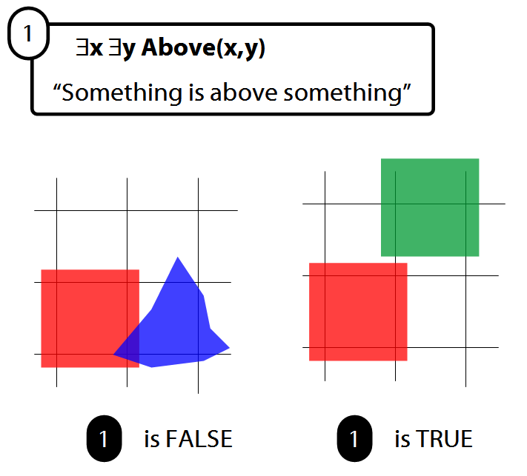

There is a store for everything
∃y∀x StoreFor(y,x)
∀y∃x StoreFor(x,y)
Other sentences to translate:
Wikipedia has an article about everything
Everyone hurts someone they love
Someone hurts everyone she loves

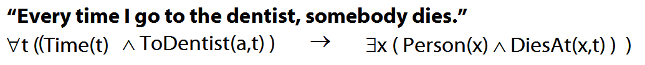
Quantifiers bind variables
Read §9.2 of Barwise & Etchemendy
Two objects are broken
∃x ∃y ( Broken(x)∧Broken(y)∧¬(x=y) )
To translate sentences involving number into FOL, use identity.

The Soundness & Completeness Theorems
‘A├ B’ means there is a proof of B using premises A
‘├ B’ means there is a proof of B using no premises
‘A╞ B’ means B is a logical consequence of A
‘╞ B’ means B is a tautology
‘A╞_{T} B’ means B is a logical consequence of A just in virtue of the meanings of truth-functions (the textbook LPL calls this ‘tautological consequence’)

Soundness: If A├ B then A╞ B
I.e. if you can prove it in Fitch, it’s valid

Completeness: If A╞_{T} B then A ├ B
I.e. if it’s valid just in virtue of the meanings

Exercise
If the following is valid, give a formal proof. If it is not valid, give a counterexample.
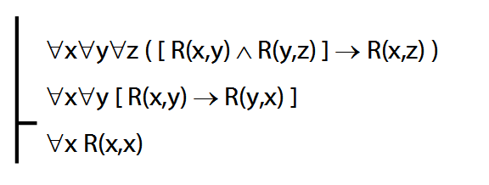

Reflexive, symmetric and transitive

A reflexive relation is one that everything bears to itself. (E.g. SameShape)
∀x R(x,x)
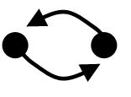
A symmetric relation is one such that if x bears it to y, then y bears it to x. (E.g. Adjacent(x,y).)
∀x∀y ( R(x,y) → R(y,x) )

A transitive relation is one such that if x bears it to y and y bears it to z then x bears it to z. (E.g. LeftOf is transitive; DifferentShape is not transitive) ∀x∀y∀z ( [ R(x,y) ∧ R(y,z) ] → R(x,z) )

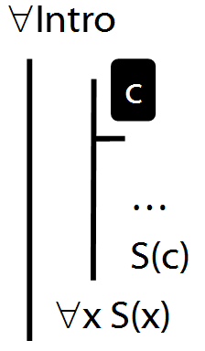

∀Intro Example proof
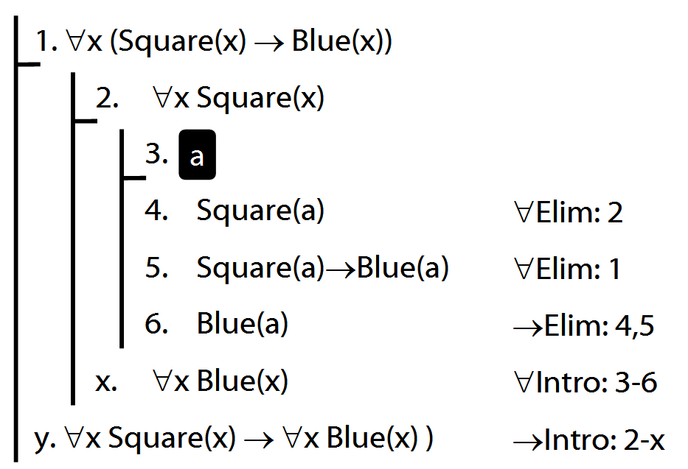
Exercise
If the following is valid, give a formal proof. If it is not valid, give a counterexample.
Quantifier Recap
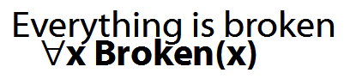
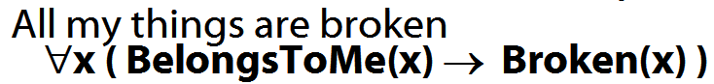
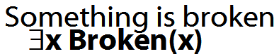
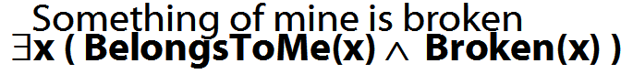
How to determine truth of a sentence with an existential quantifier as the main connective
1. Give every object a name.
2. For each name in turn, create a new sentence like this: delete the quantifier and replace all instances of the variable it binds with that name
3. If ANY OF the new sentences are true, so is the original.

How to determine truth of a sentence with a universal quantifier as the main connective
1. Give every object a name.
2. For each name in turn, create a new sentence like this: delete the quantifier and replace all instances of the variable it binds with that name
3. If ALL OF the new sentences are true, so is the original.
Multiple quantifiers
There is a store for everything
∃y∀x StoreFor(y,x)
∀y∃x StoreFor(x,y)
Other sentences to translate:
Wikipedia has an article about everything
Everyone hurts someone they love
Someone hurts everyone she loves

Exercises 06
For your sixth seminar
Only for fast groups
A. From the LPL textbook:
11.2, 11.4
11.8, 11.9, *11.11 (mixed quantifiers)
13.12, 13.14, 13.16 (quantifier proofs)
13.28 (quantifier proofs)
Despite what book says, DON’T even THINK about using TAUT CON.
B. For each of the following sentences of FOL, give a logically equivalent sentence of idiomatic English using the specified interpretation. Your English sentences should be as concise as possible.
Domain : people and actions
D(x) : x is desirable
V(x) : x is virtuous
A(x) : x is an action
H(x) : x is a person
P(x,y) : x performed y
i. ∀x [ D(x) → V(x) ]
ii. ∀x [ [A(x)∧ D(x) ] → V(x) ] ]
iii. ∃x [ A(x) ∧ ¬[ D(x) → V(x) ] ]
*iv. ∃x ∀y [[[H(x) ∧ A(y)] ∧ P(x,y)] → V(y)]
**v. ¬∃x [∃y [H(x) ∧ P(x,y) ∧ A(y) ∧ ¬V(y)]
∧ ¬∃z[P(x,z) ∧ A(z) ∧ V(z)]]

