PH126 Logic I Lecture 12
Lecturer: s.butterfill@warwick.ac.uk
Quantifier Recap
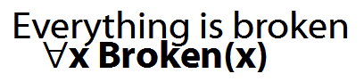
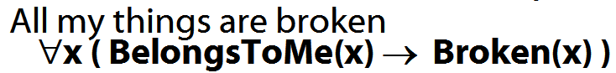
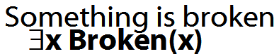
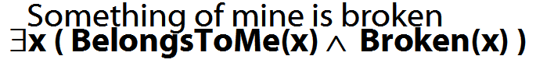
How to determine truth of a sentence with an existential quantifier as the main connective
1. Give every object a name.
2. For each name in turn, create a new sentence like this: delete the quantifier and replace all instances of the variable it binds with that name
3. If ANY OF the new sentences are true, so is the original.

How to determine truth of a sentence with a universal quantifier as the main connective
1. Give every object a name.
2. For each name in turn, create a new sentence like this: delete the quantifier and replace all instances of the variable it binds with that name
3. If ALL OF the new sentences are true, so is the original.
Multiple quantifiers
‘There is a store for everything’
∃y∀x StoreFor(y,x)
∀y∃x StoreFor(x,y)
Other sentences to translate:
‘Wikipedia has an article about everything’
‘Everyone hurts someone they love’
‘Someone hurts everyone she loves’

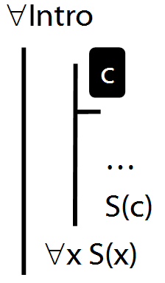

∀Intro Example proof
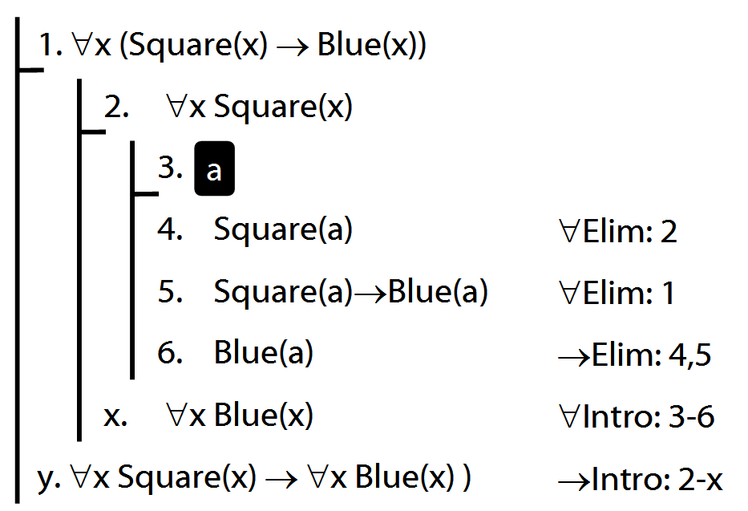
Why is this proof incorrect?
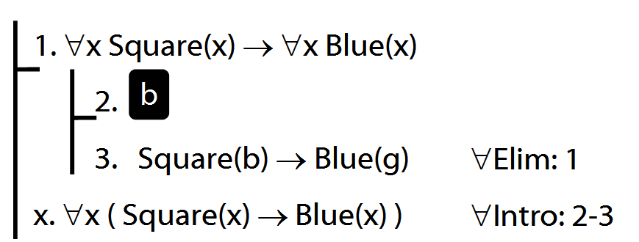

Intuitve summary of quantifier rules
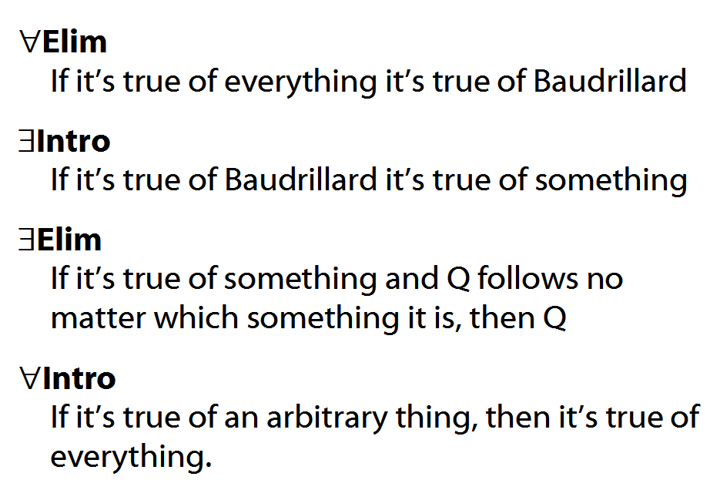

Notation:
A├ B means there is a proof of B using premises A
├ B means there is a proof of B using no premises
A├ means the same as A├ ⊥

A╞ B means B is a logical consequence of A

╞ B means B is a tautology
A╞ means the same as A╞ ⊥
A╞_{TT} B means B is a logical consequence of A just in virtue of the meanings of truth-functions (the textbook LPL calls this ‘tautological consequence’)

Proofs about proofs
1. If A├ B then ├ A→B
Proof Given a proof for A├ B …
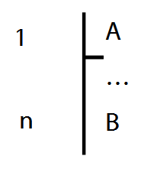
… we can turn it into a proof for ├ A→B:
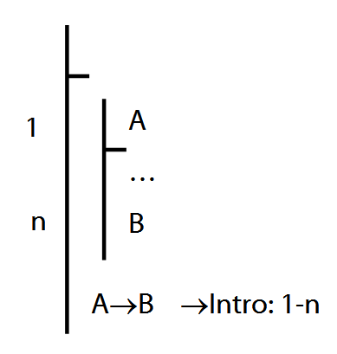

2. If ├ A→B then A├ B
3. If A├ B then A├ ¬¬B
Proof:
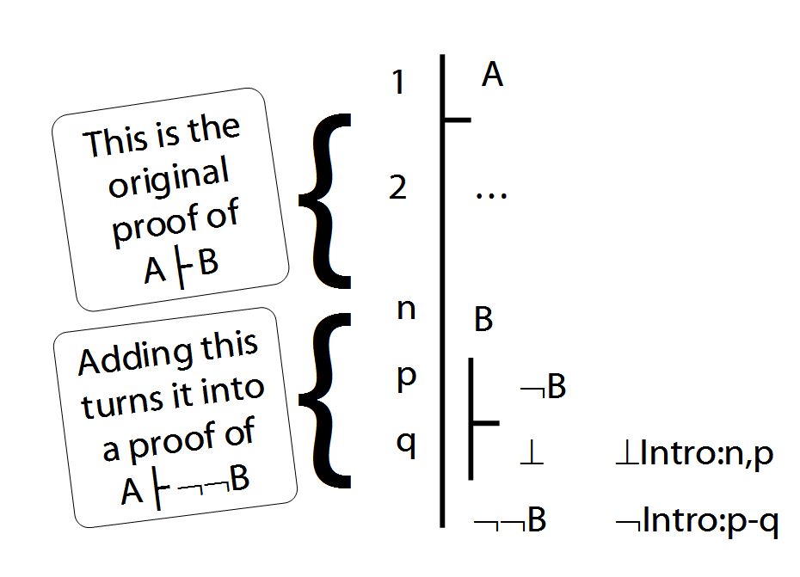
4. If A├ C then A├ B→C
5. If A├ B and A├ ¬C then A├ ¬(B→C)
Exercises 06
For your seventh seminar
Not for fast groups
A. From the LPL textbook:
9.15–17, *9.18–19 (trans.)
10.20, 10.22
11.2 (multiple quantifiers)
12.9–10
Short of time? Skip the exercises marked *

B. Each line of the table describes a combination of properties. E.g. line 1 specifies a relation that is reflexive, symmetric and transitive, line 2 specifies a relation that is reflexive, symmetric and not transitive. Complete the table by adding an example relation on each line.

