PH126 Logic I Fast Lecture 7
Lecturer: s.butterfill@warwick.ac.uk

Could there be nothing?
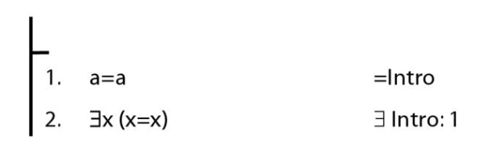

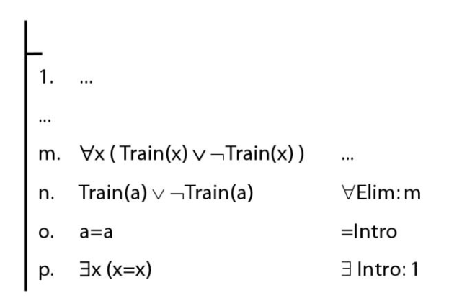

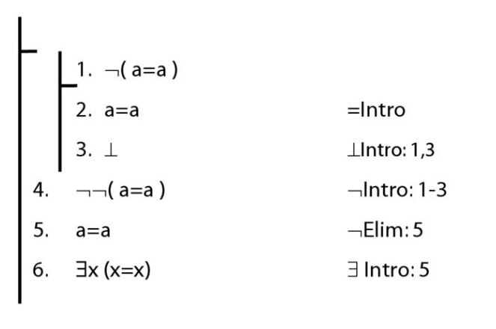

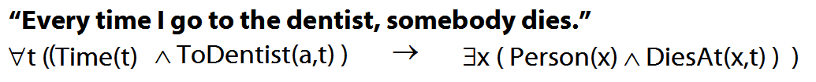

Quantifier equivalences (ctd)
Hybrid example
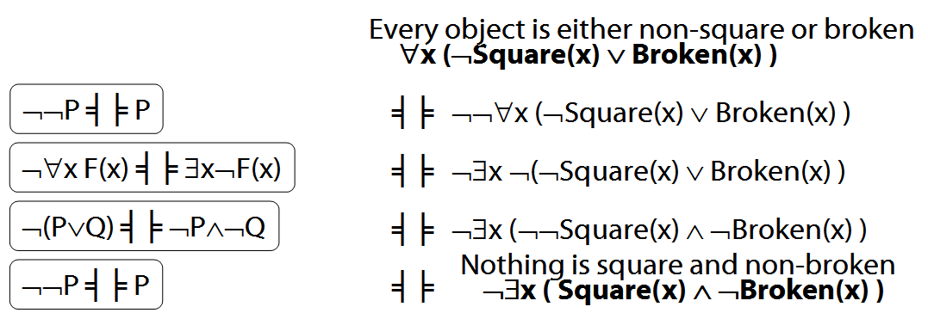

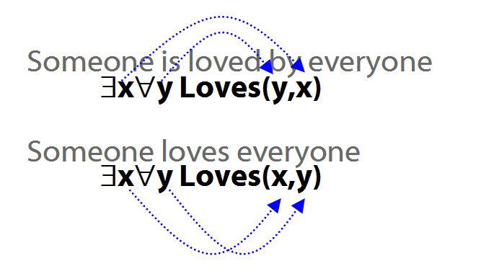

The Soundness Theorem

Notation:
A├ B means there is a proof of B using premises A

├ B means there is a proof of B using no premises

A├ means the same as A├ ⊥

A╞ B means B is a logical consequence of A

╞ B means B is a tautology

A╞ means the same as A╞ ⊥

A╞_{TT} B means B is a logical consequence of A just in virtue of the meanings of truth-functions (the textbook LPL calls this ‘tautological consequence’)

Soundness Theorem If A├ B then A╞ B
I.e. if you can prove it in Fitch, it’s valid

Completeness Theorem If A╞_{TT} B then A ├ B
I.e. if it’s valid just in virtue of the meanings of truth functions, you can prove it in Fitch

Illustration of soundness proof: ∨Intro
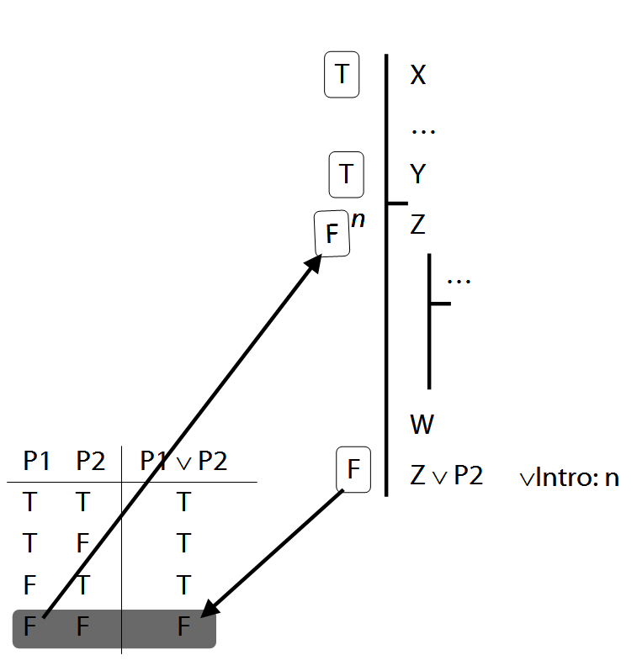
Proof of Soundness (If A├ B then A╞ B)

Useful Observation about any argument that ends with ∨Intro. Suppose this argument is not valid, i.e. the premises are true and the conclusion false. Then Z must be false. So the argument from the premises to Z (line n) is not a valid argument. So there is a shorter proof which is not valid.

Stipulation: when I say that ‘a proof is not valid’, I mean that the last step of the proof is not a logical consequence of the premises (including premises of any open subproofs).

Illustration of soundness proof: ¬Intro
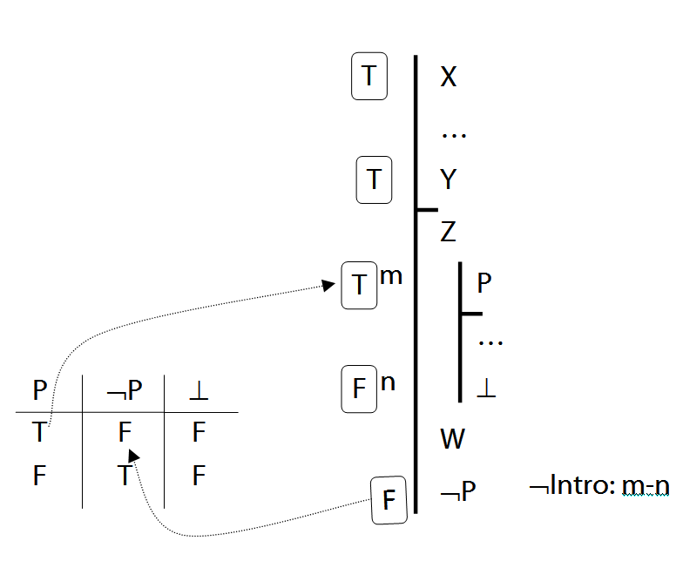

How to prove soundness? Outline
Step 1: show that each rule has this property:
Where the last step in a proof involves that rule, if proof is not valid then there is a shorter proof which is not valid.
Step 2: Suppose (for a contradiction) that some Fitch proofs are not valid. Select one of the shortest invalid proofs. The last step must involve one of the Fitch rules. Whichever rule it involves, we know that there must be a shorter proof which is not valid. This contradicts the fact that the selected proof is a shortest invalid proof.

Exercises 08
For your eighth seminar
Only for fast groups

13.51–2
14.4–5
14.13 [proofs]
14.26, 14.28

Despite what book says, DON’T even THINK about using TAUT CON.

Proofs about proofs
1. If A├ B then ├ A→B
Proof Given a proof for A├ B …
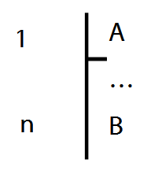
… we can turn it into a proof for ├ A→B:
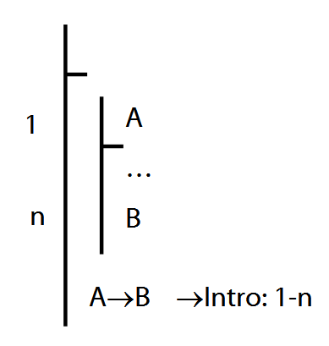

2. If ├ A→B then A├ B
3. If A├ B then A├ ¬¬B
Proof:
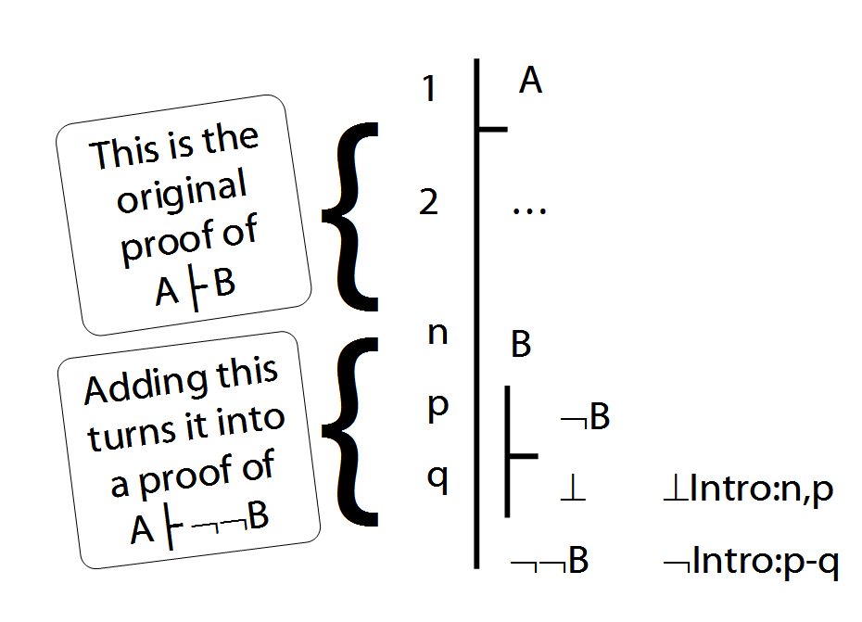
4. If A├ C then A├ B→C
5. If A├ B and A├ ¬C then A├ ¬(B→C)

Lemma for Completeness Theorem
If for every sentence letter, P, either A├ P or A├ ¬P, then for every formula, X, either A├ X or A├ ¬X.

Proof
Step a. Suppose (for a contradiction) that there are formulae, X, such that A├ X and A├ ¬X. Take a shortest such formula, call it Y.
Step b. This formula, Y, must have one of the following forms: ¬P, P∨Q, P∧Q, P→Q, P↔Q, ⊥
Step c. We can show that whichever form X has, either A├ Y and A├ ¬Y.
Case 1: X is P→Q. Then since P and Q are shorter than X, either:

(i) A ├ P and A ├ ¬Q
or

(ii) A ├ ¬P
or

(iii) A ├ Q
If (i), A├ ¬(P→Q), that is, A├ ¬X.
If (ii), A├ P→Q, that is, A├ ¬X.
If (iii), A├ P→Q, that is, A├ ¬X.
(Here we use (4) and (5) from Proofs about Proofs above)
Case 2: X is ¬P. Then since P is shorter,
A├ P or A├ ¬P.
If A├ P then A├ ¬¬P so A├ ¬X which would contradict our assumption. This is show in (3) above.
If A├ ¬P then A├ X (because X is ¬P), which would contradict our assumption.

Case 3: …
Step d. The demonstration in Step c contradicts our assumption, so we can conclude that it is false. That is, either A├ X and A├ ¬X for every formula X.

Completeness (if A╞_{T} B then A ├ B)

We prove only: 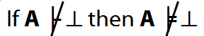
(See Lemma 2 p. 471 for how to generalise this result.)

