PH126 Logic I Lecture 10
Lecturer: s.butterfill@warwick.ac.uk

Scope
Underlining shows the scope of the quantifiers
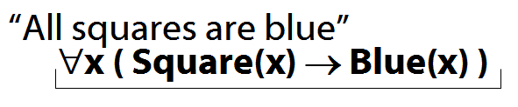
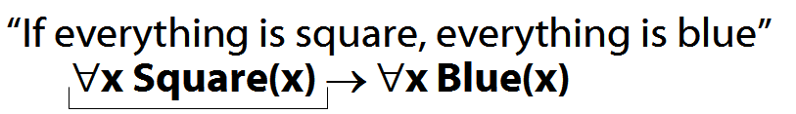

Quantifiers bind variables
Read §9.2 of Barwise & Etchemendy

Quantifiers and number
To translate statements involving number into FOL, use identity
E.g. Two objects are broken:
∃x ∃y ( Broken(x) ∧ Broken(y) ∧ ¬(x=y) )
Ex. Translate ∀Three objects are broken into FOL∀
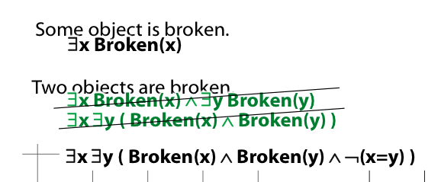

Proof example: ∃Elim
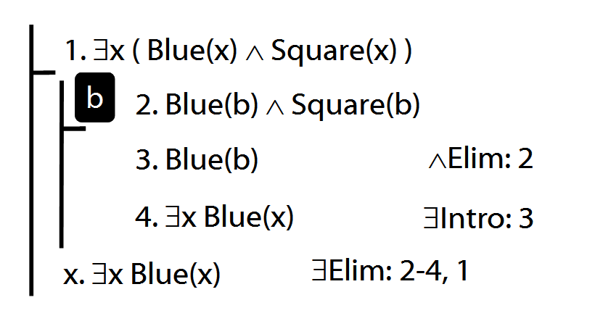
Invalid use of ∃Elim
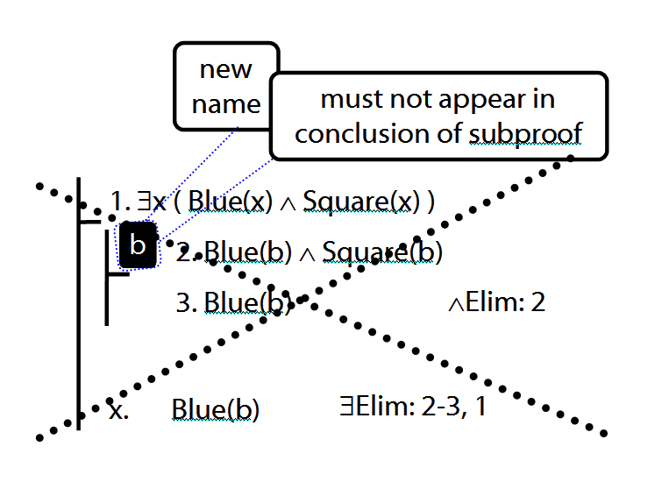
Tonk
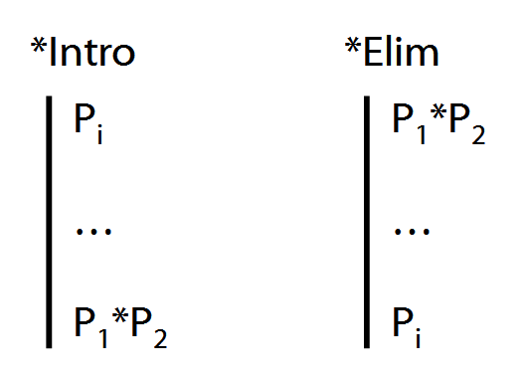

Exercises 05
(Same as from handout for lecture 09)
For your sixth seminar. Not for fast groups
A. From the LPL textbook:
7.9 (truth functions)
6.17–20 (proof)
6.33, 6.40
DO NOT USE TAUT CON. EVER.
8.24–25 (proofs/counterexamples)
12.4–5, *12.6–7 (counterexamples)

B. For each of the following sentences of FOL, give a logically equivalent sentence of idiomatic English using the specified interpretation. Your English sentences should be as concise as possible.
Domain : people and actions
D(x) : x is desirable
V(x) : x is virtuous
A(x) : x is an action
H(x) : x is a person
P(x,y) : x performed y
i. ∀x [ D(x) → V(x) ]
ii. ∀x [ [A(x)∧ D(x) ] → V(x) ] ]
iii. ∃x [ A(x) ∧ ¬[ D(x) → V(x) ] ]
*iv. ∃x[H(x) ∧ ∀y[[A(y) ∧ P(x,y)] → V(y)]]
**v. ¬∃x [∃y [H(x) ∧ P(x,y) ∧ A(y) ∧ ¬V(y)]
∧ ¬∃z[P(x,z) ∧ A(z) ∧ V(z)]]

