PH126 Logic I Lecture 13

Lecturer: s.butterfill@warwick.ac.uk

Quantifier equivalences

P→Q ╡╞ ¬Q→¬P
∀x ( Square(x) → Broken(x) )
╡╞ ∀x (¬Broken(x) → ¬Square(x) )

P→Q ╡╞ ¬P∨Q
∀x ( Square(x) → Broken(x) )
╡╞ ∀x (¬Square(x) ∨ Broken(x) )

¬P∨Q ╡╞ ¬(P∧ ¬Q)
∃x ¬F(x) ╡╞ ¬∀x F(x)
∀x (¬Square(x) ∨ Broken(x) )
╡╞ ∃x¬( Square(x) ∧ ¬Broken(x) )

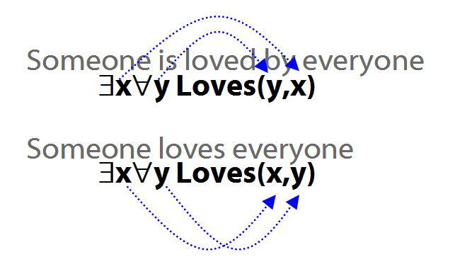
Quantifiers and negation (ctd)
Some person is dead.
∃x(Person(x) ∧ Dead(x))

Some person is not dead.
∃x(Person(x) ∧ ¬Dead(x))

No person is dead.
¬∃x(Person(x) ∧ Dead(x))

Every person is dead.
∀x(Person(x) → Dead(x))

Every person is not dead.
∀x(Person(x) → ¬Dead(x))

Not every person is dead.
¬∀x(Person(x) → Dead(x))

The Soundness Theorem

Notation:
A├ B means there is a proof of B using premises A

├ B means there is a proof of B using no premises

A├ means the same as A├ ⊥

A╞ B means B is a logical consequence of A

╞ B means B is a tautology

A╞ means the same as A╞ ⊥

A╞_{TT} B means B is a logical consequence of A just in virtue of the meanings of truth-functions (the textbook LPL calls this ‘tautological consequence’)

Soundness Theorem If A├ B then A╞ B
I.e. if you can prove it in Fitch, it’s valid

Completeness Theorem If A╞_{TT} B then A ├ B
I.e. if it’s valid just in virtue of the meanings of truth functions, you can prove it in Fitch

Proof of Soundness (If A├ B then A╞ B)

Useful Observation about any argument that ends with ∨Intro. Suppose this argument is not valid, i.e. the premises are true and the conclusion false. Then Z must be false. So the argument from the premises to Z (line n) is not a valid argument. So there is a shorter proof which is not valid.

Stipulation: when I say that ‘a proof is not valid’, I mean that the last step of the proof is not a logical consequence of the premises (including premises of any open subproofs).

How to prove soundness? Outline
Step 1: show that each rule has this property:
Where the last step in a proof involves that rule, if proof is not valid then there is a shorter proof which is not valid.
Step 2: Suppose (for a contradiction) that some Fitch proofs are not valid. Select one of the shortest invalid proofs. The last step must involve one of the Fitch rules. Whichever rule it involves, we know that there must be a shorter proof which is not valid. This contradicts the fact that the selected proof is a shortest invalid proof.

Illustration of soundness proof: ∨Intro
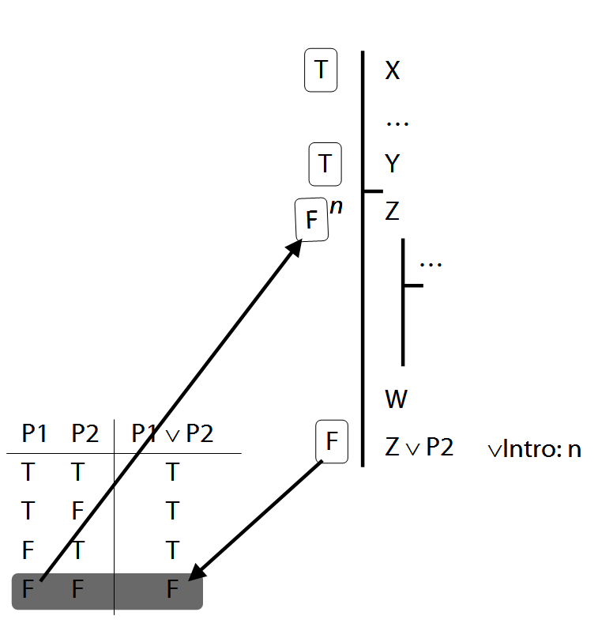

Illustration of soundness proof: ¬Intro
