PH126 Logic I Lecture 14
Lecturer: s.butterfill@warwick.ac.uk

Truth-functional completeness (LPL §7.4)
Preliminary: How many truth-functions can be constructed using 2 sentence letters?

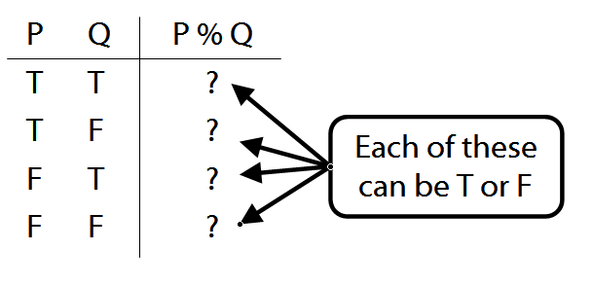

Truth-functional completeness: For any truth function, we can easily find a logically equivalent one using only ¬, ∨, ∧

Better: ‘A set of truth-functors is said to be expressively adequate (or sometimes functionally complete) iff, for every truth-function whatever, there is a formula containing only those truth-functors which express that truth-function, i.e. which has as its truth-table the truth-table specifying that function.’ (Bostock, Intermediate L’gic p. 45)
Illustration of how the proof that {¬, ∧, ∨ is truth-functionally complete}:
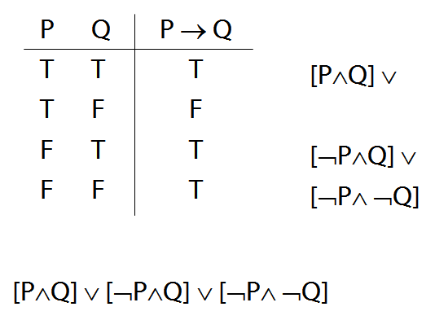

Exercise assuming {¬,∨,∧} is truth-functionally complete, show that {¬,∨} is?
Quantifiers and identity
Ahura Mazda created everything:
∀x Created(a,x)
Ahura Mazda created everything apart from himself: ∀x ( ¬(x=a) → Created(a,x) )

Quantifier proof exercise
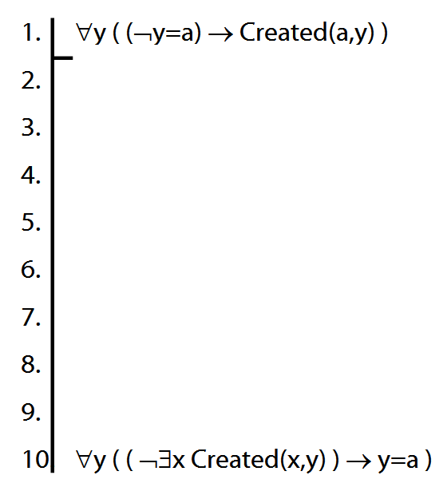

Variables
Names : a, b, c, …
Variables : x, y, z, w, …
Variables are for saying several things about one thing even without specifying which thing.

Optional extra proofs
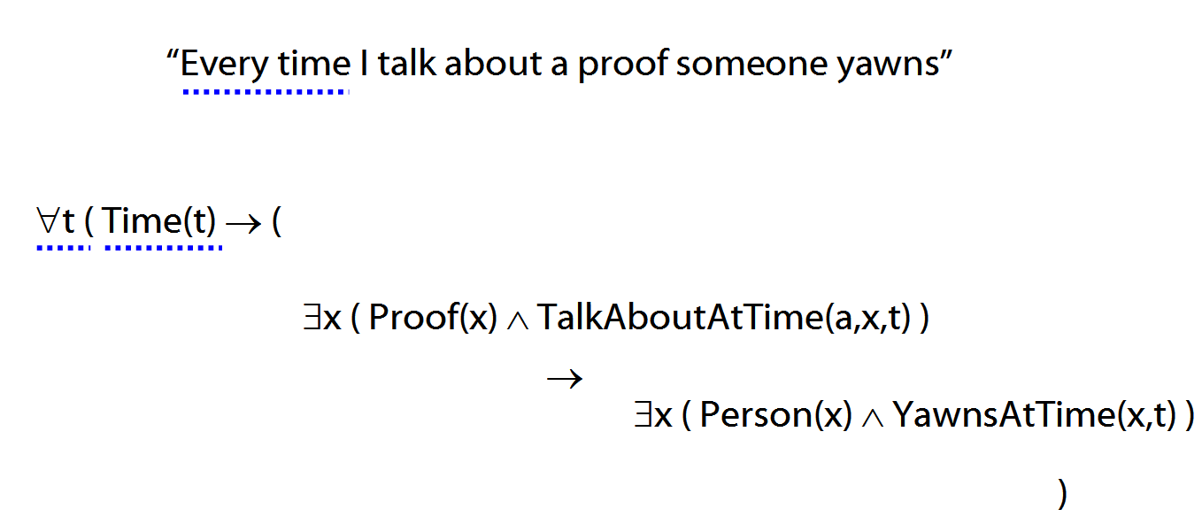
Some not all are valid. Prove the valid ones, give counterexamples for the non-valid.

1. ∃x ∀y R(x,y) ├ ∀y ∃x R(x,y)
2. ∀x ¬F(x) ├ ¬∃x F(x)
3. ¬∃x F(x) ├ ∀x ¬F(x)
4. ∀x F(x) | ∀x G(x) ├ ∀x (Fx ∨ Gx)
5. ∀x (Fx ∨ Gx) ├ ∀x F(x) | ∀x G(x)
6. ∀x F(x) ∨ ∃y F(y) ├ ∃y ∀x ( F(x) ∨ F(y) )
7. ∀x (F(x) ↔ x=a), ∀x (G(x) ↔ x=b) ├
a=b ↔ G(a)
8. ∃y ∀x (F(x) ↔ x=y) ├ (F(a) ∧ F(b) → a=b)

Exercises 07
For your eighth seminar
Not for fast groups
9.20 (trans.)
10.24–7, *10.28–9
*11.3
11.4, 11.8, 11.9
13.1–4 (quantifier proofs)
13.10–15 (*13.16)

Despite what book says, DON’T even THINK about using TAUT CON.
Proofs too easy? Try exercise 13.51
Translations too easy? Try 14.4–5
Short of time? Skip the exercises marked *

Proofs about proofs
1. If A├ B then ├ A→B
Proof Given a proof for A├ B …
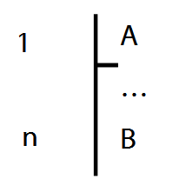
… we can turn it into a proof for ├ A→B:
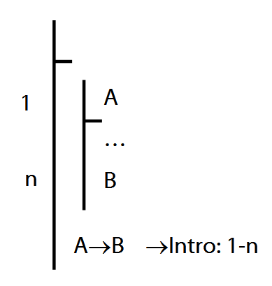

2. If ├ A→B then A├ B
3. If A├ B then A├ ¬¬B
Proof:
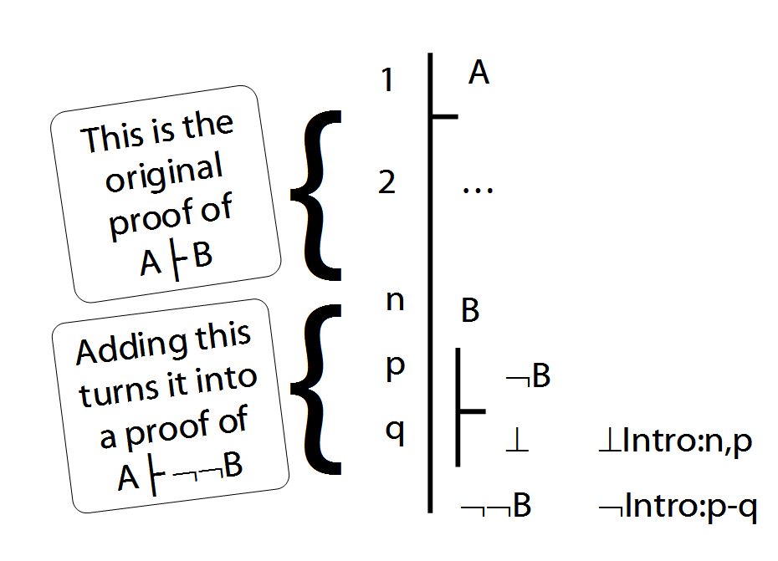
4. If A├ C then A├ B→C
5. If A├ B and A├ ¬C then A├ ¬(B→C)

Lemma for Completeness Theorem
If for every sentence letter, P, either A├ P or A├ ¬P, then for every formula, X, either A├ X or A├ ¬X.

Proof
Step a. Suppose (for a contradiction) that there are formulae, X, such that A├ X and A├ ¬X. Take a shortest such formula, call it Y.
Step b. This formula, Y, must have one of the following forms: ¬P, P∨Q, P∧Q, P→Q, P↔Q, ⊥
Step c. We can show that whichever form X has, either A├ Y and A├ ¬Y.
Case 1: X is P→Q. Then since P and Q are shorter than X, either:

(i) A ├ P and A ├ ¬Q
or

(ii) A ├ ¬P
or

(iii) A ├ Q
If (i), A├ ¬(P→Q), that is, A├ ¬X.
If (ii), A├ P→Q, that is, A├ ¬X.
If (iii), A├ P→Q, that is, A├ ¬X.
(Here we use (4) and (5) from Proofs about Proofs above)
Case 2: X is ¬P. Then since P is shorter,
A├ P or A├ ¬P.
If A├ P then A├ ¬¬P so A├ ¬X which would contradict our assumption. This is show in (3) above.
If A├ ¬P then A├ X (because X is ¬P), which would contradict our assumption.

Case 3: …
Step d. The demonstration in Step c contradicts our assumption, so we can conclude that it is false. That is, either A├ X and A├ ¬X for every formula X.

Completeness (if A╞_{T} B then A ├ B)

We prove only: 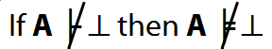
(See Lemma 2 p. 471 for how to generalise this result.)

