PH126 Logic I Lecture 15
Lecturer: s.butterfill@warwick.ac.uk
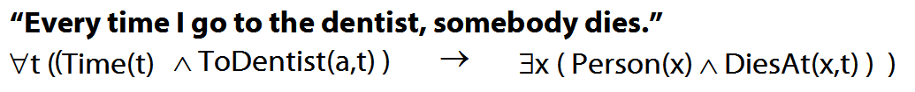
Quantifier equivalences (continued)
∃x ¬Created(x) ╡╞ ¬∀x Created(x)
Hybrid example
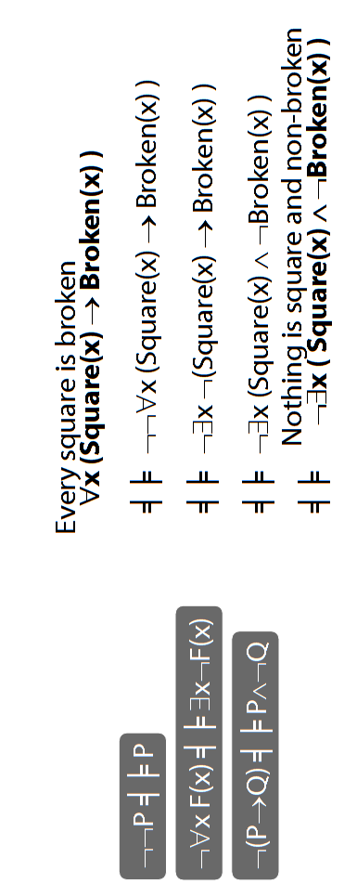

Number
There are at least two squares:
∃x ∃y ( Square(x) ∧ Square(y) ∧ ¬x=y)
At least two squares are broken:
∃x ∃y ( Square(x) ∧ Broken(x) ∧ Square(y) ∧ Broken(y) ∧ ¬x=y)
There are at least three squares:
∃x ∃y ∃z ( Square(x) ∧ Square(y) ∧ Square(z) ∧ ¬x=y ∧ ¬y=z ∧ ¬x=z)
There are at most two squares:
¬There are at least three squares
¬∃x ∃y ∃z ( Square(x) ∧ Square(y) ∧ Square(z) ∧ ¬x=y ∧ ¬y=z ∧ ¬x=z)
There are exactly two squares:
There are at most two squares ∧ There are at least two squares
Number: Alternatives
There is at most one square:
∀x∀y( (Square(x) ∧ Square(y)) → x=y )
There are at most two squares:
∀x∀y∀z( (Square(x)∧Square(y)∧Square(z))
→
(x=y∨y=z∨x=z)
)
There is exactly one square:
∃x ( Square(x) ∧ ∀y( Square(y) → x=y ))
There are exactly two squares:
∃x∃y (Square(x) ∧ Square(y) ∧ ¬x=y ∧
∀z( Square(z) → (z=x ∨ z=y) ))

Truth-functional completeness (LPL §7.4)
Preliminary: How many truth-functions can be constructed using 2 sentence letters?

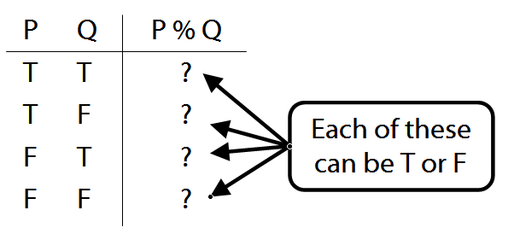
Truth-functional completeness: For any truth function, we can easily find a logically equivalent one using only ¬, ∨, ∧

Better: ‘A set of truth-functors is said to be expressively adequate (or sometimes functionally complete) iff, for every truth-function whatever, there is a formula containing only those truth-functors which express that truth-function, i.e. which has as its truth-table the truth-table specifying that function.’ (Bostock, Intermediate L’gic p. 45)

Illustration of how the proof that {¬, ∧, ∨ is truth-functionally complete}:
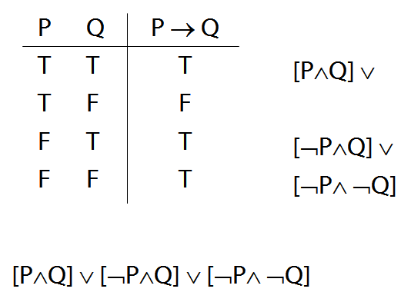

Exercise assuming {¬,∨,∧} is truth-functionally complete, show that {¬,∨} is?

