PH126 Logic I Fast Lecture 4
Lecturer: s.butterfill@warwick.ac.uk

Truth table for →
Assuming that the rules of Fitch are such that it is impossible to prove an argument which is not logically valid, the truth-table for → is fixed if we accept →Elim and →Intro.
How do the rules of proof for → fix its truth table?
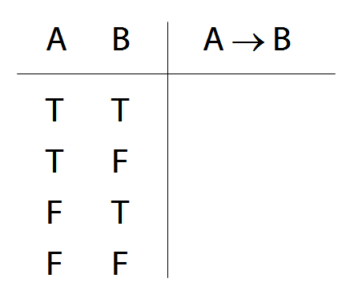

‘If’ and →
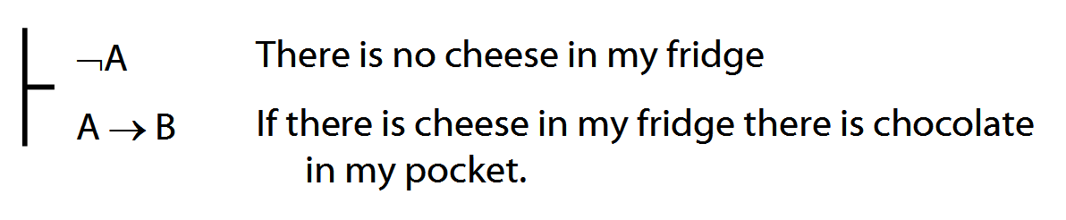
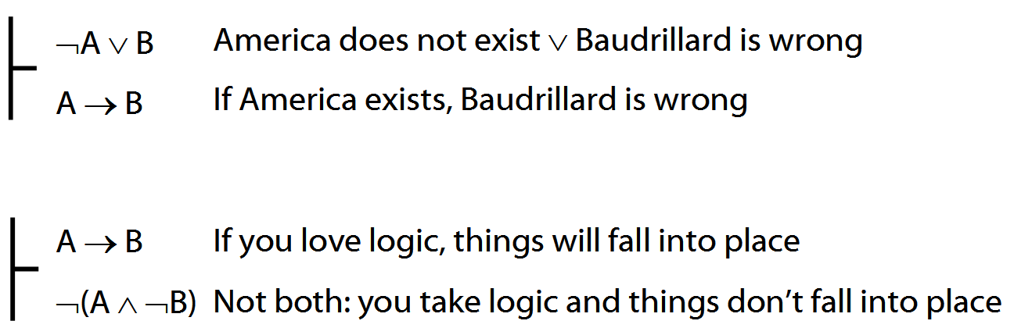
What does ∃ mean?
We give the meaning of ∃ by specifying what it takes for a sentence containing ∃ to be true:
1. Give every object a name.
2. For each name in turn, create a new sentence like this: delete the quantifier and replace all instances of the variable it binds with that name
3. If ANY OF the new sentences are true, so is the original.

∃ and ∧ work together
Some object is F and G: ∃x ( F(x) ∧ G(x) )
Some square is blue: ∃x (Square(x) ∧ Blue(x))
∀ and → work together
All my things are broken:
∀x (Belongs(a,x) → Broken(x))
All squares are blue:
∀x ( Square(x) → Blue(x) )

Substitution of logical equivalents
Two sentences are logically equivalent when each is a logical consequence of the other.
φ ╡╞ ψ means φ and ψ are logically equivalent.
Terminology: let χ[ψ/φ] be the result of replacing φ with ψ
E.g. (Q¬¬∨P) [P/¬¬P] = Q∨P
Theorem: If φ ╡╞ ψ then χ ╡╞ χ[ψ/φ]
How to determine the truth of sentences involving ∀
1. Give every object a name.
2. For each name in turn, create a new sentence like this: delete the quantifier and replace all instances of the variable it binds with that name
3. If ALL of the new sentences are true, so is the original.

Scope
Underlining shows the scope of the quantifiers
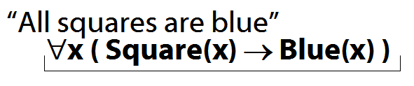
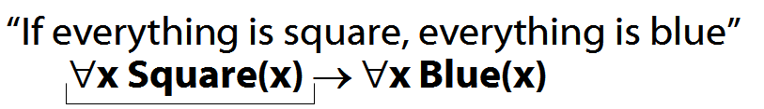

Multiple quantifers
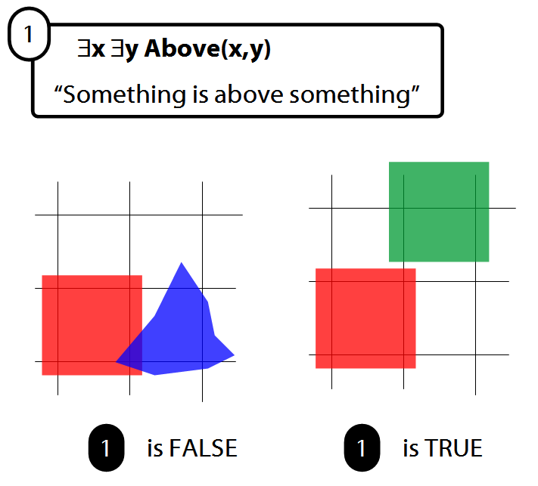
Quantifiers bind variables
Read §9.3 of Barwise & Etchemendy

Proof example: ∃Elim
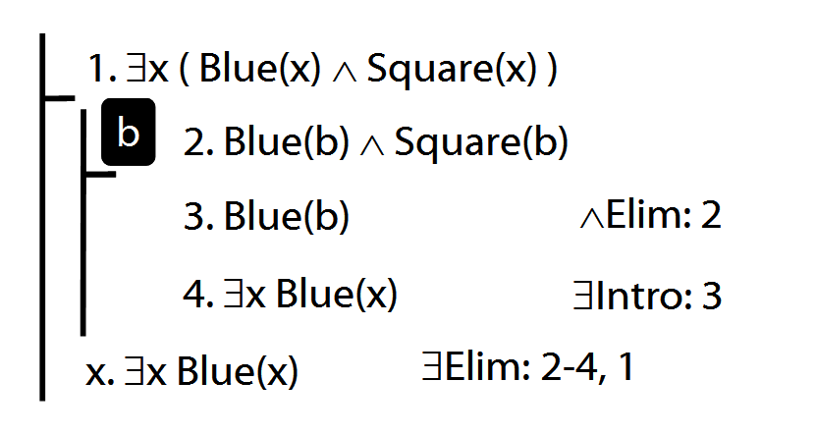

Invalid use of ∃Elim
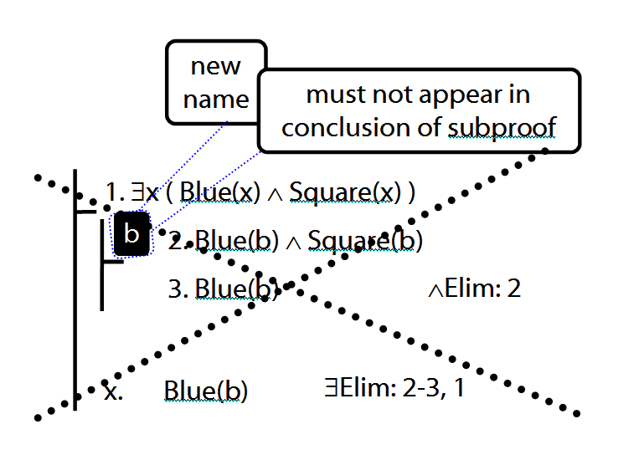

Two objects are broken
∃x ∃y ( Broken(x)∧Broken(y)∧¬(x=y) )
To translate sentences involving number into FOL, use identity.
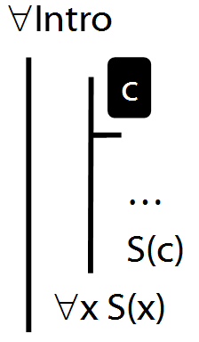

∀Intro Example proof
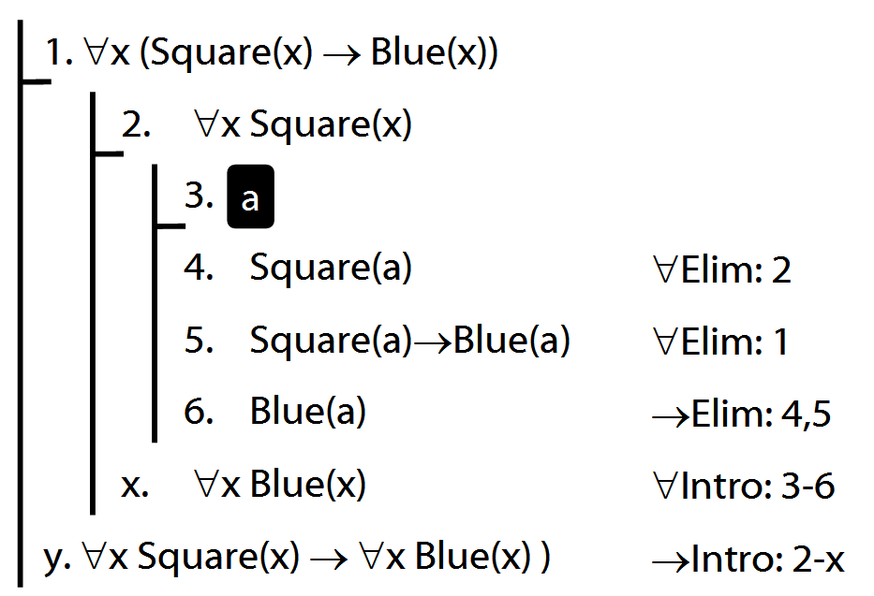

Why is this proof incorrect?
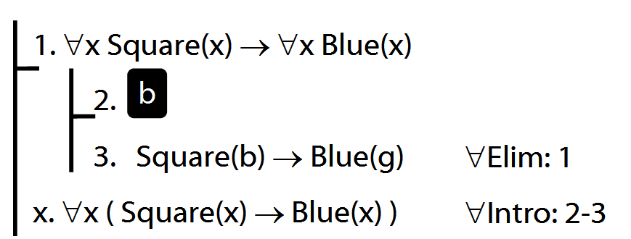

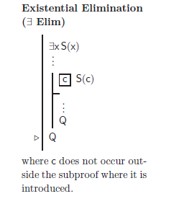
Intuitve summary of quantifier rules
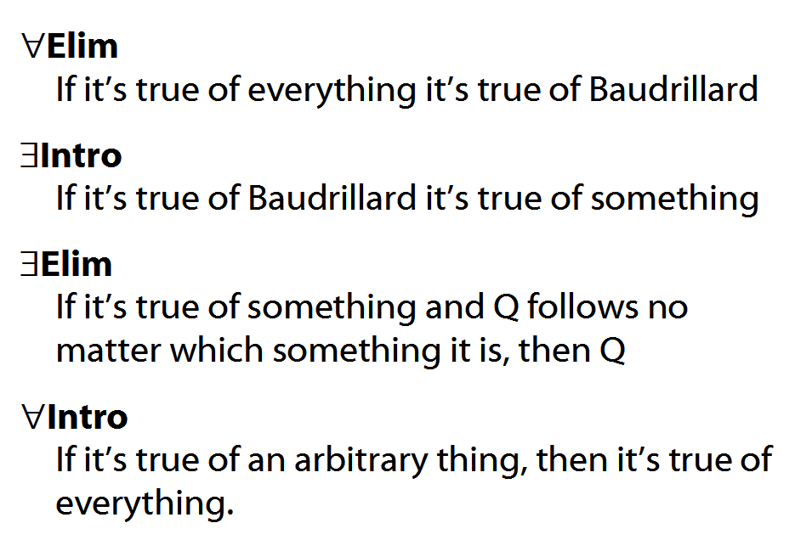

Exercises 05
For your fifth seminar
Only for fast groups
9.12–13
9.18–19 (trans.)
10.20, *10.24–7
10.28–9
13.2–3, 13.8–9 (quantifier proofs)
13.11, 13.13, 13.15
NEVER USE TAUT CON.

