**PH133 Logic I** Lecture 1

Lecturer: s.butterfill@warwick.ac.uk

An argument is *logically valid* just if there’s no possible situation in which the premises are true and the conclusion false

A *counterexample* to an argument is a possible situation in which its premises are T and its conclusion F.

An argument is *sound* just if it is logically valid and its premises are true

##### Identity: two principles

If b=c then anything true of b is also true of c

a=a is never false

**Truth tables for** ∧, ∨, ¬

|  |  |  |  |  |  |  |  |
| --- | --- | --- | --- | --- | --- | --- | --- |
| Rough guide:  ‘∧’ means and  ‘∨’ means or  ‘¬’ means not | |  |  | | --- | --- | | P | ¬P | | T | F | | F | T | |

|  |  |  |  |
| --- | --- | --- | --- |
| P | Q | P ∧ Q | P∨Q |
| T | T | T | T |
| T | F | F | T |
| F | T | F | T |
| F | F | F | F |

The *truth value* of a sentence is true (T) when the sentence is true and false (F) when the sentence is false.

Truth tables can be used to show that an argument is valid. For example:

|  |  |  |
| --- | --- | --- |
|  | P ∨ Q | // It went up the left fork or it went up the right fork |
|  | ¬P | // It didn’t go up the left fork |
|  | Q | // It went up the right fork |

Truth tables for this argument

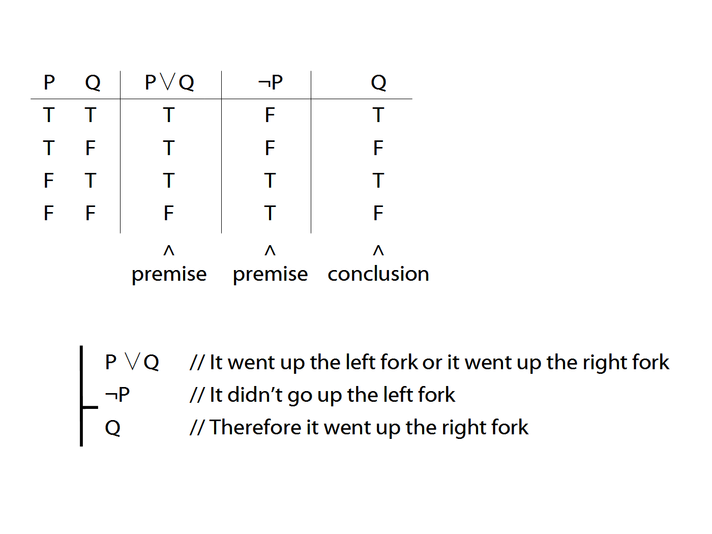

**Terminology**

A *connective* joins one or more sentences to make a new sentence. E.g. ‘because’, ‘¬’. The sentences joined by a connective are called *constituent sentences*.

E.g. in ‘P∨Q’,

∨ is the connective

P, Q are the constituent sentences

Complex truth table example

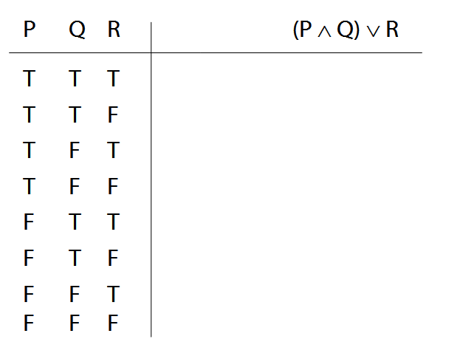

Logical Validity

Argument 3

1. (P ∧ Q) ∨ R

2. P ∨ ¬P

Argument 3b

1.

2. P ∨ ¬P

Argument 4

1. P ∧ ¬P

2. (P ∧ Q) ∨ R

P ∨ ¬P is a *logical truth*

logical truth defined p. 568

P ∧ ¬P is a *contradiction*

contradiction defined p. 564