**PH133 Logic**  Lecture 2

Lecturer: s.butterfill@warwick.ac.uk

An argument is *logically valid* just if there’s no possible situation in which the premises are true and the conclusion false

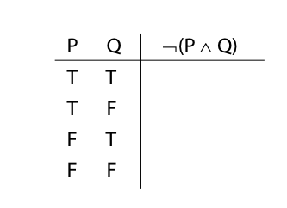

Logical Validity

Argument 3

1. (P ∧ Q) ∨ R

2. P ∨ ¬P

Argument 3b

1.

2. P ∨ ¬P

Argument 4

1. P ∧ ¬P

2. (P ∧ Q) ∨ R

P ∨ ¬P is a *logical truth*

logical truth defined p. 568

P ∧ ¬P is a *contradiction*

contradiction defined p. 564

Rules of proof

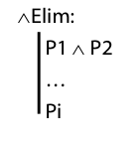

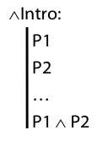

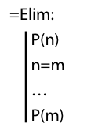

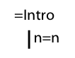Proofs with conjunction (∧)

*example*

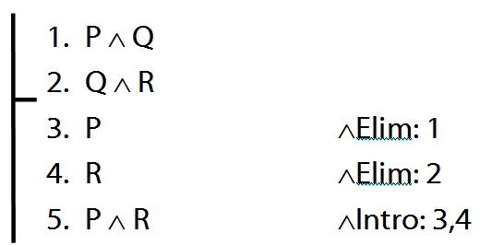

Proofs with identity

*example* (with missing justification)

