**PH133 Logic**  Lectures 3 & 4

Lecturer: s.butterfill@warwick.ac.uk

An argument is *logically valid* just if there’s no possible situation in which the premises are true and the conclusion false

**How to order reference columns**

(from lecture 2)

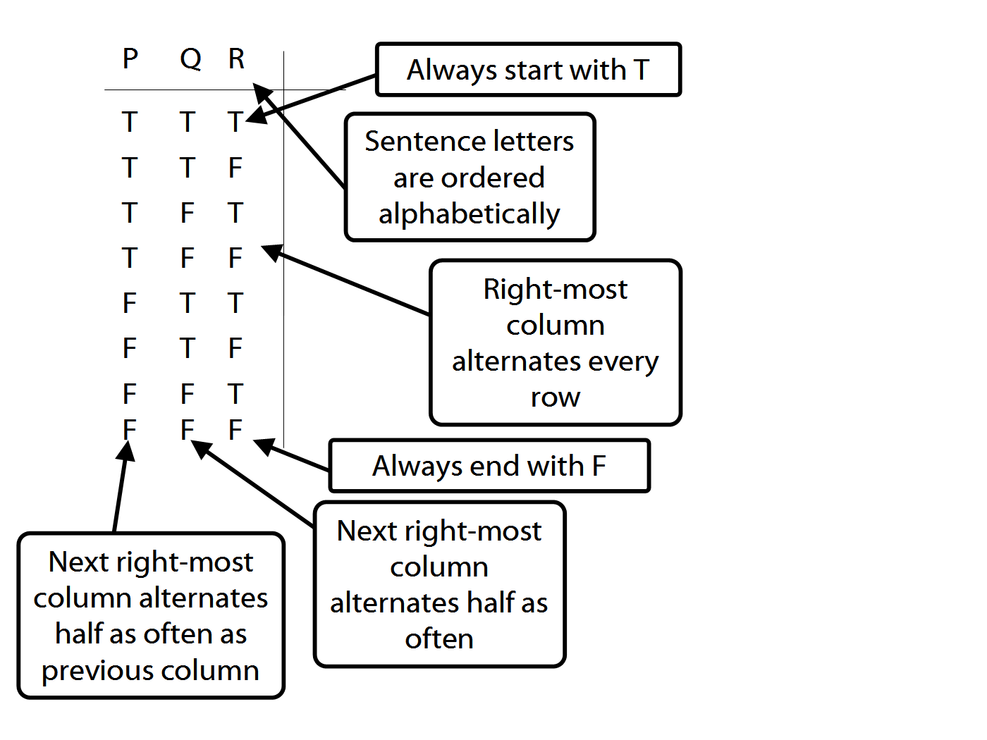

Proofs with ∧Intro and ∨Intro

*Example*

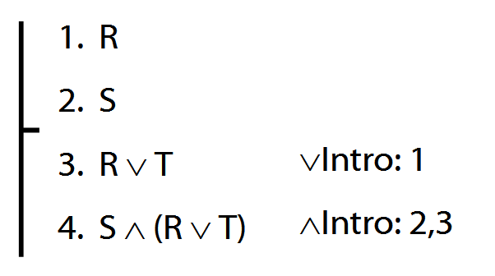

¬, ⊥

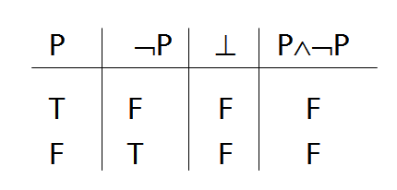

*Proof example*

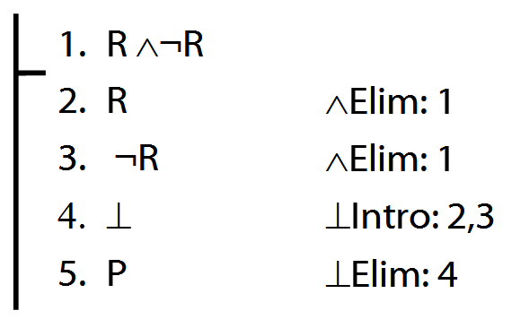

**Rules of Proof for** **→**

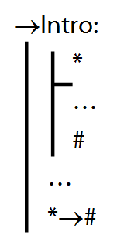 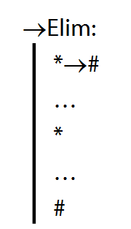

*Proof example for* **→***Intro*

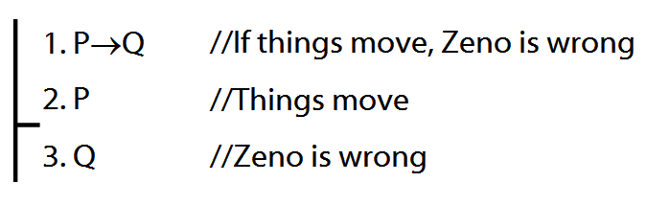

*Proof example for* **→***Elim (to complete)*

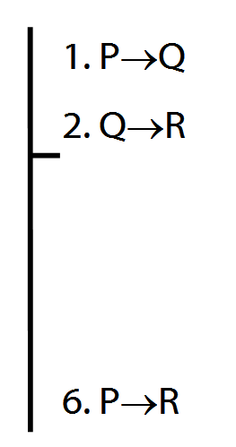

*Not all proofs have premises*

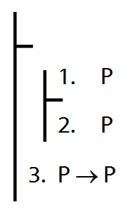

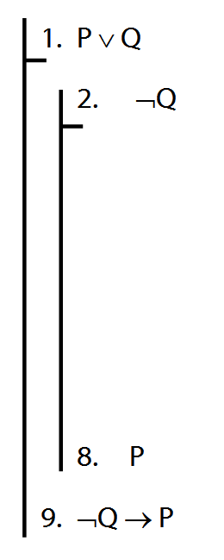

**A rule of proof for** ∨

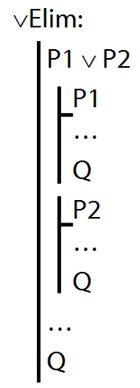 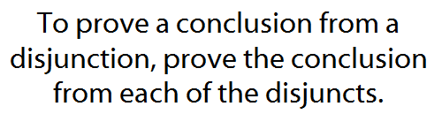

*Example proof*

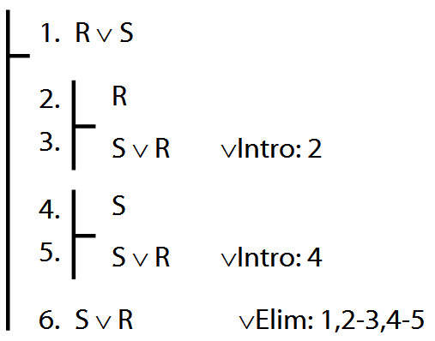

**Quantifiers --** ∀, ∃

Everything is broken: ∀x Broken(x)

Something is broken: ∃x Broken(x)

What does ∃ mean? We give the meaning of ∃ by specifying what it takes for a sentence containing ∃ to be true:

1. Give every object a name.

2. For each name in turn, create a new sentence like this: delete the quantifier and replace all instances of the variable it binds with that name

3. If ALL of the new sentences are true, so is the original.