**PH133 Logic**  Lecture 5

Lecturer: s.butterfill@warwick.ac.uk

**Truth table for →**

Assuming that the rules of Fitch are such that it is impossible to prove an argument which is not logically valid, the truth-table for **→** is fixed if we accept **→**Elim and **→**Intro.

*How do the rules of proof for* **→** *fix its truth table?*

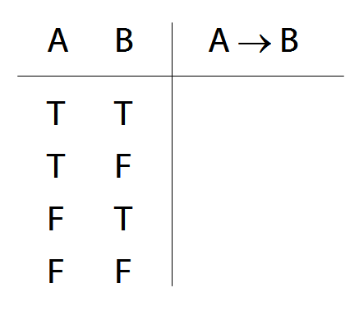

‘If’ and ‘→’ do not match

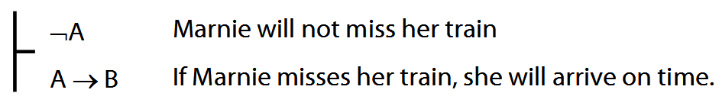

‘If’ and ‘→’ do match

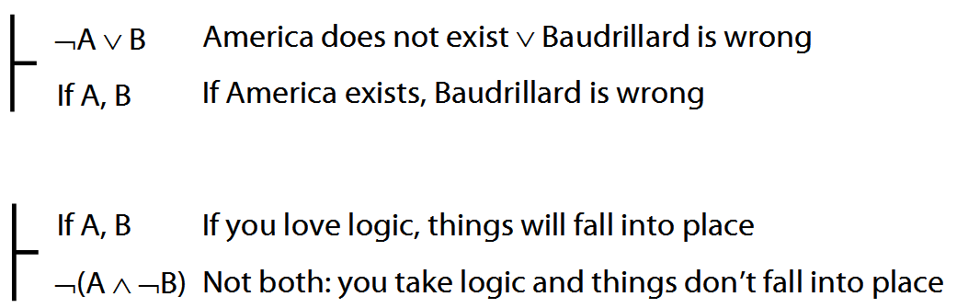

**Quantifiers**

Everything is broken: ∀x Broken(x)

Something is broken: ∃x Broken(x)

What does ∃ mean? We give the meaning of ∃ by specifying what it takes for a sentence containing ∃ to be true:

1. Give every object a name.

2. For each name in turn, create a new sentence like this: delete the quantifier and replace all instances of the variable it binds with that name

3. If ANY of the new sentences are true, so is the original.

**Translations**

Some persuasive and useful arguments are not valid.

∃x(Persuasive(x) ∧ Useful(x) ∧ Argument(x) ∧ ¬Valid(x))

All discordians weep.

∀x( Dscrdn(x) → Wps(x) )

All French discordians weep.

∀x( (Frnch(x)∧ Dscrdn(x) ) → Wps(x) )

All French discordians weep and wail.

∀x( ( Frnch(x) ∧ Dscrdn(x) ) →

( Wps(x) ∧ Wls(x) ) )

All French discordians weep and wail except Gillian Deleude.

∀x( ( Frnch(x) ∧ Dscrdn(x) ∧ ¬x=a) →

( Wps(x) ∧ Wls(x) ) )

**Fubar rules\***

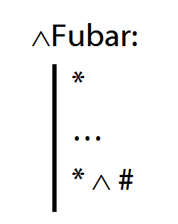

*Q1. What would be wrong with adding ∧Fubar to Fitch?*

*Q2. What would be wrong with having ∧Fubar in* any *system of proof?*

**Tonk**

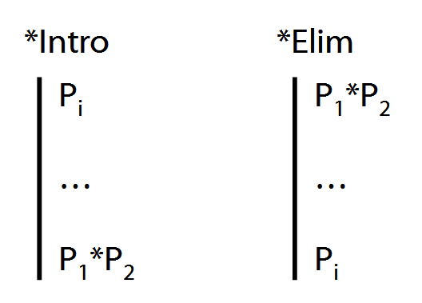

[\**I made up the Fubar rules. You don’t need to know them, and you won’t find them in the textbook. They’re only there as an illustration.*]