**PH133 Logic**  Lecture 6

Lecturer: s.butterfill@warwick.ac.uk

##### Rule of proof: ∀Elim

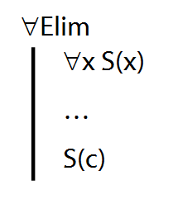

**DeMorgan and other equivalences**

¬(A ∧ B) ⫤⊨ (¬A ∨ ¬B)

¬(A ∨ B) ⫤⊨ (¬A ∧ ¬B)

A → B ⫤⊨ ¬A ∨ B

¬(A → B) ⫤⊨ ¬(¬A ∨ B) ⫤⊨ A ∧ ¬B

Scope

In P ∧ (Q∨R), the scope of ∧ is P∧ (Q∨R)

In P ∧ (Q∨R), the scope of ∨ is (Q∨R)

In (P∧Q) ∨R, the scope of ∧ is (P∧Q)

In (P∧Q) ∨R, the scope of ∨ is (P∧Q) ∨R

The scope of a connective is the smallest constituent expression which contains that connective.

**Subproofs are tricky**

Step 7 of this proof is wrong. Why?

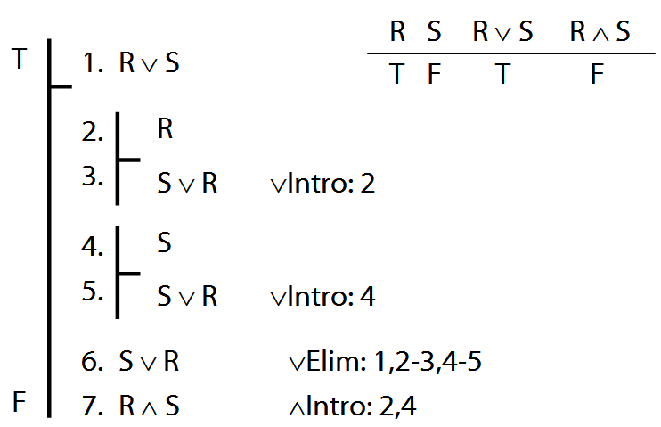

Which step of this proof is wrong? Why?

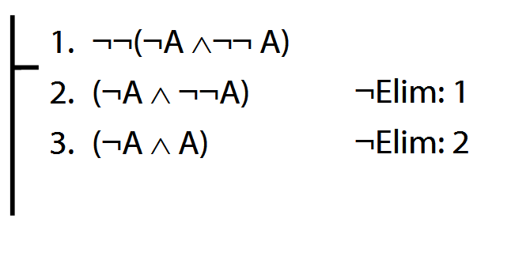

What not to confuse

∃x ( Square(x) ∧ Blue(x)) vs.   
 ∃x Square(x) ∧ ∃x Blue(x)

¬(P∨Q) vs. ¬P∨¬Q

¬(P∧Q) vs. ¬P∧¬Q

¬ (P**→**Q) vs. P**→**¬Q

**Proof example with →**

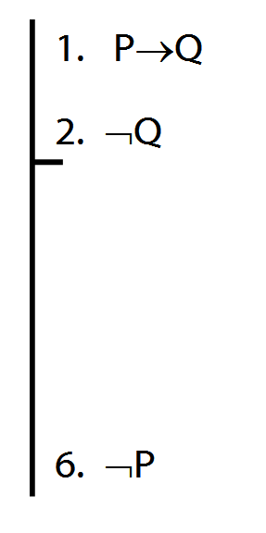

¬Intro proof example

