Abstraction:

A coffee shop website can be abstracted into the following core components:

1. Header:

Contains the logo, navigation menu, and potentially search bar or contact information.

2. Navigation:

Provides links to different sections of the website (home, menu, about us, contact, etc.).

3. Home Section:

Introduces the coffee shop, often with a captivating image and a strong call to action.

4. Order now, Book now:

Displays the coffee shop's offerings, including coffee, food, and beverages.

5. About our coffee:

Provides information about the coffee shop, its story, Few types of coffees offered in our café.

6.Our services:

Displays the coffee shop’s services and its mission.

7. Blogs:

Includes socials information, a recent content , and possibly a small info of our content.

8. Footer:

Contains copyright information, social media links, and additional navigation. Includes contact information, a contact form.

Abstraction Levels

Component-Based Abstraction

Create individual HTML and CSS files for each component.

This promotes reusability and maintainability.

Semantic HTML Abstraction

Use semantic HTML tags to define the purpose of each element.

Employ descriptive class names to enhance clarity.

CSS Architecture Abstraction

Adhere to a CSS methodology (OOCSS, SMACSS, BEM) for consistent styling.

Establish a clear hierarchy of CSS rules.

Ensure components adapt to different screen sizes (Responsive Design).

Future upgrades:

Accessibility: Make the website usable by people with disabilities.

Performance: Optimize images and CSS for faster loading times.

Maintainability: Write clean, well-formatted code with consistent indentation.

HTML & CSS Source codes used:

Filename: index.html (Main page)

<!DOCTYPE html>

<html lang="en">

<head>

    <meta charset="UTF-8">

    <title>cafecoffee</title>

<style>

body {

   font-family: Arial, sans-serif;

   margin: 0;

   padding: 0;

   color: #333;

   background-color: #e8b385;

}

header {

   background-color: #f8f8f8;

   color: #ddd;

   padding: 20px;

   text-align: center;

}

nav {

   margin-bottom: 20px;

}

nav a {

   margin: 0 10px;

   color: #DDD;

   text-decoration: none;

   font-size: 40px;

   margin-left: 25PX;

}

section {

   padding: 40px;

   text-align: center;

}

h1, h2 {

   color: #444;

}

button {

   background-color: #e67e22;

   color: #fff;

   border: none;

   padding: 10px 20px;

   border-radius: 25px;

   cursor: pointer;

   text-decoration: none;

}

.product-grid, .gallery-grid, .blog-grid {

   display: grid;

   grid-template-columns: repeat(auto-fit, minmax(200px, 1fr));

   gap: 20px;

   height: 800px;

}

.product-item, .gallery-item, .blog-item {

   background-color: #f8f8f8;

   padding: 20px;

   border-radius: 5px;

   margin-bottom: 30px;

}

.product-item img, .gallery-item img, .blog-item img {

   width: 100%;

   height: 200px;

   background-color: #ddd;

   margin-bottom: 10px;

}

footer {

   background-color: #333;

   color: #fff;

   padding: 20px;

   text-align: center;

}

#cmain{

    color: #ddd;

    position: relative;

    height: 1000px;

    background-image: url('/maincafecoffee.jpg');

background-size: cover;

background-repeat: no-repeat;

}

</style>

<body>

   <header id="cmain">

       <nav><h1 style="font-size: 90px;text-align: left;color: #ddd; margin-top: 0px;margin-bottom: 0px;">Coffee Cafe</h1>

           <a href="#home">Home</a>

           <a href="#about">About Our Coffee</a>

           <a href="#services">Our Services</a>

           <a href="#blog">Blog</a>

           <a href="#gallery">Gallery</a>

           <a href="#contact">Contact Us</a>

       </nav>

       <p style="font-size: 40px; margin-top: 250px;">Coffee shop is the place where you can get flavored coffee from global sources. <BR>Enjoy our specialty coffee and experience the taste of the world.</p>

<button  type="button" class="order" style="font-size: 45px; color: #DDD; text-decoration: none;"><a href="/menu.html">Book Now</a></button>

</header>

<section id="about">

       <h2 style="font-size: 60px;">Elite Coffee Brands</h2>

       <p style="font-size: 30px;">At Coffee Cafe, we only use the finest coffee beans sourced from around the world. Our elite brands are carefully curated to provide you with the best coffee experience.</p>

       <div class="product-grid">

           <div class="product-item" style="background-color:#FDD8C7;">

         <img src="/espresso.jpg" alt="Coffee Item 1" style="height: 500px;">

               <h3 style="font-size: 30px;">Espresso Americano</h3>

     <p style="font-size: 30px;">Cold brewed espresso with steamed milk.</p>

<button  type="button" class="order" style="font-size: 45px; color: #DDD; text-decoration: none;"><a href="/menu.html">ORDER NOW</a></button>

           </div>

           <div class="product-item" style="background-color:#FDD8C7;">

       <img src="/cappucino.jpg" alt="Coffee Item 2" style="height: 500px;">

           <h3 style="font-size: 30px;">Cappuccino</h3>

     <p style="font-size: 30px;">Espresso with milk and a touch of cream.</p>

       <button  type="button" class="order" style="font-size: 45px; color: #DDD; text-decoration: none;"><a href="/menu.html">ORDER NOW</a></button>

           </div>

           <div class="product-item"style="background-color:#FDD8C7;">

         <img src="/cold brew.jpg" alt="Coffee Item 3"style="height: 500px;">

               <h3 style="font-size: 30px;">Cold Brew</h3>

     <p style="font-size: 30px;">Cold brewed coffee with a touch of cream.</p>

<button  type="button" class="order" style="font-size: 45px; color: #DDD; text-decoration: none;"><a href="/menu.html">ORDER NOW</a></button>

       </div>

   </section>

   <section id="services" style="background-color:#FDD8C7;">

       <h2 style="font-size: 60px;">Our Services</h2>

 <p style="font-size: 30px;">A team of dedicated coffee experts who craft the finest coffee experiences.</p>

       <p style="font-size: 30px;">We make the delicious coffee we serve.</p>

<p style="font-size: 30px;">Coffee Cafe is a place where you can enjoy the best coffee.</p>

<p style="font-size: 30px;">We undertake orders and also provide home delivery.</p>

<p style="font-size: 30px;">Most of the worker are friendly with our coustomers and guests.</p>

       <p style="font-size: 30px;">We always keep our cafe clean and neat.</p>

       <p style="font-size: 30px;">Here are some of the things we offer to enhance the customer experience:</p>

        <p style="font-size: 30px;"> Knowledgeable baristas: who can help you choose a drink or customize it to your taste.</p>

        <p style="font-size: 30px;"> Comfortable seating with indoor and outdoor options at many locations.</p>

        <p style="font-size: 30px;">  Free Wi-Fi</p>

        <p style="font-size: 30px;"> Mobile ordering so you can skip the line.</p>

        <p style="font-size: 30px;">Rewards program that allows you to earn points for purchases and redeem them for free drinks and food.</p>

   </section>

   <section id="gallery">

       <h2 style="font-size: 60px;">Portfolio Gallery</h2>

       <div class="gallery-grid">

           <div class="gallery-item" style="background-color:#FDD8C7;">

     <img src="/coldbrew2.jpg" alt="Gallery Item 1" style="height: 500px;">

               <h3 style="font-size: 30px;">Cold Brew</h3>

   <p style="font-size: 30px;">A cold brewed coffee with a touch of cream.</p>

           </div>

           <div class="gallery-item" style="background-color:#FDD8C7;">

       <img src="/americano.jpg" alt="Gallery Item 2" style="height: 500px;">

               <h3 style="font-size: 30px;">Espresso Americano</h3>

<p style="font-size: 30px;">Cold brewed espresso with steamed milk and a touch of cream.</p>

           </div>

           <div class="gallery-item"style="background-color:#FDD8C7;">

       <img src="cappcino.jpg" alt="Gallery Item 3" style="height: 500px;">

               <h3 style="font-size: 30px;">Cappuccino</h3>

    <p style="font-size: 30px;">Espresso with milk and a touch of cream.</p>

           </div>

       </div>

   </section>

   <section id="blog">

       <h2 style="font-size: 60px;">Our Latest Blog Posts</h2>

       <div class="blog-grid" style="height: 325px;">

           <div class="blog-item" style="background-color:#FDD8C7;">

    <h3 style="font-size: 30px;">&#9749;What Makes Coffee Taste Good?</h3>

               <p style="font-size: 30px;">Coffee taste depends on:<br>

                Beans: Different kinds taste new.<br>

                Roast: How the beans are cooked changes the flavor.<br>

          </p>

           </div>

           <div class="blog-item"style="background-color:#FDD8C7;">

               <h3 style="font-size: 30px;">👨‍🍳How to Make Coffee</h3>

               <p style="font-size: 30px;">Varying the amount of coffee, water, and brewing methods can all affect the taste of coffee.

                Different varity of coffee beans to make different taste unique and flavored.

               </p>

           </div>

           <div class="blog-item" style="background-color:#FDD8C7;">

               <h3 style="font-size: 30px;">&#x1f375;Brewing Methods</h3>

<p style="font-size: 30px;">Different brewing methods can all affect the taste of coffee.

                Brewing for each type of coffee are different and unique.

               </p>

           </div>

       </div>

</body>

   <footer id="contact">

       <h2 style="color: white;">Connect with Us</h2>

       <p>Follow us on social media platforms for updates and announcements.</p>

       <p>insta:cafecoffee.000</p>

       <p>twitter:cafecoffee.0000</p>

       <p>We'd love to hear from you. You can also find us on the web.</p>

       <p>contact:90xxxxxxxxx</p>

       <p>Email us at info@coffee.com</p>

   </footer>

</body>

</html>

Visual output of the code:

Home:

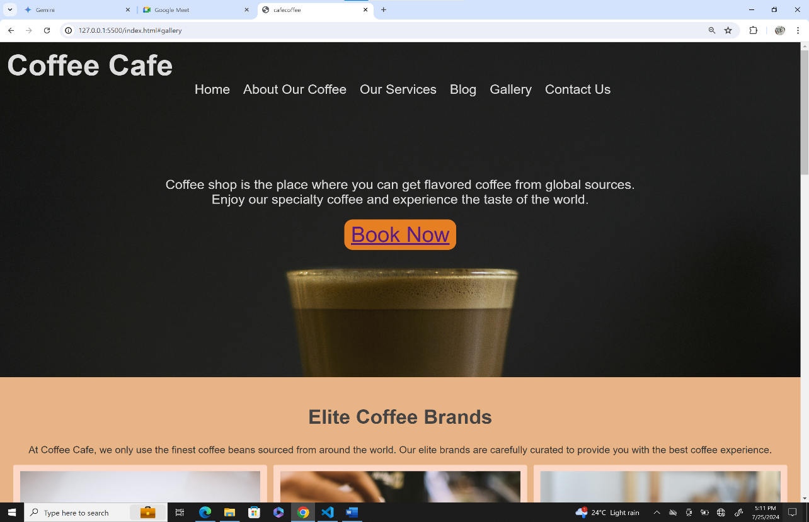

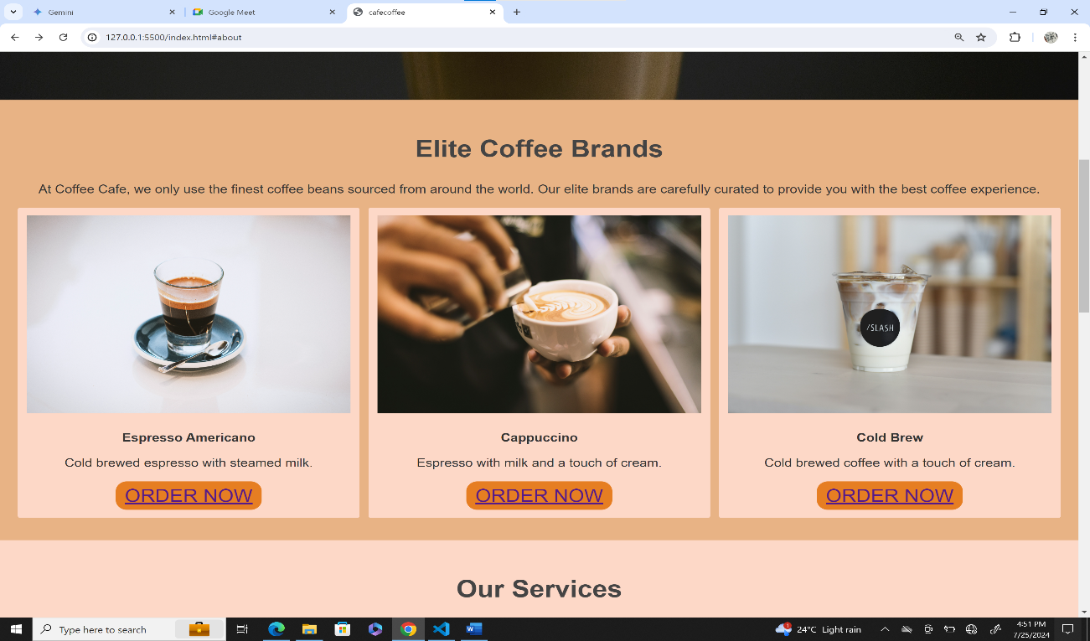About our coffee:

Our services:

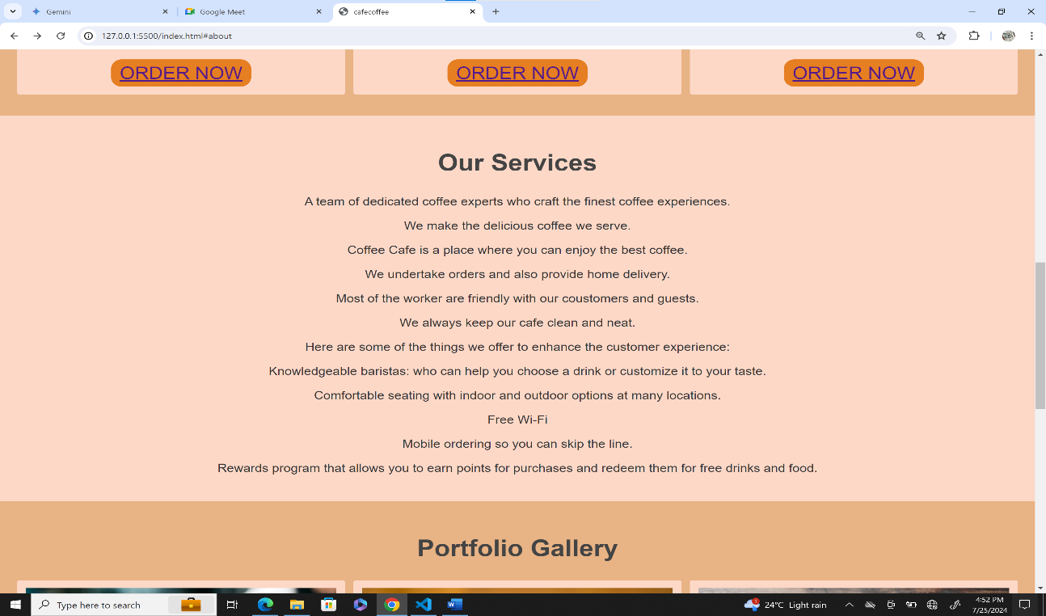

Gallery:

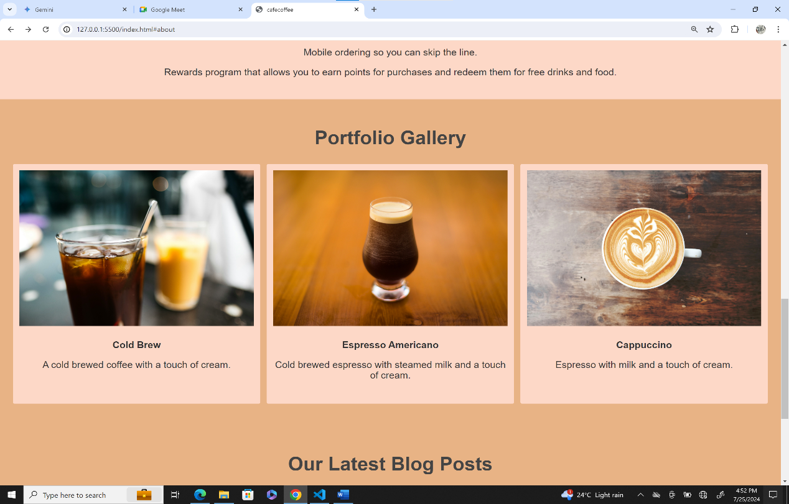

Blog & Contact us:

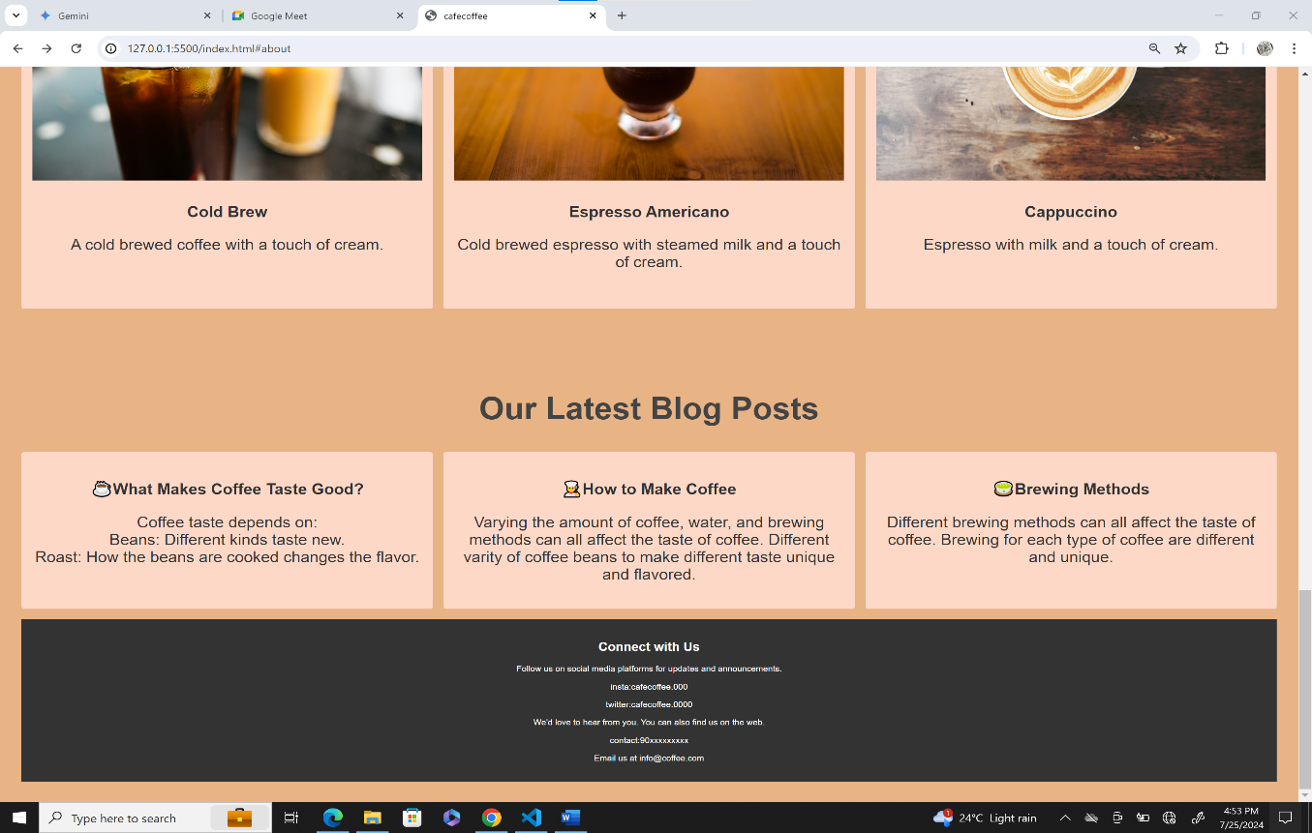

HTML Source code:

Filename:menu.html (order now , book now buttons)

<!DOCTYPE html>

<html lang="en">

<head>

    <meta charset="UTF-8">

    <meta name="viewport" content="width=device-width, initial-scale=1.0">

    <title>menu of cafe</title>

    <link rel="stylesheet" href="style1.css">

</head>

<body>

    <h1>OUR MENU</h1>

    <P>Browse through our diverse range of coffee options, carefully crafted to provide the ultimate coffee experience. Enjoy every sip at Coffee Haven! </P><hr>

    <section class="menu">

        <button class="bm1">Espresso ........$2.50</button><br>

        <button class="bm1">Latte................$4.00</button><br>

        <button class="bm1">cappuccino......$3.50</button><br>

        <button class="bm1">americano.......$2.75</button><br>

        <button class="bm1">mocha.............$4.50</button><br>

        <button class="bm1">flat White ........$3.75</button><br>

        <button class="bm1">frappuccino.....$2.15</button><br>

        <button class="bm1">nitrocoldbrew...$4.25</button><br>

        <button class="bm1">Cortado...........$3.25</button>

    </section>

</body>

</html>

CSS source code of menu:

 \*{

    margin: 0;

    padding: 0px;

    font-size: larger;

}

hr{width: 1720px;

    height: 5px;

background-color: black;

position: absolute;

top: 170px;

left: 352PX;

}

H1,P{  margin-top: 30px;

    text-align: center;

    font-size: 50px;

}

P{

    font-size: 30PX;

}

.menu{

       background-color: black;

       color:white;

       position: absolute;

       width: 100%;

       top: 200px;

       height: 1250px;

    }

 .bm1{

    font-size: 60px;

    color: white;

    border-width: 2px;

    background-color: black;

    border-color: white;

    border-radius: 30px;

    margin-right: 20px;

    margin-top: 25px;

    padding: 20px;

    margin-left:890px;

 }

 marquee{

    animation: marquee 1s linear infinite;

 }

 #m1{

    background-color: black;

    width: 1000px;

    height: 800px;

    position: absolute;

    top: 700px;

    display: flex;

    align-items: center;

    justify-content: center;

    border-radius: 30px;

 }

 #md2{

    color: black;

    border-width: 3px;

    border-color: black;

    margin-right: 5px;

 }

 #m2{

    position: absolute;

    top:700px ;

    right: 150px;

 }

Visual output of the code:

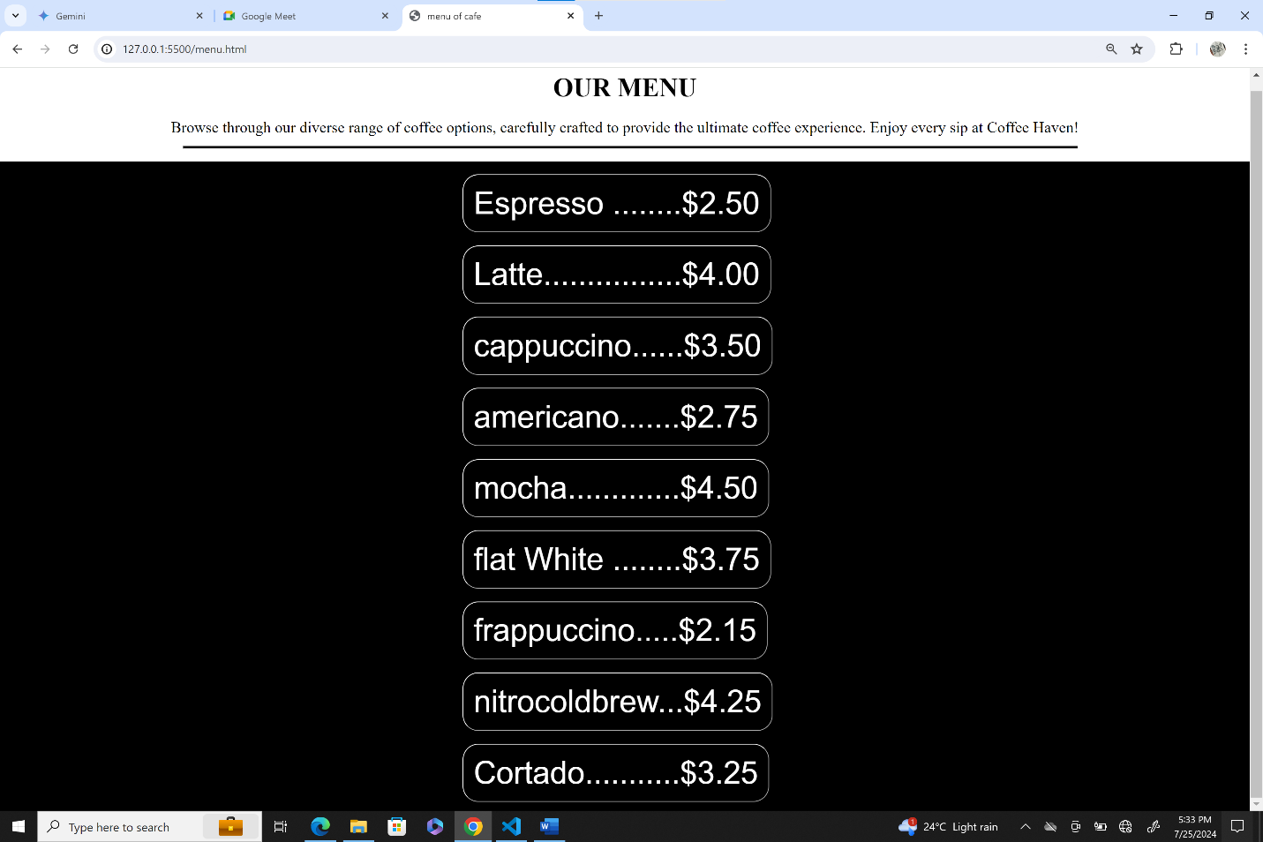

CONCLUSION:

Creating the coffee shop website using Visual Studio Code, HTML, and CSS was a rewarding experience. I focused on designing a user-friendly interface that captures the essence of the café atmosphere, incorporating interactive elements and responsive layouts. This project deepened my understanding of web design principles and the importance of detail in enhancing user experience. Moving forward, I'm excited to continue exploring new technologies and applying my skills to future web development projects.

\*\*END OF THE PROJECT\*\*

Done by T Madhulika

Diploma student (final year)