Katie Hilliard

Module 6.2 Assignment

Screenshot:

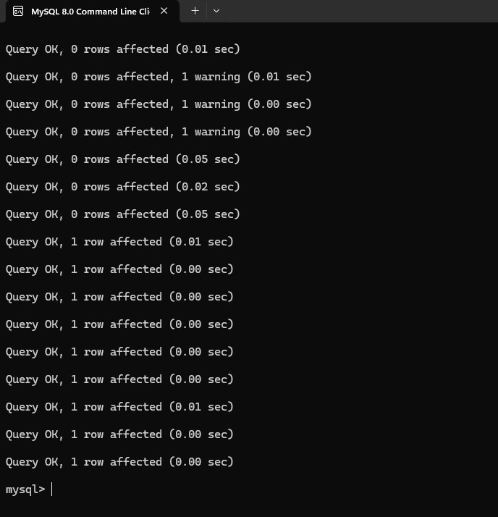

SHOW MOVIES:

RUN SCRIPT:

