Katie Hilliard

Module 1.2 Assignment

10/27/2024

Link to my GitHub repository: <https://github.com/butterfly2407/csd-325.git>

Screenshot of my GitHub repository:

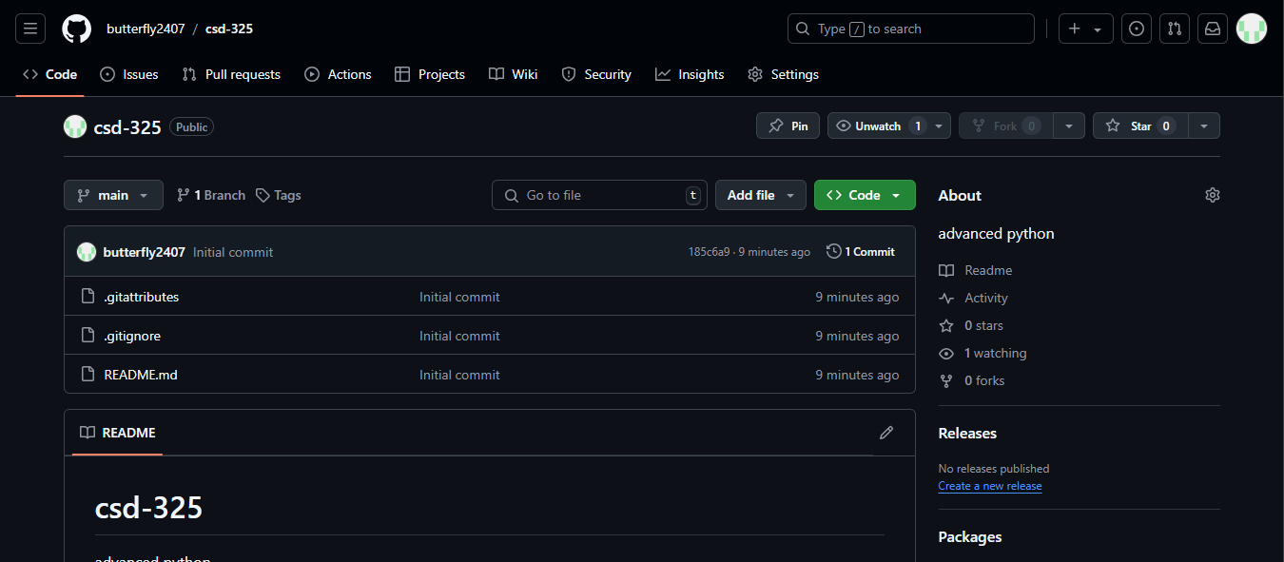

Screenshot of my local directory:

