Katie Hilliard

Module 11.2 Assignment

Screenshot 1:

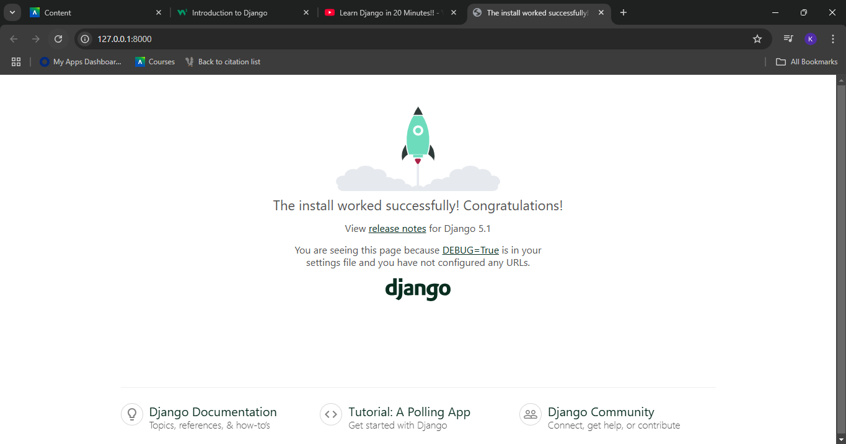

Screenshot 2:

