Katie Hilliard

Module 7.2 Assignment

City_functions.py result:

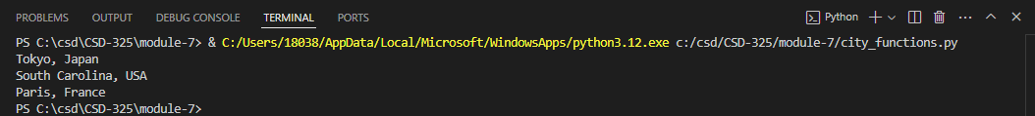

First test for test_cities.py result:

2nd test result (failure):

3rd test result after optional population modification:

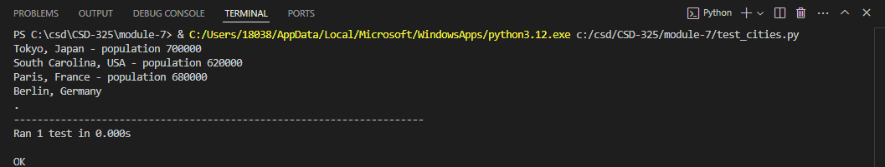

4th result language missing:



5th result pass:

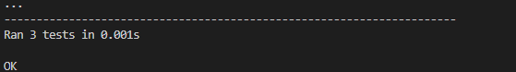

Final result:

