Katie Hilliard

Module 9.2 Assignment

Test google connection:



API tutorial results:

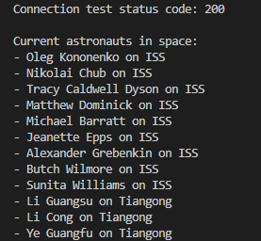

Custom API results:

