Katie Hilliard

M1-Assignment

Screenshot of local directory:

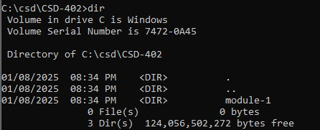

Screenshot of repository:

Link to repository: <https://github.com/butterfly2407/csd-402.git>