Katie Hilliard

05/02/2025

Module 9 Programming Assignment

After running my test application:

Screenshot #1:

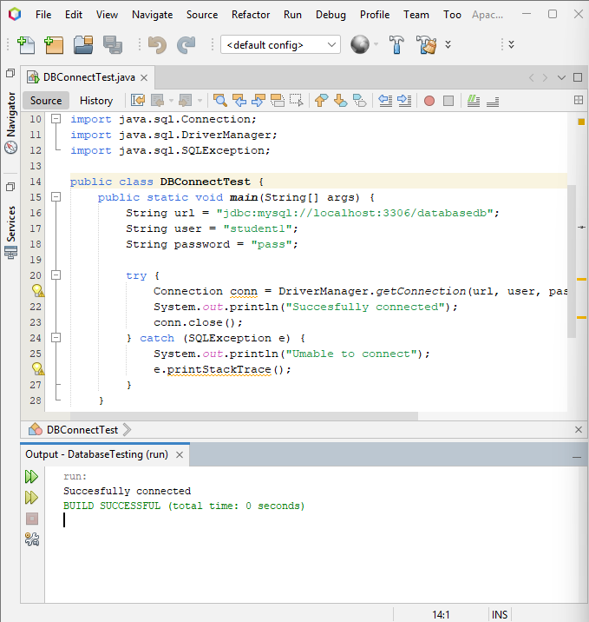

Screenshot #2:

