Katie Hilliard

06/15/2025

Module 4 Assignment – JavaBean

**Java:**

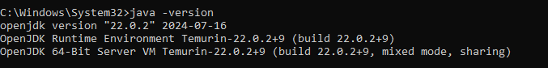

**Eclipse:**

