# HOW TO INSTALL PULSE APPLICATION?

1. Install Pulse Web Api (for server machine only)

* Step 1: Open Pulse.Web.Api.Setup

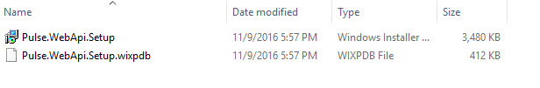

* Step 2: Follow the set up wizard. Change the destination (if needed).

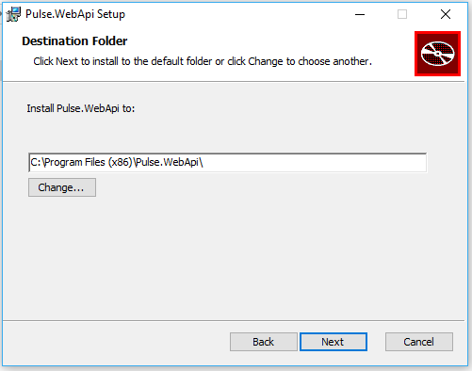

* Step 3: Open **Pulse.WebApi.exe.config** file in your destination folder to change the connection string of the database server.

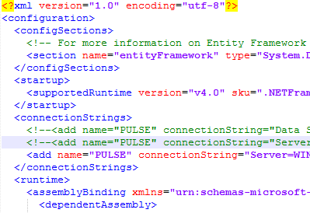

1. Install Pulse Owin Server

* Step 1: Open Pulse.Owin.Setup



* Step 2: Follow the set up wizard. Change the destination (if needed).

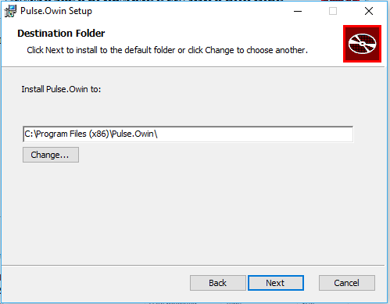

* Step 3: Open Pulse.OwinServer.exe.config file in the destination folder. Update domain address for these field information:

+ DOMAIN_SERVER

+WEBAPI_SERVER

+SERVER_URI

# RUN PULSE SERVICES

* Step 1: Type “services.msc” into the search box to open Services Management.
* Step 2: Find Pulse Api service **first** and then start Pulse Owin service.

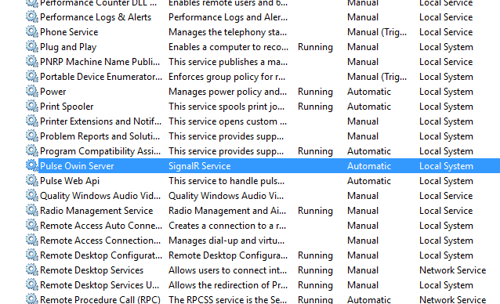

# SETUP PULSE DASHBOARD (FOR SERVER ONLY)

* Step 1: Open Internet Information Services (IIS) Management
* Step 2: Add a new website

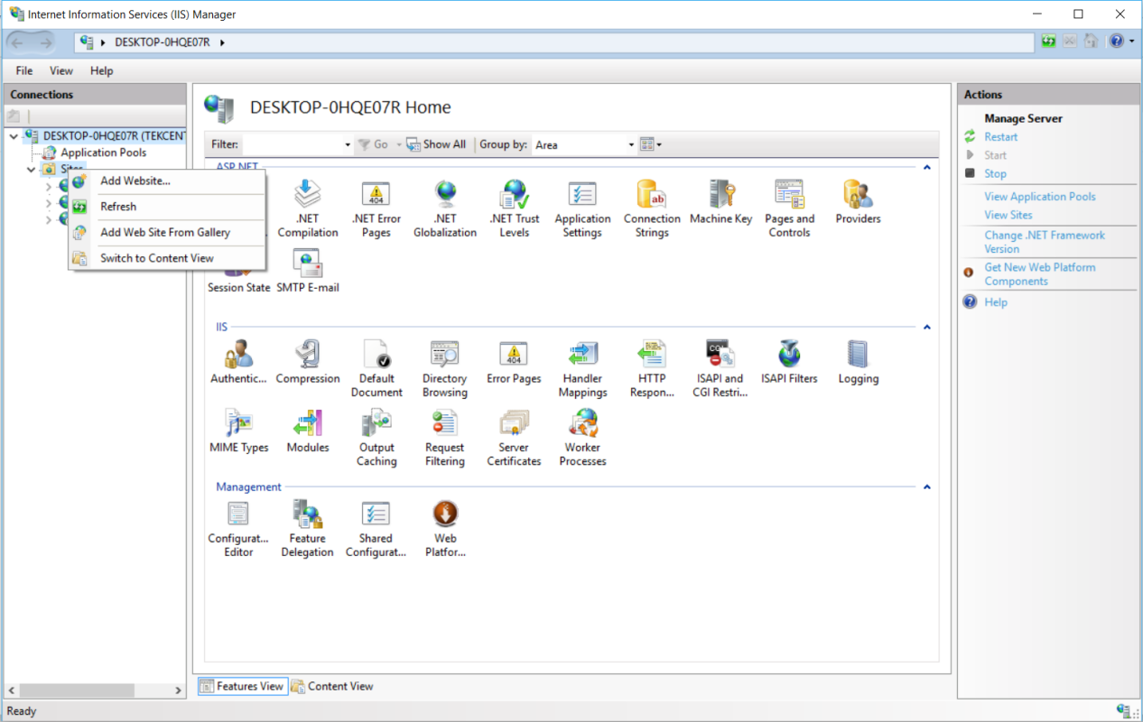

* Step 3: In the Add Website Dialog Box.

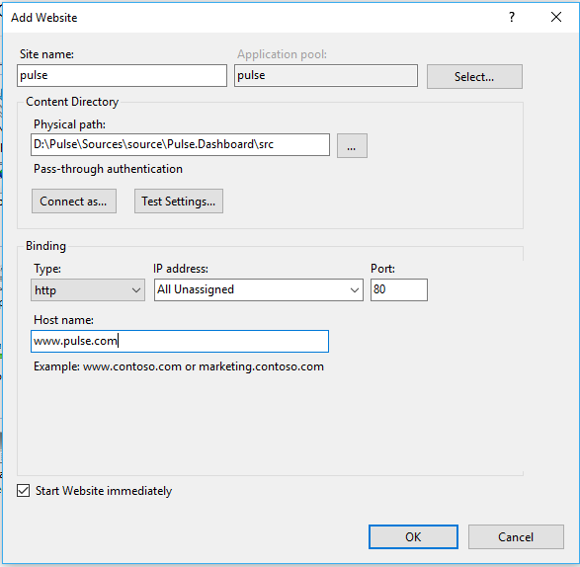

* Step 4: Change domain address for these value:

+ Index.html:

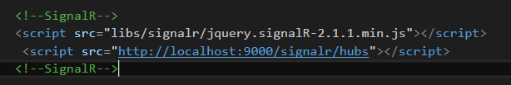

+ app.module.js:

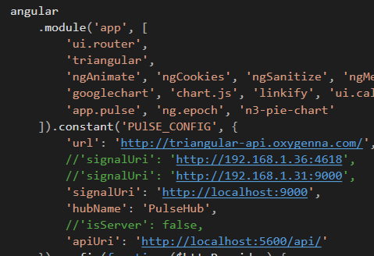

* Step 4: Run your website.

